

**A review and synthesis of CCZ benthic metazoan biodiversity data from the ISA DeepData database, the literature and other published sources**

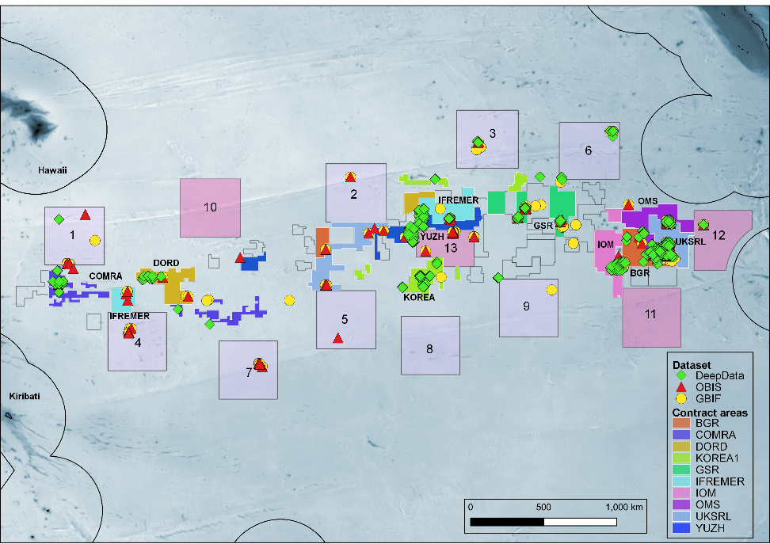

**Report Authors**

Muriel Rabone & Adrian G Glover

*Deep-Sea Systematics and Ecology Research Group, Life Sciences Department, Natural History Museum, Cromwell Rd, London SW7 5BD, UK.*

*Correspondence email:* [*a.glover@nhm.ac.uk*](mailto:a.glover@nhm.ac.uk)

**Publication Date**

DRAFT

**Report Number**

NHM SON20001/PewFR

**Prepared For Client**

The Pew Charitable Trusts. Contract ID 34394.

**Collaborating Partner**

The International Seabed Authority

**Confidentiality and Distribution List**

TBC

**Data Attachments**

Data files are attached to this report as detailed in the Supplementary Information.

**Executive Summary**

In this study, we provide the first baseline biodiversity assessment of the CCZ from all published data sources for metazoans (animals) living on the abyssal seafloor of the Clarion-Clipperton Zone (CCZ), Pacific Ocean. This is a region undergoing intensive exploration for mineral resources in the form of polymetallic nodules, potato-sized concretions that rest on the seafloor in high abundances across the six million km2 of the CCZ. We compiled, processed and analysed 6303 taxonomic species records from 163 publications (2000- present), 40,518 records from the International Seabed Authority (ISA) database ‘DeepData’, 2185 records from the Ocean Biodiversity Information System (OBIS)[1], 48,554 additional OBIS records derived from DeepData (records harvested from DeepData by OBIS and published on the OBIS ISA node in June), 2405 records from the Global Biodiversity Information Facility (GBIF), 4647 records from INSDC (International Nucleotide Sequence Database Collaboration), 1674 records from the Barcode of Life Database (BOLD) and 4 genomic datasets from SRA (Sequence Read Archive)/NCBI (National Center for Biotechnology Information); an overall total of 106,377 records. This represents the first comprehensive survey of publicly available data on biodiversity in the world’s largest mineral exploration frontier. Such data will prove crucial to inform debate on mining activities, which are predicted to have large-scale and long-term impacts on the region’s biodiversity, much of which remains to be characterised.

A survey of the literature shows a historic lack of taxonomic descriptions and records from the CCZ. Prior to 2000, 22 studies containing taxonomic information (including six containing descriptions) were identified for the CCZ. Post 2000 and particularly over the past five years there has been a rapid increase in publications, with 143 studies and 207 descriptions since 2000, and 66 species descriptions in 2019 alone. This rapid increase has been driven in part by improved methodology and the recognition by stakeholders of the importance of taxonomy- or characterising biodiversity that could be impacted by mining. The majority of species described from the CCZ (184[2] in total, and 174 since 2000) have been described solely by morphology. Even so, recent surveys have also generated a considerable amount of genetic data from the CCZ, with many recent genetic/genomic studies and 4647 sequences now published on GenBank. However, few GenBank sequences are reported in DeepData (only 268 from three contract areas) or OBIS and GBIF, partly reflecting how new these datasets are.

The ISA DeepData database contains records collected from 24 CCZ expeditions over the period 2004-2019 from 10 CCZ Contractors across the CCZ region, with most published records dating from 2015, following the introduction of a standard data reporting template for Contractors that hold exploration contracts. OBIS, GBIF and published literature contain records that date back to the Challenger expedition in the 1870s, but the majority of records are from the last decade. While there is some overlap of DeepData records with the literature, OBIS and GBIF, the latter sources contain a much broader geographical spread of data, with more data from outside the contract areas, including Areas of Particular Environmental Interest (APEIs), regions designated by the ISA as potential regional conservation zones.

DeepData contains more than 10 times the amount of benthic species data for the CCZ than any other database and is a notable achievement of the ISA; however, there is a significant issue with levels of data duplication, where up to 25% of the records being duplicates. By size class, 51% of the DeepData records were for macrofauna, 28% megafauna and 20% meiofauna. 87% of species-level records in DeepData were temporary names for which distributional data beyond the Contractor dataset cannot be assessed[3]. 46% of all records are at higher taxonomic levels (e.g. genus, or family) which is relatively high compared to the published literature. A large proportion of the species names in the literature also are temporary names defined by DNA or morphology (74%). This reflects the challenges of CCZ taxonomy, including a complete lack of field guides.Often usage of temporary species names is not harmonised across Contractor datasets, therefore the distribution of these species beyond contract areas cannot be assessed.

Critical to the long-term development of knowledge of the CCZ is the creation of field guides, and a checklist of all known species from the region that is regularly updated. In this project, we have created the first benthic metazoan checklist based on publicly available data - the CCZ Checklist. There are 642 benthic animal species known from the CCZ that have full species names including those with taxonomic identification qualifiers (e.g. cf., aff., sp. inc., incertae sedis), and 462 excluding species with qualifiers or identified solely from imagery. Remarkably, 28% of these species have been described (solely) from the CCZ (180/642); and 27% are recent CCZ descriptions, since 2000 (174/642). This high proportion illustrates both the lack of historic knowledge and the recent increase in taxonomic effort. Although the majority of species names in our CCZ Checklist are derived from the literature (309), the DeepData database has contributed 25 names (after pelagic taxa were excluded). Almost 50% of the species in the CCZ Checklist are arthropods or annelids. By size class, 296 are macrofaunal species, 241 megafauna and 115 meiofauna. While this represents only a small fraction of the total diversity in all size classes, it is likely that meiofauna are the most under-sampled group. Analysis of the CCZ Checklist together with the literature search shows that for some groups, such as Bryozoa, Annelida, Porifera and Nematoda, there has been a recent burst of taxonomic effort, but for other groups such as the Echinodermata or Mollusca there has been relatively little recent taxonomic work, likely a result of limited available expertise. However, analysis of the number of known morphospecies from all data sources compared to numbers of known species suggests that even some of these better-studied taxa are still vastly undersampled, with polychaetes for example having the most morphospecies names (1678) but only 129 named species.

With DeepData, we were able to analyse species diversity and species distributions for the first time on a regional scale and across size classes for the CCZ, with significant limitations however, due to data duplications in the database. Looking at family-level diversity with sampling effort, the Chao1 estimators[4] suggest a total of 234 families from DeepData records, less than half of the total in the CCZ Checklist, i.e. from all published sources (501 excluding pelagics). This suggests that DeepData records do not currently provide a comprehensive picture of family-level sampling / diversity. Here this family-level diversity estimate is compared to the CCZ Checklist, but the degree to which the Checklist accurately reflects family diversity in the region is unknown, but it seems feasible that the 501 families recorded in the Checklist is a minimum estimate (given that a significant degree of misidentification at family-level is unlikely as compared to lower taxonomic levels, e.g. species). Further, this estimate is for named families only. It is possible, even likely that there are undescribed families in the CCZ (with three families described from the region to date), but no undescribed families are currently noted in any datasets (whether DeepData, other databases or the literature) to the authors knowledge.

At species level, sampling is far from complete in the CCZ, with the numbers of species still accumulating rapidly with sampling effort. The estimate for total species richness in the CCZ for benthic metazoans is 5480 (Chao1, based on DeepData records and both named species and morphospecies, benthic only). Interestingly this is rather similar to the total species list for the CCZ Checklist (642) and morphospecies list combined (5078) but this is likely to be a coincidence as the morphospecies list likely contains many synonyms. If the total number of named species (642) is compared to the species estimator (5471), this suggests that 87% of species in the CCZ are as-yet unrecorded. Based on previous taxonomic studies, we estimate that between 61% and 99% of species in the CCZ are new to science (not including cryptic diversity), hence this provides an estimate of between 2770 and 4043 species in the CCZ that remain to be described (50-73% of the total). There is huge uncertainty in this figure. It could be either an over-estimate if a large proportion of the temporary names are synonyms, or more likely an under-estimate owing to duplication in the data, very limited sampling and the fact these totals do not include cryptic diversity (ADD explan).

When compared across size classes, the data are too scarce for meiofauna to make a meaningful comparison, but for macrofauna, we estimate based on species accumulation curves for total species richness2973 species and for megafauna, 419 (for named species and morphospecies combined, DeepData records only as above). In total, 488 meiofauna species were recorded in DeepData from just 33 samples, suggestive of very high diversity with a Chao1 estimate of 5419 species, but given the very small sample size, this estimate should be treated with caution. The megafauna estimate is very low at 419, and likely a significant underestimate arising from a number of factors, a key one being the extensive duplication present in DeepData. This low number also reflects general under-sampling for megafauna, given additional challenges of collection, either with ROVs (expensive) or trawls (destructive of animals.

A survey of the data by contract area shows that both the taxonomic resolution (level at which taxa are identified to), and the taxonomic composition reported, even at very coarse phylum resolution, varies greatly. The variability observed in taxonomic composition at phylum level is most likely not driven by real changes in the environment but rather biases introduced by varying efforts made by Contractors on different groups, with differing sampling strategies. Analysis of the community composition across the entire CCZ is of great importance in helping to develop the Regional Environmental Management Plan, or REMP[5]. However, this is a challenge with the current data, owing to issues with both data duplication and sample bias. For example, different contract areas show quite dramatic shifts in the composition of polychaete families, but a large amount of this trend is most likely be driven by differences in sampling methodologies – e.g. the data reported for the YUZH[6] contract area is dominated by suspension feeding polychaetes, likely a result of sampling being focussed on nodule fauna.

Analysis of species ranges in the dataset based on grouping contract areas into Eastern, Central and Western CCZ regions shows that the Central CCZ has the most unique named species and the Central and Eastern sites have the most shared species. However, sample sizes are very different. More detailed analyses across contract areas and conservation areas, known as Areas of Particular Environmental Interest (APEIs) show a large number of species unique to each site (38%), which are not represented in APEIs. Although this may be due to undersampling as the sampling effort in the APEIs is very small, with only 35 sites over a vast area and some APEIs only represented by one or two sites. The largest number of unique species (named and morphospecies combined) are found in IFR2 (401), followed by UK-1 (291). The largest numbers of shared species are between UKSRL (UK-1) and OMS, followed by GSR and IOM. This could be influenced by geographic proximity, but also by taxonomic approach as these contract areas have been surveyed by shared cruises and taxonomic teams. The Central sites showed the highest overall diversity, particularly the IFREMER contract area, but this is likely influenced by differences in faunal groups surveyed/taxonomic methodology between Contractors.

Our work using the DeepData database allows us to make a general analysis of the database in order to provide useful feedback to the ISA on its future development. The data downloaded directly from DeepData is difficult to work with as observations are distributed across both rows and columns, and therefore requires restructuring to be easily useable for analysis. The DeepData records that are now published on OBIS using the new ‘ISA’ node, are in contrast ‘analysis ready’ as the fields are mapped to DarwinCore. However, the DeepData dataset and the DeepData records published on the OBIS ISA node cannot be matched due to the usage of non-unique identifiers in DeepData.

A further issue is extensive duplication of datasets on DeepData. It will be important to remove the duplicate data, which has already been passed to the OBIS ISA node and will therefore require significant data cooperation. Once these issues are corrected, the data should be republished both on DeepData and OBIS. To address potential further data issues, we have assessed of the new ISA data template (2022) for Contractors and provided recommendations. There are many potential future developments for DeepData but one important one could be to create a dynamically updated thematic regional node on the World Register of Deep-Sea Species (WoRDSS) or alternatively a distribution flag ‘CCZ’ within WoRDSS and distributional data also added the World Register for Marine Species (WoRMS). This could be used to maintain and update the CCZ Checklist, as compiled here, which would allow all stakeholders to monitor the growth of taxonomic knowledge in the CCZ.

In conclusion, there has been a dramatic and welcome growth of knowledge on the biodiversity of the CCZ, and the data repositories DeepData, OBIS, GBIF and INSDC have all played a significant role in making these data publicly available. The rapid publication of data onto DeepData in 2021 is welcome, but there are non-trivial issues with duplication and identifiers that must be addressed, particularly given that duplication impacts abundance and incidence data, key for ecological analyses that should inform ISA decision-making. There are 642 described benthic animal species known from the CCZ but our current ‘best estimate’ of total species diversity suggests that this is just 13%[7] of total species richness. Taxonomic efforts and effective data sharing must be maintained and grown to address the biodiversity knowledge gap in the CCZ, essential to both local management of individual Contractor exploration areas and the management of the entire region.

**List of Abbreviations and Terms**

COI

ITS2: Internally Transcribed Spacer

Cytb: Cytochrome B

ABNJ: Areas Beyond National Jurisdiction

APEI: Area of Particular Environmental Interest: regions designated by the ISA as potential regional conservation zones

API: Application Programming Interface

BasisOfRecord: Darwin Core term to describe record type, e.g. preservedSpecimen

CCZ: Clarion Clipperton Zone, also known as the Clarion Clipperton Fracture Zone (CCFZ)

Checklist: Inventory of species/taxa names, often organised by taxonomic group or region

Contractors: holders of mineral exploration contracts

Darwin Core: global data standard administered by the Taxonomic Databases Working Group (TDWG). Several Darwin Core terms have been referenced in the report, these are also listed here, e.g. BasisOfRecord; taxonConceptID, identificationQualifier.

DOI: Digital Object Identifier

DSM: Deep Seabed Mining

eDNA: environmental DNA

EIA: Environmental Impact Assessment

EEZ: Exclusive Economic Zone

FAIR: Findable, Accessible, Interoperable and Reusable

GBIF: Global Biodiversity Information Facility

GUID: Globally Unique Identifier

identification qualifier: taxonomic identification qualifiers, such as aff. cf. sp. nov. (identificationQualifier in Darwin Core terminology)

IFR2: contract area code for contractor IFREMER

INSDC: International Nucleotide Sequence Database Collaboration

ISA: International Seabed Authority

JSON: JavaScript Object Notation

LTC: Legal and Technical Commission

Macrofauna: animals retained on a 250-300 µm sieve

Megafauna: animals 2cm or greater in size

Meiofauna: animals retained on a 63 µm sieve

Morphospecies: These are informal working species names used prior to formal description, also known as morphotypes, OTUs, working species, or temporary names.

NCBI: National Center for Biotechnology Information (administrates the GenBank database)

NHM: Natural History Museum, London

NOC: National Oceanography Centre, Southampton

OBIS: Ocean Biodiversity Information System

Occurrence data: distributional records of species/taxa

OTUs: Operational Taxonomic Units

Reserved Area:

ROV: Remotely Operated Vehicle

REMP: Regional Environmental Management Plan

Scientific name: The designation or identification of an organism (scientificName in Darwin Core terminology)

Sponsoring State: Mineral exploration contracts in the Area require the support of a Sponsoring State- usually the state where the company is based

Taxa: a taxonomic group of any rank, such as a species, family, or class (singular: taxon)

Taxonomic resolution: level to which taxa are described to, e.g. high taxonomic resolution would be for example most taxa described to species level

Taxonomy: the science of describing and naming new species

TDWG: Taxonomic Databases Working Group

QA/QC: quality assurance/quality control, here referring to data QA/QC

WoRDSS: World Register of Deep-Sea Species

WoRMS: World Register of Marine Species

YUZ2: contract area code for Contractor YUZ JSC Yuzhmorgeologiya

**T**able of Contents

1. INTRODUCTION 12

1.1. Overview of exploration of the Clarion-Clipperton Zone 12

1.2. The International Seabed Authority and Environmental Data 12

1.3. The DeepData database 13

1.4. Other Data Sources: databases and the literature 13

1.5. Rationale for Study and Study Scope 15

1.5.1. Main study objectives 16

1.5.2. Alterations to Scope of Work 16

2. MATERIALS AND METHODS 18

2.1. Data Collection 18

2.1.1. DeepData 18

2.1.2. OBIS and GBIF 19

2.1.3. Published Literature and INSDC 19

2.2. Data Processing 20

2.2.1. DeepData 20

2.2.2. OBIS and GBIF 21

2.2.3. Published Literature and GenBank records 24

2.2.4. The CCZ Checklist and WoRMS 24

2.3. Data Analysis 26

2.3.1. DeepData and duplication 26

2.3.2. Diversity estimates 26

2.3.3. Diversity and distribution/Community composition 26

3. RESULTS 28

3.1. Published literature containing taxonomic information 28

3.1.1. Overview 28

3.1.2. By publication year 28

3.1.3. Descriptions 30

3.2. Overview of records in DeepData; in context of other published records, focussing on taxonomic information 35

3.2.1. Overview of data in all sources 35

3.2.2. Summary of temporal coverage across the CCZ over time 35

3.2.3. Summary of spatial coverage of the data sources 37

3.3. Overview of taxonomic information 39

3.3.1. Records in common between the data sources 39

3.3.2. Taxonomic resolution 40

3.3.3. Trends by size class and identification method 43

3.3.4. Trends by Contractor and contract area 47

3.3.5. Morphospecies/temporary names 49

3.3.6. Genetic data coverage: DeepData and comparison with GenBank and the literature 52

3.4. Creation of the CCZ Checklist 54

3.4.1. CCZ Checklist species names by phylum and data source 55

3.4.2. Species names by size class 58

3.4.3. Coverage and gaps in taxonomic work/descriptions based on the CCZ Checklist 59

3.5. Analysis of Diversity and Species Distributions 62

3.5.1. Overview of species diversity in the Clarion-Clipperton Zone 62

3.5.2. Overview of community composition between contract areas 67

3.5.3. Analysis of species ranges 69

3.5.4. Common and Rare - singletons and candidates for connectivity studies 75

3.6. General Assessment of the DeepData Database 77

3.6.1. Summary 77

3.6.2. General analysis of data structure in published records 77

3.6.3. Data quality assessment: published records 79

3.6.4. General analysis of fields included in published records 83

3.6.5. Assessment of ISA environmental data template 84

3.6.6. Observations on taxonomic information in Contractor data submissions 85

3.6.7. The OBIS ISA node and data mapping 86

3.6.8. DeepData webpage interface 88

3.6.9. Recommendations and considerations for the data template and DeepData 89

3.6.10. Potential future developments of DeepData 91

4. DISCUSSION 93

4.1. Biodiversity in the Clarion-Clipperton Zone 93

4.1.1. Sampling effects 94

4.1.2. Comparing DeepData to other databases and literature 94

4.2. Taxonomy in the CCZ: coverage, gaps, and the CCZ Checklist 94

4.3. Potential future analysis and applications for DeepData 95

4.4. Study Limitations 96

5. CONCLUSIONS 97

6. ACKNOWLEDGEMENTS 100

7. SUPPLEMENTARY DATA 100

7.1. Supplementary Tables 100

7.2. Supplementary Figures 117

7.3. Supplementary Data Files 121

7.3.1. Supplementary Data File 1 121

7.3.2. Supplementary Data File 2 121

7.3.3. Supplementary Data File 3 122

7.3.4. Supplementary Data File 4 122

7.3.5. Supplementary Data File 5 122

7.3.6. Supplementary Data File 6 122

7.3.7. Supplementary Data File 7 122

7.3.8. Supplementary Data File 8 122

7.3.9. Supplementary File 1 123

7.3.10. Supplementary File 2 123

8. REFERENCES 124

8.1. Main report references 124

8.2. References for taxonomic literature review 130

# INTRODUCTION

## Overview of exploration of the Clarion-Clipperton Zone

The Clarion Clipperton Zone (CCZ) is a vast stretch of sedimented abyssal seafloor spanning 6 million km2 from the Hawaiian Archipelago to Mexico, at depths of 4000-5000m. One of its most characteristic features is an abundance of potato-sized polymetallic nodules that lie on the surface of the sediment, which have been eyed as a metal resource, particularly for nickel, cobalt and manganese for many decades (Baker & Beaudoin 2013). Nodule density (together with POC flux) is regarded to be a key environmental driver of patterns in diversity and distribution (Washburn et al., 2021). The CCZ is noted to be highly heterogeneous in terms of habitat including in terms of nodule density (Simon-Lledo et al., 2019A, B).

Recent years have seen a renewed interest in deep-sea mining in the CCZ owing in part to projected demand for minerals for so-called ‘green-technologies’, such as electric vehicles (Herrington, 2021; The Royal Society, 2017). As part of the mineral exploration process, the International Seabed Authority (ISA), regulator of mineral-related activities on the international seabed area, requires the holders of exploration contracts to collect and make available biological data to improve the understanding of the potential impacts of deep-sea mining. In the early years of the ISA, data were mostly collected in reports generated by the Contractors (holders of mineral exploration contracts). More recent years have seen an increased emphasis on the publication of biological data in the open scientific literature; and in global scientific databases such as OBIS, the Ocean Biodiversity Information System ([www.obis.org](http://www.obis.org); OBIS, 2021) and GBIF, the Global Biodiversity Information Facility, in particular biodiversity information such as species records. Most recently, data have been published by the ISA itself through the “ISA Deep Seabed and Ocean Database”, DeepData.

Although the CCZ has been intensively explored for mineral resources, there has been relatively little synthesis of biological data across the region to date, mainly owing to a lack of data availability, but also a lack of comparability across datasets arising from different sampling methods (Mincks & Smith, 2006). These baseline data are critical as they will form the basis of Contractor’s potential environmental impact assessments for future exploitation contracts. In this report, we have collected, processed and analysed all benthic metazoan species data available on the DeepData database, alongside searches of online databases and published literature to provide the first comprehensive synthesis of current knowledge on CCZ benthic metazoan biodiversity. We have also reviewed the structure and function of the DeepData database, to help inform its future development, and provide recommendations based on this review.

## The International Seabed Authority and Environmental Data

The ISA is mandated under the UN Convention on the Law of the Sea (UNCLOS) to organise, regulate and oversee all mineral-related activities in ‘the Area’ (‘the region of seabed and ocean floor and subsoil thereof, beyond the limits of national jurisdiction’). The ISA currently issues exploration contracts contracts to member States (a nation state, signatory to UNCLOS) or private entites sponsored by a member State, referred to as ‘Contractors’, to undertake survey and exploration activities in contracted areas. The CCZ is the most active region under the control of the ISA, with 17 contracts issued to date. The ISA also oversees areas Areas of Particular Environmental Interest (APEIs), regions designated by the ISA as potential regional conservation zones, which are protected from mining activities. Nine areas were established in 2013 (Wedding, 2013), but with concerns over representativeness and placement, a further four were proposed in 2019 (Deep CCZ workshop report, 2019; McQuaid et al., 2020), and accepted by the LTC in December 2021[8].

Contractors, as part of their exploration contracts, are required to submit their environmental data to the ISA, using a data template, first introduced in 2015. ‘Environmental data’ is something of an umbrella term in the ISA regulations that covers both abiotic (physical/chemical/geologic parameters), and biological data. These data templates, which are regularly being updated, have allowed the ISA to create its first publicly accessible database, DeepData (<https://www.isa.org.jm/deepdata>). Environmental data reporting is required for all size classes of fauna: microfauna, meiofauna, macrofauna, and megafauna[9]. Alongside the development of the data templates and DeepData the ISA has also contributed to the development of sampling and data standardisation, particularly for taxonomy through a long series of workshops and reports (ISA, 2020). Data standards however remain a long-standing issue in biodiversity data, coupled with the traditional challenges of taxonomy in an environment where the majority of species are still undescribed (Glover et al., 2018; Poore et al., 2015; Higgs & Attrill, 2015; Horton et al., 2021).

## The DeepData database

ISA mandate to support MSR in the area

mention confidentiality of data

The need for a central ISA database was formally identified by the Legal and Technical Commission (LTC) of the ISA in 2002, and DeepData was developed as a further iteration of the previous Central Data Repository (primarily focussed on mineral resources). Several LTC recommendations were made during the period of 2002-2019[10], and on the 28th August 2019, the ISA launched DeepData as a central repository of deep-seabed related data collected by Contractors and related parties (e.g. research organisations conducting surveys) in the Area. In its current state, it features an interactive map with searchable data points, such as the biological, physical and geochemical parameters of the marine ecosystems from the seabed to the ocean surface, submitted by all Contractors and covering approximately 1% of the CCZ[11]. For the CCZ, the ISA DeepData website provides map-based data collated from previous offshore campaigns arranged by Contractors for the CCZ and other exploration regions.

The map-based interface includes boundary data for the APEIs, contract areas and reserved sites, and point data for research samples. The sample data currently held in the database includes: analyses conducted from biological[12] samples collected from box corers; epibenthic sledges; multiple corers; ROVs and benthic trawls; also data from bathymetric seabed mapping; navigational information for offshore campaigns; data from current meter recordings; data from CTD water column measurements and water sampling deployments.

DeepData has a wide potential user community. This includes a range of stakeholders encompassing Contractors, Policymakers, Government Scientists, Academic Scientists, NGOs and the broader research community investigating a range of research questions; for example on deep-sea biology and ecology, global-scale oceanographic changes, or biochemical investigations exploring potential marine genetic resources.

## Other Data Sources: databases and the literature

Biological data for the CCZ are also available in other databases and the published literature. Relevant databases here have differing applications, focussed on different types of data, such as distributional records of species or taxa (occurrences); genetic or genomic datasets (primarily in the form of sequence data); or taxonomic information (Fig. 1). The databases described here compile (or ‘aggregate’) records from a variety of sources, including other databases, and as such they cover much of the available published information. Other data categories or types relevant but not covered here include acoustic data, imagery data for example from seabed imagery surveys, which may be available through annotation platforms, such as the Bio-Image Indexing and Graphical Labelling Environment (BIIGLE (Langenkämper et al., 2018), and more recently on FathomNet (http://fathomnet.org/). However, the majority of imagery records are not public and not searchable (Daniel Jones, pers. comm.).

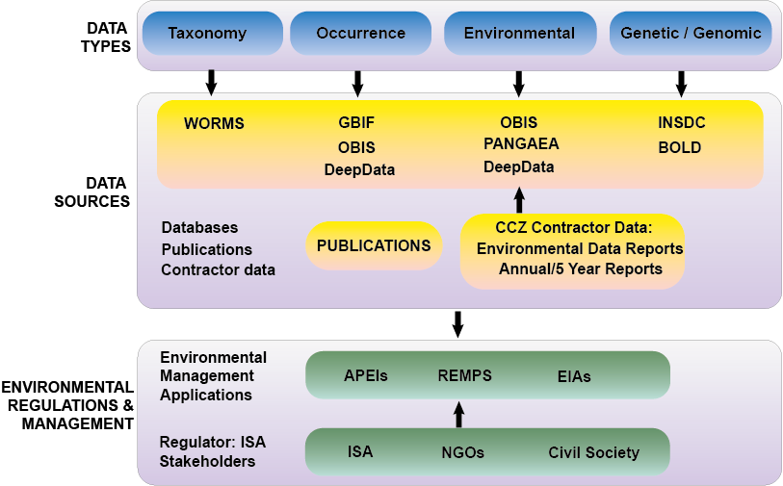Fig. 1 The Clarion Clipperton Zone biodiversity data landscape, as both outlined and discussed in this report. With thanks to the Nautilus Biodiversity Data Working Group for elements that contributed to the figure

For species occurrences, records are made available by global data aggregators which compile data from multiple sources, generally academic and government research institute databases, such as those housing museum specimen records (Collins et al., 2020). Two key databases for species occurrences are the Ocean Biodiversity Information System, [OBIS](http://www.obis.org/); and the Global Biodiversity Information Facility, [GBIF](https://www.gbif.org). While similar in scope, these databases have a different focus. Both utilise the global biodiversity data standard, [Darwin Core](https://dwc.tdwg.org/), administered by TDWG, the Taxonomic Databases Working Group. Usage of this standard allows for interoperability and comparison of data and communication between databases[13]. GBIF houses both marine and terrestrial biodiversity records; OBIS houses marine biodiversity records, and also includes environmental data, e.g. oceanographic measurements. Recent development of Darwin Core terms by OBIS[14] using the Darwin Core (extendedMeasurementOrFact) has allowed for integration of abiotic environmental/oceanographic data with biological occurrence records (Klein et al., 2019). Both databases can be interrogated for occurrences or taxonomic information, e.g. species names. Several other data repositories also house environmental and occurrence data, for example, [PANGAEA](https://www.pangaea.co.uk/).

The primary source of taxonomic information is the World Register of Marine Species ([WoRMS](https://www.marinespecies.org/)), a checklist[15] and classification of marine taxa curated by around 300 taxonomic editors (Horton et al., 2021, 2017; Vandepitte et al., 2018). The database is a comprehensive and authoritative source of taxonomic information, and both OBIS and GBIF utilise the taxonomic ‘backbone’ of WoRMS, i.e. both the checklist and classification (and other relevant taxonomic information). Other ‘thematic nodes’ of WoRMS are available, a relevant one being the World Register of Deep-Sea Species (WoRDSS; Glover et al., 2021), which is maintained as a thematic database with the taxonomic editors of WoRMS able to tag and un-tag species in WoRMS as being present or absent from the deep sea, with a literature source.

The other relevant data category is genetic and genomic data, primarily in the form of published sequences. DNA sequences are stored in the International Nucleotide Sequence Database Collaboration (INSDC) databases. The INSDC is formed of three international databases (US, EU, Japan) that contain millions of DNA and protein sequences and contextual data: the DNA Data Bank of Japan ([DDBJ](https://www.ddbj.nig.ac.jp/index-e.html))[16]; the European Nucleotide Archive, [ENA](https://www.ebi.ac.uk/ena/browser/home) and [EBI](https://www.ebi.ac.uk/)[17]; and [GenBank](https://www.ncbi.nlm.nih.gov/genbank/)[18]). These databases exchange data daily. They form something of a standalone group, being integrated with each other, but not with the databases above.

Biological records are also available in the peer-reviewed literature, which is of course considered the primary source of such datasets. Often associated records from the literature will be published on databases alongside article publication. For example, journals require sequence data to be published on databases either prior to; accompanying; or immediately following the paper publication (Jaspars et al., 2021)[19]. Taxonomy published in the literature is generally added to the WoRMS database by the taxonomic editors. In some cases, occurrence records are harvested by OBIS and GBIF directly from publications (see section 3.3.1 & Rabone et al., 2019). Therefore, while literature is the main source of biodiversity data, for many data types the records are often available on the databases above.

## Rationale for Study and Study Scope

For a number of years, there has been a clear and pressing need for a comprehensive review of available biodiversity data in the CCZ. This is both for individual Contractor regions, to assist in developing future Environmental Impact Assessments (EIAs); and at a regional level to assist the ISA in developing a Regional Environmental Management Plan (REMP). Although a few recent publications have examined findings from multiple studies, these have focussed on particular regions- generally the eastern CCZ where many more studies have been done; and/or on particular faunal size classes; or on non-metazoans (Bonifacio et al. 2020, 2021; Simon-Lledó et al. 2020; Washburn et al., 2021; Drazen et al., 2021; Leitner et al., 2021; Gooday et al., 2021). Sub-selection of studies has also been necessary in some cases given the variability of sampling and the challenges of pooling findings from disparate studies (Washburn et al., 2021).

This report is particularly timely as DeepData has now been operational for 2 years; a significant body of literature from the CCZ has recently been published; and associated records are now being actively pushed onto global data aggregators such as OBIS, GBIF and INSDC. It is important therefore to assess both the data holdings and potential of DeepData for research and environmental management applications, alongside comparisons with other published data. Such syntheses are essential to the sound environmental management of the CCZ.

The specific scope of this study is to examine all published biodiversity data for benthic metazoans from the CCZ (meiofauna, macrofauna, and megafauna). We present the first systematic review of taxonomic information attempted for the CCZ, synthesising biodiversity knowledge from published sources, the literature, the ISA database DeepData and other databases, to help identify and address existing knowledge gaps for managing any potential deep-sea mining activities, should they occur, and ensuring the protection of the marine environment.

### Main study objectives

The main objectives as defined in the Scope of Work 34394 (Client: Pew Charitable Trusts) were:

* A review of taxonomic data found in DeepData and a subset analysis of data collected by recipients of deep-sea exploration contracts (Contractors);
* A comparison of biological data of the CCZ available in DeepData and data published on global data aggregators including the Ocean Biodiversity Information System (OBIS) and the Global Biodiversity Information Facility (GBIF), and on the INSDC sequence databases (International Nucleotide Sequence Database Collaboration: GenBank, EMBL and others), World Register of Marine Species (WoRMS) and in relevant peer reviewed literature;
* Analysis of the current taxonomic data structures in DeepData, including what biological data is currently captured, how it is structured in Contractor data templates, and how it is represented on the online database;
* Analysis of ongoing CCZ taxonomic work within the last five (5) years in peer-reviewed literature and the degree to which this is represented by DeepData, OBIS and GBIF;
* Checklist of named benthic metazoan species represented by DeepData, OBIS and GBIF, and published literature in the last five (5) years;
* Synthesis of taxonomic data, including identification of taxonomic knowledge gaps;
* Based on the above analyses, recommendations on priorities for taxonomic investigation and standardization in the CCZ, focusing on data requirements; and also, on improvements for DeepData and the International Seabed Authority biological data strategy more widely, including suggestions for data capture and data modelling.

### Alterations to Scope of Work

The alterations to the scope are:

* The systematic literature review search was expanded from a 5-year search to a search without time-bounds to make data capture more comprehensive, and provide context to recent studies and compare recent with legacy literature.
* Additional analyses were conducted of the DeepData records that had been uploaded to OBIS by the ISA in June 2021

# MATERIALS AND METHODS

All data were analysed and processed in R, version 4.0.2 (2020-06-22) "Taking Off Again" (R Core Team, 2020), and Microsoft Excel 365. A full list of R packages used in analysis is detailed in the first lines of the R script, SF2. All mapping was done in R and in Quantum GIS (QGIS), version 3.10, Coruña (QGIS.org, 2020).

## Data Collection

### DeepData

The DeepData web interface has two windows, ‘HOME’ with a map view, and ‘MAP OPTIONS’, with 6 tabs: ‘Layers, ‘Search’ ‘CTD’, ’Photo/Video Gallery’, ‘Library’, and ‘Docs’ (<https://data.isa.org.jm/isa/map/>). Options to select biological data by category are on the ‘MAP OPTIONS’ window, ‘Layers’ tab, and include: ‘Contractors - Mineral Type’[20]; ‘Contract Status’ (all/active/extended), ‘Sponsoring State’; ‘Mineral Type’ (Cobalt Rich Ferromanganese Crust (CRFC); Polymetallic Nodules (PMN); Polymetallic Sulphides (PMS)); and ‘Location’[21].

Options to search and download data are on the adjacent ‘Search’ tab, and under ‘filter by data type’ is a dropdown menu to select data type 1: ‘Biological’, or ‘Environmental Chemistry’, and sample type 2: ‘Point’, or ‘Trawl Line’, with ‘Points’ being sampling events tied to a particular point in space and time e.g. a box core; and ‘Trawl lines’ being continuous sampling between two points, e.g. a Brenke Epibenthic Sled trawl.

Biological data were downloaded from the DeepData database web portal (<https://data.isa.org.jm/isa/map/>) on the 2nd of February, 2021. The data selection was as follows: ‘Layers’ tab, ‘Mineral Type’: ‘Polymetallic Nodules’ and ‘Location’: ‘Clarion Clipperton Fracture Zone’, and on the Search tab, ‘Biological data’ for both ‘Point’, and ‘Trawl line’ as above. After data collection and processing, it was ascertained that records on the database totalled 2465 and not all Contractors were represented, with records from 6 out of the 16 CCZ Contractors in total.

Following communications from ISA to check data availability on the database web interface, data were re-downloaded from DeepData on the 28th May. Subsequent to that, the DeepData records were published on OBIS on the newly operational ‘ISA node’. As a result, the decision was made to re-download all biological data records from DeepData, as well as OBIS and GBIF, on the 12th of July, to have the same timepoint for all databases and ensure consistency in comparisons.

The download of DeepData from the 12th of July of biological ‘Point’ data (as designated in the database and described above) consisted of a dataset of dimensions: 981483 rows, 48 columns; with the database download output of ‘Trawl Line’ data, a dataset of 941 rows and 49 columns. Additional biological datasets were requested from the ISA secretariat to assess state of datasets prior to processing. A subset of the annual biological data submissions from 10 Contractors were provided. These files were pre-processed biological data from annual reporting submissions, and while not yet published on the website, the data were classed as ‘unstructured data’ by the ISA as to be added to DeepData once data processing completed.

### OBIS and GBIF

The first step in data acquisition was to create a search area covering the entire CCZ region. To ensure the entire region was covered, all contract areas, both active and reserved, and APEI shapefiles were downloaded from the ISA database[22]. These were combined into one shapefile in QGIS; and coordinates for a polygon covering the entire CCZ including the combined shapefile was established with the following coordinates (in decimal degrees, longitude/latitude): northwest -164.01462, 15.70629; southwest -155.04998 -5.51238; southeast -101.9181 6.05623; northeast -117.66088 23.72549.

GBIF occurrence data were downloaded as a Darwin Core archive from the web portal on the 12th of July, from all depths, using the JSON polygon search function, with the CCZ polygon coordinates as above[23]). OBIS occurrence data were downloaded (as Darwin Core) on the 12th of July from within the R environment using the ‘occurrence’ function in the robis package (Provoost & Bosch, 2017)[24]; also with all depths and with the same search polygon.

### Published Literature and INSDC

A systematic review was undertaken according to the guidelines of PRISMA (Moher et al., 2009). The *a priori* research question was as follows: *what taxonomic information is available for benthic metazoans in the CCZ?*

Online databases were searched for publications through the Natural History Museum (NHM) London library, including: Google Scholar, Scopus, ScienceDirect, and Web of Science. Citations were checked, and any additional relevant publications identified were included. References of all papers were systematically checked and added if they also had not previously been identified through database searches. The review was carried out primarily from 2nd February to 20th August 2021, with the date of last search was the 1st of April, 2022. Search terms included: “Clarion Clipperton (Fracture) Zone”; “Central”/”East”/”Pacific”; “new”/“species”/”genera”/”genus”/”family”/description”; “biodiversity”; “megafauna”; “macrofauna”; “meiofauna”; “community”/”composition”; “species”/”assemblages”; “taxonomic studies”; “ecology”; “genetic”; “genomic”; “polymetallic”/”manganese”/”nodule” in combination searches. Within-journal searches were also conducted for key journals (e.g. Zootaxa) using the same search terms.

Criteria for inclusion were publications with records of benthic metazoan taxa including undescribed working species names, also known as temporary names, morphospecies, morphotypes, or Operational Taxonomic Units (OTUs, see section 2.2.4). Publications in all languages were included. Records identified from imagery surveys, e.g. ROV imagery were included, e.g. the selection was not restricted to specimen-based studies. The search was not confined to lower taxonomic levels, with all records included regardless of the taxonomic level (even if reported only at phylum level), to allow for assessment of taxonomic resolution across datasets. Publications with no taxonomic records were excluded. As the work focussed on benthic metazoans, any publications solely examining pelagic taxa, and microbes, foraminifera and xenophyophores were specifically excluded. All size classes of metazoans were included.

For literature and INSDC/BOLD, relevant data were extracted and records compiled into tables (see SDF 4; SDF 5). Relevant information was captured, for example faunal size category, e.g. megafauna; taxonomic information, e.g. scientific name and identification qualifiers; and sampling information, e.g. sampling method, region surveyed, including contract area if recorded, name and year of expedition, and type locality for new species descriptions (see SDF 5). For records held on INSDC databases (mainly GenBank) and BOLD, accession numbers were collated from publications, either from tables within papers or supplementary files, and where key information was missing, e.g. marker, the databases themselves were cross-referenced.

## Data Processing

Note that all data files referenced and used in the analysis: ‘Supplementary Data’ are archived (available here), and referred to as either SDF (Supplementary Data File X) or STF (Supplementary Table / File).

### DeepData

*Data restructuring; general data processing and data selection*

The structure of the DeepData download/database output had observations distributed both over rows and columns; rather than one observation/record per row[25] (Wickham and Grolemund, 2016). It was therefore necessary to restructure the data prior to analysis. This was done using the ‘spread’ function in R from the tidyverse package (Wickham et al., 2019) to ‘reshape’ the output to one record per row. This restructured data was outputted as a separate file; with the original archived (see SDF 1).

The separate ‘Point’ and ‘Trawl Line’ data downloads were combined into the same dataset. Data and column headings varied between the two datasets, e.g. ‘actual latitude’ in the ‘Point’ data, and ‘start latitude’ and ‘end latitude’ in the ‘Trawl Line’ data. Data here harmonised, e.g. for coordinates and depth the end-point was used and additional columns added to the ‘Point’ data to allow the datasets to be combined. A list of the column headings and mappings was recorded in the metadata (see SDF 1).

To examine the data, first it was necessary to establish a key or a unique identifier to every individual record or row of data in the dataset. In preliminary investigations to ascertain available keys it was found that those present in the data, ‘TaxaID’, and ‘SampleID’, were not unique in the dataset, where there were duplicates across multiple rows. A ‘composite key’ was created to ensure a unique key or identifier for every record by combining the following: ‘ContractorID’ + ‘StationID’ + ‘SampleID’. The composite key was checked for any duplicates, and none were found.

Data columns were checked and edited where necessary, e.g. for depth, missing values were listed as -9, these were replaced with ‘NA’. Where possible this was scripted in R, but in several cases, as multiple entries for character variables were present e.g. ‘SampleCollectionMethod’ was recorded a variety of ways, this was done in Excel. Any data point needing cleaning or editing was copied so the original data column and the processed data column were in the same dataset, with the latter renamed with a suffix ‘_ed’.

The same data processing was done for the subset of Contractor data submissions (also referred to as ‘raw’ files). The datasets varied by Contractor, some with the template columns removed or additional ones added, or with variable formats of data, e.g. geographic coordinates recorded as decimal minute rather than decimal. They were processed and data columns harmonised in excel to allow the files to be compiled into one dataset (see SDF 7).

*Taxonomic data processing*

Initial examination of taxonomic information found variable recording of data, e.g. for the column recording name of phylum, 74 entries were present while only 31 metazoan phyla are currently recognised). As above, all taxonomy columns were copied and edits made on the copied column, with spelling and formatting mistakes removed. Taxonomy was mapped to the correct column, e.g. class names in the order column were moved to the class column. No column for scientific name was present, i.e. the actual identification of the specimen referenced in a given record, here a column was added, populated with the lowest taxonomic level reported (i.e. species name[26] if recorded rather than genus name only). If a name was noted with question mark or written as two names, then the next highest taxonomic level was recorded, e.g. if two family names were recorded, the order name was recorded instead. For morphospecies names (column ‘putative species name or number’) scientific name was also recorded, mapped to the lowest scientific level recorded above species level. If a species name was present, e.g. *Paralicella* cf. *caperesca* no 5, the genus name was recorded for the scientific name.

Structured notes were made on data in taxonomy columns both on the published records and the Contractor data raw files, e.g. on spelling errors, formatting issues and similar (see SDF 1; SDF 7). Names were cross-referenced with the WoRMS database using the taxonMatch function, a QA/QC function on the website where names can be validated against the database. If unaccepted names were used this was recorded (and any misspellings for phonetic matches), with the final accepted scientific name added as a separate column (if no match was found on WoRMS, the original name was retained).

### OBIS and GBIF

*Mapping; general data processing and data selection*

All records from GBIF and OBIS were geographically overlapped with a shapefile map of the CCZ in R (see section 2.1.2) using the following packages: GADMTools, sp, spData, spatialEco, maptools, rgdal and rgeos. Shapefiles for areas within Exclusive Economic Zones (EEZs) were added for reference from the Flanders Marine Institute database (FLM 2019). If records overlapped with the CCZ shapefile as delineated above (either APEI or contract area), this information was appended to both OBIS and GBIF files in a column ‘layer’ (see SDF 2; SDF 3).

All dataset records were sub-selected by depth, with depths of 3000m and greater included. Records from 0-3000m depth were checked, this revealed a few benthic species at depths less than 3000 metres, 2 in both OBIS and GBIF for type specimen records, *Abyssarya acus* Bonifácio & Menot, 2018 and *Macellicephala clarionensis* Bonifácio & Menot, 2018 (Bonifacio & Menot, 2019), therefore retained. As an additional check to ensure all relevant benthic records were selected and pelagic records removed, the scientific names recorded were cross-referenced to habitat information (pelagic or benthic) in WoRMS (see section 2.2.4).

Some DeepData records published on OBIS from this depth range were also present, but none were metazoa. Records without depth values were present, those falling within the CCZ shapefile were reviewed and included if valid, for example if a benthic species/taxa associated with a publication and a benthic collection method e.g. a box core sample; and/or a relevant reference in ‘datasetName’ or ‘associatedReferences’ column. As a general note, even at depths beyond 3000 metres, records from seamount habitats may be included, as most explored seamount habitats fall below 3000 metres (Simon-Lledo, pers. comm.), therefore both seamounts and nodule field habitats may be represented in the datasets.

Following record selection by depth, datasets were remapped. The data selection by depth resulted in a significant reduction in records (from >138,000 rows to >2000 rows for GBIF, and >126,000 rows to >50,000 rows for OBIS, and all records at depth now fell within contract areas/APEIs or close by (Fig. 2B). The OBIS dataset was now significantly larger at this stage than GBIF as included the ~48,000 DeepData records that had been published on OBIS on the ISA node in June (see section 2.1.1), which were later separated for analysis (see next section). Any records falling outside the CCZ shapefile were reviewed to check all relevant records were captured (see SDF 2; SDF 3; Fig. 2). These included a number of historical records[27] which fell to the south of the CCZ so were excluded (Fig. 2). However most of the records at depth but falling outside the shapefile[28] were valid and retained, for example, records identified from the ‘EBIRP/ROV7’ site east of UKSRL referenced in the literature (Amon et al., 2017a). As a result, there was no need to draw a buffer around contract, reserve and APEI areas (Fig 2B).

The Darwin Core term ‘basisOfRecord’ for designating the type of record was also reviewed, here potential categories include for example ‘humanObservation’, ‘machineObservation’, ‘preservedSpecimen’, ‘materialSample’; ‘fossil’. As for the literature, records identified from imagery were included (e.g. those designated ‘machineObservation’). Differences between handling of site or date information between OBIS and GBIF were checked and recorded. Any data processing errors by algorithms whether relating to depth, coordinates or similar were examined and noted.

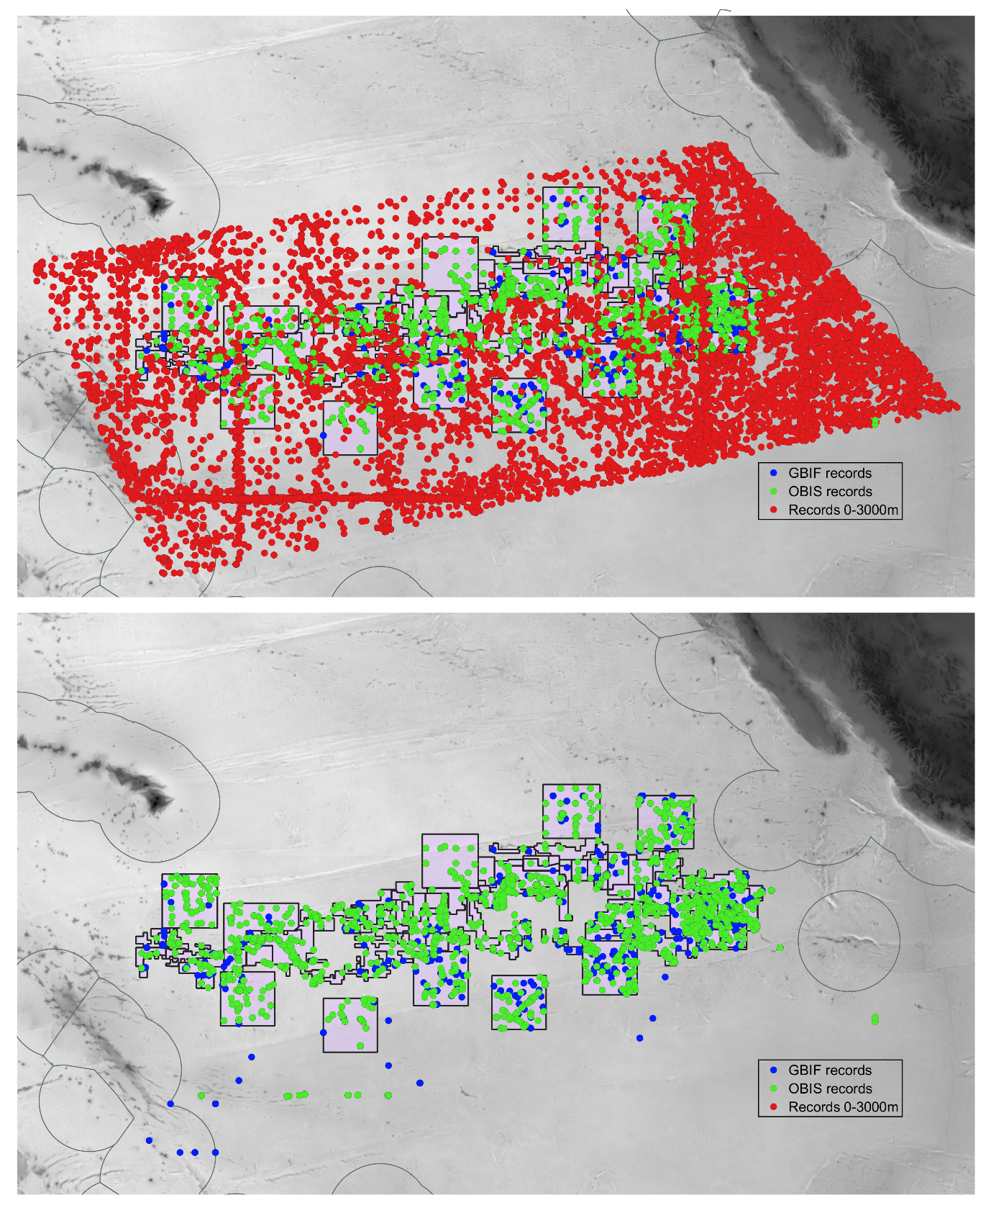

**A**

**B**

Fig. 2 OBIS and GBIF data mapping by depth. (A) all records from OBIS and GBIF, all depths; (B) records from 3000m and greater depths. Data points shown in B not final dataset for analysis, but raw data selected by depth only, therefore non-metazoan records still present, and records to the south/southwest of the contract areas/APEIs. These were removed for the final dataset and analysis.

*Taxonomic data processing*

As for sampling information, any differences evident between the handling of names between OBIS and GBIF were recorded. For example, in GBIF, the ‘acceptedScientificName’ was recorded with the name authority, usage of non-accepted names was evident in some cases; and in OBIS, a few species names with cf. in the verbatim scientific name were recorded as genus level.[29] In both datasets, a copy of the ‘acceptedScientificName’ column was added with amendments made as needed on examples above (‘acceptedScientificName_ed’), e.g. removal of name authority, and replacement of unaccepted names with accepted ones post a taxon match with WoRMS, to allow comparability between the datasets (and with DeepData and the literature). A column was added for edited identification qualifier (‘identificationQualifier_ed’) for cases where the qualifier was present in the scientific name, e.g. cf. or aff., but missing from the IdentificationQualifier column itself.

In the final data selection, all fossil and non-metazoan records were excluded from both datasets. The DeepData records published on OBIS in June on the new OBIS ISA node were subsetted to distinguish the records for comparative purposes (records tagged as owned by the ISA in the Darwin Core ‘accessRights’ field). Reference to OBIS records hereafter refers solely to those records on OBIS not originating from DeepData, and the OBIS ISA node records are referred to as ‘OBIS DeepData’ records. Any differences between the two datasets in what columns selected was noted, e.g. ‘id’ in OBIS equates to ‘gbifID’ in GBIF. Post all the data processing steps, the relevant fields were selected in R as each file contained over 200 columns; and both the original and the edited files archived (see SDF 2; SDF 3).

### Published Literature and GenBank records

For >1000 records in the literature it was not possible to resolve a particular record to a particular year, for example specimens from multiple expeditions were analysed and it was not recorded which particular specimen was from which cruise. Where samples were pooled/collection dates not available, the multiple years were pooled and averaged to allow an overall estimate of year of sampling. Records at all taxonomic levels were included, both for imagery-based and specimen-based studies. All scientific names in the literature and GenBank were ‘taxon-matched’ to WoRMS as above. Identification qualifiers were standardised as per guidelines in the literature, e.g. n sp. recorded as sp. nov. (Horton et al., 2021; Sigovini et al., 2016). For sequence data in GenBank and BOLD, data were restructured to sv plit rows by molecular marker, i.e. one accession per row. The CCZ Checklist and WoRMS

All scientific names were collated from the different data sources - OBIS, GBIF, DeepData and the literature to create a master CCZ Checklist of known CCZ metazoans. A checklist is an inventory of species names, often grouped for example by taxon or region. WoRMS is for example, in part, a checklist. DeepData records via the website and via OBIS were compared (see section 3.6.7). Where names were only present in one data source, they were reviewed and the relevant main data file cross-referenced. For morphospecies as above, scientific name was also added, mapped to the lowest scientific level recorded above species level (for OBIS and GBIF, this was already present in many cases in the Darwin Core).

Names were recorded at the taxonomic level they were present in the literature/databases, and post taxon-match to WoRMS, higher taxonomic names were then inferred for the checklist, i.e. for species records present, the genus name was added if it was not already separately recorded. Any unaccepted names were replaced with accepted names and the taxonomic name status noted in the file that the name record originated from (if not already recorded). In cases where names were not found in WoRMS, this was recorded and the original names were retained. A taxon match to WoRDSS the deep-sea node of WoRMS, was also done to ascertain if taxa were already logged as deep-sea using the Flanders Marine Institute VLIZ web-services (<https://www.lifewatch.be/data-services/>).

Suspected potential pelagic taxa records e.g. Calanoida and Cyclopoida copepods; hyperiid amphipods and Tomopteridae polychaetes were present. These records were all from benthic samples, which can inadvertently contain pelagic species, for example, incursion of the midwater layer into box core topwater. As such, these records are valid but in need of identification as pelagic and removal for a checklist of specifically benthic taxa. After consultation with experts (Geoff Boxshall (NHM), Pedro Martinez (Senkenburg), Tammy Horton (National Oceanography Centre)), and cross-referencing ‘attribute’ information in WoRMS where available, these names were excluded from the final total, but retained in the main checklist dataset, tagged as ‘pelagic’. This list of pelagic taxa was also cross-referenced back to the DeepData, OBIS and GBIF datasets.

A ‘short’ version of the CCZ checklist was created with any name with a known degree of taxonomic uncertainty excluded, e.g. any name interpolated from a morphospecies/working species name or with any of the following qualifiers- aff.; cf.; indet; incertae sedis; sp. inc. (any records with qualifiers- sp.; spp.; sp. nov or gen. nov were included) (see SDF 6)[30].

A separate list of ‘open nomenclature’ (morphospecies) names was collated for analysis with any duplicates across datasets removed (see SDF 6B). Open nomenclature is a system of signs to describe uncertainty around identifications, or designate morphospecies (Horton et al., 2021; Sigovini et al., 2016), e.g. ‘inc’ designates an identification as uncertain. Morphospecies are also termed ‘working species’, ‘temporary names’, morphotypes’ or ‘operational taxonomic units’ (OTUs; Horton et al., 2021; Sigovini et al., 2016). These terms differ slightly conceptually although are often used interchangeably: Morphospecies are in general taxa without formal names that have been discriminated to species level based on morphology only. Morphotypes generally refer specifically to taxa identified solely from imagery, such as megafauna identified from ROV or AUV footage. Temporary names are taxa that have been given temporary (informal names) but this does not necessarily imply species level (e.g. it could be a temporary genus name for an undescribed genus). OTUs are a term more often found in molecular studies (e.g. Molecular Operational Taxonomic Units, MOTUs) in which the taxa have been discriminated to species level by comparison of sequence data, often done computationally. In Darwin Core, the field taxonConceptID is recommended for input of these types of names (Horton et al., 2021). For consistency, here we use the term ‘temporary name’ or ‘morphospecies’ (the latter of which is in wide usage) which covers possibilities unless specifically referring to an as-yet undescribed new species, where we use the term ‘undescribed new species/genera’. The latter were distinguished as an undescribed species or genus if recorded as such (e.g. ‘*Aurospio* new species’; ‘*Aurospio* new name’ or similar. Some of the general morphospecies names will also be undescribed species (and some will be known taxa, e.g. if the species has not been accurately identified as a known species and misidentified as an unknown species); but without expert opinion there is no way to distinguish them. This approach will therefore provide an approximation of those species within the morphospecies pool which are new to science. It should be noted however that unless they are recorded as such by a taxonomist of the group in question (e.g. a molluscan expert on a molluscan species) there is still a degree of uncertainty.

*Checklist and taxonomic effort*

A broad assessment of taxonomic coverage and gaps was conducted, comparing ‘new species’ i.e. any species described from the CCZ identified in the literature review, to all known recorded names in the checklist, at the phylum level. Also, the proportion of morphospecies was compared to the overall total of species, to gauge the proportion of undescribed species recorded to date. Descriptions by key faunal groups in meiofauna and macrofauna were also examined to identify any obvious gaps, i.e. isopods, tanaids and polychaetes for macrofauna, and copepods, ostracods and nematodes for meiofauna.

## Data Analysis

### DeepData and duplication

In June post re-downloading of DeepData, investigations into DeepData records and cross-referencing with raw files it became clear that duplication of data was evident (see section 3.6.3). As a result, abundances will be inflated and incidence data also affected, e.g. three incidences of a given species present rather than one, for a given dataset. Similarly, numbers of singletons, or single occurrences of a species will be impacted as genuine singletons could be obscured by duplication i.e. false negatives, and doubletons cannot be accurately estimated. Several statistics, e.g. Chao1 and Chao2 depend on abundance and incidence data. The decision was made therefore to focus on analysis examining presence/absence and general patterns in species diversity rather than statistics based on abundance and or incidence estimates. Some exploratory data analysis utilising abundance and incidence was carried out however, both to demonstrate potential analyses on the data, explore any sampling bias present, and to identify broad-scale spatial patterns in the data.

### Diversity estimates

*Alpha diversity*

Firstly, simple metrics of biodiversity such as total number of new species were estimated, for example by station, contract area, and size class. This was done for each data source (databases and literature) and from the checklist for an overall estimate. All records of pelagic species/taxa were removed for the diversity analysis.

*Species accumulation curves and species richness estimates*

Species accumulation curves were plotted to species accumulation over sampling effort- defined by number of sampling events, with 1000 randomisations for all, and confidence intervals calculated for the curves; with the following R packages- vegan (Oksanen et al., 2018), picante (Kembel et al., 2010) and knitr (Chao, 2014, 1987, Cowell & Coddington, 1994). Curves were plotted separately for named species only, and all species- named and morphospecies combined, for all DeepData records pooled, with abundance data (Chao1) by site. Separate curves were also plotted by size class- megafauna, meiofauna, macrofauna. As size class was often missing in DeepData, this information was interpolated from the Checklist (via literature) where missing[31]. In many cases, taxa were recorded across size classes, here the size class was harmonised to avoid inflation, e.g. so a species was not included in both categories (e.g. *Abyssoprimnoa gemina* Cairns, 2015 is sometimes classed as macrofauna but often well within the size range specified for megafauna). Chao1 total species richness estimates (and associated standard error) were estimated in vegan (Chao, 1987, 2014). The Simpson and Shannon richness estimates were also calculated (Simpson inverse form- 1/*D*, q=2, and Shannon, exponential *H*, q = 1) in vegan with the diversity function. Estimates were made for region, East, West, Central (see directly below), exploration contract area, and contract sub-area levels.

### Diversity and distribution/Community composition

Records were first pooled by region: East, Central and West. For designating region, the groupings of East and Central were separated at the midpoint of APEI-3. This distinction between East and Central is rather arbitrary, and certainly does not represent a natural boundary or even biogreographic one like the Clarion Fracture Zone (Hall and Gurnis, 2005) which separates APEI-3 from the contract areas. The separation of West and Central is more defined as no DeepData records are present between the regions (see Fig. 7). Contractor sub-areas were mapped in QGIS, and a column for contract area was added to reflect actual location rather than origin of records, i.e. ContractorID (name of contractor submitting data) as these were not equivalent. Relative abundance by sub-area was estimated in R for key macrofaunal groups- for polychaetes, isopods and tanaids. Presence/absence species matrix tables were generated with the R package FuzzySim (Barbosa, 2015). Upset plots (UpSetR) were used to visualise patterns in species common or distinct by region and contract area, these plots allow visualisation of multiple sets in the data, such as species richness intersections with region (Gehlenborg et al., 2019; Conway et al., 2010). A ‘site’ field was created by concatenating ConractorID + contract area + station ID. For community/species evenness, Jaccards evenness (Baselga, 2010) and Sorenson similarity indices (Sorensen, 1948, Balsega & Orme, 2012) and Whittaker dissimilarity indices (Whittaker, 1972) were estimated with betapart (Baselga & Orme, 2012).

# RESULTS

## Published literature containing taxonomic information

### Overview

163 publications in total containing taxonomic information were identified and included in the review[32]. A further 42 papers identified during the review were excluded as they did not contain taxonomic information, were duplicate studies, examined pelagic taxa or were unavailable (see SDF 5). Types of studies sourced in the review included species descriptions, ecological studies, and phylogenetic or genomic analyses. All selected works were articles published in peer-reviewed journals, apart from two theses (Mahatma, 2009, Tilot, 1992) and one report (Smith et al., 2008). Taxonomic information included new descriptions, of species, genera and families; or distributional records, i.e. occurrences of known taxa. The majority of the literature has been published over the last two decades, with only 22 taxonomic articles identified published prior to 2000 (Table 1).

Taxonomic publications including descriptions numbered 63 in total, mainly purely systematics works i.e. species/genus descriptions, but 15 also included distributional records of named species and/or morphospecies/temporary names (e.g. Molodtsova & Opresko, 2017, Wiklund et al., 2017), and a few included broader analysis, e.g. modelling (Jakiel et al., 2019). Overall, 60% (97/163) of the publications were open access, and 40% (64/163) of all taxonomic publications contained descriptions. Some taxonomic publications also included a key, for example Bonifacio & Menot (2019) and Bezerra et al. (2021).

Apart from one or two exceptions (e.g. Park et al., 2004), most articles focussed on a particular size class of fauna, although some sampled specimens across faunal size classes (Amon et al., 2017c), and many included taxa that span size classes (e.g. Dahlgren et al., 2016). By size class, 79 of the 163 publications primarily examined macrofauna, 41, megafauna, and 36, meiofauna, including 1 for meroplankton (Kersten et al., 2019), the sole publication on larvae.

Of the 163 publications, 55 incorporated molecular analyses and 50 included new genetic or genomic data, e.g. sequences generated and deposited/accessioned in GenBank or BOLD.[33] Literature incorporating genetic/genomic studies were very recent, all have been published since 2013 with one exception (Smith et al., 2008), the majority, 76% (41) since 2018, including 11 from 2021 alone.

### By publication year

The rate of publications and descriptions has been increasing in recent times, particularly over the past five years (Fig. 3; Table 1). From 2000 to the present, the average rate of descriptions was nine, for the past 10 years including the current year (2012-2021), the average was 18 descriptions a year and for the past five years (2017- 2021), 30 descriptions per year. Notably, 72 descriptions (66 new species and 6 new genera) were published in 2019 alone, including 4 publications containing descriptions of more than 10 species (Blake, 2019, Bonifacio & Menot, 2019, Jakiel et al., 2019, Wiklund et al., 2019).

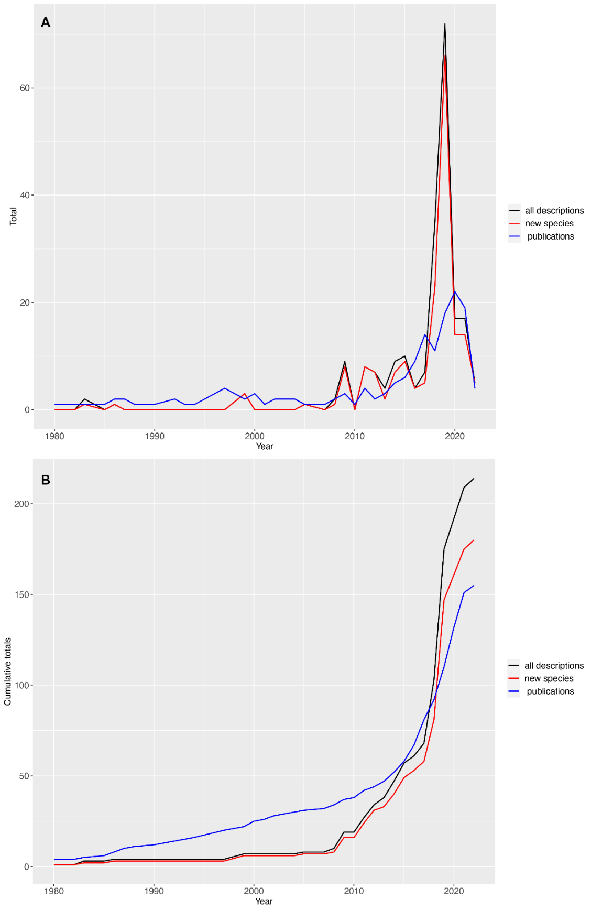

Fig. 3 Rates of taxonomic work in the Clarion-Clipperton Zone over the period 2000-2022. (A) total numbers of new taxa described and taxonomic publications per year. (B) cumulative totals of publications and descriptions over the same period. ’all descriptions’ includes descriptions of new species, genera and families combined.

Table 1. Rates of taxonomic work in the Clarion-Clipperton Zone over the period 2000-2022. CCZ descriptions and number of publications per year (All Descriptions: species, genus and family descriptions in total). Pubs with descriptions: publications containing descriptions of new species, genera or families (including 2 publications in press). * The description in this publication is not recognised due to issues with the type specimen (Drecraemer & Gourbault, 1997), and the relevant species not included here in the totals of CCZ species (for another publication the genus description is not recognised but the species is so the latter is included in the publications with descriptions and species (not genus) total (Larsen & Araujo-Silva, 2014).

|  |  |  |  |  |
| --- | --- | --- | --- | --- |
| Year | Publications | Pubs with descriptions | CCZ new species | All CCZ Descriptions |
| 1887 | 1 | 1 | 1 | 1 |
| 1975 | 1 |  |  |  |
| 1976 | 1 |  |  |  |
| 1979 | 1 |  |  |  |
| 1983 | 1 | 1 | 1 | 2 |
| 1985 | 1 |  |  |  |
| 1986 | 2 | 1 | 1 | 1 |
| 1987 | 1 |  |  |  |
| 1988 | 1 |  |  |  |
| 1990 | 1 |  |  |  |
| 1992 | 1 |  |  |  |
| 1993 | 1 |  |  |  |
| 1994 | 1 |  |  |  |
| 1997 | 4 | 1* |  |  |
| 1999 | 2 | 2 | 3 | 3 |
| 2000 | 3 |  |  |  |
| 2001 | 1 |  |  |  |
| 2002 | 2 |  |  |  |
| 2004 | 2 |  |  |  |
| 2005 | 1 | 1 | 1 | 1 |
| 2007 | 1 |  |  |  |
| 2008 | 2 | 1 | 1 | 2 |
| 2009 | 3 | 2 | 8 | 9 |
| 2010 | 1 |  |  |  |
| 2011 | 5 | 3 | 8 | 8 |
| 2012 | 2 | 1 | 7 | 7 |
| 2013 | 2 | 1 | 2 | 4 |
| 2014 | 5 | 5 | 7 | 9 |
| 2015 | 6 | 4 | 9 | 10 |
| 2016 | 10 | 3 | 4 | 4 |
| 2017 | 14 | 5 | 5 | 7 |
| 2018 | 12 | 5 | 23 | 35 |
| 2019 | 18 | 9 | 66 | 72 |
| 2020 | 23 | 9 | 14 | 17 |
| 2021 | 23 | 6 | 14 | 17 |
| 2022 | 7 | 3 | 5 | 5 |
| TOTALS | **163** | **63** | **180** | **214** |

### Descriptions

The literature included 214 descriptions in total: 180 new species, 31 new genera, and three new families. Two of the CCZ species descriptions were redescriptions, the nematode *Erebussau tenebricosus* nom nov., comb. nov (Bussau, 1993) Bezerra, Pape, Hauquier & Vanreusel, 2021; and the holothurian *Psychropotes dyscrita* (Clark, 1920) Gebruck et al., 2020. Also three new combinations (comb. nov.) were identified, *Molpadiodemas atlanticus* (R. Perrier, 1898) and *Molpadiodemas villosus* (Théel, 1886) by (O’Loughlin & Ahearn, 2005) and *Nemanema arenaria* (Shimada et al., 2020)[34]. The redescriptions were included as new species records, but the new combinations as general records. Two descriptions published from the CCZ are not accepted, the nematode species *Eudraconema dracocephalum* described in Drecraemer and Gourbault (1997) and the genus *Cheliasetosatanais*, described in Larsen & Araujo-Silva (2014). These two descriptions are not included in the totals.

For publications prior to 2000, seven descriptions were found, six new species, and one new genus *Psychronaetes*, Pawson, 1983 (Holothuroidea). These descriptions, published between 1887-1999, included a sponge, *Axoniderma longipinna* (Ridley & Dendy, 1886), three echinoderms: the holothurians, *Peniagone leander* Pawson & Foell, 1986[35] and *Psychronaetes hanseni* Pawson, 1983, and the crinoid *Hyocrinus foelli* Roux & Pawson, 1999; and the tanaids *Agathotanais ahyongi* and *Agathotanais manganicus* Larsen, 1999.

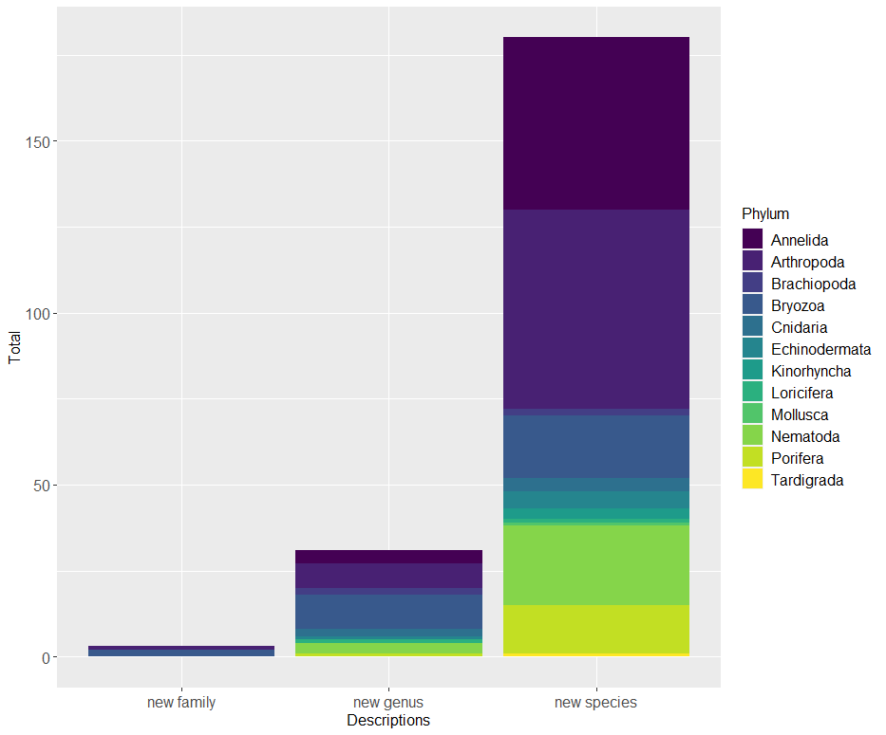

Fig. 4 Distribution of taxonomic effort across different phyla in the Clarion-Clipperton Zone: numbers of descriptions by phyla (1887-2022).

Some phyla were well-represented in CCZ species descriptions, particularly Arthropoda, 58, and Annelida, 50, followed by Nematoda, 23, Bryozoa, 18, and Porifera, 14 (Fig. 4). Other phyla with CCZ species included Echinodermata, 5, Cnidaria, 4, Kinorhyncha, 3, Brachiopoda, 2, Echinodermata, 2 (1 a redescription), and Loricifera, Mollusca and Tardigrada, all 1 species (see Table 14, CCZ Checklist section). New families included 2 for Bryozoa, Alyonushkidae and Anyutidae (Grischenko et al., 2018) and 1 for Isopoda, Urstylidae (Riehl et al., 2014).

Looking at CCZ descriptions by faunal size class, for meiofauna, Arthropoda, seven were copepods (Hexanauplia), with five Harpacticoida (Mercado-Salas et al., 2019; Gheerardyn & George, 2019; Cho et al., 2016); one Calanoida[36] (Markhaseva et al., 2017) and one Siphonostomatoida (Mahatma et al., 2008). Nematodes included seven Chromadorida (Miljuntina & Miljutin, 2012), three Desmodorida (Miljutin & Miljuntina, 2009b), three Desmoscolecida (Bezerra et al., 2021), three Enoplida (Shimada et al., 2020) and seven Plectida (Shimada et al., 2021; Miljutin & Miljuntina, 2009b. No descriptions of Ostracoda were present. New species were present for minor phyla however, three Loricifera (Fujimoto & Murakami, 2020), one Kinorhyncha (Sanchez et al., 2019) and one Tardigrada (Bai et al., 2020).

For macrofauna, 14 of the CCZ species were for isopods in four families (Table 2), one Macrostylidae (Riehl & De Smet, 2020); 4 Munnopsidae (Malyutina et al., 2020; Malyutina, 2011); 8 Nannoniscidae (Kaiser et al., 2021; 2018; Kaiser, 2014); and one Urstylidae (Riehl et al., 2014). For tanaids (Tanaidacea), 35 new species were described in eight families (Table 2) (Arauijo-Silva et al., 2015; Blazewicz et al., 2019; Chim & Tong, 2020; Jakiel et al., 2019; Larsen & Arauijo-Silva, 2014; Larsen, 2011a; Larsen, 2011b; Stepien et al., 2022; Wi et al., 2014; Wi et al., 2015; Wi et al., 2015b); and for amphipods, two species, in family Oedicerotidae (Jazdzewska et al., 2021). For polychaetes, 50 species have been described from the CCZ: 20 from order Phyllodocida: 17 Polynoidae (Bonifacio & Menot, 2019); one Nereidae (Drennan et al., 2021) and two Syllidae (Maciolek, 2020); 12 Terebellida: 10 Cirratulidae (Blake, 2016; 2019); four Spionida, family Spionidae (Paterson et al., 2016; Neal et al., in press); also 2 Orbiniidae (Blake, 2017; 2020); and 12 Scolecida: Opheliidae, Scalibregmatidae, Travisiidae (Wiklund et al., 2019).

In megafauna, of the 21 species described from the CCZ, four were cnidarians: the Antipatharian *Abyssopathes anomala* Molodtsova & Opresko, 2017 and the Alcyonaceans *Abyssoprimnoa gemina* Cairns, 2015, *Callozostron bayeri* Cairns, 2015 and *Calyptrophora persephone* Cairns, 2015. For other megafauna, 13 were Porifera- 12 Class Hexactinellida: three Amphidiscosida (Kersken et al., 2018a), eight Lyssacinosida (Wang et al., 2018; Kersken et al., 2019; Herzog et al., 2018), 1 Sceptrulophora (Kersken et al., 2019) and one Demospongiae (Ridley & Dendy, 1886); and four Echinodermata, all Holothuroidea (O’Loughlin & Ahearn, 2005; Gebruk et al., 2020; Pawson, 1983, Pawson & Foell, 1986).

Table 2. New species of the major macrofaunal groups: Isopoda (Class Malacostraca); Tanaidacea (Class Malacostraca); and Polychaeta (Annelida): by Family (with total recorded from the CCZ (see CCZ Checklist section)

|  |  |  |  |  |  |
| --- | --- | --- | --- | --- | --- |
| Class | Order | Family | Total spp. | New spp. | CCZ Description references |
| Malacostraca | **Isopoda** | Cymothoidae | 1 |  |  |
|  |  | Dendrotionidae | 2 |  |  |
|  |  | Desmosomatidae | 1 |  |  |
|  |  | Haplomunnidae | 2 |  |  |
|  |  | Haploniscidae | 3 |  |  |
|  |  | Ischnomesidae | 2 |  |  |
|  |  | Janirellidae | 2 |  |  |
|  |  | Janiroidea incertae sedis | 1 |  |  |
|  |  | Macrostylidae | 2 | 1 | Riehl & De Smet, 2020 |
|  |  | Mesosignidae | 3 |  |  |
|  |  | Munnopsidae | 11 | 4 | Malyutina et al., 2020; Malyutina, 2011 |
|  |  | Nannoniscidae | 10 | 8 | Kaiser et al., 2021; Kaiser et al., 2018; Kaiser, 2014 |
|  |  | Thambematidae | 1 |  |  |
|  |  | Urstylidae | 1 | 1 | Riehl et al., 2014 |
|  |  | **TOTAL** | **42** | **14** | **7** |
| Malacostraca | **Tanaidacea** | Agathotanaidae | 6 | 4 | Larsen 1999; Stepien et al., 2022 |
|  |  | Akanthophoreidae | 2 | 2 | Larsen 2011a |
|  |  | Colletteidae | 10 | 4 | Larsen 2011a; Wi et al., 2015a |
|  |  | Neotanaidae | 6 | 5 | Arauijo-Silva et al., 2015; Wi et al., 2014; Wi et al., 2015b |
|  |  | Paranarthrurellidae | 2 | 2 | Błażewicz et al., 2019; Larsen & Arauijo-Silva 2014 |
|  |  | Paratanaoidea incertae sedis | 4 | 3 | Chim Tong 2020; Larsen 2011a |
|  |  | Pseudotanaidae | 13 | 13 | Jakiel et al., 2019 |
|  |  | Typhlotanaidae | 5 | 2 | Larsen 2011b |
|  |  | **TOTAL** | **48** | **35** | **12** |
| Polychaeta |  | Capitellidae | 1 |  |  |
|  |  | Chaetopteridae | 1 |  |  |
|  |  | Maldanidae | 1 |  |  |
|  |  | Nerillidae | 1 |  |  |
|  |  | Opheliidae | 10 | 8 | Wiklund et al., 2019 |
|  |  | Orbiniidae | 3 | 2 | Blake, 2017; Blake, 2020 |
|  |  | Paraonidae | 5 |  |  |
|  |  | Scalibregmatidae | 3 | 3 | Wiklund et al., 2019 |
|  |  | Travisiidae | 3 | 1 | Wiklund et al., 2019 |
|  | Amphinomida | Euphrosinidae | 2 |  |  |
|  | Echiuroidea | Bonelliidae | 1 |  |  |
|  | Eunicida | Dorvilleidae | 2 |  |  |
|  | Eunicida | Eunicidae | 1 |  |  |
|  | Eunicida | Lumbrineridae | 1 |  |  |
|  | Eunicida | Onuphidae | 1 |  |  |
|  | Phyllodocida | Chrysopetalidae | 4 |  |  |
|  | Phyllodocida | Glyceridae | 2 |  |  |
|  | Phyllodocida | Goniadidae | 3 |  |  |
|  | Phyllodocida | Hesionidae | 2 |  |  |
|  | Phyllodocida | Lacydoniidae | 1 |  |  |
|  | Phyllodocida | Lopadorrhynchidae | 1 |  |  |
|  | Phyllodocida | Nereididae | 5 | 1 | Drennan et al., 2021 |
|  | Phyllodocida | Paralacydoniidae | 2 |  |  |
|  | Phyllodocida | Phyllodocidae | 4 |  |  |
|  | Phyllodocida | Pilargidae | 1 |  |  |
|  | Phyllodocida | Polynoidae | 22 | 17 | Bonifacio & Menot., 2019 |
|  | Phyllodocida | Sphaerodoridae | 1 |  |  |
|  | Phyllodocida | Syllidae | 5 | 2 | Maciolek 2020 |
|  | Sabellida | Sabellidae | 1 |  |  |
|  | Sabellida | Serpulidae | 1 |  |  |
|  | Sabellida | Siboglinidae | 1 |  |  |
|  | Spionida | Poecilochaetidae | 1 |  |  |
|  | Spionida | Spionidae | 12 | 4 | Paterson et al., 2016; Neal et al., in press |
|  | Terebellida | Cirratulidae | 17 | 12 | Blake, 2016; Blake, 2019 |
|  | Terebellida | Fauveliopsidae | 1 |  |  |
|  | Terebellida | Terebellidae | 1 |  |  |
|  | Terebellida | Trichobranchidae | 1 |  |  |
|  |  | **TOTAL** | **125** | **50** | **10** |

*Descriptions by size class and identification methods*

By size class, 69% of the CCZ species, most of the new genera and all the new families were macrofauna. Total CCZ descriptions by size class were: 149 for macrofauna, 24 for megafauna, and 41 for meiofauna; CCZ species descriptions: 124 for macrofauna, 21 for megafauna, and 35 for meiofauna; CCZ genera: 22 for macrofauna, 3 for megafauna, 6 for meiofauna; CCZ families: 3, all macrofauna (Fig. 5; Table 3).

Of the 214 CCZ descriptions published in total, 86 (40%) were described by morphology and molecular data, the remaining 128 solely by morphology (including one as previously mentioned by imagery only, *Peniagone leander* Pawson, 1983). For meiofauna, only 3 descriptions of 41 included analysis of molecular data as well as morphology- a new genus and 2 new species of copepod (Mercado-Salas et al., 2019) and only 3 of 298 papers on meiofauna included genetic/genomic data (Khodami et al., 2020; Macheriotou et al., 2020; Mercado-Salas et al., 2019).

Table 3. Distribution of taxonomic effort across different size class of metazoans in the CCZ. Publications with descriptions column- overall total of publications also given in brackets as well as publications by size class. * Total includes the aforementioned species described solely by imagery (*Peniagone leander* Pawson & Foell, 1986). Total publications with descriptions by size class also given, with total publications overall by size class in brackets.

|  |  |  |  |  |  |
| --- | --- | --- | --- | --- | --- |
| Size class | Total species Descriptions | Total Descriptions | Described by morphology  only | Described by morphology and molecular data | Publications with descriptions |
| Macrofauna | 124 | 149 | 75 | 74 | 38 (78) |
| Megafauna | 21 | 24 | 14* | 9 | 11 (42) |
| Meiofauna | 35 | 41 | 38 | 3 | 14 (36) |
| TOTALS | **180** | **214** | **128** | **86** | **54 (156)** |

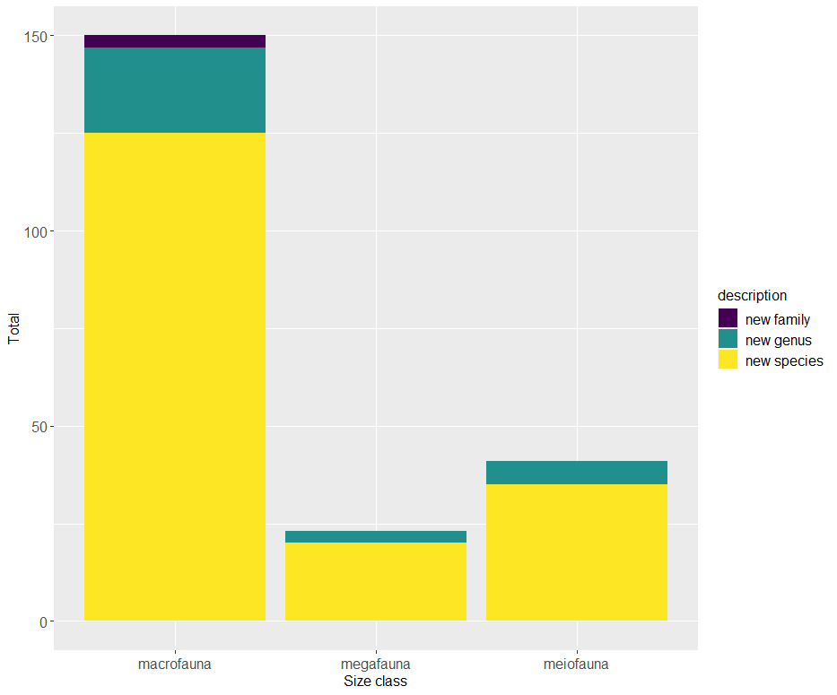Fig. 5 Distribution of taxonomic effort across size class in the Clarion-Clipperton Zone: descriptions in the literature for the Clarion-Clipperton Zone by size class (1887-2022)

*Descriptions by expedition*

Certain expeditions produced large numbers of descriptions, in particular, the consortium SO239 EcoResponse expedition to APEI-3 and the IFREMER (IFR2), GSR (B4 and B6), IOM2 and BGR east areas for JPI Oceans (Martinez et al., 2015; see S Fig 1) has produced 54 descriptions in total. Other cruises resulting in large numbers of descriptions included Nodinaut in 2004 to the IFREMER area, 26 in total, the consortium expeditions ABYSSLINE AB01 in 2013 and AB02 in 2015 to the UK-1 and OMS areas, 31 in total, and a series of cruises from 2000-2016 to the YUZ2 area, 38 descriptions in total, including all 3 of the new families. Type localities were extracted from the literature and plotted (S Fig 3), showing spcies have been described from most of the active contract areas, with concentrations of type localities i.e. new species in YUZH, and BGR. Type localities from the COMRA contract were editent only from subarea COM1A where much more sampling has been done.

## Overview of records in DeepData; in context of other published records, focussing on taxonomic information

### Overview of data in all sources

A total of 106,416 taxonomic records were identified from all data sources (Table 4).

Table 4. Summary of data availability in all data sources searched, including literature

|  |  |  |  |
| --- | --- | --- | --- |
| Data Source | Total Records | Publications | Notes |
| Deep Data | 40,518 |  | Total of 52,222 including non-metazoa/records without taxonomy |
| Literature | 6342 | 156 |  |
| OBIS | 2185 |  | >50% of records in common with GBIF datasets (and for both databases with the literature) |
| OBIS (ISA node) | 48,554 |  | DeepData records published on OBIS via the ‘ISA’ node, not included in analysis of OBIS data (see methods) |
| GBIF | 2405 |  |  |
| GenBank | 4647 |  | 6 NCBI databases also identified containing genomic datasets |
| BOLD | 1674 |  | 3 BOLD databases also containing multiple sequences |
| TOTAL | **106,416** |  |  |

### Summary of temporal coverage across the CCZ over time

*DeepData: cruises and temporal coverage*

DeepData included records from 10 of the 16 CCZ Contractors, from 24 cruises in total, conducted on 13 research vessels spanning 2004 to 2019 (Table 5; Fig. 6). Since 2010, records from at least one cruise per year were represented on the database, some joint cruises to more than one contract area, e.g. the 2014 expedition on *Yuzhmorgeologiya* to YUZ2 and IOM2. Prior to 2010, no records were available apart from the 2004 expedition to the IFREMER region (Fig. 6).

Most of the published records present were from 2015, likely due to several factors: several cruises were undertaken that year; the data template was introduced in 2015 and the ISA secretariat has prioritised publishing of data from this point. However, we have also identified duplication in the records from this year, therefore the level of sampling here is lower than it appears (see section 3.6.3). Few records post 2015 were published, potentially due to the fact that as above records are gradually being added to DeepData from the 2015 data submissions up to the current year for data reporting (see section 3.6).

Table 5. Cruises by year, Contractor and research vessel in records in DeepData. Years in bold- where datasets published from different expeditions (listed on separate rows). For joint expeditions, both contractor codes are listed (e.g. YUZH **/** IOM). *Total cruises per year, as per available data on DeepData

|  |  |  |  |
| --- | --- | --- | --- |
| Year | Contractor/s | Research Vessel | Total Cruises* |
| 2004 | IFREMER | *L'Atalante* | 1 |
| 2010 | BGR | *R/V Sonne* | 2 |
|  | KOREA | *R/V Onnuri* |  |
| 2011 | COMRA | *Hai Yang Liu Hao* | 2 |
|  | KOREA | *Kok* |  |
| 2012 | BGR | *L'Atalante* | 1 |
| 2013 | BGR | *R/V Kilo Moana* | 4 |
|  | COMRA | *Hai Yang Liu Hao* |  |
|  | KOREA | *R/V Onnuri* |  |
|  | UKSRL | *R/V Melville* |  |
| 2014 | BGR | *R/V Kilo Moana* | 3 |
|  | COMRA | *Hai Yang Liu Hao* |  |
|  | YUZH / IOM | *Yuzhmorgeologiya* |  |
| 2015 | BGR1 / GSR / IFREMER | *R/V Sonne* | 4 |
|  | OMS / UKSR | *R/V Thomas G. Thompson* |  |
|  | GSR | *Mt. Mitchell* |  |
|  | YUZH | *Yuzhmorgeologiya* |  |
| 2016 | BGR | *R/V Kilo Moana* | 3 |
|  | BGR | *R/V Sonne* |  |
|  | YUZH | *Yuzhmorgeologiya* |  |
| 2017 | COMRA | *Xiangyanghong 03* | 2 |
|  | DORD | *R/V Kilo Moana* |  |
| 2018 | KOREA | *KODOS1802* | 1 |
| 2019 | KOREA | *KODOS2019* | 1 |
| TOTAL | **10** | **13** | **24** |

*OBIS, GBIF and literature: cruises and temporal coverage*

Data were available from over 50 cruises in literature[37], spanning 1959- 2019, mostly from the past 2 decades (Fig. 6). For OBIS, records were published from 20 cruises (1875-2018), and GBIF, 25 cruises, also spanning 1875- 2018. The historical records were from museum specimen records, mainly from the Challenger expedition (see SDF 2; SDF 3). Many records were evident from 1980 and 1984, and a large number from 2004 in OBIS (Fig 6; see section 3.3.1), but majority of records for both databases were from the last decade (S Fig. 2). The most recent records, 2018 on, were only available in the literature and not in any of the databases (Fig. 6).

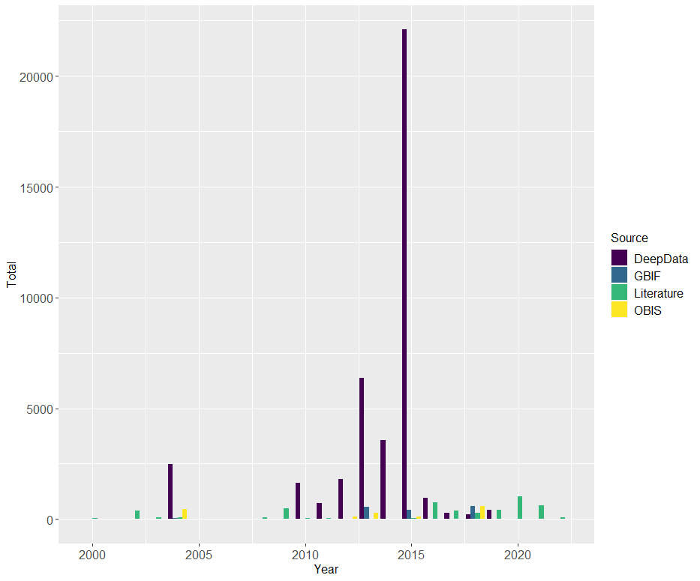

Fig. 6 Temporal coverage of sampling in the Clarion-Clipperton Zone. Record by year of sampling for all data sources. For literature, records span the years 1875-2022, DeepData, 2004-2019, and OBIS and GBIF, 1875-2018 (earlier records not shown to optimise display).

### Summary of spatial coverage of the data sources

*DeepData:* Records by Contractor and contract area

Records on DeepData are primarily published by Contractor. However, Contractor and contract area are not always equivalent in the database (see section 2.3.3). Here therefore datasets by Contractor and contract area have been separately assessed. Records from 10 Contractors were published on DeepData at the point of download (12th July 2021): BGR (Germany), COMRA (China), DORD (Japan), KOREA (Government of the Republic of Korea), GSR (Belgium), IFREMER (France), IOM Interoceanmetal Joint Organisation, OMS (Singapore), UKSRL UK Seabed Resources Limited (United Kingdom), and YUZ JSC Yuzhmorgeologiya (Russian Federation) (Fig. 7). There are 17 CCZ-based Contractors in total, but 18 contracts (UKSRL holds two separate contracts). There are also two Contractors with active licenses for polymetallic nodule mining, but with claims outside the CCZ (Government of India and Beijing Pioneer Hi-Tech Development Corporation BHDDC[38]. A further seven contractors have active PMN licenses in the CCZ but had no data published on the database at the time of this study: TOML (Tonga), NORI (Nauru); MARAWA (Kiribati), CIIC (Cook Islands), CMC (China), and a new Contractor, Blue Minerals Jamaica LtdIt is unclear if the lack of data from these Contractors is because no data has been submitted by them or if the ISA is experiencing data backlogs.

All Contractors apart from OMS have separate contract areas in different regions within the CCZ, recorded in the DeepData database as ‘SubAreas’ (see section 2.3.3 & SDF 1). Only three Contractors had data available for more than one sub-area, COMRA, GSR and KOREA (Fig. 7). It is not clear if this is due to only one sub-area for a given Contractor in most cases having been surveyed, or if other sub-areas have been sampled but these records are not yet published on DeepData. In some cases, records were present in OBIS or GBIF, or the literature for those contract sub-areas where data were not available on DeepData, e.g. UK-II, the western contract area of UKSRL and YUZ1, the western sub-area of Yuzhmorgeologiya (see SF Fig 2).

In a couple of regions, sampling has been more extensive, covering (relatively) wider spatial scales, the eastern CCZ- BGR east, OMS, IOM2 and UK-1 contract areas, also the mid-CCZ, in the YUZH contract area (Fig. 7 & 8). The sub-areas KR5 (B2 + B1) in the south of the mid CCZ, and COM1a and DOR1 in the west CCZ also show a relative breadth of sampling, with stations covering >200 km (SF Fig 2). It should be noted however that even where sampling has covered a relatively wider area it is still very restricted and patchy considering the spatial scales in question. No records were published on DeepData between the longitudes of the west border of APEI-7 to the west side of APEI-8, covering an area of xxx km2 (Fig. 7).

Looking outside of contract areas, apart from some (very limited) sampling in APEIs, only a handful of records were evident. Over 12,000 records were marked ‘OA’ or outside area in the database output, but most of these were records originating from one Contractor but from sampling within another contract area, potentially records from joint cruises (for example GSR records from within the IFREMER contract area were recorded as ‘OA’ in the sub-area field). 390 of the ‘OA’ records were from APEIs (via Contractors COMRA, GSR, IFREMER, OMS and UKSRL). Only 54 records were from outside of contract areas, all from Contractor KOREA, near APEI-6 and APEI-9 and between the southwest corner of APEI-6 and southeast corner of APEI-3 (Fig. 7; see SDF 1). Sampling by Contractor KOREA outside of contract areas on a longitudinal transect, including in APEI-8 was also identified in the literature (Park et al., 2004; Choi et al, 2004; Kim et al, 2000).

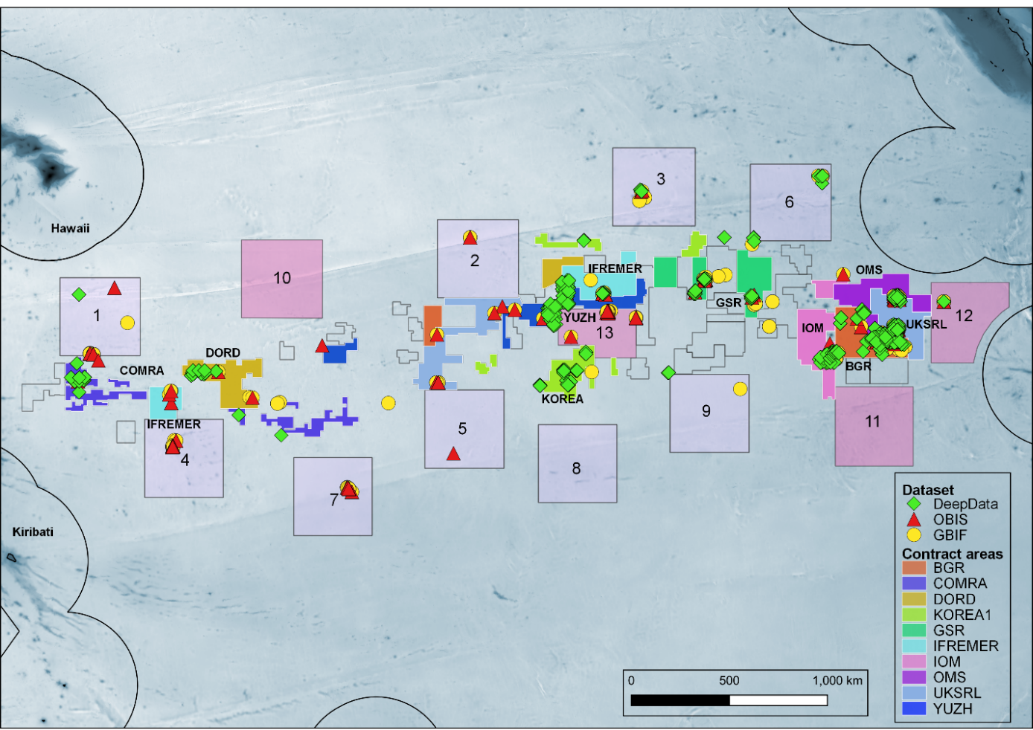Fig. 7. Distribution of DeepData, OBIS and GBIF records across the Clarion-Clipperton Zone. Active exploration contract areas are highlighted, excluding those that lack records on DeepData, which are shown in outline only (these are NORI-D, TOML, CMC, CIIC, and MARAWA; the new Blue Minerals Jamaica Ltd. contract area outline is not shown as this shapefile is not yet available).

*OBIS and GBIF*

While some of the OBIS and GBIF records overlapped with DeepData records, e.g. in the eastern CCZ (Fig. 7), overall these datasets showed more geographic spread than the DeepData records (which as above were primarily confined to the contract areas). While a large proportion of the OBIS and GBIF records overlap, distinct datasets were present in both datasets, as evident in Fig. 7 (see section 3.3.1). More APEIs were represented overall by comparatively more records in OBIS and GBIF than in DeepData, with records published from all apart from APEI-8.

*Literature*

In the literature, records from all 10 Contractors with data published on DeepData were identified (BGR, COMRA, DORD, GSR, IFREMER, IOM, KOREA, OMS, UKSRL, YUZH) and from an additional contractor, TOML. Some contract areas were well represented in the literature in multiple publications, e.g. those in the eastern CCZ (BGR, GSR, and UKSRL), others less so, e.g. data from the TOML contract area has only been included in 3 publications (Leitner et al., 2021, Simon-Lledó et al., 2020, Jones et al., 2021). APEIs were well represented in the literature, especially compared to DeepData records, where they were sparse (Fig. 7). Records were published from APEI-1, 3, 4, 6, 7, 8, 12 and 13. For APEI-8, data were only available in the literature (Park et al., 2004, Choi et al., 2004, Kim et al., 2000) and not in the databases. As above, these records are sampling of a longitudinal transect line by Contractor KOREA. For the remaining APEIs, no. 2, 5, and 9, records were available from OBIS and or GBIF. For the most recently established APEIs, records were present in the literature for APEI-13 and 12, but none yet identified from APEI-10 or 12 whether from the literature or other sources. Other regions where data were not available in the databases were represented by records in the literature, therefore overall coverage is wider than shown in Fig. 7 (See S Fig 3 for type localities).[39]

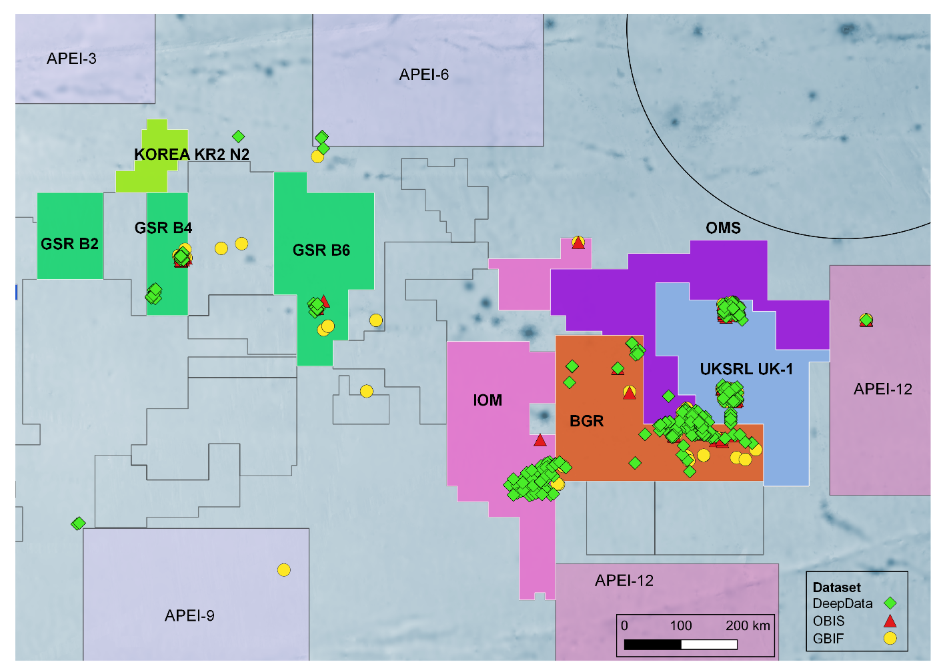Fig. 8. Taxonomic records in the the eastern Clarion-Clipperton Zone, showing contract areas OMS, UK-1 (UKSRL), IOM, GSR and KOREA (North).

## Overview of taxonomic information

Many more records were published on DeepData, >40,000 compared to other sources, >2000 for OBIS and GBIF and >6000 for the literature, however a proportion of these records, potentially up to a quarter of the total were found to be duplicates (see section 3.6). Nonwithstanding duplication, the database houses significant numbers of records.

### Records in common between the data sources

*OBIS; GBIF*

OBIS and GBIF records primarily originated from the literature and museum specimen records (including specifically from specimens referenced in/associated with publications, e.g. types). Over half of the records were ‘secondary sources’, representing records published elsewhere, e.g. in the literature. Records in common (or overlapping) between the databases included 591 NOAA deep-sea coral imagery records in both databases;[40] 721 museum records, mainly from the Smithsonian (Washington, US) and the Natural History Museum London, UK (NHM); and 109 records from publications. Different datasets between the databases were also evident: OBIS had records harvested from WoRMS (type locality records via literature housed in the WoRMS database); and 538 (of 591 total) records from IFREMER (from the 2004; 2012 cruises, records also present in the literature); GBIF had INSDC records (geotagged sequence record occurrences) and >10% more records overall from publications and museum records combined. Overall, the databases had very similar record sets.

*DeepData*

Assessing similarity between the literature and DeepData is confounded by the time differences in year of publication between datasets, with DeepData records being primarily from 2015 Contractor data submissions, while recent, in many cases, the literature more so (see section 3.1.2). For example, for YUZH, no species records were available (Table 7), and YUZH DeepData published records are from 2015 and 2016, but 19 new species names have been published from the YUZH contract area (Grischenko et al., 2018; 2021). Datasets in DeepData, being annual data reports, are likely to be less finalised or formalised with potentially lower taxonomic resolution than the published literature, and this appears to be the case in the available data (see following section and Fig. 9). Some of the records from particular studies in the eastern CCZ (ABYSSLINE studies) and central CCZ (IFREMER) were present both in DeepData[41] and in OBIS and GBIF. In DeepData, 32 of the CCZ species records and one of the CCZ genus records were present in the database, and all being for new CCZ species/genera i.e. published after 2000. In OBIS, 94 of the CCZ species/genera records were present, and in GBIF, 62.

### Taxonomic resolution

In DeepData, for the entire record set[42], a large proportion of both species-level records (both named and morphospecies) and those at higher taxonomic levels, especially order and class, were evident (Fig. 9). For the literature, most records were at species level, whether named species or morphospecies/OTUs but particularly the latter, and few at higher taxonomic levels. OBIS and GBIF showed similar trends to each other, also with a large proportion of named species-level records but relatively few temporary names, and relatively more genus-level names, with few records at high taxonomic levels. DeepData overall had proportionally more records at higher taxonomic level than the literature, OBIS, or GBIF.

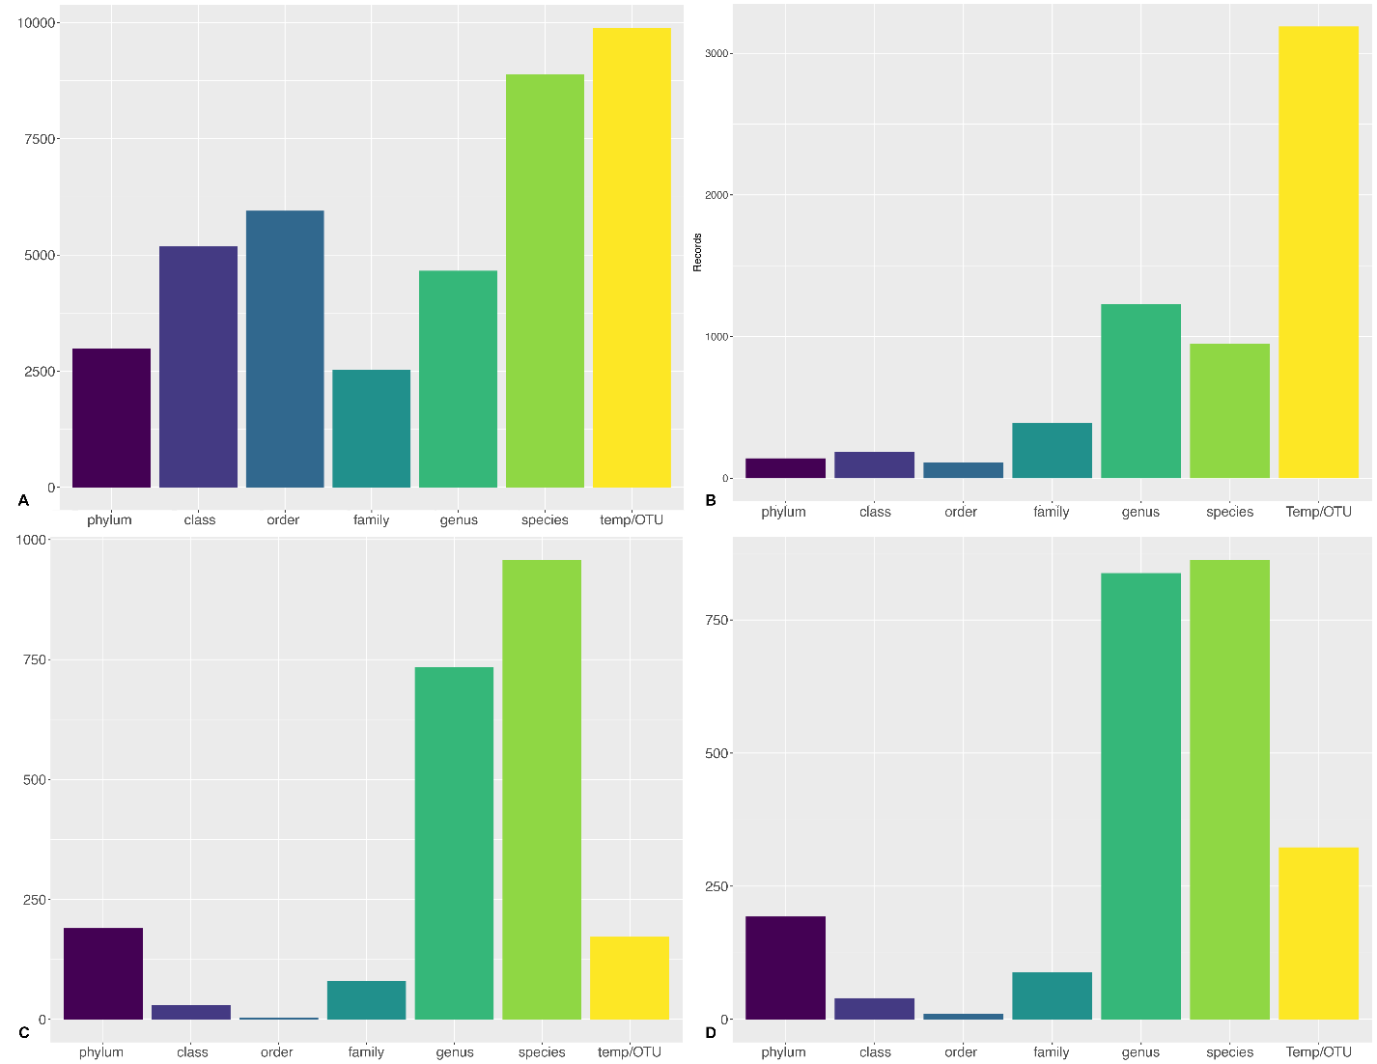Fig. 9 Taxonomic resolution of Clarion-Clipperton Zone data records in (A) DeepData, (B) literature, (C) OBIS and (D) GBIF. Dark purple- phylum, purple, class, blue, order, dark green, family, mid-green, genus, light green, species, and yellow, temporary name/OTUs/morphospecies

Examining DeepData records by both taxonomic resolution and phyla, most species-level records were for arthropods, reflecting the high diversity in this group (see section 3.4). Most genus-level records were for nematodes, which are relatively easy to resolve to genus but difficult to identify to species, with the majority of studies focussed at genus level, e.g. see SDF 5; and Singh et al. (2016); Hauquier et al. (2019); Lambshead et al. (2003); Macheriotou et al. (2020) and Pape et al. (2021). At family level, most records were annelids (all class Polychaeta apart from 4, C. Clitellata). Polychaetes are diverse at the family level (see section 3.4; Table 2). Echinodermata also had many records at species and genus level, potentially because the phylum has several common and relatively easy to identify species, e.g. *Silax daleus* (Lyman, 1879), and *Ophiosphalma glabrum* (Lütken & Mortensen, 1899) (see section 3.5.4)*.* Overall, trends appear to reflect both known patterns in diversity and also trends in identification, i.e. with some phyla being more or less challenging to resolve to lower taxonomic levels.

Table 6.All records by taxonomic level in DeepData. NB these records include 1014 of taxa identified as pelagic (309 names in total, mainly species), mainly arthropod species records (see methods section 2.2.1 and results section 3.4). These pelagic records were removed for later analysis. Total includes 17 records identified only at kingdom level

|  |  |  |  |  |  |  |  |  |
| --- | --- | --- | --- | --- | --- | --- | --- | --- |
| Phylum | Phylum | Class | Order | Family | Genus | Species | other | TOTAL |
| Annelida | 368 | 2984 | 7 | 3298 | 1223 | 422 | 21 | **8323** |
| Arthropoda | 306 | 1856 | 7351 | 824 | 1548 | 5799 | 382 | **18066** |
| Brachiopoda | 122 | 8 |  |  | 1 | 12 |  | **143** |
| Bryozoa | 104 | 3 | 22 | 49 | 23 |  |  | **201** |
| Chaetognatha | 123 |  |  | 10 | 3 | 27 |  | **163** |
| Chordata | 4 | 48 |  | 221 | 1603 | 598 | 17 | **2491** |
| Cnidaria | 48 | 35 | 74 | 94 | 82 | 83 | 5 | **421** |
| Coelenterata | 18 |  |  |  |  |  |  | **18** |
| Ctenophora | 1 |  |  |  |  |  |  | **1** |
| Echinodermata | 2 | 827 | 21 | 29 | 1356 | 1181 |  | **3416** |
| Entoprocta | 4 |  |  | 1 |  |  |  | **5** |
| Gastrotricha | 219 |  |  |  | 1 |  |  | **220** |
| Gnathostomulida | 19 |  |  |  |  |  |  | **19** |
| Kinorhyncha | 237 |  |  |  | 3 |  |  | **240** |
| Loricifera | 237 |  |  |  |  |  |  | **237** |
| Mollusca | 9 | 938 | 18 | 56 | 97 | 160 |  | **1278** |
| Nematoda | 731 | 98 | 31 | 904 | 2075 | 416 |  | **4255** |
| Nemertea | 39 |  |  | 2 | 4 |  |  | **45** |
| Platyhelminthes | 1 | 4 |  | 10 |  |  |  | **15** |
| Porifera | 146 | 93 | 45 | 42 | 53 | 190 |  | **569** |
| Priapulida | 26 |  |  | 7 |  |  |  | **33** |
| Rotifera | 111 |  |  |  |  |  |  | **111** |
| Tardigrada | 231 |  |  |  |  |  |  | **231** |
| TOTAL | **3106** | **6894** | **7569** | **5547** | **8072** | **8888** | **442** | **40518** |

The relative proportion of records by phylum varied by data source. DeepData mostly arthropods, followed by annelids and nematodes, which reflect known patterns with dominant phyla within macrofauna being arthropods and annelids. Proportions for the literature were similar but relatively more annelid (polychaete) and nematode records were present. OBIS and GBIF appear to show bias resulting from smaller datasets, for example large proportions of nematode records in OBIS and echinoderm records in GBIF were present, both from only a few datasets (Fig. 10).

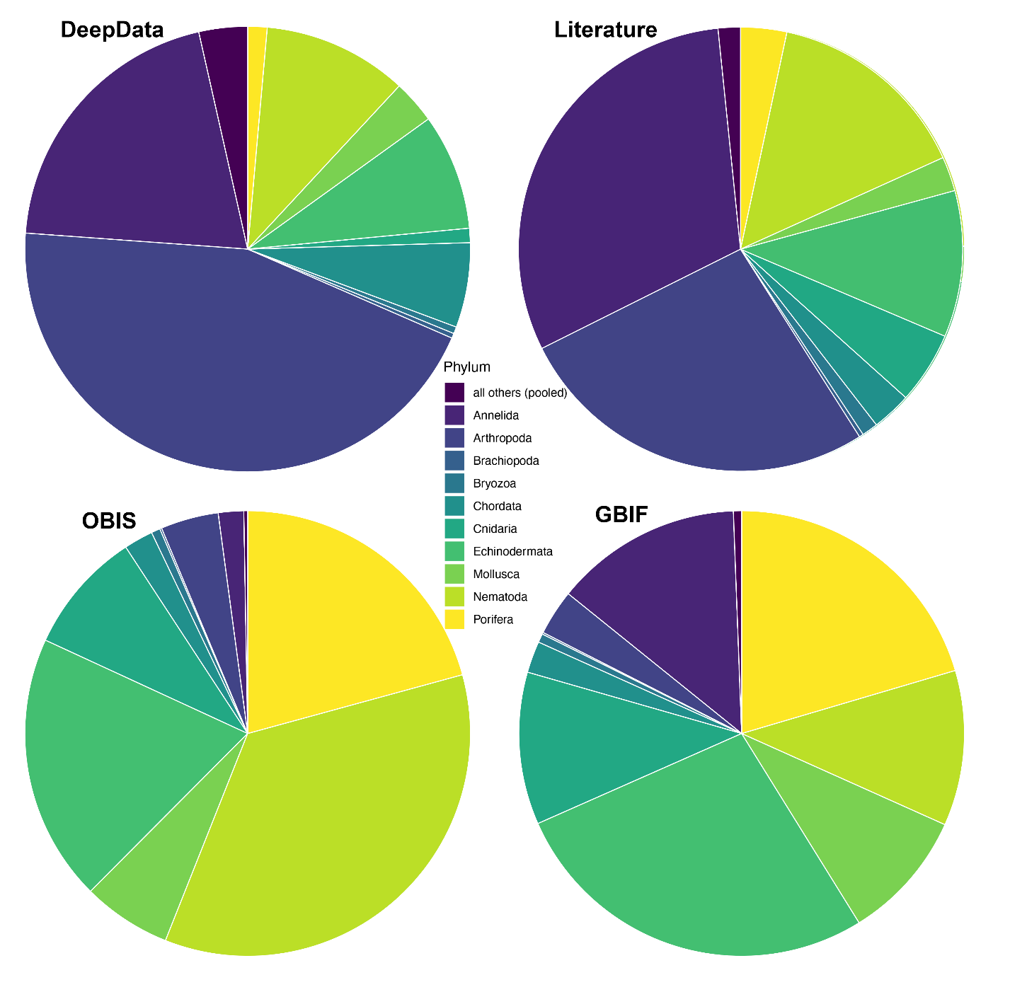Fig. 10Relative proportion of Clarion-Clipperton Zone data records by phylum for DeepData, literature, OBIS and GBIF. For phyla with few records, totals were combined (‘all others pooled’: Chaetognatha; Ciliophora; Coelenterata; Ctenophora; Dicyemida; Entoprocta; Gastrotricha; Gnathostomulida; Hemichordata; Kinorhyncha; Loricifera; Nemertea; Placozoa; Platyhelminthes; Priapulida; Rotifera; Tardigrada; Xenacoelomorpha).

### Trends by size class and identification method

The majority of general records of previously described species were of macrofauna, both in the literature and DeepData (Fig. 11). Proportions of records for macrofauna and megafauna in DeepData and the literature were similar, but in DeepData, relatively more megafauna records were evident (Fig. 11 & Fig 12); however some of these megafauna records are believed to be duplicates (see section 3.6.3). As above, a large proportion of macrofauna and megafauna records in the literature were temporary names, many of which were based on imagery (Fig. 11; Table 7). Size class was often not recorded in DeepData, therefore where missing, names were cross-referenced from the CCZ Checklist (see section 3.4). Size class information was not recorded in OBIS or GBIF apart from a few exceptions where size classes were recorded in dataset names for example.

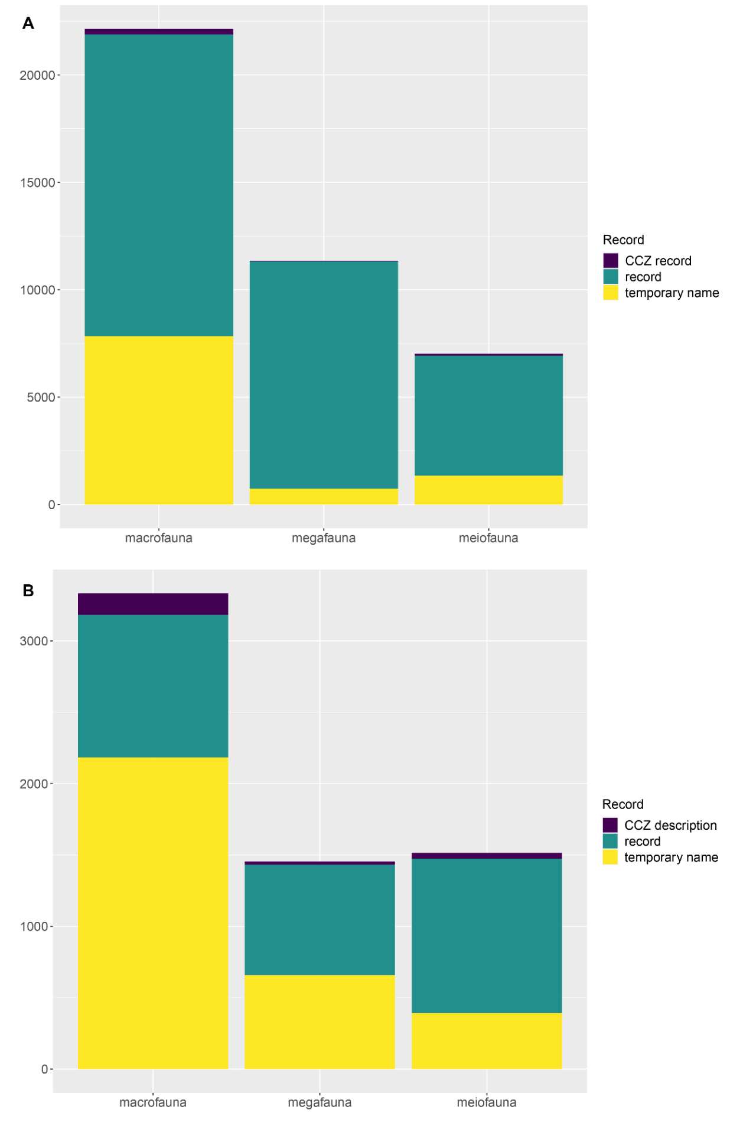

Fig. 11 Total records in in the Clarion-Clipperton Zone by size class for (A) DeepData and (B) literature (entire record set- not records of different taxa). In (A): DeepData, ‘CCZ record’ equates to any record of a species or genus described from the CCZ.

Data on identification method, i.e. “DNA” or “Morphological” is recorded only for a subset of records in DeepData, 2383 in total (6%), the remainder being ‘not reported’[43]. For OBIS and GBIF, 578 records were ‘machineObservation’ in the basisOfRecord column (imagery derived), and for ‘humanObservation’[44], 821 for OBIS and 338 for GBIF. The remainder were ‘preservedSpecimen’ i.e. specimen records. Identification method was well recorded in the literature however (Table 10). Some taxa were described solely by molecular data (Table 7A; Janssen et al., 2015; Kersten et al., 2017; Janssen et al., 2019; Kersten et al., 2019; Macheriotou et al., 2020; Lejzerowicz et al., 2021; Laroche et al., 2020). In total, 1258 records (of 6314) were described by morphology and molecular data, 3798 by morphology only (specimens), 60 by molecular data only, and 1187 from imagery only (Table 7). Breakdowns by record type (Table 7B) show predominance of identification by morphology only (specimens) for macrofauna; and reliance on imagery for identification of megafauna whether for morphospecies records or general records (where the majority of studies are imagery-based are from ROV surveys, not specimen based).

Table 7(A). Identification method of all records (top) and for incidences of scientific names at all taxonomic levels (bottom) for literature; (B) Identification method of all records for literature, with breakdowns by record type: CCZ descriptions / general records / temporary name records. CCZ description: new species/genera/family combined. DeepData, OBIS and GBIF data not shown as incomplete/unavailable.

|  |  |  |  |  |  |  |  |  |
| --- | --- | --- | --- | --- | --- | --- | --- | --- |
| A | Size class | molecular data only | | morphology & molecular data | morphology only (specimens) | morphology only (imagery) | TOTAL | |
| Records | Macrofauna | 13 | | 1032 | 2179 | 109 | **3333** | |
|  | Megafauna |  | | 173 | 204 | 1077 | **1454** | |
|  | Meiofauna | 47 | | 64 | 1415 | 1 | **1527** | |
|  | **TOTAL** | **60** | | **1269** | **3798** | **1187** | **6314** | |
| Names | Macrofauna | 13 | | 351 | 544 | 49 | **957** | |
|  | Megafauna |  | | 109 | 166 | 396 | **671** | |
|  | Meiofauna | 47 | | 55 | 542 |  | **644** | |
|  | **TOTAL** | **60** | | **515** | **1252** | **445** | **2272** | |
| B |  | |  |  |  |  |  |
| CCZ description | Macrofauna | |  | 74 | 76 |  | **150** |
|  | Megafauna | |  | 9 | 13 | 1 | **23** |
|  | Meiofauna | |  | 3 | 38 |  | **41** |
|  |  | |  |  |  |  | **214** |
| record | Macrofauna | | 13 | 249 | 679 | 63 | **1004** |
|  | Megafauna | |  | 90 | 157 | 525 | **772** |
|  | Meiofauna | | 47 | 59 | 985 |  | **1091** |
|  |  | |  |  |  |  | **2867** |
| temporary name | Macrofauna | |  | 709 | 1424 | 46 | **2179** |
|  | Megafauna | |  | 74 | 34 | 552 | **660** |
|  | Meiofauna | |  | 2 | 392 |  | **394** |
|  |  | |  |  |  |  | **3233** |
|  | **TOTAL** | | **60** | **1269** | **3798** | **1187** | **6314** |

By phylum and size class (Fig. 11), DeepData had relatively more arthropod records in macrofauna, whereas in the literature, most macrofauna records were for annelids. In megafauna also proportionally more arthropod records were present in DeepData, and many echinoderm and chordate records, for literature, megafauna records were mainly echinoderms, and large proportions of chordates but also cnidarian and sponge records (Fig. 12).

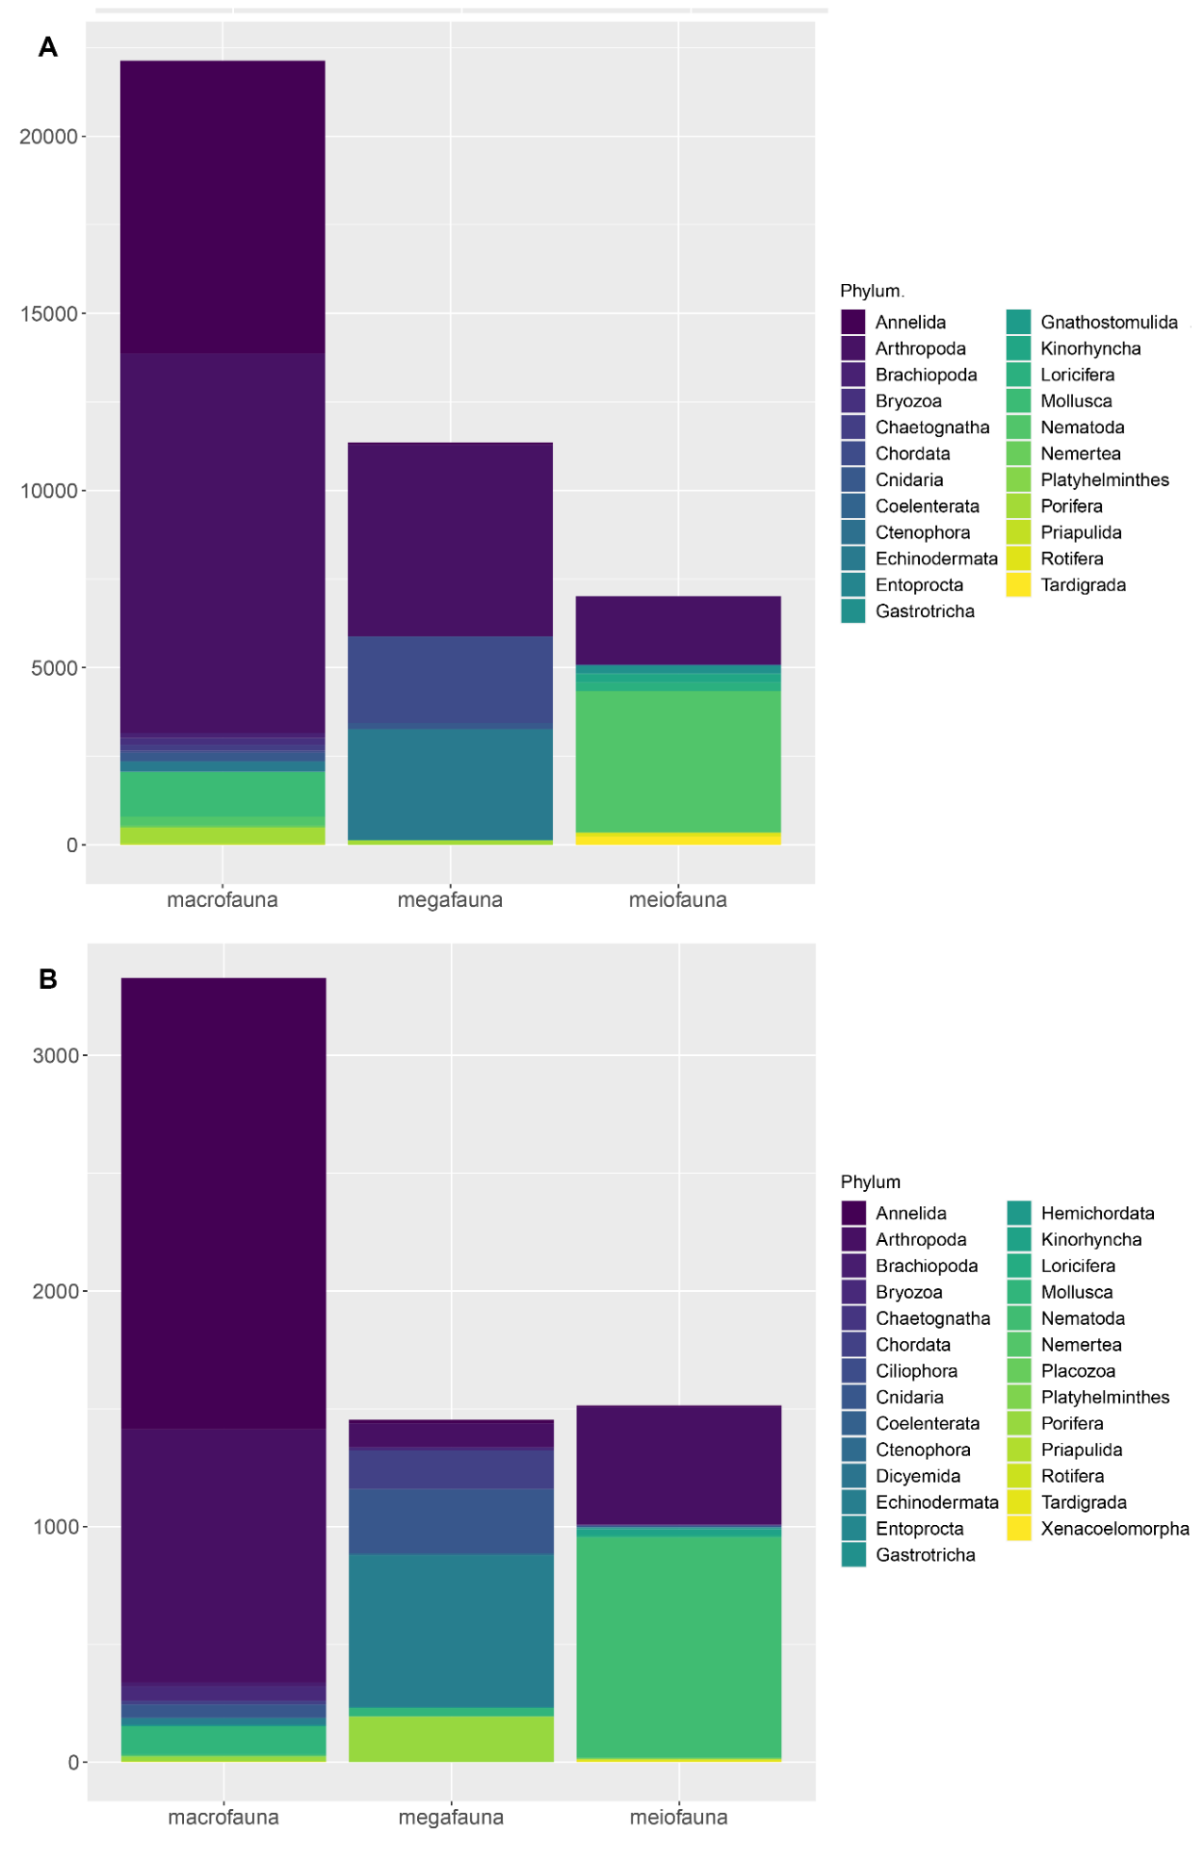

Fig. 12 Data records in the Clarion-Clipperton Zone by size class and phylum for (A) DeepData and (B) literature.

### Trends by Contractor and contract area

A basic analysis of the differences in records provided by Contractors is provided, although it is likely to be heavily biased by issues of data duplication (see section 3.6). . For example, the largest number of records are from BGR and UKSRL (Table 8). however, these are also the Contractors with most duplication of records identified on DeepData (see section 3.6.3).The numbers are also likely to be biased by different Contractors focussing on different size classes or taxonomic groups. For example, macrofauna are much more abundant than megafauna, and some Contractors are likely to have differing levels of expertise, e.g. having resident experts on megafauna or meiofauna but not macrofauna, and this could impact the number of records considerably. This analysis is not intended to be discussion of differing levels of activity or effort by Contractor, rather it is just an indication of the number of records published on DeepData on the 12th of July, 2021 It should be noted here too that these are records by Contractor not contract area, which in many cases are not equivalent (see section 2.3).

Table 8. Total records by taxonomic resolution by Contractor. Other: assorted taxonomic levels- kingdom, subphylum, subclass, superclass, infraorder, superfamily. NB record breakdown is by Contractor providing data, not contract area, which are not always equivalent. Here totals affected by duplication for BGR and UKSRL (see section 3.6.3). Total records of morphospecies/temporary names (i.e. as in rest of table total of records not individual incidences of names) are also indicated (not included in overall totals which are for scientific names only).

|  |  |  |  |  |  |  |  |  |  |  |
| --- | --- | --- | --- | --- | --- | --- | --- | --- | --- | --- |
| Contractor | Phylum | Class | Order | Family | Genus | Species | Other* | TOTAL | Morphospp. |  |
| BGR | 1412 | 3870 | 2749 | 229 | 397 | 195 | 194 | 9046 | 3006 |  |
| COMRA | 1 | 4 |  | 624 | 36 | 614 | 4 | 1283 |  |  |
| DORD | 80 | 57 | 91 | 11 | 1 |  | 7 | 247 |  |  |
| GSR | 141 | 193 | 179 | 234 | 452 | 142 | 18 | 1359 | 143 |  |
| IFREMER | 119 | 105 | 100 | 247 | 2472 | 369 | 27 | 3439 | 1882 |  |
| IOM | 42 | 70 | 25 | 126 | 70 |  | 3 | 336 |  |  |
| KOREA | 83 | 123 | 138 | 76 | 278 | 83 | 4 | 785 | 187 |  |
| OMS | 516 | 396 | 789 | 974 | 140 | 157 | 79 | 3051 | 34 |  |
| UKSRL | 370 | 1593 | 3358 | 2898 | 4203 | 7328 | 106 | 19856 | 4684 |  |
| YUZH | 273 | 483 | 209 | 128 | 23 |  |  | 1116 |  |  |
| TOTAL | **3037** | **6894** | **7638** | **5547** | **8072** | **8888** | **442** | **40518** | **(9936*)** |  |

Looking at total names recorded by Contractor, most species records were from COMRA, but some of these were pelagic species. Pelagic taxa were also present in the UKSRL datasets. These records were excluded for the checklist and diversity analyses (see section 3.4; 3.5). Relatively large totals of species names were present from IFREMER and UKSRL (again some pelagics evident in the latter total; Table 9). For some Contractors, no species level records were present for DORD, YUZH and IOM, although as already mentioned for YUZH, all these Contractors have species records published in the literature (see SDF 5). As above, this breakdown is by Contractor providing data, when looking at actual contract area, species-level records were present for IOM (Table 10). Usage of morphospecies names/temporary names was evident for 6 Contractors, particularly UKSRL and IFREMER (Table 8 & 9).

Table 9. total names recorded by Contractor and phylum, including morphospecies (e.g. unique instances of given species names). Totals of scientific names recorded shown are overall totals, not of column total given shared names across Contractor, *Similarly, total of morphospecies is overall total minus temporary names shared across Contractors. Not shown are other taxonomic levels recorded, e.g. kingdom, subphylum, subclass, superclass, infraorder, superfamily. *Species and Genus column, totals without pelagic names also given in brackets (see section 2.3).

|  |  |  |  |  |  |  |  |
| --- | --- | --- | --- | --- | --- | --- | --- |
| Contractor | Phylum | Class | Order | Family | Genus | Species* | Morphospp. |
| BGR | 17 | 19 | 11 | 12 | 33 | 9 | 78 |
| COMRA | 1 | 2 |  | 19 | 19(11) | 282(19) |  |
| DORD | 1 | 4 | 4 | 4 | 1 |  |  |
| GSR | 12 | 16 | 16 | 46 | 143 | 28 | 88 |
| IFREMER | 9 | 12 | 13 | 36 | 211 | 65 | 793 |
| IOM | 6 | 11 | 8 | 15 | 8 |  |  |
| KOREA | 11 | 13 | 9 | 30 | 79 | 25(24) | 111 |
| OMS | 16 | 19 | 13 | 78 | 22 | 29(28) | 27 |
| UKSRL | 19 | 24 | 36 | 111 | 141(116) | 73(58) | 964 |
| YUZH | 11 | 18 | 9 | 12 | 1 |  |  |
| TOTAL | **24** | **38** | **47** | **197** | **497**(466) | **466**(231) | **1990\*** |

Looking at total scientific names by size class (Fig. 13), the clear majority of names were macrofauna for all Contractors, apart from IFREMER where most names were meiofauna, and GSR where half the names were meiofauna and megafauna combined, but mostly the former; and a sizeable proportion of OMS and UKSRL were megafauna. This illustrates the different focus by Contractor, and also likely reflects that the records published on DeepData at present is a subset of the total collected.

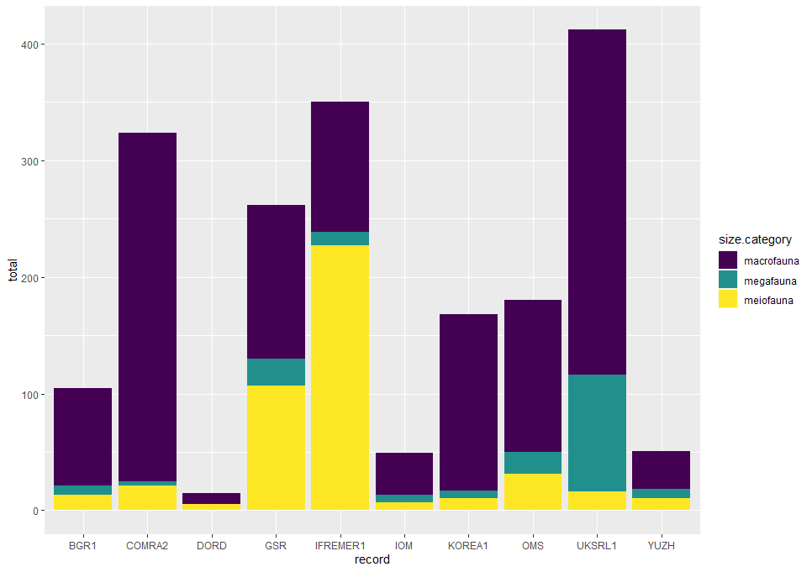

Fig 13. Proportions of total scientific names for different size classes of animals between different Contractors in the Clarion-Clipperton Zone, based on DeepData records.

Given the disjunct between Contractor and contract area, we also tabulated records by contract area (Table 10). Sizeable totals of species were evident for IF2 (IFREMER) with 73, UK-1 (UKSRL) with 58, OMS with 41, and COMRA2, 32. As above no species level records were present for YUZ2 or DOR1 but these are present in the literature.

Table 10. Total names recorded by contract area including morphospecies (e.g. unique instances of species names). Totals of scientific names recorded shown are overall totals, not of column total given shared names across contract area. *Similarly, total of morphospecies is overall total minus temporary names shared across contract areas. Not shown are other taxonomic levels recorded, e.g. kingdom, subphylum, subclass, superclass, infraorder, superfamily. *Species and Genus column, totals without pelagic names also given in brackets (see section 2.3). *Outside: data collected outside of either contract areas or APEIs, from Contractor KOREA (between SW corner of APEI-6 and SE corner APEI-3, and COMRA, near APEI-1.

|  |  |  |  |  |  |  |  |
| --- | --- | --- | --- | --- | --- | --- | --- |
| Contract area | Phylum | Class | Order | Family | Genus | Species* | Morphospp. |
| Outside* |  |  | 4 | 3 | 5 | 5 | 2 |
| APEI-3 |  |  |  |  | 4 | 18 | 3 |
| APEI-6 | 2 | 5 | 5 | 13 | 19 | 8 | 39 |
| APEI-9 | 1 | 1 | 3 | 2 | 8 | 1 | 5 |
| BGR1 | 17 | 18 | 10 | 11 | 30 | 7 | 69 |
| COMRA2 | 1 | 2 |  | 19 | 19(10) | 281(32) |  |
| DOR1 | 1 | 4 | 4 | 4 | 1 |  |  |
| GSR | 12 | 16 | 16 | 46 | 144 | 26 | 89 |
| IFR2 | 11 | 14 | 18 | 45 | 221 | 73 | 818 |
| IOM2 | 10 | 12 | 8 | 15 | 13 | 14 | 10 |
| KOREA1 | 11 | 13 | 9 | 29 | 73 | 22 | 107 |
| OMS | 16 | 24 | 16 | 83 | 48 | 42(41) | 207 |
| UK-1 | 19 | 27 | 34 | 109 | 146(121) | 72(58) | 891 |
| YUZ2 | 11 | 18 | 9 | 12 | 1 |  |  |
| TOTAL | **24** | **38** | **47** | **197** | **497**(466) | **466**(207) | **1990\*** |

### Morphospecies/temporary names

In total, 4436 unique benthic morphospecies or temporary names have been recorded. By data source, significant numbers of temporary names were present in both the literature and DeepData (Table 11; Fig. 14). In DeepData, 1990 temporary names[45] were recorded. In the literature, 2747 temporary names were identified, from OBIS, 82, and from GBIF, 143. Also 635 temporary names were present in the OBIS ‘DeepData’ records ie those on the OBIS ISA node, i.e. DeepData records harvested by OBIS, none of which overlapped with the DeepData ones. These were excluded from the total as these names are represented in the DeepData dataset and do not show up as separate names because of additional steps in DeepData processing that have resulted in different name coding.

By phylum, the largest numbers were for annelids and arthropods (common macrofaunal groups), followed by nematodes (meiofauna) and echinoderms (megafauna; Table 12). In the literature (as for DeepData), significant numbers of temporary name records were from imagery identifications, not specimens, for megafauna and macrofauna (22% of records overall). A large proportion of annelids (all polychaete) temporary names were from the literature, for arthopods most of the temporary names were from DeepData. While relatively few, some morphospecies names were present in OBIS and GBIF, particularly for echinoderms, and to a lesser degree, molluscs and chordates (Fig. 14). Overall, phyla with significant numbers of temporary names included Annelida, Arthropoda, Nematoda and Echinodermata.

Table 11. Total of morphospecies names (mspp.) by phylum and data source. Totals of undescribed species and named species also shown for comparison (see CCZ Checklist section). Only phyla with morphospecies names shown.

|  |  |  |  |  |  |  |
| --- | --- | --- | --- | --- | --- | --- |
| Phylum | Literature | DeepData | OBIS | GBIF | Total mspp. | Undescr. Spp. |
| Annelida | 1049 | 661 | 5 | 1 | 1678 | 812 |
| Arthropoda | 948 | 694 |  | 7 | 1345 | 297 |
| Brachiopoda |  | 4 |  |  | 4 |  |
| Bryozoa | 16 | 23 |  | 4 | 39 | 2 |
| Chaetognatha |  | 3 |  |  | 3 |  |
| Chordata | 55 | 6 | 9 | 15 | 76 |  |
| Cnidaria | 177 | 39 | 7 | 7 | 212 | 26 |
| Ctenophora | 6 |  |  | 4 | 9 |  |
| Echinodermata | 291 | 76 | 49 | 89 | 392 | 58 |
| Gastrotricha |  | 1 |  |  | 1 |  |
| Hemichordata | 2 |  |  |  | 2 |  |
| Kinorhyncha | 9 | 1 |  |  | 10 |  |
| Loricifera |  | 1 |  |  | 1 |  |
| Mollusca | 35 | 65 | 12 | 16 | 91 | 12 |
| Nematoda | 63 | 366 |  |  | 429 | 5 |
| Nemertea |  | 5 |  |  | 5 |  |
| Porifera | 96 | 43 |  |  | 137 | 9 |
| Rotifera |  | 1 |  |  | 1 |  |
| Tardigrada |  | 1 |  |  | 1 |  |
| TOTAL | **2747** | **1990** | **82** | **143** | **4436** | **1221** |

By faunal size class, 2674 morphospecies names were macrofauna, 847 were megafauna, and 915 meiofauna (Table 11). In total, 1221 of these names were classified as undescribed new species or genera, mainly names from the literature (1181) but also 42 from DeepData. These were mostly macrofauna (1104), and by phyla, mainly annelids (812) and to a lesser extent arthropods (297). 1192 were for undescribed species, 27 undescribed genera, and 2 both the species and genus were new and undescribed.

Table 12. Total morphospecies names (mspp.) by phylum and size class. Totals of undescribed species and genera (Undescr. spp./gen) by phylum shown with breakdowns as total for undescribed species; then genera; then species + genera: ‘species’ / ‘**genera’** / ‘**species + genera**’

|  |  |  |  |  |  |
| --- | --- | --- | --- | --- | --- |
| Phylum | Macro | Mega | Meio | Total mspp. | Undescr. spp./gen |
| Annelida | 1665 | 13 |  | 1678 | 810 / **2** |
| Arthropoda | 833 | 40 | 472 | 1345 | 277 / **20** |
| Brachiopoda | 4 |  |  | 4 |  |
| Bryozoa | 29 | 10 |  | 39 | 2 |
| Chaetognatha | 3 |  |  | 3 |  |
| Chordata | 3 | 73 |  | 76 |  |
| Cnidaria | 20 | 192 |  | 212 | 19 / **5** / **2** |
| Ctenophora |  | 9 |  | 9 |  |
| Echinodermata | 6 | 386 |  | 392 | 58 |
| Gastrotricha |  |  | 1 | 1 |  |
| Hemichordata | 2 |  |  | 2 |  |
| Kinorhyncha |  |  | 10 | 10 |  |
| Loricifera |  |  | 1 | 1 |  |
| Mollusca | 83 | 8 |  | 91 | 12 |
| Nematoda |  |  | 429 | 429 | 5 |
| Nemertea | 5 |  |  | 5 |  |
| Porifera | 21 | 116 |  | 137 | 9 |
| Rotifera |  |  | 1 | 1 |  |
| Tardigrada |  |  | 1 | 1 |  |
| TOTAL | **2674** | **847** | **915** | **4436** | **1221** |

The large numbers of morphospecies names is a reflection first of the large number of species new to science in the region; second, the lack of faunal guides and keys preventing identification, and third, the reliance on imagery survey only for groups such as the megafauna (for example echinoderms), which are challenging to identify solely from imagery. There is almost certainly some degree of overlap both within and between data sources, due to the informal nature of recording morphospecies names, with different coding in different data sources resulting in inflation of the total, for example ‘species a’ in one dataset or literature source may equate to ‘species b’ in another.

Quantifying the degree of overlap – or duplication in these names however is challenging. For example, in DeepData, only 6 Contractors are using temporary names, and only 2 to a significant extent, UKSRL (and IFREMER (Table 10). A total of 71 morphospecies names were shared across different Contractors in DeepData. For these records, the relevant Contractor was checked. This generally occurred between certain pairs of Contractors, mainly between GSR and IFREMER, and UKSRL and OMS who have carried out shared cruises, both in 2015 (Table 5). Other pairs of Contractors with shared morphospecies names were evident, for 9 names in total (BGR / KOREA; BGR / UKSRL; IFREMER / UKSRL and GSR / UKSLR). In these cases, all had a coding of genus name followed by ‘sp. 1’, or ‘sp. 2’ e.g. *Laonice* sp. 1 both in KOREA and BGR datasets. 7 of the overlapping names here are coincidental i.e. genuine duplicates as they occur between UKSRL and another Contractor, resulting from publication of 2015 versions of UKSRL data. It should be noted that for UKSRL and OMS a protocol for morphospecies names has since been established (Horton et al., 2021; Wiklund et al., 2019). For the remaining two names, *Laonice* sp. 1 and *Mirabilicoxa* sp.1, these overlaps could have arisen coincidentally or by harmonisation of usage e.g. the same taxonomists being on board different Contractor cruises.

As a result, for DeepData we estimate that very few of the morphospecies names are duplicates, but this is uncertain. It should be noted for the seven overlapping (i.e. duplicate) names that this was only ascertained because of the authors knowledge of the datasets in question. Generally speaking, it will be difficult to distinguish duplicates/coincidental overlap of names and harmonisation of name usage (i.e. the degree of actual overlap in name usage) unless there is information available for the dataset in question to elaborate on the approach applied to morphospecies name coding. This is an inevitable consequence of the informal nature of temporary names.

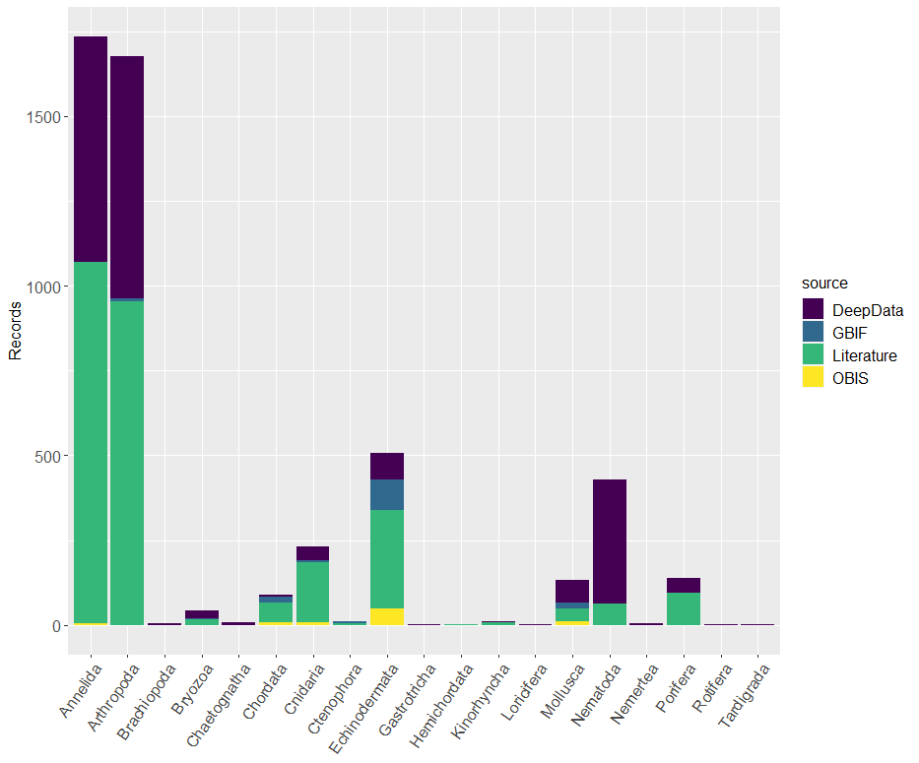Fig. 14 Number of temporary species name records (morphospecies/morphotypes/OTUs) distributed across phyla and between data sources for the Clarion-Clipperton Zone.

### Genetic data coverage: DeepData and comparison with GenBank and the literature

Genetic and genomic data records collated from the literature and databases included 4647 GenBank accessions (each representing an individual sequence in the database), 1674 BOLD accessions (and 3 BOLD projects) and 5 genomic datasets in NCBI (National Center for Biotechnology Information) and also housed in the Also housed in the SRA (Sequence Read Archive) (Taboada et al., 2018b, Kersten et al., 2019; Macheriotou et al, 2020; see SDF 4).

By marker, more than half of the sequences were the mitochondrial marker COI (2667), widely used in phylogenetics, followed by the nuclear (rRNA) marker 16S (1090), with relatively few for the remaining markers, which included 18S, 28S, ITS2 (Internally Transribed Spacer) and Cytb (Cytochrome b) (the latter a mitochondrial marker, the others being nuclear markers- rRNA). These markers, commonly used in taxonomy studies, represent short sequences that can be compared to a reference library. Microsatellites, nuclear markers used for population connectivity studies, have also been published in one case for a sponge, *Plenaster craigi* (Taboada et al., 2018a, b).

In DeepData, 268 INSDC accession numbers were present, from three contract areas, COMRA, IFREMER and UKSRL. Of these, 252 were present both in DeepData and the literature, from 5 studies (Bonifacio & Menot, 2019; Amon et al., 2017a[46]; Glover et al., 2016; Dahlgren et al., 2016; Wiklund et al., 2017). An additional 16 GenBank accessions from COMRA were present in DeepData only and not in the published literature, in this case only the sequences have been published without an associated publication (see SDF 1). The actual sequence itself (not the accession number) was included in 92 cases, again for COMRA, these sequences were also present in the OBIS DeepData records, i.e. published on the OBIS ISA node[47].

In OBIS, 72 GenBank accessions were present, and in GBIF, 229, with additional INSDC records harvested from the literature (see section 3.3.1). Overall therefore, most sequences (>4000) were published only in INSDC/the literature and not harvested by other databases, partly a reflection of how recent these genetic publications and datasets are, with 11 published in 2021 alone (see section 3.1.3). In some cases, for DeepData, GenBank accession numbers were available in the Contractor data, but not harvested by the database (see section 3.6).

Table 13. Summary of genetic and genomic datasets available in the INSDC databases and BOLD

|  |  |  |  |
| --- | --- | --- | --- |
| Data Source | Accessions | Genomic Data | Notes |
| GenBank | 4647 |  | Markers: COI, 16S, 18S, 28S, ITS2, Cytb |
| BOLD | 1674 |  | Also 3 project databases (Christodolou et al., 2019; 2020; Brix et al., 2020; Malyutina et al., 2020; Mohrbeck et al., 2021) |
| NCBI/SRA |  | 5 genomic datasets | Macheriotou et al, 2020; Kersten et al., 2019; Taboada et al., 2018b |
|  |  |  |  |

The BOLD database also had a significant number of accessions, 1674 (see SDF 4); and several BOLD project databases/datasets were identified (see Mohrbeck et al., 2021; Brix et al., 2020; Malyutina et al., 2020; Christodoulou et al., 2019, 2020). It appears to be widely used for CCZ studies therefore. No BOLD identifiers were referenced in DeepData or on OBIS or GBIF. However, the field to capture sequence number in the current DeepData template is specifically for INDSC accessions. For OBIS and GBIF, the Darwin Core term associatedSequences can be used for INSDC or BOLD sequences but appears only used for the former at least in this case. however the publications with accessions in BOLD are all very recent (Jażdżewska et al., 2021; Laming et al., 2021; Mohrbeck et al., 2021; Bonifacio et al., 2021; Brix et al., 2020; Malyutina et al., 2020; Christodoulou et al., 2020), whereas DeepData at the time of writing housed datasets from annual Contractor data reporting, primarily submitted from 2015-2017, and OBIS and GBIF, datasets up to (and including) 2018 (Fig. 6).

## Creation of the CCZ Checklist

A master checklist of known benthic CCZ fauna, hereafter the ‘CCZ Checklist’ based on all data sources was created by the authors with the aim that this could be used as, for example, a thematic webpage of WoRDSS. Accepted names only were included apart from where no match was available on WoRMS, initially 16 species names and 23 names in total, including 9 of the new species and 2 of the new genera (see SDF 6; S Table 1). After the authors contacted Tammy Horton of the WoRMS secretariat in November 2021, these names were added to the WoRMS database. The Checklist includes four species not matched to WoRMS which remain to be confirmed: *Cycladicama lunaris*, *Lucifer hawaiensis*, *Endomyzostoma cysticolum*, and *Ceratocephale regularis*. Also nine species have uncertain taxonomic status- ‘taxon inquirendum’ recorded in WoRMS, e.g. if the description is based on only one or two specimens. Several pelagic species were identified, 294 in total, mostly names recorded in DeepData (see section 2.2.4). These names were not included in the totals or analysis but the records retained in the dataset as they are valid distributional records of pelagic taxa in the region (see SDF 6).

This checklist contains 642 benthic named species in total. Total species recorded without the qualifiers cf., aff., sp. inc., or incertae sedis (or identified solely from imagery) numbered 462 overall (see SDF 6). Total species identified solely from imagery in the Checklist numbered 104, all megafauna, with the majority from 2 publications by the same author (Tilot et al., 1992; 2018). Most of these 104 names were echinoderms (77), and resepresent 44% of total megafauna names recorded. This subset of names be treated with a degree of uncertainty however, even though they were not recorded with ‘incertae sedis’ or similar open nomenclature signs (Sigovini et al., 2016) given the inherent uncertainty of identification solely from imagery. With 174 new species described from the CCZ since 2000, 27% of the overall total of species names recorded from the region were ‘new species’ (i.e. described since 2000). With 180 species described from the CCZ in total (Table 14), 28% are CCZ descriptions.

Only six of the species described from the CCZ have been recorded elsewhere (i.e. outside the CCZ) to date, as recorded in OBIS (*Psychropotes dyscrita* (Clark, 1920) Gebruck et al., 2020; *Erebussau tenebricosus* (Bussau, 1993) Bezerra, Pape, Hauquier & Vanreusel, 2021; *Psychronaetes hanseni* Pawson, 1983; *Axoniderma longipinna* (Ridley & Dendy, 1886)); WoRMS (*Abyssarya acus* (Bonifácio & Menot, 2018)) and the literature (*Hyocrinus foelli* Roux & Pawson, 1999); although as the first two listed are redescriptions this would be expected. This has not been comprehensively assessed however and given that our review was limited to the CCZ, other records of the CCZ species may appear in the wider literature.

All species recorded from the CCZ as collated in the CCZ Checklist are also tabulated in Supplementary Table 1, including information on whether species have been described from the CCZ, faunal size category, data source, i.e. literature and/or the database the name was recorded in, if names were recorded only with identification qualifiers, and whether identifications were based solely on imagery (see S Table 1).

Table 14: Named species recorded in the CCZ and species described from the CCZ by phylum

|  |  |  |
| --- | --- | --- |
| Phylum | Total spp. | CCZ spp. |
| Annelida | 129 | 50 |
| Arthropoda | 147 | 58 |
| Brachiopoda | 6 | 2 |
| Bryozoa | 21 | 18 |
| Chordata | 23 |  |
| Cnidaria | 26 | 4 |
| Echinodermata | 140 | 5 |
| Hemichordata | 1 |  |
| Kinorhyncha | 9 | 3 |
| Loricifera | 1 | 1 |
| Mollusca | 21 | 1 |
| Nematoda | 77 | 23 |
| Platyhelminthes | 1 |  |
| Porifera | 39 | 14 |
| Tardigrada | 1 | 1 |
| TOTAL | **642** | **180** |

### CCZ Checklist species names by phylum and data source

The most speciose phyla in terms of known/named diversity were Arthropoda, with 147 species, followed by Echinodermata, with 140 species, Annelida, with 129 species and Nematoda, with 77 species. Relatively high totals were also evident in Porifera, with 39 species, Cnidaria, with 26 species, Chordata with 23 species and Mollusca and Bryozoa, both with 21 species (Table 14 & 15, Fig. 15).

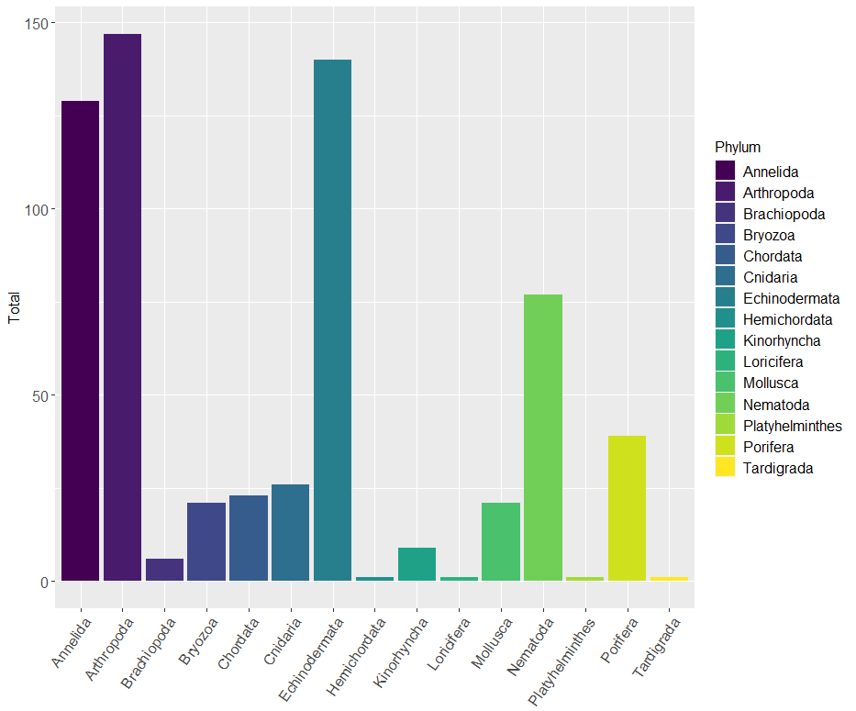Fig. 15 Total number of species names in the CCZ Checklist by phylum, data from all available sources. It should be noted that a large number of the echinoderm species were identified from imagery only, 77 in total (excluded from the CCZ Checklist *sensu stricto*)

Looking at totals of known species names by data source where names were not recorded elsewhere, the majority were from the literature (307), but with some names also from DeepData, 37; OBIS 18 and GBIF, 15. The remainder of the names were from multiple data sources, e.g. names recorded in the literature and one or more databases. For species by phylum, the majority of species names were from the literature, particularly Echinodermata (Table 15, Fig. 16). By phylum, OBIS and GBIF proportions by were relatively similar (apart from a large number of nematode records in OBIS but not GBIF, from IFREMER), and also rather similar to the literature- reflecting overlapping datasets. For echinoderms and sponges, both OBIS and GBIF had more species names present than DeepData (again partly reflecting overlap with the literature where there is also a higher degree of taxonomic resolution); and both also had species records for bryozoans and kinorhynchs, unlike DeepData.

Table 15.Species names in checklist by phylum and data source (NB total given is overall total by phylum not total of columns, given overlap of names across sources).

|  |  |  |  |  |  |
| --- | --- | --- | --- | --- | --- |
| Phylum | Literature | DeepData | OBIS | GBIF | TOTAL |
| Annelida | 123 | 42 | 32 | 34 | **129** |
| Arthropoda | 109 | 41 | 30 | 17 | **147** |
| Brachiopoda | 6 | 1 | 3 | 2 | **6** |
| Bryozoa | 21 |  | 4 | 4 | **21** |
| Chordata | 17 | 9 | 7 | 13 | **23** |
| Cnidaria | 24 | 9 | 7 | 9 | **26** |
| Echinodermata | 132 | 15 | 35 | 39 | **140** |
| Hemichordata | 1 |  |  |  | **1** |
| Kinorhyncha | 9 |  | 3 | 1 | **9** |
| Loricifera | 1 |  |  |  | **1** |
| Mollusca | 14 | 15 | 8 | 9 | **21** |
| Nematoda | 73 | 57 | 53 | 4 | **77** |
| Platyhelminthes | 1 |  |  |  | **1** |
| Porifera | 38 | 3 | 14 | 18 | **39** |
| Tardigrada | 1 |  |  |  | **1** |
| TOTAL | **570** | **192** | **196** | **150** | **642** |

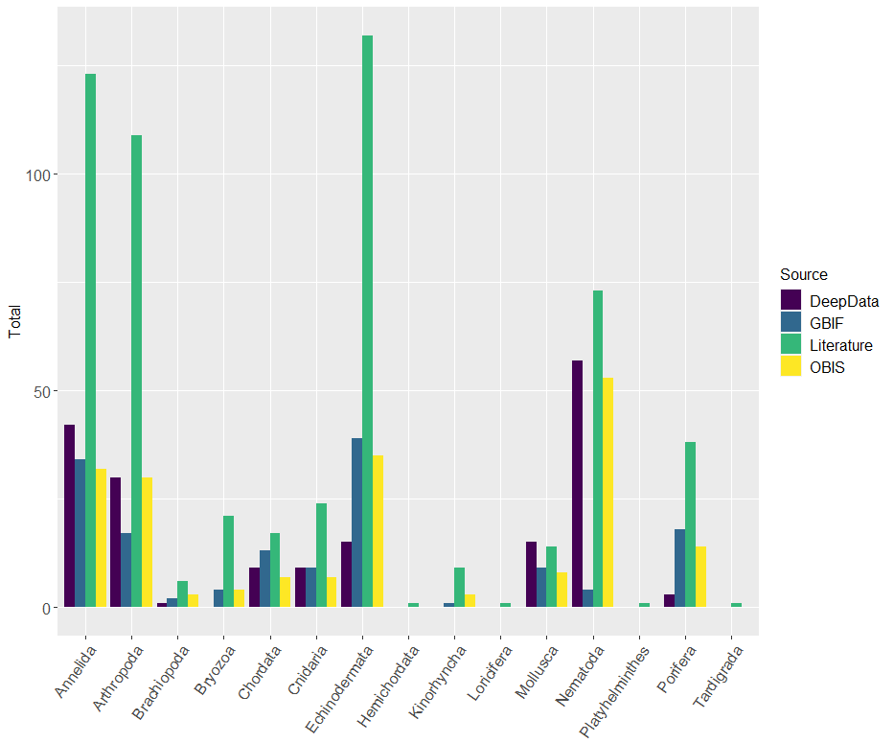Fig 16: Total number of species names in the CCZ Checklist by phylum and data source, data from all sources.

Looking at taxonomic resolution of names as recorded, i.e. excluding inferred higher classification (e.g. genus names inferred from a species record), most names were at genus or species level (Table 16), but this reflects the inherent structure of taxonomic classification more than anything with many more names at lower taxonomic levels. Taxonomic resolution by phylum was relatively consistent (Fig. 17), but trends were evident, for example relatively more names at genus level were present for nematodes, which as above are characteristically identified to genus level, being challenging to resolve to species (Table 16; Fig. 17).

Table 16. Taxonomic resolution by Phylum. * Only name recorded was that of the phylum name itself (Cephalorhyncha, Coelenterata, Gastrotricha, Gnathostomulida, Priapulida, Rotifera). Phylum* Coelenterata – this is an unaccepted Phylum name (nomen nudum). Other taxonomic rank included gigaclass, infraflass, infraorder, parvphylum, tribe, super- order / family / class; sub- class / family / order / phylum. In total, 28 phyla were recorded (accepted names only)

|  |  |  |  |  |  |  |
| --- | --- | --- | --- | --- | --- | --- |
| Phylum | Class | Order | Family | Genus | Species | other |
| Annelida | 3 | 10 | 58 | 171 | 129 | 15 |
| Arthropoda | 5 | 21 | 145 | 330 | 147 | 21 |
| Brachiopoda | 3 | 3 | 5 | 7 | 6 |  |
| Bryozoa | 2 | 4 | 26 | 31 | 21 | 2 |
| Cephalorhyncha |  |  |  |  |  | * |
| Chaetognatha | 1 | 1 |  | 1 |  |  |
| Chordata | 4 | 18 | 22 | 34 | 23 | 4 |
| Ciliophora |  |  |  | 1 |  |  |
| Cnidaria |  | 16 | 39 | 52 | 26 | 3 |
| Coelenterata* |  |  |  |  |  | * |
| Ctenophora | 1 | 2 | 1 |  |  |  |
| Dicyemida |  |  |  |  |  | * |
| Echinodermata | 6 | 25 | 45 | 71 | 140 | 3 |
| Entoprocta |  |  | 1 |  |  |  |
| Gastrotricha |  | 1 | 1 | 1 |  |  |
| Gnathostomulida |  |  |  |  |  | * |
| Hemichordata | 1 |  | 1 |  | 1 |  |
| Kinorhyncha | 2 | 3 | 4 | 8 | 9 |  |
| Loricifera |  | 1 | 1 | 3 | 1 |  |
| Mollusca | 10 | 29 | 48 | 51 | 21 | 4 |
| Nematoda | 3 | 9 | 58 | 305 | 77 | 3 |
| Nemertea | 2 | 2 | 2 | 2 |  |  |
| *Placozoa* |  |  |  |  |  | * |
| Platyhelminthes |  | 2 | 2 | 2 | 1 | 1 |
| Porifera | 3 | 8 | 17 | 34 | 39 | 4 |
| Priapulida |  | 1 | 1 |  |  |  |
| Rotifera |  |  |  |  |  | * |
| Tardigrada |  | 1 | 1 | 1 | 1 |  |
| Xenacoelomorpha |  |  |  | 1 |  |  |
| 28 | **49** | **157** | **479** | **1106** | **642** | **61** |

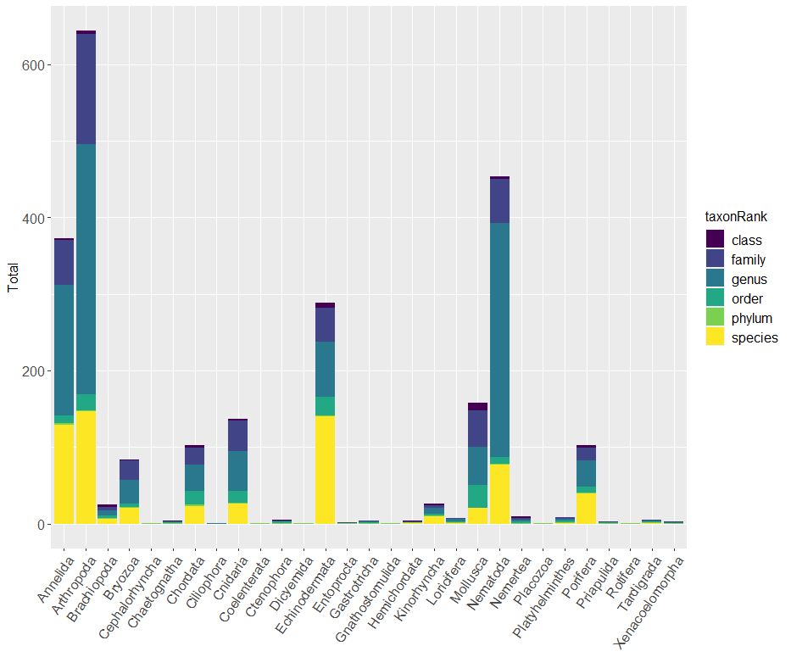Fig. 17 Total scientific names in CCZ Checklist by taxonomic rank, organised by phylum, data from all sources. Other taxonomic ranks- subgenus etc not shown.

### Species names by size class

By size class, 296 species names were macrofauna, 242 megafauna, and 115 meiofauna. By Phylum, most macrofauna species names were arthropods (134), with significant numbers of annelids also (127). For megafauna, most were echinoderms (138), with relatively sizeable numbers of sponges, chordates and cnidarians; and meiofauna, most species names recorded were nematodes (77; Fig 18; Table 17).

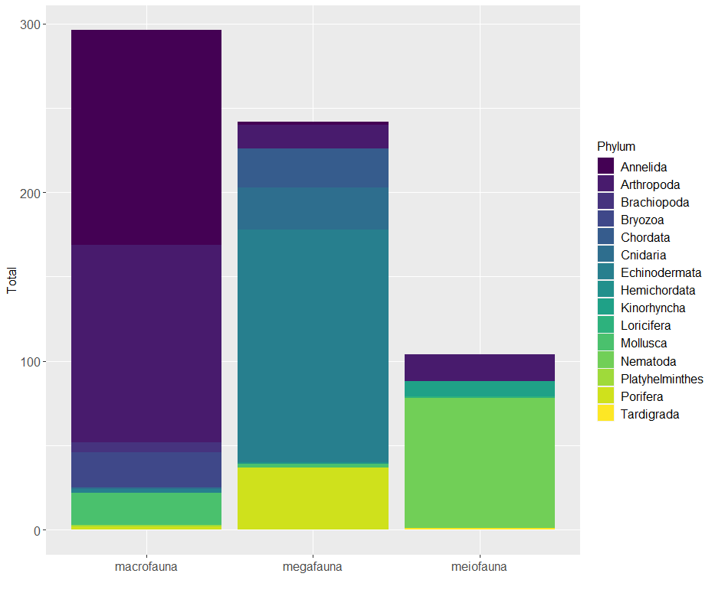Fig. 18 Total species names in CCZ Checklist by size class and phylum, data from all sources.

Table 17: Total species names in CCZ checklist by size class and phylum; data from all sources

|  |  |  |  |  |
| --- | --- | --- | --- | --- |
| Phylum | Macro | Mega | Meio | TOTAL |
| Annelida | 127 | 2 |  | **129** |
| Arthropoda | 134 | 14 | 10 | **147** |
| Brachiopoda | 6 |  |  | **6** |
| Bryozoa | 21 |  |  | **21** |
| Chordata |  | 23 |  | **23** |
| Cnidaria | 1 | 25 |  | **26** |
| Echinodermata | 2 | 138 |  | **140** |
| Hemichordata |  | 1 |  | **1** |
| Kinorhyncha |  |  | 9 | **9** |
| Loricifera |  |  | 1 | **1** |
| Mollusca | 19 | 2 |  | **21** |
| Nematoda |  |  | 77 | **77** |
| Platyhelminthes | 1 |  |  | **1** |
| Porifera | 3 | 36 |  | **39** |
| Tardigrada |  |  | 1 | **1** |
| TOTAL | **314** | **241** | **98** | **642** |

### Coverage and gaps in taxonomic work/descriptions based on the CCZ Checklist

To examine coverage and gaps in taxonomic work and descriptions, we compared the numbers of species in our CCZ Checklist with the numbers of species described from the CCZ based on the literature search. This gives an indication of the relative efforts put into describing new species from the CCZ, by phylum. A large number of phyla are rather rare, e.g. Loricifera, Platyhelminthes, Hemichordata and Tardigrada have only one species recorded in DeepData or the CCZ Checklist; and for some phyla, no species names are present (Cephalorhyncha, Chaetognatha, Ciliophora, Coelenterata, Ctenophora, Dicyemida, Entoprocta, Gastroricha, Gnathostomulida, Nemertea, Placoza, Priapulida, Rotifera, Xenacoelomorpha; Table 17 & 18).

In more abundant phyla, it is possible to compare rates of species discovery (Fig 19), e.g. in Bryozoa, 86% (18 of 21) of the recorded species names have been recently described from the CCZ (since 2000). For other phyla, significant taxonomic effort was detected for Annelida (39%, 50 of 129), Porifera (37%, 14 of 38) and Nematoda (30%, 23 of 77). In contrast, some phyla had relatively high recorded diversity but few (or no descriptions): Echinodermata with 72 species recorded for the CCZ and 5 CCZ species descriptions; Mollusca, 28 recorded species and 1 CCZ description, *Ledella knudseni* (Wiklund et al., 2017) and Chordata, 23 recorded species and no CCZ descriptions. Similar trends were evident also at genera level (S Fig 4).

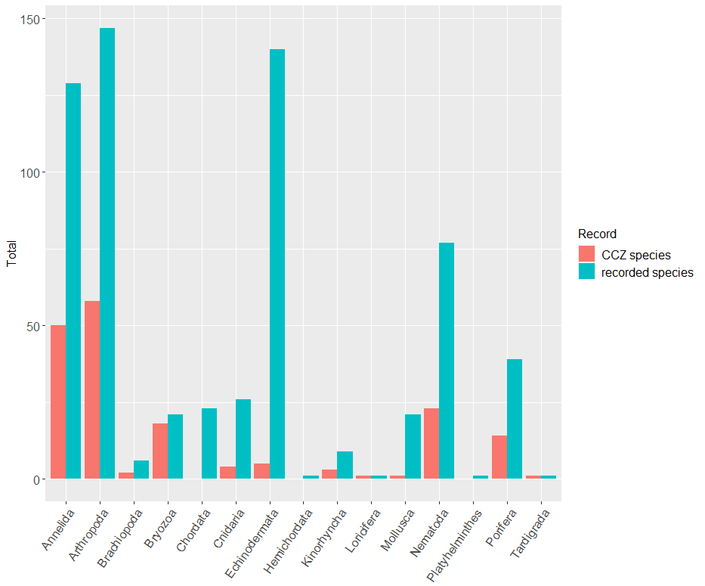Fig. 19 Assessment of taxonomic effort in the Clarion-Clipperton Zone. Comparison of numbers of (A) CCZ species (species described from the CCZ, all apart from 6 described since 2000) (red bars) with numbers of species names in the CCZ Checklist, i.e. all species recorded from the CCZ region.

Another way to group taxa to assess taxonomic effort/gaps is by size class and key faunal groups (Table 2; S Table 1). For meiofauna, these are primarily represented by nematodes, and the arthropods, both harpacticoid copepods (class Hexanauplia, order, Harpacticoida), and ostracods (class Ostracoda). For macrofauna, main faunal groups are polychaetes (Annelida, class Polychaeta); and arthropods, tanaids (order, Tanaidacea) and isopods (order Isopoda), both in class Malacostraca.

Within meiofauna, for arthopods for example, Ostracoda have significant recorded diversity, with 29 species within families Halocyprididae and Cypridinidae; but these have all been confirmed as pelagic, and no ostracod species have been described from the CCZ. In contrast, harpacticoid copepods, where 14 species have been recorded from the CCZ, 5 new descriptions have been published (Mercado-Salas et al., 2019; Gheerardyn & George, 2019; Markhaseva et al., 2017; Cho et al., 2016; Mahatma et al., 2008). There were also several new CCZ descriptions for nematodes, 23 in total (Bezerra et al., 2021; Shimada et al., 2021; Shimada et al., 2020; Miljuntina & Miljutin, 2012; Miljutin & Miljuntina 2009a, 2009b).

For macrofauna, Amphipoda has high recorded diversity, 42 species within 22 families, but only two recent CCZ descriptions, *Oedicerina henrici* and *Oedicerina teresae* (Jazdzewska et al., 2021). Also within Malacostraca, the key macrofaunal groups isopods and tanaids have been well studied in the CCZ (see section 3.1.3, Table 2). For polychaetes, the order Phyllodocida has high recorded diversity. Within this order, the family Polynoidae has been well studied in the CCZ with 17 new descriptions (Bonifacio & Menot, 2019), and descriptions have been published for other families, *Neanthes goodayi* Drennan, Wiklund, Rabone, Georgieva, Dahlgren & Glover, 2021 in Nereididae and *Anguillosyllis hessleri* Maciolek, 2020 and *Anguillosyllis truebloodi* Maciolek, 2020 in Syllidae, but other families less so, e.g. Chrysopetalidae; Sphaerodoridae; Goniadidae; Hesionidae (Table 2). In other orders, for Terebellida there are 12 CCZ descriptions (Blake, 2016, 2019), andthree for Spionida (Neal et al., in press).

Assessing in this way has significant limitations (aside from being an informal approach) as it does not reveal gaps where species-level diversity is not known/recorded from the CCZ, only cross-referencing to known diversity. For example, in polychaetes, there are no Amphinomida species recorded from the CCZ but this is a known gap, and three new species descriptions are currently in review (Neal et al., in review). For meiofauna, there are 5 recent copepod and over 20 nematode descriptions from the CCZ, but this is likely to represent a fraction of diversity in these highly diverse groups.

Table 18. Potential taxonomic gaps in the Clarion-Clipperton Zone. Relative proportions of morphospecies names versus all species names recorded by phyla- i.e. both named and morphospecies combined; and CCZ species (i.e. those described from the CCZ) versus all named species recorded in different phyla, based on the CCZ Checklist. *Several phyla have morphospecies names but no named species, of these, Chaetognatha and Ctenophora both had named species recorded in DeepData (12 and 1 respectively) but these species are identified as pelagic in WoRMS). Proportions not shown if total species very low, e.g. Hemichordata, Tardigrada and Loricifera.

|  |  |  |  |  |  |  |
| --- | --- | --- | --- | --- | --- | --- |
| Phylum | Morphospp. | Named species | CCZ  species | Prop: new of all named spp. | Prop: morpho of all spp. | Undescr. spp. |
| Annelida | 1685 | 129 | 50 | 39 | 93 | 810 |
| Arthropoda | 1526 | 147 | 58 | 36 | 90 | 277 |
| Brachiopoda | 4 | 6 | 2 | 33 | 40 |  |
| Bryozoa | 39 | 21 | 18 | 86 | 65 | 2 |
| Chaetognatha* | 7 |  |  |  |  |  |
| Chordata | 80 | 23 |  |  | 78 |  |
| Cnidaria | 214 | 26 | 4 | 15 | 89 | 21 |
| Ctenophora* | 9 |  |  |  |  |  |
| Echinodermata | 392 | 140 | 5 | 4 | 74 | 58 |
| Gastrotricha | 1 |  |  |  |  |  |
| Hemichordata | 2 | 1 |  |  |  |  |
| Kinorhyncha | 10 | 9 | 3 | 33 | 53 |  |
| Loricifera | 1 | 1 | 1 | 100 |  |  |
| Mollusca | 94 | 21 | 1 | 5 | 82 | 12 |
| Nematoda | 657 | 77 | 23 | 30 | 85 | 5 |
| Nemertea | 5 |  |  |  |  |  |
| Platyhelminthes |  | 1 |  |  |  |  |
| Porifera | 136 | 39 | 14 | 37 | 78 | 9 |
| Rotifera | 1 |  |  |  |  |  |
| Tardigrada | 1 | 1 | 1 | 100 |  |  |
| TOTAL | **4864** | **642** | **180** | **28** | **87** | **1194** |

To attempt to address this limitation, we also looked at relative proportions of known species in the CCZ Checklist versus morphospecies from the online databases and literature (Table 18). A large proportion remain unnamed for the major phyla, particularly Annelida, Arthropoda, Nematoda and Cnidaria, but also Mollusca, Porifera, Chordata, Echinodermata and Bryozoa. It is important to note that this is a very broad overview, with significant caveats, including that not all the morphospecies will be new/undescribed species, some may simply be unidentified, but known species. Also sampling bias may be present with some phyla or groups more likely to be given morphospecies names depending on differing taxonomic approaches by expedition or Contractor for example (see section 3.3.3). Further, assessing this way requires documented diversity, both described and undescribed so is less relevant for rare phyla where low diversity is recorded, like Loriciferans or Tardigrades, with only one morphospecies and one named species each (for both the latter being a new CCZ description).

## Analysis of Diversity and Species Distributions

We are aware that the DeepData database contains significant record duplication, which is likely to reduce diversity estimates by inflating sampling effort proportional to species discovery (see section 3.6). However, it has been possible to make some initial broad scale analyses of species diversity and distributions. These are the first such analyses from a large dataset collected across the CCZ and including all size classes. It should be noted however that there are significant limitations inherent in the analysis owing not just to duplication, but variable coverage, and sampling techniques. For example, in species accumulation curves we assessed samping effort by number of sampling events, therefore pooling disparate sampling techniques. These analyses are therefore provided as a broad overview to highlight general patterns.

### Overview of species diversity in the Clarion-Clipperton Zone

We analysed species accumulation rates from the entire database at family and species level. At a family level, while families still accumulating, the curve is flattening (Fig. 20A). Based on Chao1 estimators, we estimated 261 (+/-27SE) families from DeepData (Table 19). This is less than half of the total families recorded in the CCZ Checklist at 501 (based on all data sources, and as above excluding any pelagics). This suggests that even family level sampling in DeepData is far from comprehensive. Here this family-level diversity estimate is compared to the CCZ Checklist, but how comprehensive the Checklist is for family diversity in the region is unknown. It is likely that the 501 families recorded is at least a minimum estimate, given that a significant degree of misidentification at family-level is unlikely (as compared to lower taxonomic levels, e.g. species). This estimate is for named families only. It is possible, even likely that there are undescribed families in the CCZ (with 3 families described from the region to date), but no undescribed families are currently noted in any datasets (whether DeepData, other databases or the literature) to the authors knowledge.

For species, we computed estimates based on both known named species and morphospecies combined. At a species level, it is clear that sampling of the CCZ is far from complete, with the numbers of species still accumulating rapidly with increasing sampling. The Chao1 estimator for total species richness in the CCZ is 5471(+/-261SE) based on DeepData records. This compares with a total of 5078 species in the CCZ Checklist (642 named species, 4436 morphospecies). The DeepData records therefore may provide a better estimate of species-level diversity than family-level diversity – if the checklist accurately represents species-level diversity, and there is a great deal of uncertainty around that question. For a start, the morphospecies totals are highly uncertain for the reasons elaborated in section 3.3.5 (and other previous sections). Within the species-level data, the pooling of disparate datasets with completely different sampling methods has created large confidence intervals (Fig. 20B), which should be noted.

Table 19. Family and species-level diversity across different size classes in the Clarion-Clipperton Zone. Data from DeepData only (excluding all pelagic species). Species diversity estimate based on named and morphospecies names combined

|  |  |  |  |  |
| --- | --- | --- | --- | --- |
| Size class | N | Total Species /Families | Chao total richness | Std error (SE) |
| Family | 334 | 185 | 261 | 27 |
| Species | 321 | 2181 | 5471 | 261 |

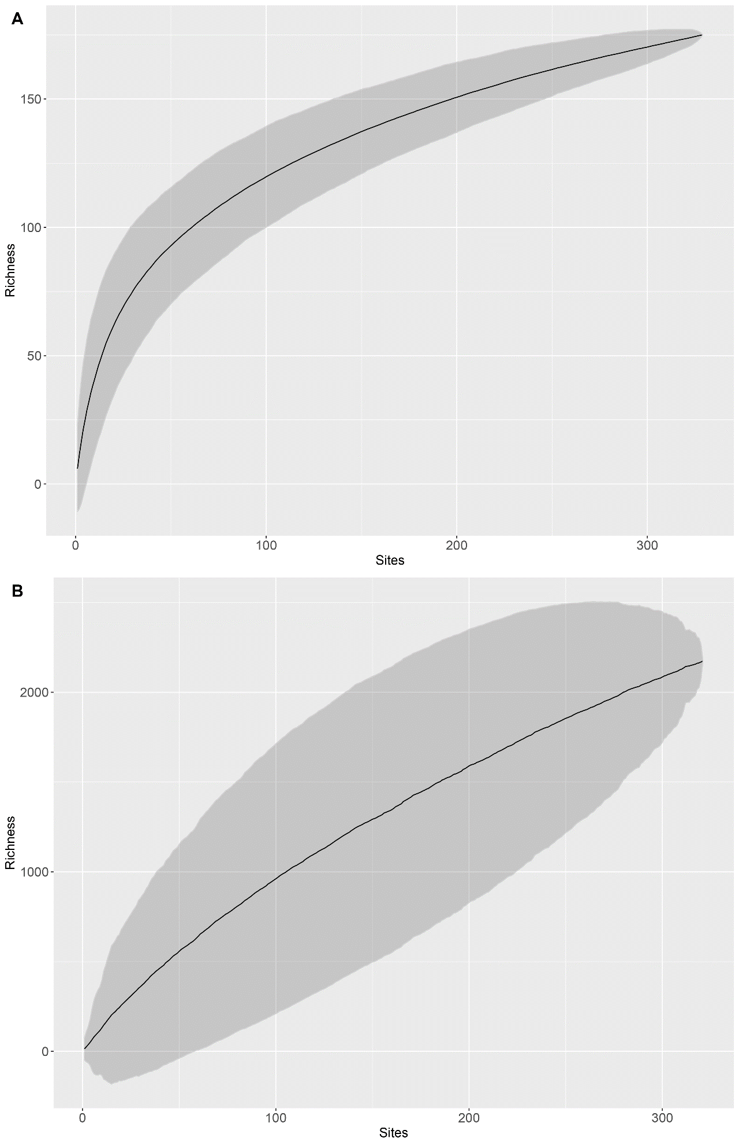

Fig. 20 Family and Species diversity in the Clarion-Clipperton Zone. (A) family accumulation rates with sampling effort, Chao1 estimator 261(+/-27SE); sample size 334; (B) species accumulation rates with sampling effort (both named and morphospecies); Chao1 estimator 5471 (+/-261SE); sample size 321. Based on data from DeepData only. (comparing named and named+ un-named)

*Comparisons of diversity between size classes (named species and morphospecies)*

This comparison was possible for megafauna and macrofauna but the data for meiofauna are too scarce for meaningful comparison (Table 15). The macrofauna are the best sampled and suggest a total species richness of 1653 (Chao1) from 1102 species recorded. The Checklist houses 296 known macrofauna names and the morphospecies list, 2674, a combined total of 2970. Given that as for the family-level diversity, we can compare to existing data (with caveats that morphospecies totals are uncertain and likely to have synonmies), the Chao1 estimate from DeepData, therefore appears low.

For the megafauna, diversity is estimated at 419 from 186 species recorded. This is likely to be a significant underestimate, given the CCZ Checklist houses 241 named megafauna species, and 847 megafauna temporary names/morphotypes have been identified (Table 12; SDF 8), with a combined total of 1089 megafauna names. A catalogue of almost 700 megafauna morphotypes has also been compiled (Simon-Lledo et al., in prep), where each morphotype regarded to represent at least one species, and in some cases more than one, with cryptic species present in many cases (Simon-Lledo, pers. comm.). This apparently low megafauna diversity estimate of 419 is most likely an artefact of several factors, including: the duplication present in some of the megafauna datasets published on DeepData (see section 3.6.3); that megafaunal sampling tends to be biased towards certain groups (Dan Jones, pers. comm.); and a general under-sampling of megafauna given collection challenges, as they are collected either via ROV which are expensive, or trawls which tend to damage specimens (Pawson et al., 1988; Simon-Lledo, pers. comm.). As a result, there is often a dependence on imaging via ROV or similar to survey and ‘remotely sample’ the larger fauna, but this produces an inherently high uncertainty in identifications (Bribiesca-Contreras et al., in press).

For meiofauna, diversity is likely to be very high, but the sample size very small. However, 893 species are recorded from just 38 samples, leading to high Chao1 estimators of 7158 species, which even accounting for the high standard error (976), is over four times that of the macrofauna estimate, suggesting very high levels of unsampled diversity for meiofauna. The Checklist houses 115 known meiofauna names and the morphospecies list, 915, a combined total of 1030. The Chao1 estimate from DeepData therefore appears very high compared to collated data. There is however a great deal of uncertainty both in the collated names as above and in the estimate given the sample size.

Table 20. Species diversity across different size classes in the Clarion-Clipperton Zone.

|  |  |  |  |  |
| --- | --- | --- | --- | --- |
| Size class | N | Species total | Chao total richness | Std error |
| Macrofauna | 274 | 1102 | 1653 | 64.9 |
| Megafauna | 149 | 186 | 419 | 67.3 |
| Meiofauna | 38 | 893 | 7158 | 976.2 |

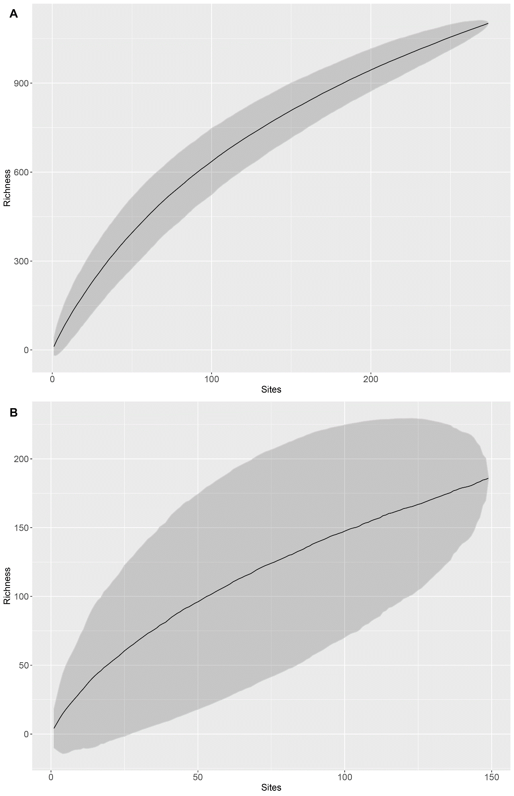

Fig 21. Species diversity (accumulation rates) in the Clarion Clipperton Zone based on DeepData (named species and morphospecies combined). (A) macrofauna, (B) megafauna. Meiofauna not shown given small sample size.

### Overview of community composition between contract areas

It is possible to examine relative abundances of key taxonomic groups across contract areas to explore large-scale regional shifts in community composition. This is subject to the caveat that Contractors use different sampling methods and/or have placed different efforts on different groups. Analysis at a very coarse taxonomic resolution of the DeepData dataset at phyla level by contract area shows high heterogeneity in composition (Fig. 22). This could be a result of shifts in habitat or environmental variables across the CCZ (e.g. nodule type, abundance or surface production e.g. McQuaid et al 2021; Vanreusel et al., 2016). Contract areas for example differ greatly by depth (S Fig. 35). Most likely however, this might be explained by different taxonomic approach, and Contractors working on different taxonomic groups, and reflecting that the data published on DeepData to date is a subset of overall collected records. For example, UK-1 and OMS2 show similar trends, and are adjacent contract areas, but they have been sampled on joint cruises.

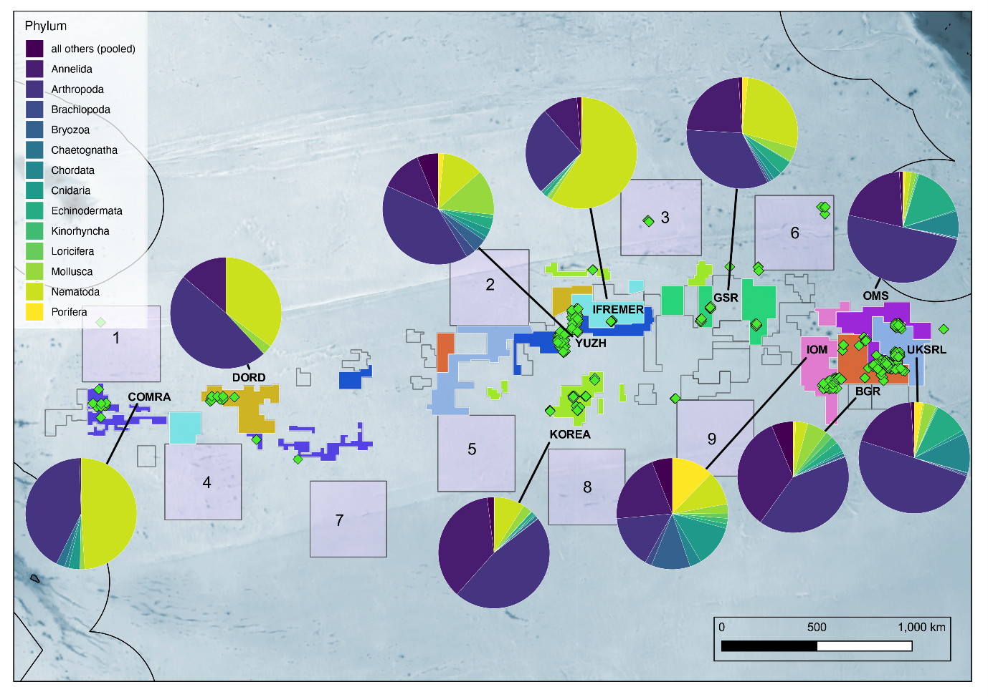 Fig. 22 Variations in community composition at phylum level across the entire Clarion-Clipperton Zone based on Contractor data. Phylum not shown, those recorded in low numbers (‘all others pooled’): Coelenterata; Ctenophora; Entoprocta; Gastrotricha; Gnathostomulida; Nemertea; Platyhelminthes; Priapulida; Rotifera; Tardigrada)

Analysis of distribution of key macrofaunal groups at family level also shows sampling effects. Looking at polychaete families across contract areas shows for example that the eastern CCZ sites of BGR, UKSR, OMS, and GSR look relatively similar in composition (Fig. 23). Also the KOREA1 site is quite similar to the eastern CCZ sites. The YUZH site in contrast is dominated by Serpulidae. This is likely a result of the YUZH surveys focussing on nodule-fauna whilst the other surveys focussed mainly on sediment fauna. The COMRA site where sampling has focussed on benthic trawls is dominated by tomopterid polychaetes which are pelagic.

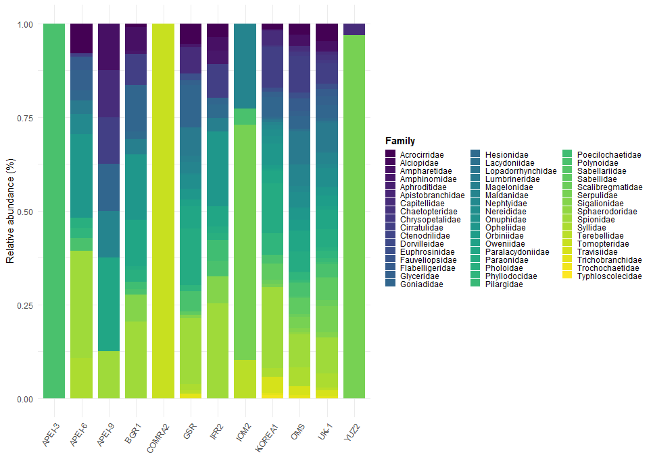

Fig. 23 Variation in community composition between contract areas and APEIs of the CCZ based on relative abundance of polychaete families (data shown where available).

For isopods, the data suggest high heterogeneity across the CCZ in terms of general composition (Fig 24). However, certain families showed high relative abundance over several contract areas, particularly Desmosomatidae, also Macrostylidae, Nannoniscidae, and Haploniscidae. Here data are only available for the eastern CCZ and one contract area in central CCZ.

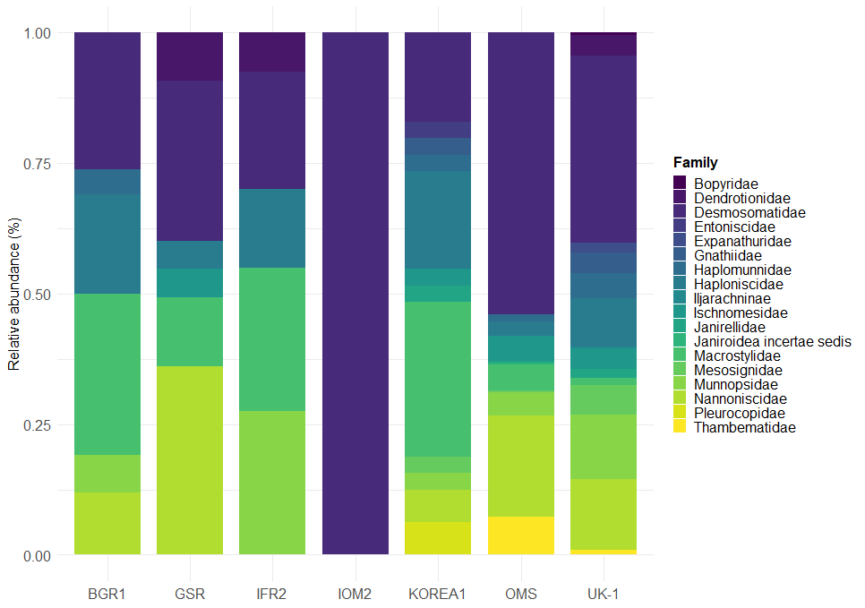

Fig. 24 Variation in community composition between contract areas of the CCZ based on relative abundance of isopod families. Data only available for eastern CCZ and Korea.

### Analysis of species ranges

*UpSet Plots*

The data allow for an analysis of species ranges across the Clarion Clipperton Zone using UpSet plots. These plots allow us to visualize intersections of multiple sets in the same way as a Venn diagram but with more than three sets and are thus ideal for analysing species ranges across a range of sites. Here we look at ranges for named species, and both morphospecies and named species combined over different spatial scales. Key caveats here are that sample sizes are very different when morphospecies are included - West, 9 sites, East 250 sites (including duplication), and Central, 63, and for APEIs, 35 (2 in APEI-9, 19 in APEI-3; 2 in APEI-12, 11 in APEI-6 and 1 in APEI-1). For the West sites, these were only from one contract area, COMRA, where all the species records were named species, i.e. no morphospecies named used.

To provide an overview, we organised the Contractor sites into three categories, East, Central and West (see section 3.3.3 and S Table 3). This shows that for named species, the Central region has marginally more unique named species (although having a much smaller sample size), closely followed by the East region and relatively few in the West (Fig. 25 A). The most shared species are between the Central and East regions. The Central and West sites share few species. East sites have by far the most records but fewer species. It should be noted here though that a large proportion of East region records were duplicates. Including morphospecies, most species are recorded in the East, followed by Central (Fig. 25 B). Here patterns are likely to reflect different taxonomic approaches, e.g. extensive usage of morphospecies names by Contractors IFREMER (Central) and UKSRL (East); with relatively few in usage elsewhere. ADD sample size

At a more detailed level, examination of species ranges across individual contract areas shows a large number of species unique to each contract area (Fig. 26 A). The IFREMER contract area IFR2 shows the largest number of unique species not recorded in other contract areas or any APEIs, followed by UK-1. The largest numbers of shared species are between UKSRL and OMS; followed by GSR and IOM. Including morphospecies, the largest number of shared species are between UKSRL and OMS; followed by GSR and IFREMER (IFR2); and BGR and UKSRL (Fig. 26 B). These contract areas are adjacent in the case of OMS and UKSRL, and in a similar region; Central- to East in the case of GSR and IFREMER. Shared morphospecies names implies some harmonisation in approach or even shared cruises, which is in fact the case for UKSRL and OMS, and also for GSR and IFREMER (see section 3.2.2, Table 5) suggesting patterns again may be influenced by taxonomic approach of Contractor.

When sub-areas within contract areas and APEIs are included, the pattern is similar with the majority of species unique to sites, particularly where morphospecies are included, but also with a few pairs of sub-areas where a number of shared species are evident. A noticeable pattern is that the Central CCZ sites (e.g. IFR2, GSR B6) share a larger number of species than the ones on the periphery (Fig. 27; 28), this requires further analysis but may also simply reflect as above commonality in taxonomic approach. This may be an interaction too with the very high diversity recorded in the IFREMER contract area. Some shared species between contract areas and APEIs are evident but as above sampling within the APEIs is very limited (and data only available for those in the east apart from a few data points from one site in APEI-1).

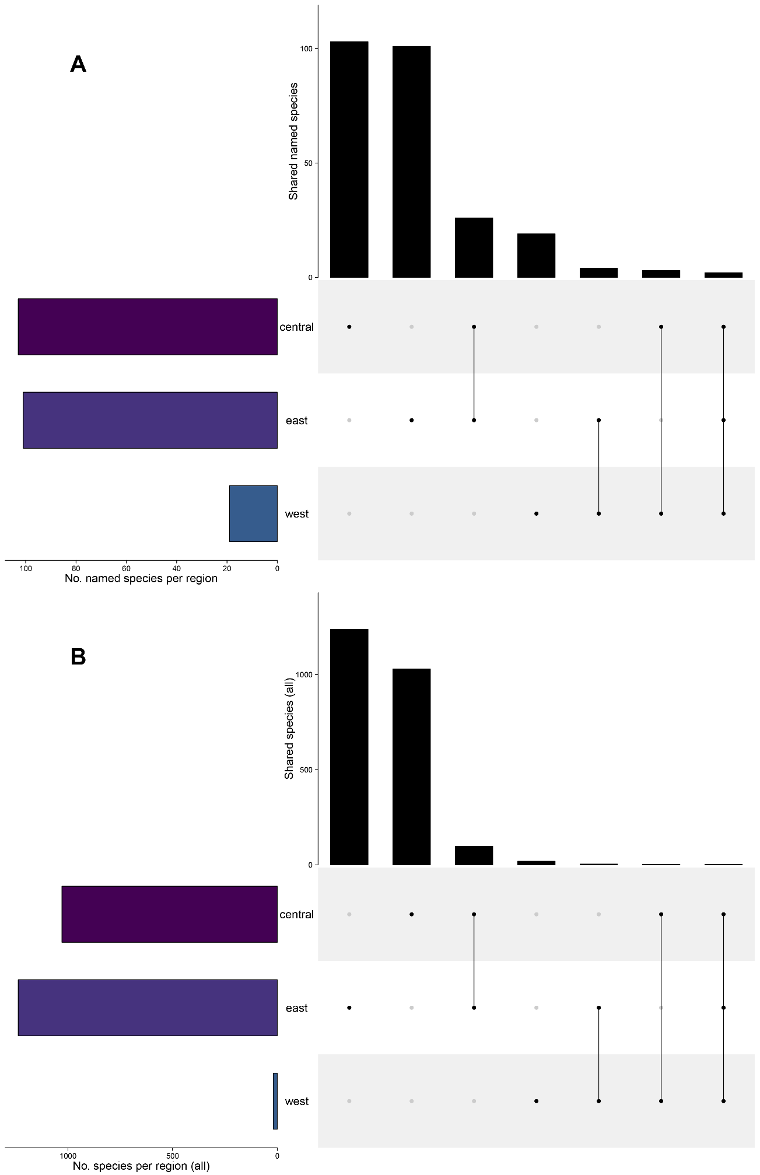

Fig. 25. Assessment of species ranges across the Clarion-Clipperton Zone with Contractor sites grouped into broad categories of East, West, Central (See S Table 2 and S Fig 2). (A) named species only (B) both named and morphospecies.

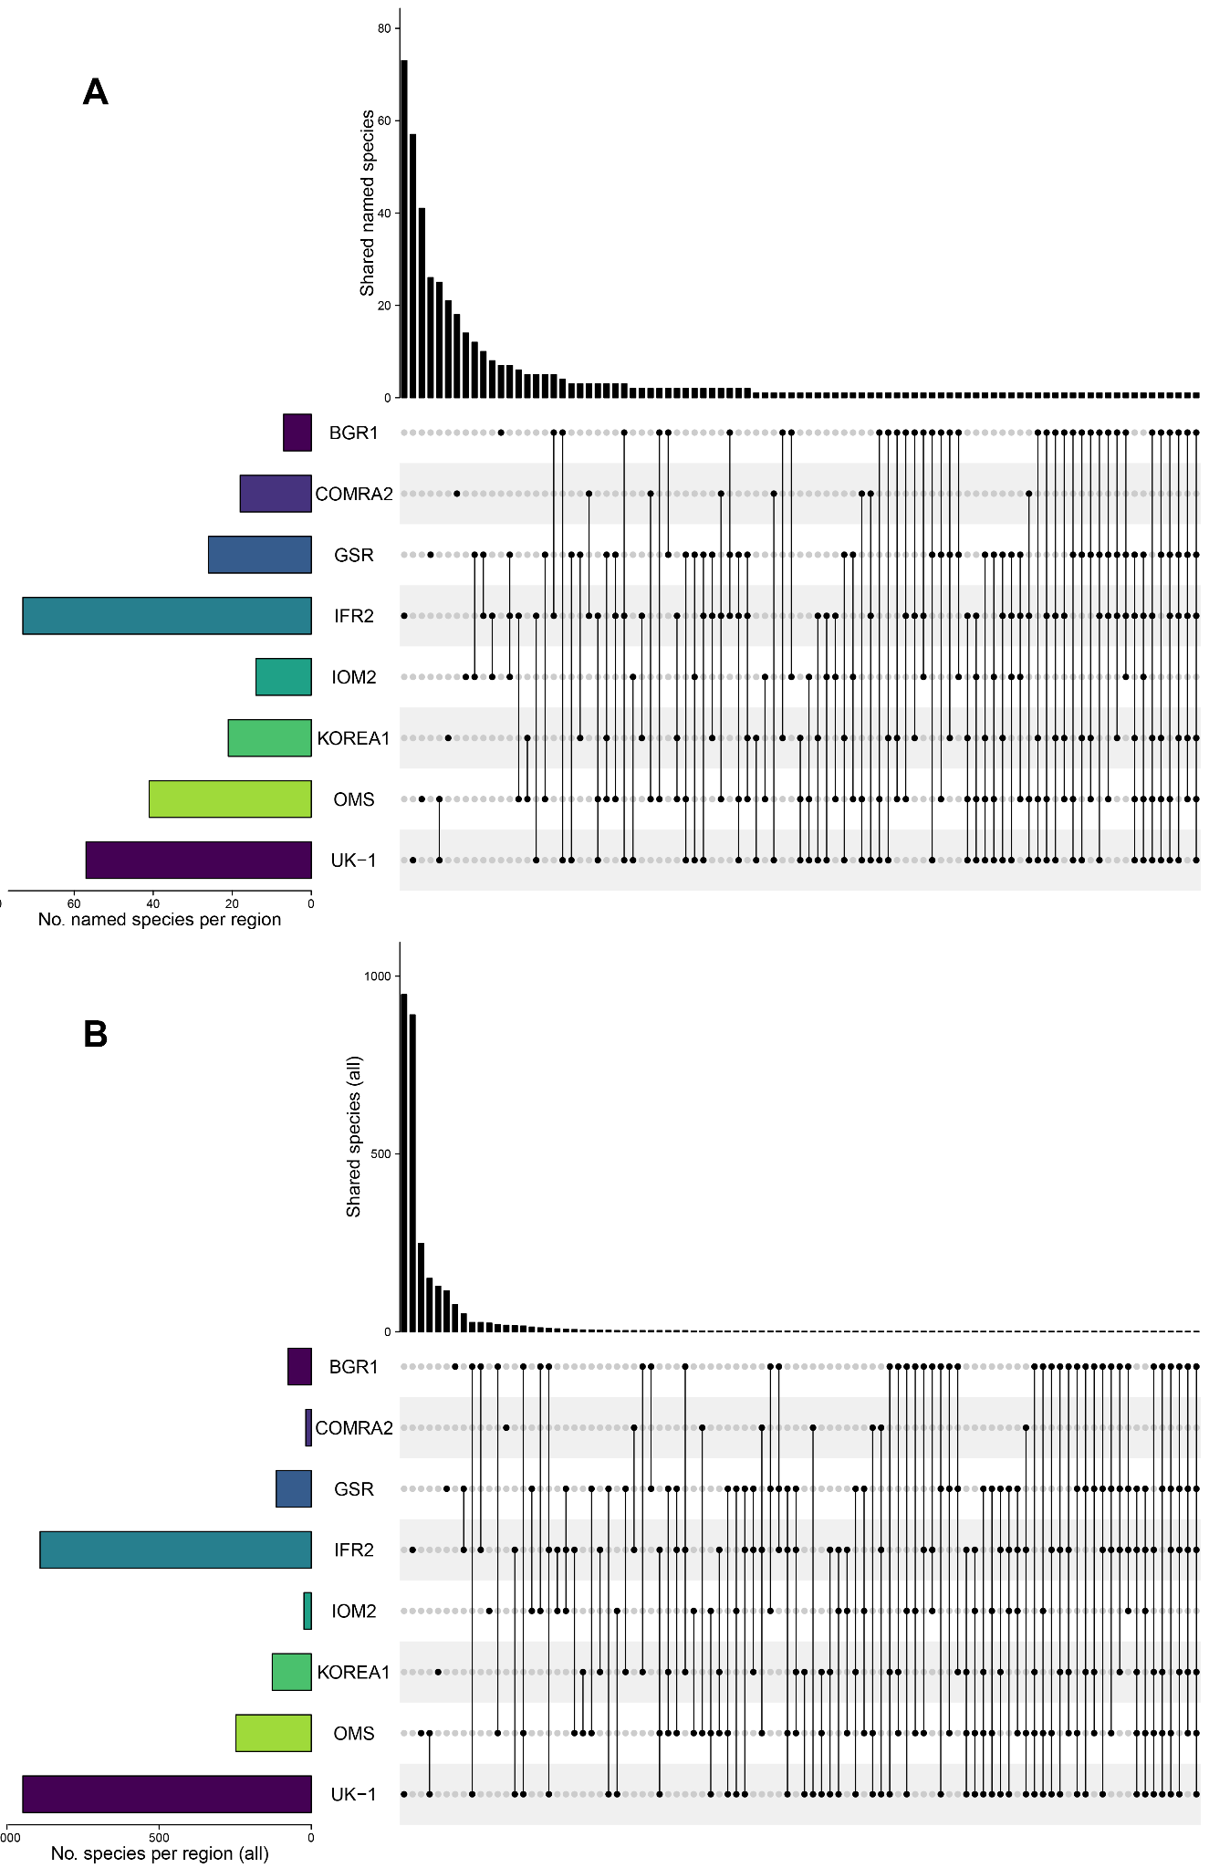

Fig. 26. Assessment of species ranges across the Clarion-Clipperton Zone between contract areas (A) named species only, (B) both named and morphospecies.

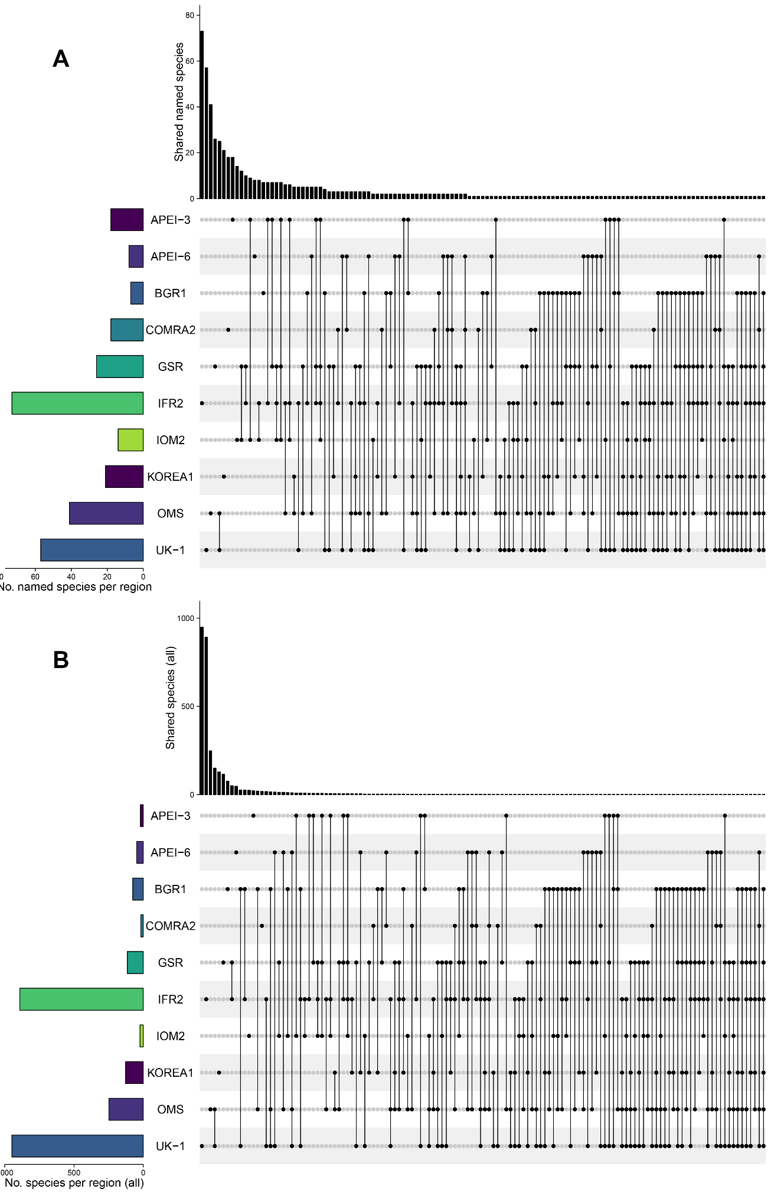

27. Assessment of species ranges across the Clarion-Clipperton Zone between contract areas and APEI 3 and 6 (other APEIs shown in Fig 28). (A) named species only, (B) both named and morphospecies.

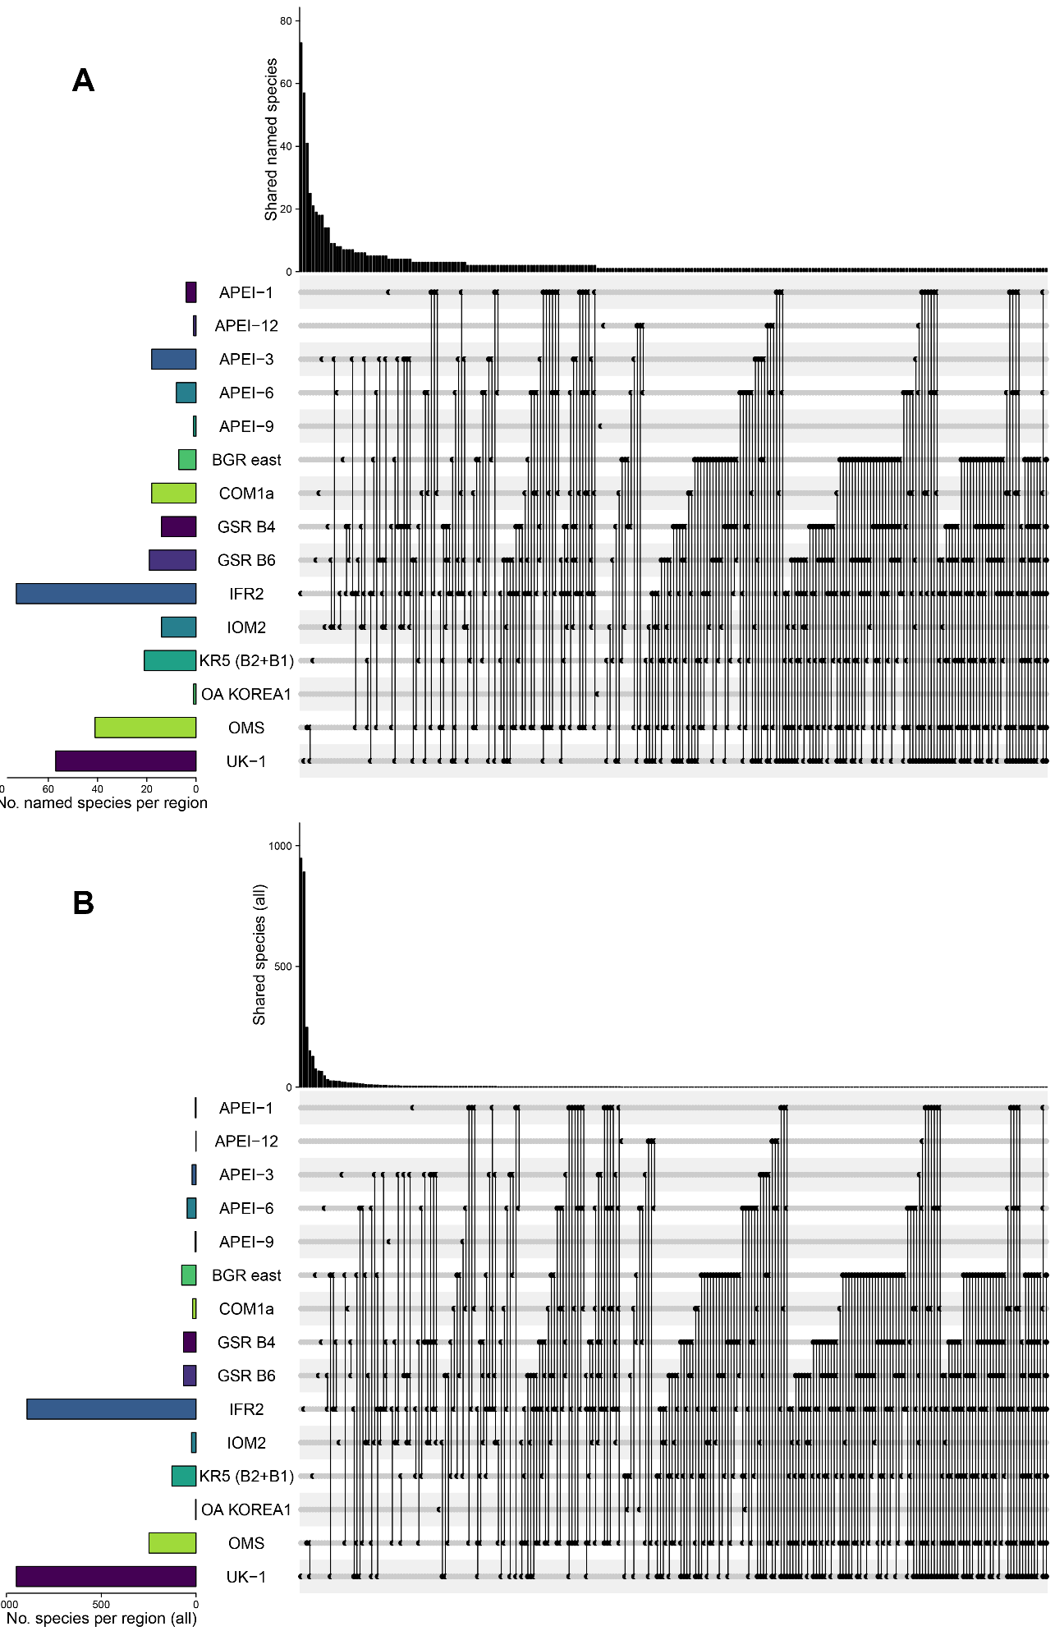

Fig. 28. Assessment of species ranges across the Clarion-Clipperton Zone between contract areas, split into sub-areas where possible (e.g. different parts of a contract area) and all APEIs where data are available, for (A) named species only, (B) both named and morphospecies. For APEIs, data are not available for APEI-2; 4; 5; 7 and 8 (or new APEIs 10; 11 and 13)

### Common and Rare - singletons and candidates for connectivity studies

*Singletons*

Given the large proportion of species unique to sites in the UpSet plots we looked closer at singletons, or species represented by a sole specimen. Species with an abundance of 1 and recorded from only one site across all contract areas were 38% of any named or morphospecies (824/2176); 24% of named species (46/192) and 39% of morphospecies (778/1984).

11 species (5 named, 6 morphospecies) were only found in APEIs. Six were found in APEI-3: the nematodes *Halalaimus aedificandistudiosus*; *Halalaimus longicollis*; *Halalaimus tenuicapitatus*; the polychaetes *Hodor hodor* and morphospecies (*Yodanoe*)[48] sp. 659-3 and sp. 692. Two were found in APEI-6: the polychaete morphospecies *Acrocirridae* sp. (NHM_2090) and *Augeneria* sp. B PIP_8; and 3 in APEI-9: the polychaete morphospecies *Caulleriella* sp. A PIP_96; and (*Spiophanes*) *longisetus* PIP_4; also the mollusc *Chaetoderma japonicum*. In contrast, APEI-12 (far east APEI) had only a handful of records, of the common ophiuroid species *Ophiosphalma glabrum*; and APEI 1 (far west) again only common species (see following section), the widely distributed amphipods *Abyssorchomene gerulicorbis*; *Paralicella caperesca*; *Paralicella tenuipes* and *Eurythenes gryllus* (the latter is a polar species so is likely to be a misidentification[49] (Tammy Horton, pers. comm.).

For presence/absence data (i.e. not accounting for abundance), 66% of species (named or morphospecies) were recorded from a sole location (1434/2183) and for named species only, 51% (98/192); by contract area (excluding APEIs), 86% of all species (1886/2183) and 69% of named species (132/192); by sub-area, 87% of all species (1903/2183) and 70% of named species (135/192), were found in one sub-area only; and by region, 95% of all species (2082/2183) and and 85% of named species (164/192) were found only in one region- east/central or west.

These proportions of singletons are lower but within a similar range to the literature- where estimates are based on both morphospecies and named species, e.g. 40.5% for isopods (Brix et al., 2020), and >50% for nematodes (Pape et al., 2021), tanaids (Błażewicz et al., 2019a), and polychaetes (Bonifacio et al., 2020, 2021; Janssen et al., 2019). It should be noted here that estimates of the singletons in DeepData are likely reduced by duplication in the data.All species matrix tables- with both abundance data (underpinning species accumulation curves) and presence/absence data (underpinning UpSet plots) are included in SDF 8.

Widespread species and population connectivity studies

Several polychaetes, were found over multiple contract areas, including those noted in the literature to be common, widespread species e.g. *Bathyglycinde profunda* (Hartman & Fauchald, 1971), and *Aurospio dibranchiata* Maciolek, 1981 (Washburn et al., 2021), also *Aphelochaeta monilaris* (Hartman, 1960) and *Macellicephaloides moustachu* Bonifácio & Menot, 2018. most common by incidence in separate sites (both within and across contract area, S Table 2). Looking at incidence by contract area overall, other common species were *Bathyfauvelia glacigena* Bonifácio & Menot, 2018, found across five contract areas, also *Bathyfauvelia ignigena* Bonifácio & Menot, 2018 and *Prionospio branchilucida* Altamira, Glover & Paterson in Paterson et al., 2016 in four contract areas/APEIs respectively (Table 21). Four species were also present across three contract areas, *Bathyeliasona mariaae* Bonifácio & Menot, 2018, *Chaetozone corona* Berkeley & Berkeley, 1941, *Paralacydonia weberi* Horst, 1923 and *Polaruschakov lamellae* Bonifácio & Menot, 2018. Several of these species have been recently described (Bonifacio & Menot, 2019) and are in fact subject of a recent diversity and distribution study (Bonifacio et al., 2021).

For nematodes, several species were found in several contract areas, *Halalaimus abyssus* Bussau, 1993 and *Halalaimus egregius* Bussau, 1993, both in five, and *Halalaimus absconditus* Bussau, 1993, *Halalaimus oblongus* Bussau, 1993 and *Halalaimus praestans* Bussau, 1993, in four. One phylogenetics study been done so far on CCZ nematodes (Macheriotou et al., 2020) but at genus level. Abundances were low- 1-3 individuals per site, making connectivitiy studies challenging, but some species were locally abundant, e.g. 15 specimens of *Halalaimus egregius* Bussau, 1993 present in one of the IFREMER sites, therefore this species may be a suitable one for population connectivity studies. One sponge has also been recorded from 2 contract areas and APEI-6, *Plenaster craigi* Lim & Wiklund, 2017, where connectivity studies have already been done (Taboada et al., 2018a, b). Also the echinoderm *Ophiosphalma glabrum* (Lütken & Mortensen, 1899) has been recorded from different regions, this species, or species complex (Christiodolou et al., 2020, 2019, Laming et al., 2021) may therefore may be a candidate for connectivity studies. For arthropods, several amphipod species were widely distributed *Abyssorchomene gerulicorbis*; *Paralicella caperesca*; *Paralicella tenuipes* (the amphipod *Erythenes gryllus* is present in several Contractor datasets, but as above is a polar species, so appears as a common misidentification.

Table 21. Most frequently recurring species across contract area/APEI. NB APEI column – number of APEI shown, e.g. *Paralicella tenuipes* found in APEI-1 and 6. Phy- code for Phylum- Ann= Annelida, Art = Arthropoda, Nem = Nematoda, Ech = Echinodermata, Por = Porifera.

|  |  |  |  |  |  |  |  |  |  |  |  |  |
| --- | --- | --- | --- | --- | --- | --- | --- | --- | --- | --- | --- | --- |
| Phy | Species | APEI* | BGR | COM1a | GSR B4 | GSR B6 | IFR2 | IOM2 | KR5 | OMS | UK-1 | TOT |
| Ann | *Bathyglycinde profunda* |  | 1 | 0 | 1 | 1 | 1 | 0 | 1 | 1 | 1 | 7 |
| Ann | *Bathyfauvelia glacigena* |  | 0 | 0 | 0 | 1 | 1 | 1 | 0 | 1 | 1 | 5 |
| Ann | *Aurospio dibranchiata* | ***6*** | 0 | 0 | 1 | 0 | 0 | 0 | 1 | 1 | 0 | 4 |
| Ann | *Bathyfauvelia ignigena* | ***3*** | 0 | 0 | 0 | 1 | 0 | 1 | 0 | 0 | 1 | 4 |
| Ann | *Macellicephaloides moustachu* |  | 1 | 0 | 0 | 1 | 1 | 1 | 0 | 0 | 0 | 4 |
| Ann | *Prionospio branchilucida* |  | 0 | 0 | 1 | 0 | 1 | 0 | 1 | 1 | 0 | 4 |
| Ann | *Bathyeliasona mariaae* | ***3*** | 1 | 0 | 0 | 0 | 0 | 0 | 0 | 0 | 1 | 3 |
| Ann | *Ceratocephale abyssorum* |  | 0 | 0 | 1 | 1 | 0 | 0 | 0 | 1 | 0 | 3 |
| Ann | *Chaetozone corona* |  | 1 | 0 | 0 | 0 | 1 | 0 | 0 | 0 | 1 | 3 |
| Ann | *Paralacydonia weberi* |  | 1 | 0 | 0 | 0 | 1 | 0 | 0 | 0 | 1 | 3 |
| Ann | *Polaruschakov lamellae* | ***3*** | 1 | 0 | 0 | 0 | 0 | 0 | 0 | 1 | 0 | 3 |
| Art | *Paralicella tenuipes* | ***1,6*** | 0 | 1 | 0 | 0 | 1 | 0 | 0 | 1 | 1 | 6 |
| Art | *Paralicella caperesca* | ***1,6*** | 0 | 1 | 0 | 0 | 1 | 0 | 0 | 1 | 0 | 5 |
| Art | *Abyssorchomene gerulicorbis* | ***1*** | 0 | 1 | 0 | 0 | 1 | 0 | 0 | 0 | 0 | 3 |
| Art | *Eurythenes gryllus* | ***1*** | 0 | 0 | 0 | 0 | 0 | 0 | 0 | 1 | 1 | 3 |
| Nem | *Halalaimus abyssus* | ***3*** | 0 | 0 | 1 | 1 | 1 | 1 | 0 | 0 | 0 | 5 |
| Nem | *Halalaimus egregius* | ***3*** | 0 | 0 | 1 | 1 | 1 | 1 | 0 | 0 | 0 | 5 |
| Nem | *Halalaimus absconditus* | ***3*** | 0 | 0 | 0 | 1 | 1 | 1 | 0 | 0 | 0 | 4 |
| Nem | *Halalaimus oblongus* | ***3*** | 0 | 0 | 1 | 0 | 1 | 1 | 0 | 0 | 0 | 4 |
| Nem | *Halalaimus praestans* | ***3*** | 0 | 0 | 1 | 0 | 1 | 1 | 0 | 0 | 0 | 4 |
| Nem | *Halalaimus amphidellus* | ***3*** | 0 | 0 | 0 | 1 | 0 | 1 | 0 | 0 | 0 | 3 |
| Nem | *Halalaimus delamarei* |  | 0 | 0 | 1 | 1 | 0 | 1 | 0 | 0 | 0 | 3 |
| Nem | *Halalaimus longinquus* | ***3*** | 0 | 0 | 0 | 0 | 1 | 1 | 0 | 0 | 0 | 3 |
| Ech | *Ophiosphalma glabrum* | ***6*** | 0 | 0 | 0 | 0 | 0 | 0 | 0 | 1 | 1 | 3 |
| Por | *Plenaster craigi* | ***6*** | 0 | 0 | 0 | 0 | 0 | 0 | 0 | 1 | 1 | 3 |
|  | **TOTAL** |  | **6** | **3** | **9** | **10** | **15** | **11** | **3** | **11** | **10** | **97** |

## General Assessment of the DeepData Database

DD section

Taxonomic versioning- include verbatim scientific name and accepted scientific name in DWC

Issues with taxonomy in DD data on OBIS

Is data FAIR- analysis shows shortfalls- duplication- taxonomic issues- significant processing needed before usable in analysis (i.e. reusable)

[data structure] Option- export query, versus export pivot query- need for description on what these options represent.

### Summary

As part of our study we assessed the usability of DeepData for research purposes. In our assessment of the database holdings we found non-trivial levels of duplication in the records. We estimate 7500-10,000 records of the >40,000 are duplicates. This will require further investigation by the ISA.

Considering the data structure of the database output file, observations are distributed both across rows and columns, rather than for example solely by row i.e. a distinct observation or data point per row in the file. Substantial further processing is needed before datasets can be used for analysis, including addition of a valid identifier, and extensive data cleaning and editing, particularly for taxonomy records. We completed this processing for the analyses in this report, but it would be easier for the user if it was already done at the DeepData side.

DeepData holdings are now published on OBIS on the new ISA node, these records in contrast are effectively ‘analysis ready’ and all fields are mapped to Darwin Core, as a result, the data meet the criteria of being Findable, Accessible, Interoperable and Reusable, or FAIR (Wilkinson et al., 2016). This is a significant advancement for DeepData. However because of underlying issues in the DeepData holdings with identifiers, there is no common identifier and the datasets via OBIS and DeepData cannot be matched, and there are now two versions of the data. Once the issues with duplication and identifiers are addressed by the ISA, the data can be republished on DeepData, and the OBIS ISA node.

Analysis of Contractor data templates shows variable usage and data quality, partly stemming from inherent problems with the template itself. The new template is a significant improvement with incorporation of previously missing fields, ‘scientific name’ for example, and much easier to use. However there are potential pitfalls to address to ensure some of the existing issues with duplication and data quality are not perpetuated, particularly regarding identifiers (see section 3.6.9).

### General analysis of data structure in published records

The download of DeepData from the 12th of July (biological ‘Point’ data as designated in the database) was a large dataset, dimensions- 981483 rows, 48 columns. The data were restructured to one observation per row (see section 2.2.1), resulting in a much-reduced file, of 52177 rows and 56 columns. The database download output of ‘Trawl Line’ data was a dataset of 941 rows and 49 columns, restructured to 45 rows and 48 columns; and the two files were combined to produce a dataset of 52222 rows, 56 columns, with a final dataset for analysis, 40518 rows (see section 2.2.1 & SDF 1).

These restructuring requirements highlight several considerations. Firstly, prior to restructuring of the data, the records are distributed both across columns and rows, or where the data are a combination of both ‘wide’ and ‘long’ format (Wickham & Grolemund, 2016). Wide format is one record or observation per row; and ‘long’ format’ is where one record or observation is split across multiple rows. All data are wide format, until the columns/data fields ‘Analysis’ and ‘Result’, where the data is then structured in long format. Both ‘Analysis’ and ‘Result’ pertain to the adjacent ‘Category’ column (‘Category’ data fields: ‘Taxonomy ID’, ‘Taxonomy info’, ‘Ecology’, and ‘Organism details’). From the column ‘Analysis’, the data is therefore then ‘stacked’, with new data directly underneath on the next row, and new data in the column to the right (‘Result’), but the data directly to the left is a repeat of the data on the row directly above (‘TaxaID’, ‘Category’, and all columns to the left-hand side). This is best described visually, and as an illustration, a subset of data is shown in Table 22, with valid data (i.e. one given record/observation) in green, e.g. the ‘Analysis’ and ‘Result’ information, and the redundant, or repeated, data in blue.

Table 22. A subset of the DeepData database output, showing how observations are distributed both across rows and columns, or a combination of both wide and long format in the data. Text in bold italic represent distinct observations, in blue, repeated, redundant data. This text was restructured- ‘spread’ over separate columns in restructuring, e.g. for ‘Ecology’ data in the ‘Category’ column, ‘Nominal size Category’ became a separate column (e.g. adjacent to the ‘Result’ column), with the entries as recorded in ‘Result’, i.e. ‘macro’.

|  |  |  |  |  |
| --- | --- | --- | --- | --- |
| **ContractorID** | **Category** | **TaxaID** | **Analysis** | **Result** |
| BGR1 | Ecology | 612 | Nominal size Category | macro |
| BGR1 | Ecology | 612 | *Number of individuals* | *1* |
| BGR1 | Organism Details | 612 | *Sex* | ***Unidentified*** |
| BGR1 | Taxonomist information | 612 | *Taxonomist* | ***Not Reported*** |
| BGR1 | Taxonomist information | 612 | *Taxonomist E-mail* | ***Not Reported*** |
| BGR1 | Taxonomist information | 612 | *Taxonomist Institution* | ***Not Reported*** |
| BGR1 | Taxonomy ID | 612 | *Class* | ***Polychaeta*** |
| BGR1 | Taxonomy ID | 612 | *Identification Method* | ***Not Reported*** |
| BGR1 | Taxonomy ID | 612 | *Kingdom* | ***Not Reported*** |
| BGR1 | Taxonomy ID | 612 | *Morphotype* | ***Not Reported*** |
| BGR1 | Taxonomy ID | 612 | *Order* | ***Not Reported*** |
| BGR1 | Taxonomy ID | 612 | *Phylum* | ***Annelida*** |
| BGR1 | Taxonomy information | 612 | *Database Taxa ID* | ***Not Reported*** |
| BGR1 | Taxonomy information | 612 | *Taxonomic Database* | ***Not Reported*** |
| BGR1 | Taxonomy information | 612 | *Taxonomic Status* | ***Uncertain*** |
| BGR1 | Ecology | 613 | Nominal size Category | macro |
| BGR1 | Ecology | 613 | *Number of individuals* | *1* |
| BGR1 | Organism Details | 613 | *Sex* | ***Unidentified*** |
| BGR1 | Taxonomist information | 613 | *Taxonomist* | ***Not Reported*** |
| BGR1 | Taxonomist information | 613 | *Taxonomist E-mail* | ***Not Reported*** |
| BGR1 | Taxonomist information | 613 | *Taxonomist Institution* | ***Not Reported*** |
| BGR1 | Taxonomy ID | 613 | *Class* | ***Polychaeta*** |
| BGR1 | Taxonomy ID | 613 | *Identification Method* | ***Not Reported*** |
| BGR1 | Taxonomy ID | 613 | *Kingdom* | ***Not Reported*** |
| BGR1 | Taxonomy ID | 613 | *Morphotype* | ***Not Reported*** |
| BGR1 | Taxonomy ID | 613 | *Order* | ***Not Reported*** |

This structure- with observations distributed both across rows and columns has produced significant redundancy in the data, only 5 columns are shown here, but there were 48 columns in total (or 49 for ‘Line’ data), the majority containing this redundant repeated data- 39066594 cells in total. As a result, the file is very large and there is a delay before the file loads in excel or R. As an informal calculation, all rows combined- 982424 (981483 Point + 941 Line), minus rows containing records 52267 (52222 Point + 45 Trawl Line) = 930157 repeated rows, times 42 for repeated columns = 390665954. With more records added to DeepData therefore, the redundancy will multiply.

The separation of the two datasets into ‘Trawl Line’ and ‘Point’ data also results in an extra data processing step. With harmonisation of data fields and column headings the datasets can be combined however, which in most cases would be necessary before further analysis. For example, with trawls there is a start and an end coordinate, here we mapped ‘endLongitude’ to ‘actualLongitude’ for example, given that the end point of a trawl is where the samples are actually recovered (see methods section 2.2.1).

The separation of point and trawl line data is not advisable in the first instance given there is no reason to distinguish them into separate datasets based simply on sampling method. By that criteria, records of box core collections would necessitate a third separate table, ROV a forth and so on, and it is not necessary for analysis as the sampling method information is recorded in a specific field. Further, the distinction between ‘Points’ and ‘Trawl Line’ in datasets in DeepData appears to be incomplete, with numerous trawl-collected records e.g. benthic plankton trawls and epibenthic sledge-collected samples (which would both be categorised as ‘Trawl Line’ and therefore in the line dataset) are in fact present in the point dataset (see SDF 1). The ‘Trawl Line’ data in the database output actually only contained one dataset, of epibenthic sledge-collected specimens.

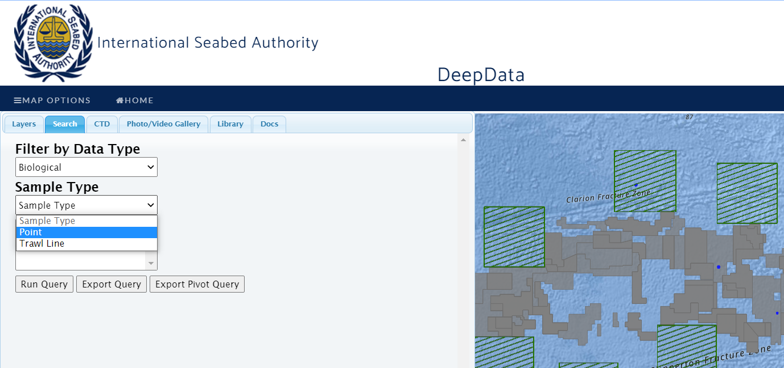

Fig. 29 DeepData interface showing data selection menu for ‘Point’ and ‘Trawl Line’ data.

Another key consideration was that the database output lacked a ‘primary key’, or a unique identifier- a number or code unique for every row in the dataset. Such a key is critical for tracing any given record and in fact any usage of the data is highly problematic without one. Identifier columns were present, such as sampleID which is the sample identifier (analogous to ‘catalogNumber’ in Darwin Core terms), but duplication in ‘SampleID’ was identified both across datasets and Contractors (see SDF 1A). A unique identifier or key was therefore created by concatenating the fields of SampleID, ‘ContractorID’, and ‘StationID’. This produced an identifier that was unique within the dataset (see SDF 1B). As an aside, even if ‘SampleID’ had been unique, best practice would require a unique identifier for the row of data itself, (analogous to ‘occurrenceID’ in DarwinCore terms), as well as for the sample.

### Data quality assessment: published records

*Taxonomy*

Taxonomic information for all columns was published close-to verbatim from Contractors (see section 3.6.6). This was suspected from initial observations of the files, and ascertained from cross-referencing data published in the database with a subset of the Contractor data templates (‘raw’ files). Some data processing of taxonomy was evident, but this appears to have caused additional complexities. During data mapping, taxonomy records appear to have been re-allocated to other designations in a few cases. For example, *Monticellina* records from GSR datasets were present in DeepData (incorrectly) as *Monticellina* Westblad, 1953 (Platyhelminthes) rather than *Monticellina* Laubier, 1961 accepted as *Kirkegaardia* Blake, 2016 (Annelida). A taxon match for the genus *Monticellina* in WoRMS returns an ‘ambiguous match’ (a standard result for homonyms, pre-occupied names and similar) with the two options (*Monticellina* Westblad, 1953; *Kirkegaardia* Blake, 2016). In the data template, it is evident the relevant record was *Kirkegaardia* from higher taxonomy columns (see SDF 7), but the genus name was recorded as *Monticellina* and presumably and understandably in the DeepData processing the matching is done on the lowest taxonomic level, perhaps without reference to higher taxonomy, and the record was therefore taxon matched to *Monticellina* Westblad, 1953 i.e. the Platyhelminth genus. This error has been perpetuated in the OBIS DeepData records (see SDF 2A). This potentially could be amended by additional scripting in the case of ambiguous matches e.g. where a name matches more than one in the WoRMS database, the higher taxonomy levels are interrogated and cross-referenced (for additional commentary on issues with data processing by DeepData see section 3.6.7).

The database output also lacks a column for scientific name- i.e. the designation or identification of a given record, which therefore required interpolation of the identification from the other taxonomic columns and mapping the lowest level recorded. The output did not include a separate column for identification qualifier either. This introduced an element of interpretation, even guesswork into the scientific name designation. For example, the scientific term (but not a scientific name) for larval Crustacea ‘Nauplius’, was often recorded in datasets. Other examples include morphospecies records where both family and genus names are recorded but the genus identification is uncertain and the qualifier recorded only in notes. This could easily be reported incorrectly as the genus name, as mining free-text fields like notes for specific data can be very challenging.

*Other data fields*

Several columns where data should match a pre-defined list, or a ‘controlled vocabulary’[50], as opposed to free text fields (e.g. notes) required cleaning and harmonising of data. For example, the field ‘SampleCollectionMethod’ should have a standard list of potential entries, e.g. ‘box corer’, ‘ROV’, but here misspellings and variable entries were evident (e.g. multicore, MUC, Multi Corer, Multi-corer). Other examples include ‘ResearchVessel’, and ‘StorageLocation’, again with variable entries and formatting, misspellings and similar (e.g. R/V Mt Mitchell; RV Mt Mitchell). Contractors are recording these data in variable ways in the data templates, and it appears that like the taxonomic data, the entries have not been harmonised prior to publication (e.g. transforming of all data entries for ‘SampleCollectionMethod’ to a standard set of terms such as MUC for multicore, EBS for Epibenthic Sled and similar).

In some cases, it appears actual data processing by DeepData has resulted in the need for downstream processing steps. For example, in several cases the character Ã is appended onto entries in the data (e.g. 2500 cmÂ² in ‘AreaSampled’ column). Numerical data recording by DeepData also necessitated some data processing, for example ‘Water Depth’ null values were recorded as -9, i.e. a numeric value rather than NA, therefore recognised in R as a valid value rather than a null one. In many cases ‘not reported’ was present as a text entry including in numeric data fields, e.g. in ‘Number.of.individuals’, a numeric value for abundance data. As this has been recorded in a standard way however, this is easy to remove but it would best here if fields were left blank.

For some fields the origin of the information present is not clear as it does not appear in the Contractor templates. For the column ‘HabitatType’ for example, for approximately half the DeepData records habitat was recorded as ‘water column’, but none of the corresponding Contractor files listed water column for the habitat (or in any other field). As this information appears to be rarely recorded in the raw files, presumably this is a DeepData processing step to add this information, but this requires confirmation.

Overall, significant data processing (and in some cases, interpretation) was required for taxonomy and to a lesser extent, sampling information. In contrast, site information, e.g. coordinates were well curated and required minimal processing. Some anomalies were evident here, however, for example, for ‘SubArea’, a column specifying the Contractor sub-area, a number of cases are designated as ‘OA’ (outside area) but are within the claim of that Contractor (see SDF 1B) and it was therefore necessary to map the records and revise accordingly. In our edited dataset, the data processing was generally done by creating a copy of the column with the edited entries, or in straightforward cases, within the R script itself, but is best done entirely within a script if possible to make the entire process reproducible. In some cases it may be challenging to account for all variations within a script, however, particularly for highly variable text entries.

*Duplication*

A key issue identified in data quality is the presence of duplication in the DeepData records. Multiple years of the annual data submissions have been published, but in some cases this appears to have resulted in duplicates. ISA are publishing year by year, from 2015 (the year the previous data template was introduced) and plan to continue until up-to-date (ISA secretariat, pers. comm.). For the yearly data reports, these are either one-off data submissions, e.g. a standalone dataset for a particular cruise which is not then re-submitted the following year, or are incremental submissions, where data are added to the previous year’s dataset, and any edits or updates added to the existing records. For example in the BGR data, >9000 records are published on DeepData, and >3000 records were present in each of the 2015, 2016 and 2017 data submissions that were published[51]. However, these submissions are not separate datasets, but the same records, with updates on existing and addition of a few new records in the 2016 and 2017 submissions. Similarly, the yearly UKSRL submissions (via NHM) are not separate new datasets but are ‘iterative’ where the same data are submitted yearly with updates, and some new records added every year. In the NHM data, a unique NHM number is allocated to every specimen- equating to one row of data, but there were 1457 duplicate NHM numbers (in SampleID) in DeepData. It appears that the yearly data submissions are handled as separate datasets in these cases at least.

In most cases, unique specimen identifiers are not present in the Contractor data submissions, with no SampleID or one that is not unique, e.g. it is used across several rows (this applies to all the records at least for the 2015/2016/2017 data submissions, apart from two Contractors). In some cases, duplicates of SampleID were present in Contractor templates, i.e. SampleID used over several rows, but these were not present in the published records. (In others, as above, duplicates in SampleID were present where not originally evident in the templates). Presumably, records missing a sample ID are allocated one (and duplicates in SampleID are removed). This appears to be the case for the BGR data, and may have contributed to duplication of records, e.g. one record from 2015 is allocated a SampleID when that dataset is uploaded, then the same record (not recognised as a duplicate) is allocated a different SampleID when the 2016 data is uploaded, and on the DeepData output therefore appears as two seemingly separate records. The database uses the SampleID as the records identifier to reconcile records, therefore records submitted year on year with the same ID would in theory be recognised as the same records and associated data updated if it has changed (Sheldon Carter, pers. comm.). However, in cases such as UKSRL above, this does not appear to have worked, with duplication of records- as evidenced in duplication of the SampleID in the database output. Sometimes Contractors are submitting data collected in other contract areas- e.g. joint cruises which potentially could also result in duplication if say a record of a given sample is included in both Contractor data submissions.

A compounding issue is that the SampleID field may be used or interpreted in a variety of ways by Contractors. For example, some cruises may be using SampleID for a batch of samples, equivalent to a sampling event ID or batch ID for a given sampling event, e.g. a box core number, not for an individual specimen record, which is what the field is intended for. Some Contractors do not use the identifier at all, but rather other ones, such as voucher codes. Usage of identifiers is highly variable in biological sampling and data handling which results in problems in downstream data handling (Jaspars et al., 2021; Rabone et al., 2019; Guralnick et al., 2014).

Because of the nature of these data, without a sample ID or a record identifier it can be challenging to identify duplicates within a given sampling event, where much of the data may be identical row by row, e.g. as a multicore drop, with the same multicore collection code, station ID, date, time, depth, latitude, and even taxa collected. Looking for mismatches across multiple columns to identify duplicates may not be feasible therefore. In the BGR data above, there was a distinctive taxonomic coding in Contractor data, (‘Desmo’ short for Desmosomatidae) evident in one record only in each of the submissions, but three in the published data, in ‘SubFamily’ column) (see SDF 1; 7). The record included a unique voucher code, and a GenBank accession number in the template, allowing definitive identification, neither of these identifiers were present in the DeepData output however, it appears they haven’t been harvested for the BGR records (and for other datasets).

This demonstrates that while duplicates can be difficult to identify in DeepData, it is possible to reconcile records through cross-referencing with original data files using other identifiers such as sample voucher code, or GenBank accessions. These identifiers in any case should be included in the database output when they are present in the Contractor data, for example mapped to the Darwin Core term ‘recordNumber’ or otherCatalogNumber for a sample voucher code. Here we had access to the relevant Contractor data submissions (raw files) to cross reference. Duplicate records were suspected in IFREMER for example where 6 phyla all had 11 records each, but duplicates could not be identified as sampleID was the only identifier available and we did not have access to raw files to cross-reference other identifiers or contextual notes.

In summary, we estimate >6000 records are duplicated for BGR, and between 1457 and 3901 for UKSRL in the current dataset. We have known duplication in these cases, and duplicates may be present elsewhere, for example there are indications in the records from OMS, KOREA and IOM. Examining the list of Contractor datasets published on the 12th of July[52] suggest this is may be current extent of the duplication. This would however need to be confirmed with cross-referencing between all Contractor data templates and data published on the database.

### General analysis of fields included in published records

Several fields are included in the database output that are potentially not necessary to include, for example, the fields ‘AreaKey’; ‘ClusterID’; and ‘BlockID’ appear to be database specific codes (e.g. backend column names) and for the latter two, the columns are unpopulated with no data entries recorded. The output is also displaying columns for vents/sulphide deposits: HydrothermalActivity; HydrothermalVentAge; ExtensionPMSSite; VPFileNam- these columns are not relevant for polymetallic nodule regions and ideally would not be included if possible if searching for CCZ data. This may not be a straightforward fix however, and even require some database development so it may not be worthwhile trying to exclude these columns from output at this stage.

For a few fields, it is not clear why they have been included, for example ‘Subfamily’, while a useful column, is the only sub- or super- taxonomic classification. Not only is the reason for its inclusion unclear but also the rules around its usage, as it appears to have been used not for subfamily names but as a column to capture morphospecies names, even though there are actually two separate columns for recording this in the output: ‘Putative.species.name.or.number’, and ‘Morphotype’, the latter unpopulated. Further, ‘Putative.species.name.or.number’ appears to have been deprecated for ‘Morphotype’ in the new template, presumably why both columns are included in the database output but only the former populated. Although it appears in the database output, there is no subfamily column in the existing data template, but it is included in the proposed new template. It therefore appears to be the result of data processing. Incidentally, recording of morphospecies/morphotype is highly variable in Contractor data (see section 3.6.6) which is not surprising given there are no existing conventions for temporary names, however this needs to be addressed (Horton et al., 2021). Given the centrality of morphospecies names in the CCZ as illustrated in the results above, it is important that they are mapped to one specific field in DeepData, ideally using the Darwin Core field ‘taxonConceptID’.

Additional fields may not be necessary to include in database output, such as ‘Cruise_Leg’; ‘StationDesc’; and ‘GPSPosition’, however there may be good reasons to include them. At this stage it is more important to remedy missing fields than to remove any fields that may not be needed in the output. For example, there is no field for scientific name (‘scientificName’ in Darwin Core), which necessitates creation of this field by mapping the lowest taxonomic level recorded. This is now included in the data template (see section 3.6.5) so it could easily be harvested and published as part of the data pipeline. Darwin Core includes the terms ‘verbatimScientificName’ and acceptedScientificName’, therefore the verbatim name as recorded by Contractor and the accepted name as according to WoRMS could be captured in DeepData, helpful for taxonomic versioning. **‘**IdentificationQualifier’ similarly should be included in the database output and again has now been added to the template therefore it would be straightforward to include it in the database output.

Another issue is missing or incomplete information within fields. Multiple columns have over 90% missing information (see S File 2). In the initial February database download, some key fields were missing, for example ‘SampleCollectionMethod’, but had been added in the interim and was present in the July download. This illustrates iterative improvements in the published data. However, the data entries here are incomplete or variable (see section 3.6) or missing in many cases. Sampling method is generally fully described in publications and is critical information for analysis. Also size class (‘nominalSizeCategory’) is key information and often submitted by the Contractor but generally in an informal way, in the title of the dataset name[53]. It was not present for ~10,000 records, necessitating cross-referencing with the literature and other sources to add size class where absent. This in itself is problematic, as these size classes are fluid, some fauna will be some size classes in juvenile development, many taxa cross size classes, therefore ideally the verbatim size class from the Contractor data is recorded. This is a required field in the data template, therefore potentially the template could be adapted so this field must be added.

As missing information in the database is likely often due to incomplete and/or variable information in the Contractor data submissions, this issue could also be addressed by establishing a line of communication with the Contractors. For example, relative density and relative abundance data, key for ecological analyses, are only present for a handful of records, and are often missing in the Contractor data submissions. These data should be available, and accurate information on abundance and area sampled should be provided in the template so estimates can be calculated and displayed by DeepData.

### Assessment of ISA environmental data template

*Structure*

The new environmental data template is now split into separate tables for ‘Point Sample’ (see section 3.6.2), Towed Gear Sample (for ‘Trawl Line’ data), with separate tables by tab including the following: *Chem_Results*, *Biological_Results*, *Qualifiers*, *ValidValues*, *ValidValues_Analysis*, *refQualifiers*, *StudyNotes* and *ErrorChecker* (see S File 1). In the previous template, the template was structured with all these sub-tables as one wide table. This new structure of sub-tables is much easier to use. However as discussed above, the ‘Point Sample’ and ‘Towed Gear Sample’ tables do not need to be separate, and with some adjustments to column headings as above, these tables could be combined (see section 3.6.2).

*Data fields*

Examining data fields in Biological_Results (taxonomic data), the new template now includes scientific name; and taxonomic identification qualifier. These fields were key gaps that were not previously available so their inclusion is a significant step forward. One key field that is still absent however is the Darwin Core field ‘basisOfRecord’ for designating the type of record- with potential entries- ‘humanObservation’, ‘machineObservation’, ‘preservedSpecimen’, ‘materialSample’ among others. Some Contractors have included a variety of non-specimen records in the data, e.g. environmental samples (eDNA), fossils or even wood samples. This could be specified using the basisOfRecord field.

As for the database output, there are also a couple of fields in the template that are present but may not be necessary. ‘OrgNum’ for example is a field listed as required but is an arbitrary number required by contractors to help generate a key for ISA data processing. Therefore, it is a redundant field that doesn’t capture any existing data in Contractor datasets and is even liable to cause confusion. Subfamily is included but this field potentially as above doesn’t need to be included. LSID is life science identifier- a unique identifiers for names in the Aphia database which underpins WoRMS (Vandepitte et al., 2018). The ID is very useful for resolving taxonomic confusion e.g. where the same name is used for different species, but here it may be useful to have a column to record the equivalent Aphia ID as well, so the either ID could be added.

For the other tabs within the template, most of the data fields included are appropriate, but a few observations on fields are noted as follows: ‘Target latitude’/’Target longitude’ –these are not necessary fields to include; some field naming is ambiguous, e.g. ‘Profile’- the following definition for this column is unclear: “Sampler collects water quality information at different depths throughout the water column (e.g., CTD cast)”; ‘MatrixType’ is material or sample type (i.e. biological sample, sediment or water unfiltered) but could be renamed to ‘sampleType’ so it would be clear what is refers to.

*Testing*

The new template was tested with a dataset from the Contractor UKSRL. Three key issues were noted, 1) a bug in the errorchecker macro was present that resulted in the macros wiping all data records when it was run. Macros in excel can be somewhat prone to bugs but this is a critical issue to fix, otherwise the errorchecker should be deactivated. 2) It was also necessary to subset the trawl collected samples to map to template, as above, the separation of these data tables should ideally be reconsidered. 3) Phylum and SampleCollectionMethod still do not have a controlled vocabulary, e.g. it is still possible to add misspelt names or those of other taxonomic levels, but more critically, required fields such as sampleID Columns can still be left blank. As above, usage of identifiers is critical to avoid potential duplication downstream.

Notable improvements are evident, however. As mentioned, the inclusion of taxonomic columns scientific name into the new template, i.e. a column for the identification for the specimen, and identification qualifier, are significant improvements - these fields that were previously missing (and absent from the database output) (see section 3.6.3). The length of the table in the previously template was unwieldy and the restructuring into several tables has addressed some of the issues with usability. Metadata and Template guidance has also improved considerably. For example, ‘Identification method’- the previous template required that one method only was stated, with guidance that if more than one, that ‘the final, most reliable method’ should be entered. Now different methods can be entered e.g. ‘Genetic ID + Morphological ID’ - this is an improvement as while there should be one designation all the methods should be recorded, e.g. it is important to record if both were utilised. Inclusion in guidance a taxon match with WoRMS is a most helpful step (see section 2.2.2), but this could be clarified.

It is important to recognise that the current situation is in flux, as the new template is not yet in use. To answer how it is likely to be used it was necessary therefore to examine Contractor data submissions in the previous template. These examinations suggest that some of the changes to the template will improve data quality, but some of the data issues may continue with the new template unless rules in usage are implemented. Many of these would be straightforward, for example simply in providing a controlled vocabulary or list of standard terms for sampling method, or names for taxonomy e.g. phylum. For required fields it may be necessary to implement rules within the template so they cannot be left blank e.g. for sampleID, nominalSizeCategory, or depth. This may even help address the duplication issue currently evident within DeepData. Alternatively, if data are received with these key fields blank, they could then be sent back to Contractors to amend, e.g. the process is not a one-off submission but an iterative process until all required QA/QC checks are complete.

### Observations on taxonomic information in Contractor data submissions

Approximately half the records in total had issues with data entries in columns, and many of these had multiple issues across multiple columns. The lower the taxonomic rank, the more data issues were present in the columns. Taxonomic information data quality issues included: miss-recording of rank (e.g. Phylum name in class column), misspellings of scientific names, blank columns where data were needed (e.g. genus name missing). Other issues included formatting: such as extra spaces or commas after names, notes in column including informal ‘taxonomic’ terms (e.g. the term “Nauplius” was extensively used, referring to juvenile Crustacea, or notes referring to non-specimen records, e.g. ‘wood’ or “eDNA". Extensive usage of unaccepted names was present, although in most cases this can be clarified with a taxon match to WoRMS. These issues were present across all Contractor data. As taxonomy was published near-to verbatim in DeepData, these issues were also present, and similar notes were also made on the published data (see SDF 1A; 7). Data quality issues in the raw data are continued therefore in the published data.

Sometimes ambiguous taxonomy was recorded, from straightforward cases of question marks after names, indicating uncertainty in identification, to more complex cases, for example mismatches between taxonomic rank, e.g. records of Tentaculata, but Bryozoa recorded as the phylum. In several cases therefore confirmation from Contractors would be required. The datasets were variable overall, and in many cases the templates themselves had been customised, extra columns added, and/or others removed, with the result that some manual processing was required just to restructure them back into a standard format. It may need to be reiterated in the guidance that no customisations are to be made to the data template, or modifications are made to the template itself to block such editing steps. Overall therefore, substantial data processing was needed to harmonise the contractor data. This factor may have contributed to the delays in publishing of Contractor data submissions to DeepData.

### The OBIS ISA node and data mapping

Given that the data were published on the OBIS DeepData node at a relatively late stage of the project, in-depth analysis of the data mapping between the systems was not made. Observations on the OBIS DeepData records are relevant, however, and outlined here in brief. These are informal observations of a few key issues of the DeepData mapping to Darwin Core, rather than the OBIS data processing pipeline itself which has been very well-implemented. We have only one point of issue with the latter in designation of records as ‘humanObservation’, given most of these records are of specimens (some are observations however, e.g. the imagery records), therefore the category ‘preservedSpecimen’ in some cases may be more accurate. The preliminary mapping of the DeepData datasets to Darwin Core was done by the ISA data team (Pieter Provoost, pers. comm.). What is known of the initial data mapping been interpreted from the OBIS documentation and cross referencing with the records published in DeepData (or contractor data submissions). The remainder of the data processing pipeline is fully documented by the OBIS secretariat and in the public domain, in the OBIS DeepData GitHub notebook (<https://github.com/iobis/notebook-deepdata>). As documented in the notebook, the data processing is done on the datasets mapped to Darwin Core on the ISA server, not the DeepData database output itself.

*DeepData initial Darwin Core processing*

It is evident that data is mapped to some Darwin Core terms, e.g. scientificName and basisOfRecord prior to any data processing by OBIS. As noted above, these two key fields are not included in the current iteration of published records in DeepData. Some mapping has gone awry in scientificName, with duplication of genus name, as a result species names have been obscured and the OBIS estimates of total species on the ISA node are therefore much lower at 75[54] than the 466 from DeepData including pelagic species as ascertained from our analysis of the DeepData holdings.

Another complexity is that the duplication of genus name has resulted in species names being reallocated, even to other phyla. For example, some nematode records of the species *Capsula galeata* Bussau, 1993 have been mistakenly assigned to the diatom phyla Ocrophyta (non-metazoan), presumably because the scientificName is designated in the DeepData as ‘*Capsula*’ from ‘capsula capsula galeata’, causing an error in taxonomic processing by DeepData prior to the OBIS pipeline. It is not clear exactly how this has happened however, as ‘Capsula’ in WoRMS only matched to the nematode genus.

Similarly, issues have arisen in mapping to taxonRank, the Darwin Core term for taxonomic rank, where 18,304 records were listed as species, but many of these are not species level records, rather at higher taxonomic level, such as genus, or family (Fig. 30). Also, taxonConceptID, a Darwin Core field for recording morphospecies name, was mapped to taxonRemarks. This has resulted in very low numbers of morphospecies names (Fig. 30). Mapping of DeepData records to Darwin Core fields also appears to be incomplete- e.g. INSDC accession numbers map to associatedSequences in Darwin Core (as a side note these accession numbers have only been harvested from the template in some cases (see section 3.6.3).

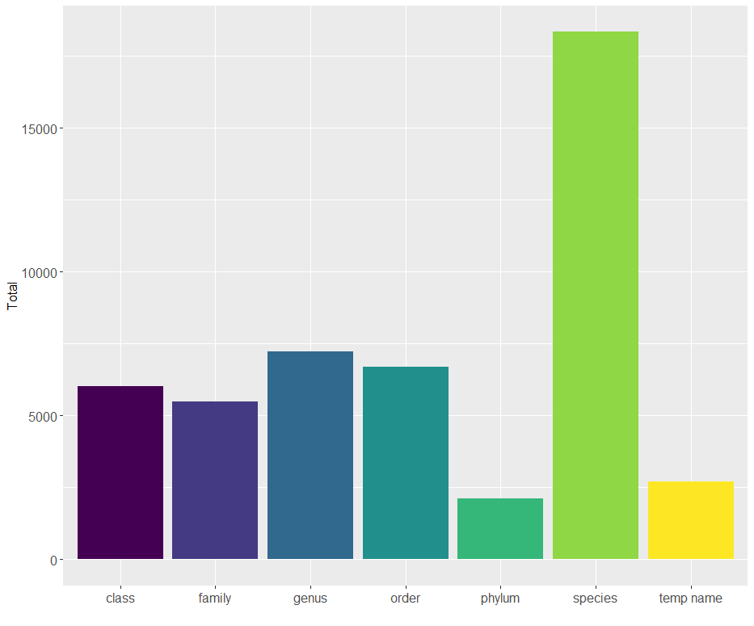Fig. 30 OBIS DeepData records by taxonomic resolution showing large proportions of records at species level and very few temporary names/OTUS. In comparison in Fig. 9, there are >8500 species records and almost 10,000 temporary name records in DeepData. Here initial steps in taxonomic processing of DeepData records by the Secretariat prior to the OBIS data pipeline have led to many higher classification records tagged as species, and mis-mapping of taxonConceptID to taxonRemarks, resulting in low numbers of temporary names/morphospecies

Another field already mapped to Darwin Core prior to OBIS data processing is ‘occurrenceID’ a key field in Darwin Core terminology for record identifier. It appears to have been generated as a composite key, from combining ‘StationID’ and SampleID’. This is also how we created a record identifier, however during creation of our identifier/key we tried different combinations of key fields (including above), testing for duplicates during the process, and including three columns in the final dataset (see section 2.1.1), which did not appear to occur here. The duplicates in occurrenceID in the DeepData Darwin Core records were identified by the OBIS secretariat, as recorded in the OBIS GitHub notebook, and at the start of the OBIS processing pipeline records were all allocated a unique identifier (similar to our process). Because of the duplicates in the ‘occurrenceID’ however, a proportion of records cannot be definitively matched between the two databases, i.e. there is not a common unique identifier. To rectify this, DeepData will need to include this same identifier, or ideally generate a unique identifier for each row of data that OBIS could then harvest, so it is clear which record in DeepData correlates to the same record in OBIS. This should be part of the DeepData pipeline in any case. Once possible to match records definitively between the OBIS ISA node, this would clarify the situation significantly.

While there are a few wrinkles to iron out, publishing of records on OBIS and in the process, mapping the data to the global data standard, Darwin Core has greatly improved discoverability and accessibility of the data, making the data FAIR, or Findable, Accessible, Interoperable and Reusable (Wilkinson et al., 2016). Points discussed in this section reflect complexities with the biodiversity informatics landscape more widely, where duplication, data quality, and more importantly, inadequate identifiers are noted issues (Guralnick et al., 2014, 2015). For example, gaps in records were also present in a number of records in OBIS and GBIF, such as missing depth values- a critical piece of information. There are also some known depth record issues in OBIS which were discovered during the WoRDSS analyses, for example records of ‘bottom depth’ for taxa sampled higher in the water column, and records of depths deeper than the bottom depth (Tammy Horton, pers. comm.). Duplication of records is also evident in OBIS and GBIF, which can result from different institutions publishing the same dataset, or duplication through data harvesting from both databases and literature, including the authors own data, duplicated through GBIF harvesting the NHM data portal and records in the literature. However, duplication is better than no data, especially in case of abyssal environments as here where so little is known that this duplication is certainly preferable to these records not being available.

### DeepData webpage interface

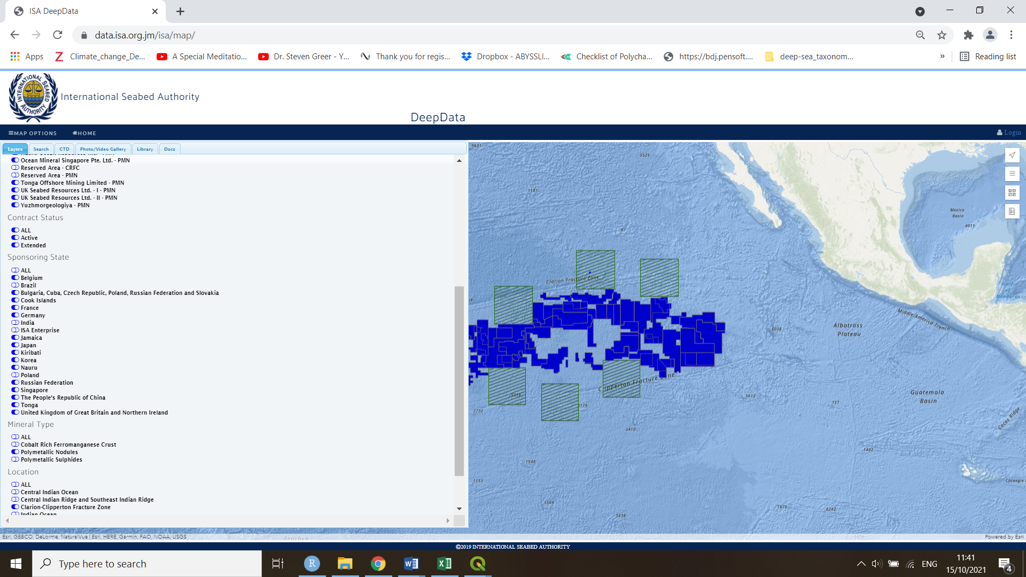

Fig. 30 The ISA DeepData webpage interface (redo fig)

The web interface is map-based, with a side panel where you can select options, for example, ‘contractor’, mineral type’ and ‘location’. Now that data is available on OBIS on the DeepData node, there is not the same imperative to develop the web interface, as significant functionality for summarising and visualising data is now available via the OBIS ISA node. However, some additional developments could prove beneficial. For example, the functionality to interrogate data by APEI layer would be useful, this is currently not possible and the data is obscured in the database output as the region is labelled OA (outside area) rather than with the APEI in question. The usability of the web interface could be developed further, for example the ability to click on a section of the map, such as a given contract area or APEI, and a summary of available data for that given region is made visible in a side-bar. Such functionality is not duplicating what is present on OBIS, and aligned with the map-based focus of DeepData.

### Recommendations and considerations for the data template and DeepData

The ISA has met a significant challenge to reconcile and publish often variable datasets from Contractor data submissions. It is a notable achievement that significant data holdings are now published and available on the database. Further, through publishing of DeepData records on OBIS some key issues have been addressed and the data can now be classified as FAIR. The template has also significantly improved. There are improvements to be made however that can address key data quality issues with the result of greater utility of the data for various applications. The database is at a nascent phase of its development, here engagement with the science community and Contractors to further the development of DeepData is crucial. Several potential improvements would be relatively straightforward, e.g. inclusion of fields in the database output. Some may be more involved and require some database development or reconfiguration and therefore may be more feasible at a later stage. We provide a couple of key recommendations in the following paragraphs, in order of priority, for consideration by the Secretariat.

*(a) Address duplication in records in DeepData*

To address the duplication issues, a review of existing usage of identifiers by DeepData is needed. Within the data pipeline, all records need be given a unique identifier in the database, i.e. an ‘occurrenceID’. Also, all records should have a valid SampleID, and records submitted without them are sent back to the Contractor for review. Detailed guidelines on usage of identifiers should be provided by the Secretariat. Improved versioning and documentation of datasets may be required to avoid duplication, including a process to clearly ascertain what are new records and what are existing ones, as records are falling through the cracks in the current system. Potentially guidelines should be re-worked to require iterative data publishing rather than one-off data submissions, this could simplify identification of duplicates.

We recommend an extensive analysis by the ISA secretariat of the duplicated records including establishing a line of communication with the Contractors to address this issue. We were only able to do a limited and informal analysis here given access to only a subset of the raw files to cross-reference and limited knowledge of DeepData data processing steps for adding sample IDs where missing for example. When the duplicates have been identified and removed, the datasets could be republished on DeepData, and on the OBIS ISA node (including a unique identified common to both databases). Ideally rather than publishing from 2015 on, the latest data submissions, i.e. 2021 or even 2022 post-processing are published, and any one-off data submissions from previous years identified from the process above could then be added.

*(b) Improvements on the Environmental Data Template*

We recommend that the templates are made fully Darwin Core compliant and that the data template column headings are replaced with Darwin Core terms with a full key provided. Darwin Core fields are a global data standard in wide usage in biology and terms are intuitive to understand, and in some cases, more so than some of the current column headings (e.g. ‘samplingProtocol’). Mapping the data to Darwin Core in the first instance would avoid ambiguity and benefit the Contractors and the ISA data team. This could also allow the ISA to implement many of the steps done by the OBIS secretariat (as discussed in section 3.6.7).

Extensive testing of the template is also recommended. Feedback from the Contractors is key to the success of the template and the resulting quality of the data collected (and ultimately published) on the database. With data systems, usability and user testing is more critical than theories as to how the systems may work. The ISA here could draw on the model of ‘agile’ software development with extensive user testing and response to user feedback.

Specific recommendations on the template are as follows: add a ‘basisOfRecord’ column to the template, so it can be specified if a record is a specimen record, observation or other; combine the ‘Point’ and ‘Trawl Line’ datasets in template or on the web interface; add a field for contract area (separate from ContractorID) and improved guidance for populating the ‘subarea’ field which is currently unclear; add rules into the template so required fields such as SampleID must be populated as above; implement controlled vocabularies where appropriate i.e. where data would be a standard set of terms so misspellings are not included; in the interim, a script to mine through and clean all taxonomy columns- and avoid taxonomic mismatches like the *Montecillina* example above. Adjustments to template are a priority as that should ensure data from this point on are better quality.

*(c) Data output from DeepData*

We recommend inclusion of the ‘scientificName column’ in output from DeepData (which has now been included into the Contractor data template). This would avoid many problems including potential subjective interpretation of identification, and of differences in taxonomy between records on the OBIS ISA node and DeepData. We also recommend restructuring of data on website to one record per row, while this may require some database development or reconfiguring, it may even have associated benefits such as improved database performance. Related to first recommendation above, we recommend that the database output can be downloaded as a Darwin Core archive, which once all data are mapped to Darwin Core terms should be a possibility. This should match the OBIS ISA node Darwin Core.

*(d) Consultation and training workshops with Contractors and prioritisation of data quality over data quantity*

Training workshops for the Contractors in Darwin Core, WoRMS, including functions such as taxon match, and usage of the new template, including best practice in identifiers should be considered. Previous workshops on taxonomy run by the ISA have been successful and would have additional benefit of building collaborations between the regulator, Contractors and other stakeholders.

A general emphasis should be on quality rather than quantity of the data, fully verified records QA/QC’d, both prior to submission and post-submission. There is the potential for errors if data is used in secondary analysis which could lead to erroneous scientific conclusions. Data without depth information, sampling method, or identification methods for example should not be published. Other missing data, such as relative abundance, relative dominance, habitat- nodule/sediment/water column- is also essential information and gaps here should also be addressed. Given that most explored seamount habitats fall below 3000 metres (Simon-Lledo, pers. comm.), some records in the data may be from seamounts, however we were unable to differentiate nodule field from seamount data as this data is not present in the DeepData records. Therefore, broader habitat classification information, e.g. ‘seamount’/’abyssal plain’/’rocky outcrop’ which the template aims to capture, should also be present.

Currently, the deadline for annual data submissions is the 31st of March. It may be of benefit to have a period after this date whereby the data is reviewed, QA/QC checks are run by the ISA, and if relevant data is missing for example, the template is sent to the Contractor to add the required information, i.e. the annual data submission is not a one-off process but there is a limited period of review following the submission. Alternatively, at a later stage when the process is more automated, datasets submitted with missing data could generate an error code as is currently done on web forms. Together with the improved template and additional QA/QC, this should result in greater quality of submitted data to be ingested into the database (with less processing steps required, scripted or otherwise). This would benefit the scientific community with improved biological datasets and the ISA data team with less data processing required.

### Potential future developments of DeepData

A useful future development could be that the CCZ should be added as a thematic regional node of WoRMs. For the time being, this project can contribute here by ensuring distribution data is updated in WoRMS, where species from the CCZ Checklist linked to a publication are tagged with a verified CCZ distribution. As a result, the species will be searchable by CCZ region within WoRMS. This in the first instance can be done with the 214 CCZ descriptions- currently only 9 are tagged as CCZ distribution on WoRMS. DeepData would also benefit from a process of assessing and tagging species as pelagic within the data pipeline, our CCZ Checklist has illustrated the importance of identifying pelagic species, of which there are many in the database. Working closely with WoRMS could help achieve this, and WoRMS and ISA have now signed a Letter of Cooperation (Luciana Genio, pers. comm.). Other potential future developments could include the ability to interrogate DeepData for APEI data, i.e. include as a separate mapping layer on the website. Additional mapping functionality which could be of benefit also to the user community would be an ‘interactive search’ on the map, e.g. clicking on a region, such as an APEI, and a side bar summarises what data is available. Such functionality would align with the map-based focus of the DeepData.

When DeepData is at a more mature state, other possible developments include the following: provision of an API (Application Programming Interface) to allow the database to be directly accessed from within the R environment (or similar); provision of a DOI (Digital Object Identifier) from DeepData to allow citation of datasets, as available for OBIS and GBIF; development of a data dashboard for interrogating, summarising and visualising the data; this may be particularly helpful for policymakers, who may be less likely to download and analyse the database holdings; have functionality whereby taxonomic experts can flag erroneous records of the website, as ‘community curation’, this is possible in WoRMS and GBIF and a smiliar feature is planned in OBIS; potentially move to web-based data submission platform; provide information on data updates, e.g. an information page stating when the site updated and a list of datasets published, similar to the OBIS GitHub notebook. Similarly, it could be helpful for ISA to have a dynamically updated cruise inventory on the database for all cruises that have taken place up to current cruises and potentially those in planning.

An additional future direction for DeepData could include the storage and handling of image data, for example megafauna specimen imagery or in-situ images. Image data however is computationally expensive in terms of required storage, and the technicalities of handling more complex data types. Alternatively, DeepData could partner with, for example, BIIGLE, as has been done with OBIS and WoRMS, to provide images with metadata to develop data availability/image libraries. There is a precedent here with the CCFZ image atlas for in situ imagery, “Atlas of Abyssal Megafauna Morphotypes of the Clipperton-Clarion Fracture Zone” co-administered by the ISA, which was in wide usage by researchers (see Cairns et al., 2015). This could even be extended to acoustic images e.g. multibeam imagery for bathymetry. For multibeam imagery, and here DeepData could work directly with the GEBCO-Nippon Foundation SeaBed 2030 project (Mayer et al., 2018) where (as for WoRMS and OBIS) existing partnerships are already in place.

# DISCUSSION

## Biodiversity in the Clarion-Clipperton Zone

This synthesis of all published biodiversity data from the CCZ, incorporating information from the literature, DeepData, the central repository of Contractor data, and other databases, OBIS, GBIF, and INSDC has allowed the first estimates of the known and unknown biodiversity at regional scales in all size classes for the CCZ. At species level, sampling is a very long way from reaching asymptote, and the vast majority (our best estimate using abundance measures, being 87%) of species are so far not named, and known only as temporary morphospecies or OTUs. Our best estimator for total species richness in the CCZ is 5471, but this is subject to many caveats. For example, we have used a species list which may contain many synonyms, this is likely to lead to the estimate being too high. On the other hand, we know that there are vast regions, and habitats of the CCZ, that have been barely sampled at all, which would make the total species richness figure of 5471 a big under-estimate. For example, rocky seamounts and outcrops in the CCZ have very rarely been sampled, with most published data being very recent, and are likely to host completely different communities (Cuvelier et al., 2020; Leitner et al., 2021; Durden et al., 2021; Bribiesca-Contreras et al., 2021). With this in mind, our best guess would be that actual biodiversity exceeds our estimate, potentially even by several orders of magnitude.

In terms of actual, known, named species we have created the first CCZ Checklist which contains 642 named species, including 180 described from the CCZ. However, even with this there are significant caveats, firstly it is probable that many of these species are misidentified owing to the lack of field guides to the fauna of the CCZ. For example, a person identifying annelids from the CCZ is almost certainly going to be use monographs and papers from bathyal depths, most likely from other ocean basins. This leads to the problem of range-inflation of so-called ‘cosmopolitan species’ and the only way to overcome this is to obtain genetic data from both the sample and the type locality of the species it most closely resembles. This is time-consuming and costly work. There are a great number of species in DeepData (38%) that have been recorded only once and with an abundance of 1, known as singletons. It is important to note however that this may be an underestimate because of duplication in the records. Proportions in the literature are even higher over a range of taxa (Pape et al., 2021; Brix et al., 2020; Bonifacio et al., 2020, 2021; Błażewicz et al., 2019a). This is normally indicative of lack of sampling and hence also leads to high predictors of total species diversity.

While the job of describing all (or at least a reasonable percentage) of the CCZ fauna seems almost insurmountable, there has been a remarkable growth in taxonomic efforts in recent years. Of the species in the Checklist that have been described from the CCZ, 174 have been described since 2000, and 66 in 2019 alone. However, even at a very optimistic rate of 100 species per year, it would take another ~48 years to describe the remaining species. It should be pointed out that there are no habitats on Earth where all species are described, so this would be a benchmark far in excess of what has been achieved elsewhere.

There are rather few estimators of biodiversity in other regions of the deep sea to compare this with. One rare example is the Mediterranean deep sea in which total species richness has been estimated at 2805 species, of which 66% are undiscovered (Danovaro et al., 2010). The deep Mediterranean is unusual however, having high temperatures and being extremely oligotrophic, and is known to have an impoverished deep fauna (Danovaro et al., 2010). The CCZ figure of 5534 species, of which 87% are undiscovered is clearly in excess of this. However, this higher diversity would always be expected for the CCZ given our general understanding of high abyssal Pacific diversity (at least relative to other sedimented environments (Hessler & Jumars, 1974, Glover et al., 2002). One study of the Southern Ocean deep-sea reported 674 isopod species of which also, 87% were new to science (Brandt et al., 2007), which is comparable to our numbers for CCZ isopods with an estimated 82% new species (42 named, 484 unnamed). Globally, there are at least 28,000 known deep-sea species found at depths >500 m (Glover et al., 2022) hence our current total for the CCZ represents just 2.5%, but as species are recorded or described this percentage is likely to increase.

### Sampling effects

When comparing sites across the CCZ the main signal in the data appears to be one of sampling effects, for example differences in sampling methods or taxonomy, or taxonomic approach. Taxonomic challenges can be amplified in meiofauna and megafauna, which appears to be supported by the diversity estimates reported here. Both megafauna and meiofaunal biodiversity estimates may be significantly affected by sampling effects.

For example the species richness estimate for meiofauna was 419, likely to be a significant underestimate given the CCZ Checklist houses 241 named megafauna species, and >800 megafauna temporary names/morphotypes have been identified. Further, an unpublished catalogue of almost 700 megafauna morphotypes has also been compiled (Simon-Lledo et al., in prep). This low megafauna diversity estimate of 419 was most likely an artefact of several factors, in particular the duplication present in some of the megafauna datasets published on DeepData and a general under-sampling of megafauna given collection challenges, as they are collected either via ROV which are expensive, or trawls which tend to damage specimens (Pawson et al., 1988; Simon-Lledo, pers. comm.). As a result, there is often a dependence on imaging via ROV or similar to survey and ‘remotely sample’ the larger fauna, but this produces an inherently high uncertainty in identifications (Bribiesca-Contreras et al., in press). In contrast, meiofauna estimates conversely were very high, over 7000. Meiofauna can be more easily missed in sampling operations, simply due to the consequences of relative scale of size of the fauna to the corresponding volume of sample (generally sediment; Lins et al., 2021). by the consequences of size, and estimates can be reduced as a result. Meiofauna are noted to be a key component of deep-sea biodiversity (Sinniger et al., 2016; Le et al., 2022). The high estimate for meiofauna here may be more representative of true diversity therefore than the very megafauna estimate. While there have been major efforts from the regulator (ISA) to improve standardisation, it is inevitable that different Contractors will have access to different sets of expertise and historical methodologies. For example, for most abyssal benthic invertebrate groups (e.g. Crustacea, Polychaeta, Bryozoa) there is only one research lab in the world studying them, and each lab is not equipped to work on 16 different Contractor sample sets simultaneously. Expertise in these groups is very rare globally, and as such it is very unlikely that any single Contractor will have access to experts for all groups and size classes. It is clear that there is the will for standardisation but in general the taxonomic expertise and capacity is simply not there.

### Comparing DeepData to other databases and literature

As well as data duplication, problems with data vocabulary and exchange contribute to significant challenges in the CCZ data landscape, particularly for legacy data which is yet to be published on the Database. DeepData contains records spanning 2004-2019, a recent window given that environmental survey cruises to the CCZ started in the 1970s. Despite this, there is much more data available on DeepData than on the other databases (OBIS, GBIF) reflecting the recent work being carried out by Contractors. GBIF in particular and to a lesser extent OBIS are driven by museum accession records, which typically only appear after a long time lag. It is clear that it is critical to look at all datasets when accumulating data to get a more comprehensive picture.

## Taxonomy in the CCZ: coverage and gaps

The vast majority of biological literature on the CCZ is very recent, and the past seven years in particular shows a remarkable rate of publication, including for species descriptions. In particular, large numbers of descriptions were published in 2019, 4 years after two major consortium cruises to the eastern CCZ (JPI Oceans and ABYSSLINE); illustrating the importance of collaborative programmes to taxonomic work. Significant progress within taxonomic groups were also evident, Bryozoans for example (Grischenko et al., 2021, 2018), illustrating that focussed efforts by expert taxonomists within single contract areas have also been highly productive. Prior to 2000, relatively few publications have been published and only six species descriptions were found, highlighting a historic lack of taxonomic work in the region.

Similarly the vast majority of genetic studies are very recent. Genetic and genomic analyses have previously been noted as a data gap, for example in the CCZ-ISA Friday Harbor Workshop in 2019 (Smith et al., 2019)[55] although over 20[56] papers including genetics studies have been published since. Many descriptions are still based on morphology only, however, particularly for meiofauna. Genetic studies can be challenging for groups like meiofauna, being so small that molecular work can equate to destructive sampling (i.e. complete usage of the specimen in the process of molecular identification if subsampling is not possible). It is critical to make use of all the most recent methodologies to enable integrative morphological and molecular work as far as feasible (Glover et al., 2015). That many of the descriptions utilised morphology only may result in underestimation of diversity as molecular studies tend to show higher diversity (Bonifacio et al., 2021).

The lack of standardisation and equal taxonomic effort makes it almost impossible to compare diversity and composition across the CCZ in the sense of ecology or environmental variables, but the data reported here should at least be useful to highlight gaps and further develop taxonomic programs. As the taxonomic data gaps exist for all size classes, e.g. ostracods in meiofauna, and major phyla, e.g. Echinodermata, Mollusca, and even well-studied groups like Annelida, it is not so feasible to identify particular gaps, other than trying to encourage work on all. From a conservation perspective, it might be of use to start discussions on priority groups, e.g. nodule fauna, but this is fraught with difficulty as typically the value of different groups, or their sensitivity to impact is unknown until at least the taxonomic work has been completed. The ISA is well placed to aid these discussions by providing both fora to discuss (e.g. workshops), direct links to Contractors and build collaborative efforts, including via existing and nascent partnerships, e.g. OBIS, WoRMS and GEBCO.

Only a handful of papers to date have examined genetic connectivity in the CCZ (Taboada et al., 2018; Jansen et al., 2019; Mohrbeck et al., 2020; Bribiesca-Contreras et al., 2021; Macheriotou et al., 2020), likely stemming in large part from the generally low faunal abundances and many collections being from single localities (Jansen et al., 2019). The data reported here may be of use in identifying more target taxa for connectivity studies. To date few studies have utilised genomic data or metabarcoding techniques (Taboada et al., 2018; Kersten et al., 2019; Macheriotou et al., 2020; Lejzerowicz et al., 2021; Jones et al., 2021). These studies however also indicate very high molecular diversity in the CCZ (Christiodolou et al., 2019; 2020; Lejzerowicz et al., 2021). Usage of eDNA and metabarcoding techniques have been proposed for monitoring marine environments including the deep-sea, but for monitoring to occur, the biodiversity of the region or environment needs to be characterised in the first instance (and associated generation of reference data). These techniques are sometimes proposed as a solution for addressing deep-sea knowledge gaps, but they are not suitable for species discovery, rather, for known biodiversity. A key issue for usage of eDNA in deep-sea environments is therefore availability of reference data. Identifying ‘leakage’ of pelagic taxa into sediment eDNA datasets without reference data is not feasible for example. Other considerations include technique development, and screening of exogenous DNA (Levin et al., 2019). Such techniques could eventually prove viable however for monitoring biodiversity in the CCZ.

## Potential future analysis and applications for DeepData

The current utility of DeepData is significantly limited by known and potentially wider duplication. This will impact estimates of abundance and incidence, and any statistics that rely on these measures will be affected. With the current iteration of the data, the duplicates potentially will produce lower estimates of diversity than are actually present, for example several statistical measures are dependent on estimates of singletons and doubletons. In DeepData, 46 singletons of known named species were present (24%) and 824 for named and morphospecies combined (38%), this is a high proportion of overall species recorded in total from the database but it may be an underestimate with singleton records potentially obscured by record duplication. Doubletons could not be estimated at all because of duplication. Analysis of DeepData records utilising abundance data or estimates of singletons for example will require careful assessment and ideally will be performed once the duplicates are definitively identified and removed from the records. As a general point abundance data for the region may be problematic, given noted issues with abundance data (Washburn et al., 2021), for example misidentified taxa inflating abundance estimates of other taxa. Therefore, presence/absence based analysis is potentially more suitable than analysis measures based on abundance at this stage.

Potential future analyses of DeepData at a more mature stage include beta diversity estimates and broader studies of species ranges (e.g. Bonifacio et al., 2021). The UpSet plots examining species assemblages by contract area were done with presence/absence data, therefore are not dependent on abundances, but are still underpinned by variable sampling strategies (and of course also affected by potential misidentifications). As more datasets are added with more consistent and comparable sampling, improved estimates of beta diversity are possible. The current lack of data on density of species/taxa in general is a significant limitation for ecological analysis, for example density is needed for modelling of food webs (e.g. Stratman et al., 2020). It should be feasible for DeepData to provide estimates of density where data on abundances and quantitative areas sampled are accurately reported.

DeepData currently lacks considerable ecological information on habitats or natural history, e.g. if an organism is found on a nodule. Remarkably little is known on nodule fauna for example with only a few key publications (e.g. Veillette et al., 2007; Mullineaux et al., 1987) and descriptions (Grischenko et al., 2021, 2018; Molodtsova & Opresko, 2017; Cairns, 2015) with more nodule fauna being identified all the time (Saskia Brix, pers. comm.). A recent study has also identified sediment infauna in nodule crevices for the first time in the CCZ (Pape et al., 2021), and a large predatory polychaete worm that lives within nodules described in 2021 (Drennan et al., 2021). These recent works highlight both the gaps and the rapid increase in knowledge in this environment, including the interconnectivity and even overlap of sediment and nodule fauna.

Other potential future analyses for DeepData include species distribution modelling, which has for example previously been applied to CCZ datasets for the BGR contract area utilising Random Forest techniques (Uhlenkott et al., 2020). These modelling approaches could be applied at regional scales, including different contract areas. Species distribution modelling utilising presence-only data can be problematic for seabed habitats, with sparse data on habitat heterogeneity (Stephenson et al., 2021), known to be high in the CCZ ((Washburn et al., 2021b; McQuaid et al., 2020). Improved abundance data could therefore support species modelling efforts in the CCZ. More advanced modelling approaches may also be required, such as Integrated Nested Laplace Approximation, INLA (Morgara et al., 2015; Rue et al., 2009), which is relatively robust to sampling bias, patchy sampling effort or presence-only data.

A key consideration is the application of DeepData from an environmental management perspective. It would be of great value to be able to interrogate species distribution or diversity heat maps when developing preservation reference zones within contract areas for example, or for the ISA’s review and evaluation of applications for exploitation activities. On a regional scale, DeepData should ultimately become critical in helping to develop the CCZ REMP, for example in the continued review and assessment of the APEI network. There is thus the potential for DeepData to provide an invaluable resource both for research and environmental management.

## Study Limitations

The primary limitation of our study is the restriction to benthic metazoans. Non-metazoans make up a significant proportion of the biodiversity and biomass, for example 26 species of foraminifera have been described in recent years (Gooday et al., 2015, 2017, 2018a, 2018b, 2018c, 2020; Kamenskaya et al., 2012, 2013, 2015, 2017). This highlights significant levels of diversity in foraminifera, with indications also of high molecular diversity from metabarcoding studies (Lejzerowicz et al., 2020). Also, eDNA surveys have reported considerable undocumented microbial diversity (e.g. Wear et al., 2021). We have also not examined pelagic or surface ocean taxa in this study, which do form part of the environmental remit of the ISA and DeepData.

Owing to the problem of duplication on the databases, it has not been possible to look at quantitative abundance data, other than in an overview sense, and to illustrate some of the influence on differing taxonomic approaches on the observed trends. Even without the duplication problem, this would be problematic, however, given the differing sampling methods in the CCZ.

# CONCLUSIONS

One of the main goals of this project was to review the state of knowledge of published data on CCZ biodiversity, just two years after DeepData was launched. We can say with certainty that the release of these data to the community is very welcome and has made a big difference to our understanding of CCZ biodiversity. There has been a dramatic increase in the rate of taxonomic work on the CCZ in recent years, much of it supported directly by Contractors and the ISA.

We have developed the first CCZ Checklist containing 642 species names, as a priority this should be made a regional page of WoRDSS (and species names sourced from a publication to have distribution tagged as CCZ in WoRMS); to help maintain taxonomic standards and build the Checklist, which is clearly only a tiny fraction of the actual biodiversity. DeepData is at a nascent phase of its development, and must be maintained and grown, with improvements to the reporting requirements and increasing the user base, this will lead to significant improvements in quality and removal of the main issues such as data duplication. Our review covers DeepData in the relatively early stages of development, and while there are QA/QC issues to address, the database has already proved invaluable for compiling biodiversity data from the region, for example in contributing 37 species names to the checklist. As it develops further it will be key in developing recommendations on both potential baseline exploration surveys and future development of Environmental Impact Assessments.

The proportion of species new to science in the CCZ is commonly reported in publications and the media as being over 80%, but often without citation. This is mainly because it is quite a hard number to estimate. However, our study has provided some quantitative support to that figure (our estimate is 87%) and clearly shows the large remaining taxonomic impediment to a reasonable understanding of CCZ biodiversity and natural history. There are no established precedents in terms of standards and guidelines for what percentage of a fauna should be described before an industrial activity can take place. UNCLOS clearly states however that necessary measures must be taken to ensure the effective protection for the marine environment from harmful effects. High-seas fisheries have historically been commenced with almost no baseline data – that which is available typically only arrives after the fishery has commenced. For the hydrocarbon industry, reasonable baseline taxonomic data would be present in somewhere like the North Sea, but rather less in other hotspots for exploitation such as the West African margin where taxonomic knowledge is probably no better than it is for the CCZ. Deep-water regions of exploration off the Gulf States of the Gulf of Mexico probably lie somewhere between these two extremes. A useful future report would be to examine a range of different habitats (marine and terrestrial) to explore what taxonomic knowledge has been available to support industrial environmental best practice, and lessons learned.

There is a collective responsibility amongst all stakeholders to support open data efforts such as DeepData and community curation and engagement is going to be critical. Useful models of this can be found in the community process that supports the World Register of Marine Species. An additional lesson here is maintaining a priority of quality over quantity and keeping the database as simple as possible. Partnerships with big international science programs will be critical, for example major genomic data projects, the UN Decade of Ocean Science and the UN Biodiversity Beyond National Jurisdictions (BBNJ) treaty process.

UPDATE TOTALS OF PAPERS

LIT AND DESCRIPTIONS

DESCRIBED BY

CHECKLIST

CHANGES OVER TIME- GEN ET SP INDET- VASOPORA CERAMICA- HOW TO CAPTURE HERE

# ACKNOWLEDGEMENTS

This work was funded by The Pew Charitable Trusts (Contract ID 34394). It involved a collaboration of The Pew Charitable Trusts, the Natural History Museum, and the ISA, the first formal collaboration of these organisations. We wish in particular to thank members of the ISA Secretariat, Luciana Genio, Sheldon Carter, Tamique Lewis and Ansel Cadien for their cooperation and assistance; and Andrew Friedman, Chris Pickens and Peter Edwards of Pew Charitable Trusts for invaluable support, assistance, and general input on the project. The authors are also grateful to the following individuals: the authors Dave Pawson, Paulo Bonifacio, Saskia Brix, Diva Amon, Travis Washburn and Erik Simon-Lledó for providing additional data to their published works; Stefanie Kaiser, Sam Smith, Magdalena Błażewicz, Torben Riehl, Ellen Pape and Bart deSmet for permission to use the species lists (both named species and morphospecies) that underpin the analysis in Washburn et al. (2021)); Geoff Boxhall, NHM London, Pedro Martinez, Senkenburg, Hamburg, Tammy Horton, National Oceanography Centre, UK / WoRMS Steering Committee, Simone Brandão, WoRMS and Stefanie Dekeyzer, WoRMS Data Management for information on habitat associations of species in the CCZ Checklist; NHM library staff for assistance with interlibrary loans for the literature review, in particular Jon Earle and Rosie Jones; Pieter Provoost and Ward Appeltans, OBIS Secretariat and Tammy Horton, WoRMS Steering Committee for assistance and background information on the databases. The authors also wish to thank Lupita Bribiesca-Contreras with assistance with ggplot for figures 25-27, the Nautilus Biodiversity Data Working Group and the Deep-Sea Taxonomy Workshop, Frankfurt 2019 for relevant discussions, and elements contributing to Fig 1, and Dan Jones, Thomas Dahlgren, Tammy Horton, Erik Simon-Lledo, Regan Drennan, and Pew and ISA colleagues for reviewing the draft report.

# SUPPLEMENTARY DATA

Supplementary data is made available here in the form of Supplementary Tables and Figures (ST/F) and Supplementary Data Files (SDF, available for download only).

## Supplementary Tables

|  |  |  |  |  |  |  |  |
| --- | --- | --- | --- | --- | --- | --- | --- |
| S Table 1. All species recorded from the CCZ, from the CCZ Checklist, organised by phylum. Column ‘CCZ’ denoting if species described from CCZ.  Species described from the CCZ are marked in bold with an asterisk, e.g. *Abyssarya acus\** Bonifácio & Menot, 2018. Those species which have only been recorded with qualifiers (other than sp. nov.) e.g. cf. aff. incertae sedis, sp. inc. are marked with an ~. Any species identified solely from imagery denoted with a #; e.g. *Ophiacantha sentosa#*. Source denotes where the name originates from, “L” being literature, “DD” DeepData, “G” GBIF, and “O” OBIS. Size Cat indicates faunal size class/category. | | | | | | | |
| Phylum | **Class** | **Order** | **Family** | **Species** | **Authority** | **Source** | **Size Cat** |
| Annelida | Polychaeta | Amphinomida | Euphrosinidae | *Euphrosinopsis crassiseta~* | Kudenov, 1993 | L | macro |
| Annelida | Polychaeta | Amphinomida | Euphrosinidae | *Euphrosinopsis horsti~* | Kudenov, 1993 | L | macro |
| Annelida | Polychaeta | Echiuroidea | Bonelliidae | *Jakobia birsteini#* | Zenkevitch, 1958 | L | mega |
| Annelida | Polychaeta | Eunicida | Dorvilleidae | *Ophryotrocha maculata* | Åkesson, 1973 | L | macro |
| Annelida | Polychaeta | Eunicida | Dorvilleidae | *Ophryotrocha vivipara* | Banse, 1963 | L | macro |
| Annelida | Polychaeta | Eunicida | Eunicidae | *Leodice antillensis* | (Ehlers, 1887) | G; O | macro |
| Annelida | Polychaeta | Eunicida | Lumbrineridae | *Lumbrinerides laubieri* | Miura, 1980 | L | macro |
| Annelida | Polychaeta | Eunicida | Onuphidae | *Nothria abyssia* | Kucheruk, 1978 | DD | macro |
| Annelida | Polychaeta | Phyllodocida | Chrysopetalidae | *Dysponetus caecus* | (Langerhans, 1880) | L | macro |
| Annelida | Polychaeta | Phyllodocida | Chrysopetalidae | *Dysponetus hesionides~* | Böggeman, 2009 | L | macro |
| Annelida | Polychaeta | Phyllodocida | Chrysopetalidae | *Dysponetus profundus~* | Böggemann, 2009 | L | macro |
| Annelida | Polychaeta | Phyllodocida | Chrysopetalidae | *Pseudodysponetus fragmentosus~* | Böggemann, 2009 | L; DD | macro |
| Annelida | Polychaeta | Phyllodocida | Glyceridae | *Glycera capitata~* | Örsted, 1842 | L; DD | macro |
| Annelida | Polychaeta | Phyllodocida | Glyceridae | *Glycera nana~* | Johnson, 1901 | L | macro |
| Annelida | Polychaeta | Phyllodocida | Goniadidae | *Bathyglycinde profunda~* | (Hartman & Fauchald, 1971) | L; DD | macro |
| Annelida | Polychaeta | Phyllodocida | Goniadidae | *Bathyglycinde sibogana~* | (Augener & Pettibone in Pettibone, 1970) | L | macro |
| Annelida | Polychaeta | Phyllodocida | Goniadidae | *Progoniada regularis~* | Hartman, 1965 | L; DD | macro |
| Annelida | Polychaeta | Phyllodocida | Hesionidae | *Neogyptis julii* | Summers, Pleijel & Rouse, 2015 | L | macro |
| Annelida | Polychaeta | Phyllodocida | Hesionidae | *Sirsoe sirikos* | Summers, Pleijel & Rouse, 2015 | L | macro |
| Annelida | Polychaeta | Phyllodocida | Lacydoniidae | *Lacydonia papillata~* | Uschakov, 1958 | L | macro |
| Annelida | Polychaeta | Phyllodocida | Lopadorrhynchidae | *Pelagobia longicirrata~* | Greeff, 1879 | L | macro |
| Annelida | Polychaeta | Phyllodocida | Nereididae | *Ceratocephale abyssorum* | (Hartman & Fauchald, 1971) | L; DD | macro |
| Annelida | Polychaeta | Phyllodocida | Nereididae | *Ceratocephale loveni~* | Malmgren, 1867 | L | macro |
| *Annelida* | Polychaeta | Phyllodocida | Nereididae | *Ceratocephale regularis* |  | L | macro |
| Annelida | Polychaeta | Phyllodocida | Nereididae | ***Neanthes goodayi\**** | Drennan, Wiklund, Rabone, Georgieva, Dahlgren & Glover, 2021 | L | macro |
| Annelida | Polychaeta | Phyllodocida | Nereididae | *Rullierinereis profunda* | (Hartman, 1965) | L; DD | macro |
| Annelida | Polychaeta | Phyllodocida | Paralacydoniidae | *Paralacydonia paradoxa* | Fauvel, 1913 | L; DD | macro |
| Annelida | Polychaeta | Phyllodocida | Paralacydoniidae | *Paralacydonia weberi~* | Horst, 1923 | L; DD | macro |
| Annelida | Polychaeta | Phyllodocida | Phyllodocidae | *Alciopina parasitica~* | Claparède & Panceri, 1867 | L | macro |
| Annelida | Polychaeta | Phyllodocida | Phyllodocidae | *Eulalia anoculata~* | Hartman & Fauchald, 1971 | L; DD | macro |
| Annelida | Polychaeta | Phyllodocida | Phyllodocidae | *Pseudomystides bathysiphonicola~* | (Hartmann-Schröder, 1983) | L; DD | macro |
| Annelida | Polychaeta | Phyllodocida | Phyllodocidae | *Pseudomystides rarica* | (Uschakov, 1958) | L; DD | macro |
| Annelida | Polychaeta | Phyllodocida | Pilargidae | *Ancistrosyllis groenlandica* | McIntosh, 1878 | L; DD | macro |
| Annelida | Polychaeta | Phyllodocida | Polynoidae | ***Abyssarya acus\**** | Bonifácio & Menot, 2018 | L | macro |
| Annelida | Polychaeta | Phyllodocida | Polynoidae | ***Bathyedithia retierei\**** | Bonifácio & Menot, 2018 | L; DD; O | macro |
| Annelida | Polychaeta | Phyllodocida | Polynoidae | ***Bathyeliasona mariaae\**** | Bonifácio & Menot, 2018 | L; DD; O | macro |
| Annelida | Polychaeta | Phyllodocida | Polynoidae | *Bathyfauvelia affinis~* | (Fauvel, 1914) | L | macro |
| Annelida | Polychaeta | Phyllodocida | Polynoidae | ***Bathyfauvelia glacigena\**** | Bonifácio & Menot, 2018 | L; G; DD; O | macro |
| Annelida | Polychaeta | Phyllodocida | Polynoidae | ***Bathyfauvelia ignigena\**** | Bonifácio & Menot, 2018 | L; DD; O | macro |
| Annelida | Polychaeta | Phyllodocida | Polynoidae | *Bathykurila guaymasensis* | Pettibone, 1989 | L | macro |
| Annelida | Polychaeta | Phyllodocida | Polynoidae | ***Bathymoorea lucasi\**** | Bonifácio & Menot, 2018 | L; G; O | macro |
| Annelida | Polychaeta | Phyllodocida | Polynoidae | *Bathypolaria magnicirrata* | (Neal, Barnich, Wiklund & Glover, 2012) | L | macro |
| Annelida | Polychaeta | Phyllodocida | Polynoidae | ***Bruunilla nealae\**** | Bonifácio & Menot, 2018 | L; O | macro |
| Annelida | Polychaeta | Phyllodocida | Polynoidae | ***Hodor anduril\**** | Bonifácio & Menot, 2018 | L; DD; O | macro |
| Annelida | Polychaeta | Phyllodocida | Polynoidae | ***Hodor hodor\**** | Bonifácio & Menot, 2018 | L; DD; O | macro |
| Annelida | Polychaeta | Phyllodocida | Polynoidae | *Macellicephala aciculata~* | (Moore, 1910) | L | macro |
| Annelida | Polychaeta | Phyllodocida | Polynoidae | ***Macellicephala clarionensis\**** | Bonifácio & Menot, 2018 | L; O | macro |
| Annelida | Polychaeta | Phyllodocida | Polynoidae | *Macellicephala gloveri* | Neal, Brasier & Wiklund, 2018 | L | macro |
| Annelida | Polychaeta | Phyllodocida | Polynoidae | ***Macellicephala parvafauces\**** | Bonifácio & Menot, 2018 | L | macro |
| Annelida | Polychaeta | Phyllodocida | Polynoidae | ***Macellicephaloides moustachu\**** | Bonifácio & Menot, 2018 | L; G; DD; O | macro |
| Annelida | Polychaeta | Phyllodocida | Polynoidae | ***Nu aakhu\**** | Bonifácio & Menot, 2018 | L; DD; O | macro |
| Annelida | Polychaeta | Phyllodocida | Polynoidae | ***Polaruschakov lamellae\**** | Bonifácio & Menot, 2018 | L; DD; O | macro |
| Annelida | Polychaeta | Phyllodocida | Polynoidae | ***Polaruschakov limaae\**** | Bonifácio & Menot, 2018 | L; DD; O | macro |
| Annelida | Polychaeta | Phyllodocida | Polynoidae | ***Polaruschakov omnesae\**** | Bonifácio & Menot, 2018 | L; DD; O | macro |
| Annelida | Polychaeta | Phyllodocida | Polynoidae | ***Yodanoe desbruyeresi\**** | Bonifácio & Menot, 2018 | L; DD; O | macro |
| Annelida | Polychaeta | Phyllodocida | Sphaerodoridae | *Ephesiella brevicapitis~* | (Moore, 1909) | L | macro |
| Annelida | Polychaeta | Phyllodocida | Syllidae | *Anguillosyllis capensis* | Day, 1963 | L; DD | macro |
| Annelida | Polychaeta | Phyllodocida | Syllidae | ***Anguillosyllis hessleri\**** | Maciolek, 2020 | L; G; O | macro |
| Annelida | Polychaeta | Phyllodocida | Syllidae | *Anguillosyllis palpata* | (Hartman, 1967) | L; DD | macro |
| Annelida | Polychaeta | Phyllodocida | Syllidae | ***Anguillosyllis truebloodi\**** | Maciolek, 2020 | L; G; O | macro |
| Annelida | Polychaeta | Phyllodocida | Syllidae | *Parexogone wolfi~* | (San Martín, 1991) | L | macro |
| Annelida | Polychaeta | Sabellida | Sabellidae | *Potamethus scotiae~* | (Pixell, 1913) | L | macro |
| Annelida | Polychaeta | Sabellida | Serpulidae | *Bathyditrupa hovei* | Kupriyanova, 1993 | L | macro |
| Annelida | Polychaeta | Sabellida | Siboglinidae | *Osedax frankpressi* | Rouse, Goffredi & Vrijenhoek, 2004 | L | macro |
| Annelida | Polychaeta | Spionida | Poecilochaetidae | *Poecilochaetus fulgoris~* | Claparède in Ehlers, 1875 | L | macro |
| Annelida | Polychaeta | Spionida | Spionidae | *Aonides selvagensis* | Brito, Nunez & Riera, 2006 | L | macro |
| Annelida | Polychaeta | Spionida | Spionidae | *Aurospio abranchiata~* | Neal, Paterson & Soto in Paterson et al., 2016 | L; DD | macro |
| Annelida | Polychaeta | Spionida | Spionidae | *Aurospio dibranchiata* | Maciolek, 1981 | L; DD | macro |
| Annelida | Polychaeta | Spionida | Spionidae | *Aurospio foodbancsia~* | Mincks, Dyal, Paterson, Smith & Glover, 2009 | L; DD | macro |
| Annelida | Polychaeta | Spionida | Spionidae | *Glandulospio orestes* | Meißner, Bick, Guggolz & Götting, 2014 | L | macro |
| Annelida | Polychaeta | Spionida | Spionidae | *Prionospio amarsupiata~* | Neal & Altamira in Paterson et al., 2016 | L; DD | macro |
| Annelida | Polychaeta | Spionida | Spionidae | ***Prionospio branchilucida\**** | Altamira, Glover & Paterson in Paterson et al., 2016 | L; G; DD; O | macro |
| Annelida | Polychaeta | Spionida | Spionidae | *Prionospio kaplani* | Altamira, Glover & Paterson in Paterson et al., 2016 | G | macro |
| Annelida | Polychaeta | Spionida | Spionidae | *Spiophanes longisetus~* | Meißner, 2005 | L | macro |
| Annelida | Polychaeta | Spionida | Spionidae | ***Laonice finnelli\**** |  | L | macro |
| Annelida | Polychaeta | Spionida | Spionidae | ***Laonice shulseae\**** |  | L | macro |
| Annelida | Polychaeta | Spionida | Spionidae | ***Poecilochaetus brenkei\**** |  | L | macro |
| Annelida | Polychaeta | Terebellida | Cirratulidae | ***Aphelochaeta abyssalis\**** | Blake, 2019 | L; G; O | macro |
| Annelida | Polychaeta | Terebellida | Cirratulidae | ***Aphelochaeta clarionensis\**** | Blake, 2019 | L; G; O | macro |
| Annelida | Polychaeta | Terebellida | Cirratulidae | ***Aphelochaeta clippertonensis\**** | Blake, 2019 | L; G; O | macro |
| Annelida | Polychaeta | Terebellida | Cirratulidae | *Aphelochaeta monilaris~* | (Hartman, 1960) | L; DD | macro |
| Annelida | Polychaeta | Terebellida | Cirratulidae | ***Aphelochaeta spargosis\**** | Blake, 2019 | L; G; O | macro |
| Annelida | Polychaeta | Terebellida | Cirratulidae | ***Aphelochaeta tanyperistomia\**** | Blake, 2019 | L; G; O | macro |
| Annelida | Polychaeta | Terebellida | Cirratulidae | ***Aphelochaeta wilsoni\**** | Blake, 2019 | L; G | macro |
| Annelida | Polychaeta | Terebellida | Cirratulidae | ***Caulleriella bathytata\**** | Blake, 2019 | L; G; O | macro |
| Annelida | Polychaeta | Terebellida | Cirratulidae | ***Chaetozone akaina\**** | Blake, 2019 | L; G; O | macro |
| Annelida | Polychaeta | Terebellida | Cirratulidae | *Chaetozone brunnea~* | Blake, 2006 | L | macro |
| Annelida | Polychaeta | Terebellida | Cirratulidae | *Chaetozone corona* | Berkeley & Berkeley, 1941 | DD | macro |
| Annelida | Polychaeta | Terebellida | Cirratulidae | *Chaetozone gracilis~* | (Moore, 1923) | L | macro |
| Annelida | Polychaeta | Terebellida | Cirratulidae | ***Chaetozone grasslei\**** | Blake, 2019 | L; G; O | macro |
| Annelida | Polychaeta | Terebellida | Cirratulidae | *Chaetozone setosa~* | Malmgren, 1867 | L | macro |
| Annelida | Polychaeta | Terebellida | Cirratulidae | ***Chaetozone truebloodi\**** | Blake, 2019 | L; G; O | macro |
| Annelida | Polychaeta | Terebellida | Cirratulidae | ***Kirkegaardia fragilis\**** | Blake, 2016 | L; G; O | macro |
| Annelida | Polychaeta | Terebellida | Cirratulidae | ***Tharyx hessleri\**** | Blake, 2019 | L; G; O | macro |
| Annelida | Polychaeta | Terebellida | Fauveliopsidae | *Fauveliopsis scabra* | Hartman & Fauchald, 1971 | L | macro |
| Annelida | Polychaeta | Terebellida | Terebellidae | *Neoamphitrite figulus* | (Dalyell, 1853) | L | macro |
| Annelida | Polychaeta | Terebellida | Trichobranchidae | *Terebellides abyssalis* | (Hartman, 1965) | L | macro |
| Annelida | Polychaeta |  | Capitellidae | *Capitella capitata* | (Fabricius, 1780) | L | macro |
| Annelida | Polychaeta |  | Chaetopteridae | *Phyllochaetopterus limicolus* | Hartman, 1960 | L | macro |
| Annelida | Polychaeta |  | Maldanidae | *Lumbriclymene interstricta~* | (Ehlers, 1908) | L | macro |
| Annelida | Polychaeta |  | Nerillidae | *Speleonerilla saltatrix* | (Worsaae, Sterrer & Iliffe, 2004) | L | macro |
| Annelida | Polychaeta |  | Opheliidae | ***Ammotrypanella keenani\**** | Wiklund, Neal, Glover, Drennan, Rabone & Dahlgren, 2019 | L; G | macro |
| Annelida | Polychaeta |  | Opheliidae | ***Ammotrypanella kersteni\**** | Wiklund, Neal, Glover, Drennan, Rabone & Dahlgren, 2019 | L; G | macro |
| Annelida | Polychaeta |  | Opheliidae | *Ophelina abranchiata~* | Støp-Bowitz, 1948 | L; G; DD | macro |
| Annelida | Polychaeta |  | Opheliidae | *Ophelina acuminata~* | Örsted, 1843 | L | macro |
| Annelida | Polychaeta |  | Opheliidae | ***Ophelina curli\**** | Wiklund, Neal, Glover, Drennan, Rabone & Dahlgren, 2019 | L; G; DD | macro |
| Annelida | Polychaeta |  | Opheliidae | ***Ophelina ganae\**** | Wiklund, Neal, Glover, Drennan, Rabone & Dahlgren, 2019 | L; G | macro |
| Annelida | Polychaeta |  | Opheliidae | ***Ophelina juhazi\**** | Wiklund, Neal, Glover, Drennan, Rabone & Dahlgren, 2019 | L; G | macro |
| Annelida | Polychaeta |  | Opheliidae | ***Ophelina martinezarbizui\**** | Wiklund, Neal, Glover, Drennan, Rabone & Dahlgren, 2019 | L; G | macro |
| Annelida | Polychaeta |  | Opheliidae | ***Ophelina meyerae\**** | Wiklund, Neal, Glover, Drennan, Rabone & Dahlgren, 2019 | L; G | macro |
| Annelida | Polychaeta |  | Opheliidae | ***Ophelina nunnallyi\**** | Wiklund, Neal, Glover, Drennan, Rabone & Dahlgren, 2019 | L; G | macro |
| Annelida | Polychaeta |  | Orbiniidae | ***Leitoscoloplos simplex\**** | Blake, 2017 | L; G | macro |
| Annelida | Polychaeta |  | Orbiniidae | ***Orbiniella abyssalis\**** | Blake, 2020 | L; O | macro |
| Annelida | Polychaeta |  | Orbiniidae | *Orbiniella andeepia~* | Narayanaswamy & Blake, 2005 | L | macro |
| Annelida | Polychaeta |  | Paraonidae | *Aricidea (Strelzovia) antennata~* | Annenkova, 1934 | L | macro |
| Annelida | Polychaeta |  | Paraonidae | *Aricidea (Strelzovia) belgicae~* | (Fauvel, 1936) | L; DD | macro |
| Annelida | Polychaeta |  | Paraonidae | *Levinsenia uncinata* | (Hartman, 1965) | L; DD | macro |
| Annelida | Polychaeta |  | Paraonidae | *Paradoneis abranchiata~* | Hartman, 1965 | L; DD | macro |
| Annelida | Polychaeta |  | Paraonidae | *Paraonella abranchiata* | Fauchald & Hancock, 1981 | L; DD | macro |
| Annelida | Polychaeta |  | Scalibregmatidae | ***Oligobregma brasierae\**** | Wiklund, Neal, Glover, Drennan, Rabone & Dahlgren, 2019 | L; G | macro |
| Annelida | Polychaeta |  | Scalibregmatidae | ***Oligobregma tani\**** | Wiklund, Neal, Glover, Drennan, Rabone & Dahlgren, 2019 | L; G | macro |
| Annelida | Polychaeta |  | Scalibregmatidae | ***Oligobregma whaleyi\**** | Wiklund, Neal, Glover, Drennan, Rabone & Dahlgren, 2019 | L; G | macro |
| Annelida | Polychaeta |  | Travisiidae | *Travisia glandulosa~* | McIntosh, 1879 | L; DD | macro |
| Annelida | Polychaeta |  | Travisiidae | *Travisia kerguelensis* | McIntosh, 1885 | L | macro |
| Annelida | Polychaeta |  | Travisiidae | ***Travisia zieglerae\**** | Wiklund, Neal, Glover, Drennan, Rabone & Dahlgren, 2019 | L; G | macro |
| Annelida |  | Myzostomida | Endomyzostomatidae | *Endomyzostoma cysticolum* |  | L | macro |
| Annelida |  | Sipuncula | Phascolosomatidae | *Apionsoma (Apionsoma) misakianum* | (Ikeda, 1904) | DD | macro |
| Annelida |  | Sipuncula | Golfingiidae | *Nephasoma (Nephasoma) constricticervix* | (Cutler, 1969) | O | macro |
| Annelida |  | Sipuncula | Golfingiidae | *Nephasoma (Nephasoma) wodjanizkii elisae#* | (Murina, 1977) | L | mega |
| Arthropoda | Arthropoda | Malacostraca | Tanaidacea | ***Agathotanais beatae\**** | Jóźwiak & Pełczyńska, 2022 | L | macro |
| Arthropoda | Arthropoda | Malacostraca | Tanaidacea | ***Agathotanais jani\**** | Jóźwiak & Pełczyńska, 2022 | L | macro |
| Arthropoda | Hexanauplia | Calanoida | Aetideidae | ***Pseudeuchaeta vulgaris\**** | Markhaseva, Mohrbeck & Renz, 2017 | L | meio |
| Arthropoda | Hexanauplia | Cyclopoida | Cyclopinidae | *Cyclopina agilis* | Wilson C.B., 1932 | L | macro |
| Arthropoda | Hexanauplia | Harpacticoida | Aegisthidae | *Cerviniopsis longicaudata* | Sars G.O., 1903 | L | meio |
| Arthropoda | Hexanauplia | Harpacticoida | Aegisthidae | ***Siphonis aurreus\**** | Mercado-Salas, Khodami & Martínez Arbizu, 2019 | L | meio |
| Arthropoda | Hexanauplia | Harpacticoida | Aegisthidae | ***Siphonis ruehlemanni\**** | Mercado-Salas, Khodami & Martínez Arbizu, 2019 | L | meio |
| Arthropoda | Hexanauplia | Harpacticoida | Argestidae | *Mesocletodes abyssicola* | (Scott T. & Scott A., 1901) | L | meio |
| Arthropoda | Hexanauplia | Harpacticoida | Argestidae | ***Neoargestes laevis\**** | Gheerardyn & George, 2019 | L | meio |
| Arthropoda | Hexanauplia | Harpacticoida | Cylindropsyllidae | *Selenopsyllus antarcticus* | Moura & Pottek, 1998 | L; DD; O DD | meio |
| Arthropoda | Hexanauplia | Harpacticoida | Cylindropsyllidae | *Selenopsyllus dahmsi* | Moura & Pottek, 1998 | DD | meio |
| Arthropoda | Hexanauplia | Harpacticoida | Ectinosomatidae | *Parabradya dilatata* | (Sars G.O., 1904) | L | meio |
| Arthropoda | Hexanauplia | Harpacticoida | Miraciidae | *Sarsamphiascus varians* | (Norman & Scott T., 1905) | DD | meio |
| Arthropoda | Hexanauplia | Harpacticoida | Parameiropsidae | ***Parameiropsis kodosensis\**** | Cho, Wi & Suh, 2016 | L | meio |
| Arthropoda | Hexanauplia | Harpacticoida | Parameiropsidae | ***Parameiropsis tetraspinosa\**** | Cho, Wi & Suh, 2016 | L | meio |
| Arthropoda | Hexanauplia | Harpacticoida | Pseudotachidiidae | *Paradanielssenia meikae* | Willen, 2008 | DD | meio |
| Arthropoda | Hexanauplia | Harpacticoida | Pseudotachidiidae | *Pseudotachidius bipartitus~* | Montagna, 1980 | L | meio |
| Arthropoda | Hexanauplia | Siphonostomatoida | Brychiopontiidae | ***Neobrychiopontius galeronae\**** | Mahatma, Martínez Arbizu & Ivanenko, 2008 | L; G; DD; O | meio |
| Arthropoda | Hexanauplia | Siphonostomatoida | Nicothoidae | *Rhizorhina soyoae* | Kakui, 2016 | L | macro |
| Arthropoda | Malacostraca | Amphipoda | Alicellidae | *Alicella gigantea* | Chevreux, 1899 | DD | mega |
| Arthropoda | Malacostraca | Amphipoda | Alicellidae | *Paralicella caperesca* | Shulenberger & Barnard, 1976 | L; DD | macro |
| Arthropoda | Malacostraca | Amphipoda | Alicellidae | *Paralicella tenuipes* | Chevreux, 1908 | L; DD | macro |
| Arthropoda | Malacostraca | Amphipoda | Eurytheneidae | *Eurythenes magellanicus* | (H. Milne Edwards, 1848) | L; G; O | mega |
| Arthropoda | Malacostraca | Amphipoda | Eurytheneidae | *Eurythenes maldoror* | d'Udekem d'Acoz & Havermans, 2015 | L | mega |
| Arthropoda | Malacostraca | Amphipoda | Eurytheneidae | *Eurythenes sigmiferus* | d'Udekem d'Acoz & Havermans, 2015 | L | mega |
| Arthropoda | Malacostraca | Amphipoda | Eusiridae | *Cleonardo spinicornis* | Chevreux, 1908 | DD | macro |
| Arthropoda | Malacostraca | Amphipoda | Hirondelleidae | *Hirondellea dubia* | Dahl, 1959 | L | macro |
| Arthropoda | Malacostraca | Amphipoda | Leucothoidae | *Leucothoe panpulco* | J.L. Barnard, 1961 | L | macro |
| Arthropoda | Malacostraca | Amphipoda | Oedicerotidae | ***Oedicerina henrici\**** | Jażdżewska in Jażdżewska, Brandt, Martínez Arbizu & Vink, 2021 | L | macro |
| Arthropoda | Malacostraca | Amphipoda | Oedicerotidae | ***Oedicerina teresae\**** | Jażdżewska in Jażdżewska, Brandt, Martínez Arbizu & Vink, 2021 | L | macro |
| Arthropoda | Malacostraca | Amphipoda | Pardaliscidae | *Princaxelia marianaensis* | Tomikawa & Watanabe in Tomikawa, Watanabe, Tanaka & Ohara, 2021 | O | macro |
| Arthropoda | Malacostraca | Amphipoda | Phoxocephalidae | *Pseudharpinia abyssalis* | (Pirlot, 1932) | L | macro |
| Arthropoda | Malacostraca | Amphipoda | Scopelocheiridae | *Paracallisoma alberti~* | Chevreux, 1903 | L; DD | macro |
| Arthropoda | Malacostraca | Amphipoda | Stegocephalidae | *Parandania gigantea* | (Stebbing, 1883) | L | macro |
| Arthropoda | Malacostraca | Amphipoda | Uristidae | *Abyssorchomene chevreuxi* | (Stebbing, 1906) | L | macro |
| Arthropoda | Malacostraca | Amphipoda | Uristidae | *Abyssorchomene distinctus* | (Birstein & Vinogradov, 1960) | L; DD | macro |
| Arthropoda | Malacostraca | Amphipoda | Uristidae | *Abyssorchomene gerulicorbis* | (Shulenberger & Barnard, 1976) | L; DD | macro |
| Arthropoda | Malacostraca | Amphipoda | Valettiopsidae | *Valettietta anacantha~* | (Birstein & Vinogradov, 1963) | L | macro |
| Arthropoda | Malacostraca | Cumacea | Gynodiastylidae | *Gynodiastylis dilatata* | Hale, 1946 | L | macro |
| Arthropoda | Malacostraca | Cumacea | Nannastacidae | *Procampylaspis armata* | Bonnier, 1896 | L | macro |
| Arthropoda | Malacostraca | Decapoda | Acanthephyridae | *Acanthephyra cucullata* | Faxon, 1893 | L | mega |
| Arthropoda | Malacostraca | Decapoda | Acanthephyridae | *Acanthephyra curtirostris* | Wood-Mason in Wood-Mason & Alcock, 1891 | L | mega |
| Arthropoda | Malacostraca | Decapoda | Aristeidae | *Cerataspis monstrosus* | Gray, 1828 | L; G; DD; O | mega |
| Arthropoda | Malacostraca | Decapoda | Aristeidae | *Hemipenaeus spinidorsalis~#* | Spence Bate, 1881 | L; G; O | mega |
| Arthropoda | Malacostraca | Decapoda | Grapsidae | *Planes minutus* | (Linnaeus, 1758) | G | macro |
| *Arthropoda* | Malacostraca | Decapoda | Luciferidae | *Lucifer hawaiensis* |  | DD | macro |
| Arthropoda | Malacostraca | Decapoda | Munidopsidae | *Munidopsis verrucosus* | Khodkina, 1973 | G | macro |
| Arthropoda | Malacostraca | Decapoda | Panopeidae | *Eurytium limosum* | (Say, 1818) | G | macro |
| Arthropoda | Malacostraca | Decapoda | Parapaguridae | *Probeebei mirabilis#* | Boone, 1926 | L | mega |
| Arthropoda | Malacostraca | Decapoda | Solenoceridae | *Hymenopenaeus doris* | (Faxon, 1893) | DD | macro |
| Arthropoda | Malacostraca | Decapoda | Solenoceridae | *Hymenopenaeus nereus* | (Faxon, 1893) | L; G; DD; O | mega |
| Arthropoda | Malacostraca | Decapoda | Stylodactylidae | *Bathystylodactylus echinus~* | Wicksten & Martin, 2004 | L | mega |
| Arthropoda | Malacostraca | Isopoda | Cymothoidae | *Nerocila excisa* | Searle, 1914 | G | macro |
| Arthropoda | Malacostraca | Isopoda | Dendrotionidae | *Acanthomunna tannerensis* | Schultz, 1966 | O | macro |
| Arthropoda | Malacostraca | Isopoda | Dendrotionidae | *Dendrotion thylogale* | Cohen, 1998 | DD; O | macro |
| Arthropoda | Malacostraca | Isopoda | Desmosomatidae | *Eugerdella egoni~* | Tschesche & Brix, 2018 | L | macro |
| Arthropoda | Malacostraca | Isopoda | Haplomunnidae | *Haplomunna japonica* | (Gamo, 1983) | O | macro |
| Arthropoda | Malacostraca | Isopoda | Haplomunnidae | *Thylakogaster lobotourus* | Wilson & Hessler, 1974 | O | macro |
| Arthropoda | Malacostraca | Isopoda | Haploniscidae | *Haploniscus bicuspis* | (G. O. Sars, 1877) | O | macro |
| Arthropoda | Malacostraca | Isopoda | Haploniscidae | *Haploniscus intermedius* | Birstein, 1971 | L; DD; O | macro |
| Arthropoda | Malacostraca | Isopoda | Haploniscidae | *Mastigoniscus andeepi~* | Brökeland & Brandt, 2006 | L; O | macro |
| Arthropoda | Malacostraca | Isopoda | Ischnomesidae | *Ischnomesus bruuni* | Wolff, 1956 | O | macro |
| Arthropoda | Malacostraca | Isopoda | Ischnomesidae | *Ischnomesus simplex* | Menzies & George, 1972 | O | macro |
| Arthropoda | Malacostraca | Isopoda | Janirellidae | *Janirella aculeata* | Gamo, 1983 | O | macro |
| Arthropoda | Malacostraca | Isopoda | Janirellidae | *Janirella ornata* | Birstein, 1963 | O | macro |
| Arthropoda | Malacostraca | Isopoda | Janiroidea incertae sedis | *Sugoniscus parasitus* | Menzies & George, 1972 | O | macro |
| Arthropoda | Malacostraca | Isopoda | Macrostylidae | *Macrostylis hadalis* | Wolff, 1956 | L | macro |
| Arthropoda | Malacostraca | Isopoda | Macrostylidae | ***Macrostylis metallicola\**** | Riehl & De Smet, 2020 | L; O | macro |
| Arthropoda | Malacostraca | Isopoda | Mesosignidae | *Mesosignum asperum~* | Menzies & Frankenberg, 1967 | L | macro |
| Arthropoda | Malacostraca | Isopoda | Mesosignidae | *Mesosignum truncatum* | Menzies & George, 1972 | O | macro |
| Arthropoda | Malacostraca | Isopoda | Mesosignidae | *Mesosignum vitjazi* | Birstein, 1963 | O | macro |
| Arthropoda | Malacostraca | Isopoda | Munnopsidae | *Acanthocope galatheae~* | Wolff, 1962 | L; DD; O | macro |
| Arthropoda | Malacostraca | Isopoda | Munnopsidae | *Betamorpha fusiformis* | (Barnard, 1920) | L | macro |
| Arthropoda | Malacostraca | Isopoda | Munnopsidae | *Betamorpha profunda* | (Menzies & George, 1972) | DD | macro |
| Arthropoda | Malacostraca | Isopoda | Munnopsidae | *Eurycope linearis~* | Birstein, 1963 | L; DD | macro |
| Arthropoda | Malacostraca | Isopoda | Munnopsidae | *Eurycope longiflagrata* | Wilson, 1983 | L | macro |
| Arthropoda | Malacostraca | Isopoda | Munnopsidae | *Eurycope scabra* | Hansen, 1897 | DD | macro |
| Arthropoda | Malacostraca | Isopoda | Munnopsidae | *Munneurycope nodifrons* | (Hansen, 1916) | L | macro |
| *Arthropoda* | Malacostraca | Isopoda | Munnopsidae | ***Pirinectes martinezi\**** | Malyutina & Brix, 2020 | L | macro |
| *Arthropoda* | Malacostraca | Isopoda | Munnopsidae | ***Pirinectes osbornae\**** | Malyutina & Brix, 2020 | L | macro |
| Arthropoda | Malacostraca | Isopoda | Munnopsidae | ***Rectisura slavai\**** | Malyutina, 2011 | L | macro |
| Arthropoda | Malacostraca | Isopoda | Munnopsidae | ***Storthyngura yuzhmorgeo\**** | Malyutina, 2011 | L | macro |
| Arthropoda | Malacostraca | Isopoda | Nannoniscidae | ***Hebefustis juansenii\**** | Kaiser, 2014 | L; O | macro |
| Arthropoda | Malacostraca | Isopoda | Nannoniscidae | ***Hebefustis vecino\**** | Kaiser, 2014 | L; O | macro |
| Arthropoda | Malacostraca | Isopoda | Nannoniscidae | ***Ketosoma ruehlemanni\**** | Kaiser & Janssen, 2018 | L; O | macro |
| Arthropoda | Malacostraca | Isopoda | Nannoniscidae | *Micromesus nannoniscoides~* | Birstein, 1963 | L; O | macro |
| *Arthropoda* | Malacostraca | Isopoda | Nannoniscidae | ***Nannoniscus brenkei\**** | Kaiser, Brix & Jennings, 2021 | L | macro |
| *Arthropoda* | Malacostraca | Isopoda | Nannoniscidae | ***Nannoniscus hilario\**** | Kaiser & Kihara, 2021 | L | macro |
| *Arthropoda* | Malacostraca | Isopoda | Nannoniscidae | ***Nannoniscus magdae\**** | Kaiser, Brix & Jennings, 2021 | L | macro |
| *Arthropoda* | Malacostraca | Isopoda | Nannoniscidae | ***Nannoniscus menoti\**** | Kaiser, Janssen & Mohrbeck, 2021 | L | macro |
| Arthropoda | Malacostraca | Isopoda | Nannoniscidae | *Nannoniscus menziesi* | Mezhov, 1986 | O | macro |
| *Arthropoda* | Malacostraca | Isopoda | Nannoniscidae | ***Nannoniscus pedro\**** | Kaiser, Brix & Kihara, 2021 | L | macro |
| Arthropoda | Malacostraca | Isopoda | Thambematidae | *Microthambema tenuis* | Birstein, 1961 | O | macro |
| Arthropoda | Malacostraca | Isopoda | Urstylidae | ***Urstylis solicopia\**** | Riehl, Wilson & Malyutina, 2014 | L | macro |
| Arthropoda | Malacostraca | Tanaidacea | Agathotanaidae | ***Agathotanais ahyongi\**** | Larsen, 1999 | L | macro |
| Arthropoda | Malacostraca | Tanaidacea | Agathotanaidae | ***Agathotanais manganicus\**** | Larsen, 1999 | L | macro |
| Arthropoda | Malacostraca | Tanaidacea | Agathotanaidae | *Agathotanais spinipoda* | Larsen, 1999 | DD | macro |
| Arthropoda | Malacostraca | Tanaidacea | Agathotanaidae | *Paranarthrura tridens* | Bird & Holdich, 1989 | G | macro |
| Arthropoda | Malacostraca | Tanaidacea | Akanthophoreidae | ***Stenotanais arenasi\**** | Larsen, 2011 | L; DD | macro |
| Arthropoda | Malacostraca | Tanaidacea | Akanthophoreidae | ***Tumidochelia tuberculata\**** | Larsen, 2011 | L; G; O | macro |
| Arthropoda | Malacostraca | Tanaidacea | Colletteidae | ***Collettea aspera\**** | Wi, Suh & Kim, 2015 | L | macro |
| Arthropoda | Malacostraca | Tanaidacea | Colletteidae | ***Collettea eminula\**** | Wi, Suh & Kim, 2015 | L | macro |
| Arthropoda | Malacostraca | Tanaidacea | Colletteidae | *Collettea larviformis* | (Kudinova-Pasternak, 1973) | DD | macro |
| Arthropoda | Malacostraca | Tanaidacea | Colletteidae | *Collettea lilliputa* | Blazewicz-Paszkowycz & Larsen, 2005 | DD | macro |
| Arthropoda | Malacostraca | Tanaidacea | Colletteidae | *Collettea longipedia* | Kudinova-Pasternak, 1986 | DD | macro |
| Arthropoda | Malacostraca | Tanaidacea | Colletteidae | ***Collettea longisetosa\**** | Larsen, 2011 | L | macro |
| Arthropoda | Malacostraca | Tanaidacea | Colletteidae | ***Collettea prominentia\**** | Wi, Suh & Kim, 2015 | L; DD | macro |
| Arthropoda | Malacostraca | Tanaidacea | Colletteidae | *Leptognathiella clivicola* | Bird & Holdich, 1984 | G | macro |
| Arthropoda | Malacostraca | Tanaidacea | Colletteidae | *Leptognathiella occidentis* | Larsen, 2005 | L | macro |
| Arthropoda | Malacostraca | Tanaidacea | Colletteidae | *Macrinella clavipes* | (Hansen, 1913) | G | macro |
| Arthropoda | Malacostraca | Tanaidacea | Neotanaidae | ***Neotanais brevis\**** | Wi, Suh & Yu, 2015 | L | macro |
| Arthropoda | Malacostraca | Tanaidacea | Neotanaidae | ***Neotanais capillus\**** | Wi, Suh & Yu, 2014 | L | macro |
| Arthropoda | Malacostraca | Tanaidacea | Neotanaidae | ***Neotanais pacificus\**** | Wi, Suh & Yu, 2014 | L | macro |
| Arthropoda | Malacostraca | Tanaidacea | Neotanaidae | ***Neotanais triqueturus\**** | Wi, Suh & Yu, 2015 | L | macro |
| Arthropoda | Malacostraca | Tanaidacea | Neotanaidae | *Venusticrus rotermundiae* | Weigmann & Guerrero-Kommritz, 2009 | L | macro |
| Arthropoda | Malacostraca | Tanaidacea | Neotanaidae | ***Venusticrus thor\**** | Araújo-Silva & Larsen, 2015 | L; G | macro |
| Arthropoda | Malacostraca | Tanaidacea | Paranarthrurellidae | ***Paranarthrurella polonez\**** | Błażewicz & Jóźwiak, 2019 | L | macro |
| Arthropoda | Malacostraca | Tanaidacea | Paranarthrurellidae | ***Paranarthrurella spinimaxillipeda\**** | (Larsen & Araujo-Silva, 2014) | L | macro |
| Arthropoda | Malacostraca | Tanaidacea | Paratanaoidea incertae sedis | *Exspina typica* | Lang, 1968 | L | macro |
| Arthropoda | Malacostraca | Tanaidacea | Paratanaoidea incertae sedis | ***Portaratrum birdi\**** | Chim & Tong, 2020 | L; G | macro |
| Arthropoda | Malacostraca | Tanaidacea | Paratanaoidea incertae sedis | ***Robustochelia pacifica\**** | Larsen, 2011 | L; G; O | macro |
| Arthropoda | Malacostraca | Tanaidacea | Paratanaoidea incertae sedis | ***Unispinosus eopacificus\**** | Chim & Tong, 2020 | L; G | macro |
| Arthropoda | Malacostraca | Tanaidacea | Pseudotanaidae | ***Beksitanais apocalyptica\**** | Jakiel, Palero & Błażewicz, 2019 | L | macro |
| Arthropoda | Malacostraca | Tanaidacea | Pseudotanaidae | ***Pseudotanais chaplini\**** | Jakiel, Palero & Błażewicz, 2019 | L | macro |
| Arthropoda | Malacostraca | Tanaidacea | Pseudotanaidae | ***Pseudotanais chopini\**** | Jakiel, Palero & Błażewicz, 2019 | L | macro |
| Arthropoda | Malacostraca | Tanaidacea | Pseudotanaidae | ***Pseudotanais gaiae\**** | Jakiel, Palero & Błażewicz, 2019 | L | macro |
| Arthropoda | Malacostraca | Tanaidacea | Pseudotanaidae | ***Pseudotanais georgesandae\**** | Jakiel, Palero & Błażewicz, 2019 | L | macro |
| Arthropoda | Malacostraca | Tanaidacea | Pseudotanaidae | ***Pseudotanais geralti\**** | Jakiel, Palero & Błażewicz, 2019 | L | macro |
| Arthropoda | Malacostraca | Tanaidacea | Pseudotanaidae | ***Pseudotanais julietae\**** | Jakiel, Palero & Błażewicz, 2019 | L | macro |
| Arthropoda | Malacostraca | Tanaidacea | Pseudotanaidae | ***Pseudotanais kobro\**** | Jakiel, Palero & Błażewicz, 2019 | L | macro |
| Arthropoda | Malacostraca | Tanaidacea | Pseudotanaidae | ***Pseudotanais mariae\**** | Jakiel, Palero & Błażewicz, 2019 | L | macro |
| Arthropoda | Malacostraca | Tanaidacea | Pseudotanaidae | ***Pseudotanais oloughlini\**** | Jakiel, Palero & Błażewicz, 2019 | L | macro |
| Arthropoda | Malacostraca | Tanaidacea | Pseudotanaidae | ***Pseudotanais romeo\**** | Jakiel, Palero & Błażewicz, 2019 | L | macro |
| Arthropoda | Malacostraca | Tanaidacea | Pseudotanaidae | ***Pseudotanais uranos\**** | Jakiel, Palero & Błażewicz, 2019 | L | macro |
| Arthropoda | Malacostraca | Tanaidacea | Pseudotanaidae | ***Pseudotanais yenneferae\**** | Jakiel, Palero & Błażewicz, 2019 | L | macro |
| Arthropoda | Malacostraca | Tanaidacea | Typhlotanaidae | *Paratyphlotanais alveolus* | Błażewicz-Paszkowycz, 2007 | DD | macro |
| Arthropoda | Malacostraca | Tanaidacea | Typhlotanaidae | ***Typhlotanais froufesae\**** | Larsen, 2011 | L | macro |
| Arthropoda | Malacostraca | Tanaidacea | Typhlotanaidae | *Typhlotanais mixtus* | Hansen, 1913 | L | macro |
| Arthropoda | Malacostraca | Tanaidacea | Typhlotanaidae | ***Typhlotanais pereosetulosa\**** | Larsen, 2011 | L | macro |
| Arthropoda | Malacostraca | Tanaidacea | Typhlotanaidae | *Typhlotanais plebejus* | Hansen, 1913 | L | macro |
| Arthropoda | Ostracoda | Myodocopida | Cypridinidae | *Codonocera pusilla* | Müller, 1906 | DD | macro |
| Arthropoda | Ostracoda | Myodocopida | Cypridinidae | *Cypridina acuminata* | (Müller, 1894) | DD | macro |
| Arthropoda | Ostracoda | Myodocopida | Cypridinidae | *Cypridina amphiacantha* | Müller, 1890 | DD | macro |
| Arthropoda | Ostracoda | Myodocopida | Cypridinidae | *Cypridina dentata* | (Müller, 1906) | DD | macro |
| *Arthropoda* | Ostracoda | Myodocopida | Cypridinidae | *Cypridina galatheae* |  | DD | macro |
| Arthropoda | Ostracoda | Myodocopida | Cypridinidae | *Cypridina multipilosa* | Poulsen, 1962 | DD | macro |
| Arthropoda | Ostracoda | Myodocopida | Cypridinidae | *Cypridina nana* | Poulsen, 1962 | DD | macro |
| Arthropoda | Ostracoda | Myodocopida | Cypridinidae | *Cypridina serrata* | (Müller, 1906) | DD | macro |
| Arthropoda | Ostracoda | Myodocopida | Cypridinidae | *Cypridina sinuosa* | (Müller, 1906) | DD | macro |
| Arthropoda | Ostracoda | Myodocopida | Cypridinidae | *Paravargula hirsuta* | (Müller, 1906) | DD | macro |
| Arthropoda | Ostracoda | Myodocopida | Cypridinidae | *Skogsbergia crenulata* | Poulsen, 1962 | DD | macro |
| Arthropoda | Thecostraca | Scalpellomorpha | Scalpellidae | *Amigdoscalpellum torbenwolffi* | Zevina, 1981 | L | macro |
| Arthropoda | Thecostraca | Scalpellomorpha | Scalpellidae | *Arcoscalpellum radiatum* | Rao & Newman, 1972 | L | macro |
| Arthropoda | Thecostraca | Scalpellomorpha | Scalpellidae | *Catherinum albatrossianum~* | (Pilsbry, 1907) | L | mega |
| Arthropoda | Thecostraca | Scalpellomorpha | Scalpellidae | *Catherinum novaezelandiae~* | (Hoek, 1883) | L | mega |
| Arthropoda | Thecostraca | Scalpellomorpha | Scalpellidae | *Catherinum tortilum* | (Zevina, 1973) | L | macro |
| Arthropoda | Thecostraca | Scalpellomorpha | Scalpellidae | *Trianguloscalpellum gigas* | (Hoek, 1883) | L | mega |
| Arthropoda |  |  |  | *Tauroceratus steiningeri* | (George, 2006) | L | meio |
| Brachiopoda | Lingulata | Lingulida | Discinidae | *Pelagodiscus atlanticus* | (King, 1868) | L; G; DD; O | macro |
| Brachiopoda | Rhynchonellata | Rhynchonellida | Frieleiidae | *Neorhynchia strebeli* | (Dall, 1908) | L | macro |
| Brachiopoda | Rhynchonellata | Terebratulida | Dyscoliidae | *Abyssothyris wyvillei* | (Davidson, 1878) | L | macro |
| Brachiopoda | Rhynchonellata | Terebratulida | Dyscolioidea incertae sedis | ***Oceanithyris juveniformis\**** | Bitner & Zezina, 2013 | L; O | macro |
| Brachiopoda | Rhynchonellata | Terebratulida |  | *Gwynia capsula~* | (Jeffreys, 1859) | L; G; O | macro |
| Brachiopoda | Rhynchonellata | Terebratulida |  | ***Simpliciforma profunda\**** | Bitner & Zezina, 2013 | L | macro |
| Bryozoa | Gymnolaemata | Cheilostomatida | Bifaxariidae | *Bifaxaria submucronata* | Busk, 1884 | L | macro |
| Bryozoa | Gymnolaemata | Cheilostomatida | Bifaxariidae | ***Raxifabia oligopora\**** | Matsuyama, Jansen, Arbizu, Martha & Freiwald, 2014 | L | macro |
| Bryozoa | Gymnolaemata | Cheilostomatida | Bugulidae | *Camptoplites bicornis~* | (Busk, 1884) | L | macro |
| Bryozoa | Gymnolaemata | Cheilostomatida | Smittinidae | *Phylactella alulata* | Osburn, 1952 | L | macro |
| Bryozoa | Gymnolaemata | Ctenostomatida | Arachnidiidae | ***Pierrella plicata\**** | Grischenko, Gordon & Melnik, 2018 | L | macro |
| Bryozoa | Gymnolaemata | Ctenostomatida | Haywardozoidae | ***Haywardozoon pacificum\**** | Grischenko, Gordon & Melnik, 2018 | L | macro |
| Bryozoa | Stenolaemata | Cyclostomatida | Alyonushkidae | ***Alyonushka echinata\**** | Grischenko, Gordon & Melnik, 2018 | L | macro |
| Bryozoa | Stenolaemata | Cyclostomatida | Alyonushkidae | ***Alyonushka filia\**** | Grischenko, Gordon & Melnik, 2018 | L; G; O | macro |
| Bryozoa | Stenolaemata | Cyclostomatida | Alyonushkidae | ***Alyonushka hystricosa\**** | Grischenko, Gordon & Melnik, 2018 | L | macro |
| Bryozoa | Stenolaemata | Cyclostomatida | Alyonushkidae | ***Calyssopora clarionensis\**** | Grischenko, Gordon & Melnik, 2018 | L | macro |
| Bryozoa | Stenolaemata | Cyclostomatida | Alyonushkidae | ***Calyssopora vasiformis\**** | Grischenko, Gordon & Melnik, 2018 | L | macro |
| Bryozoa | Stenolaemata | Cyclostomatida | Alyonushkidae | ***Calyssopora volcano\**** | Grischenko, Gordon & Melnik, 2018 | L | macro |
| Bryozoa | Stenolaemata | Cyclostomatida | Alyonushkidae | ***Vasopora ceramica\**** | Grischenko, Gordon & Melnik, 2021 | L | macro |
| Bryozoa | Stenolaemata | Cyclostomatida | Anyutidae | ***Anyuta anastema\**** | Grischenko, Gordon & Melnik, 2018 | L; G; O | macro |
| Bryozoa | Stenolaemata | Cyclostomatida | Anyutidae | ***Rallocytus ridiculus\**** | Grischenko, Gordon & Melnik, 2018 | L; G; O | macro |
| Bryozoa | Stenolaemata | Cyclostomatida | Horneridae | ***Frontohornera frontalis\**** | Grischenko, Gordon & Melnik, 2018 | L | macro |
| Bryozoa | Stenolaemata | Cyclostomatida | Lichenoporidae | ***Saccocamera ampulla\**** | Grischenko, Gordon & Melnik, 2018 | L | macro |
| Bryozoa | Stenolaemata | Cyclostomatida | Oncousoeciidae | ***Abyssoecia elevata\**** | Grischenko, Gordon & Melnik, 2018 | L | macro |
| Bryozoa | Stenolaemata | Cyclostomatida | Plagioeciidae | ***Discantenna metallica\**** | Grischenko, Gordon & Melnik, 2018 | L | macro |
| Bryozoa | Stenolaemata | Cyclostomatida |  | ***Orectopora flabellum\**** | Grischenko, Gordon & Melnik, 2018 | L; G; O | macro |
| Bryozoa | Stenolaemata | Cyclostomatida |  | ***Pandanipora helix\**** | Grischenko, Gordon & Melnik, 2018 | L | macro |
| Chordata | Actinopteri | Anguilliformes | Nemichthyidae | *Avocettina infans* | (Günther, 1878) | G | mega |
| Chordata | Actinopteri | Anguilliformes | Nemichthyidae | *Nemichthys scolopaceus* | Richardson, 1848 | G | mega |
| Chordata | Actinopteri | Anguilliformes | Serrivomeridae | *Serrivomer sector* | Garman, 1899 | G; O | mega |
| Chordata | Actinopteri | Anguilliformes | Synaphobranchidae | *Histiobranchus bathybius* | (Günther, 1877) | L; G; DD; O | mega |
| Chordata | Actinopteri | Anguilliformes | Synaphobranchidae | *Ilyophis arx#* | Robins, 1976 | L | mega |
| Chordata | Actinopteri | Aulopiformes | Bathysauridae | *Bathysaurus mollis#* | Günther, 1878 | L; G; DD; O | mega |
| Chordata | Actinopteri | Aulopiformes | Ipnopidae | *Bathytyphlops sewelli~#* | (Norman, 1939) | L | mega |
| Chordata | Actinopteri | Aulopiformes | Ipnopidae | *Ipnops meadi#* | Nielsen, 1966 | L; G; DD; O | mega |
| Chordata | Actinopteri | Gadiformes | Macrouridae | *Coryphaenoides armatus* | (Hector, 1875) | DD | mega |
| Chordata | Actinopteri | Gadiformes | Macrouridae | *Coryphaenoides yaquinae#* | Iwamoto & Stein, 1974 | L; DD | mega |
| Chordata | Actinopteri | Lophiiformes | Chaunacidae | *Chaunacops coloratus#* | (Garman, 1899) | L | mega |
| Chordata | Actinopteri | Lophiiformes | Melanocetidae | *Melanocetus johnsonii* | Günther, 1864 | L; G | mega |
| Chordata | Actinopteri | Myctophiformes | Myctophidae | *Symbolophorus evermanni* | (Gilbert, 1905) | G | mega |
| Chordata | Actinopteri | Ophidiiformes | Ophidiidae | *Barathrites iris* | Zugmayer, 1911 | L; G; DD | mega |
| Chordata | Actinopteri | Ophidiiformes | Ophidiidae | *Bassogigas walkeri#* | Nielsen & Møller, 2011 | L | mega |
| Chordata | Actinopteri | Ophidiiformes | Ophidiidae | *Bassozetus nasus#* | Garman, 1899 | L; G; DD; O | mega |
| Chordata | Actinopteri | Ophidiiformes | Ophidiidae | *Bathyonus caudalis* | (Garman, 1899) | L; G; DD; O | mega |
| Chordata | Actinopteri | Ophidiiformes | Ophidiidae | *Typhlonus nasus* | Günther, 1878 | L | mega |
| Chordata | Actinopteri | Perciformes | Zoarcidae | *Pachycara bulbiceps~#* | (Garman, 1899) | L; DD | mega |
| Chordata | Actinopteri | Perciformes | Zoarcidae | *Pachycara nazca* | Anderson & Bluhm, 1997 | L; G; O | mega |
| Chordata | Actinopteri | Scombriformes | Chiasmodontidae | *Chiasmodon niger* | Johnson, 1864 | L | mega |
| Chordata | Actinopteri | Scombriformes | Chiasmodontidae | *Dysalotus alcocki* | MacGilchrist, 1905 | L | mega |
| Chordata | Actinopteri | Stomiiformes | Gonostomatidae | *Cyclothone microdon* | (Günther, 1878) | G | mega |
| Cnidaria | Anthozoa | Actiniaria | Actinoscyphiidae | *Actinoscyphia verrilli#* | (Gravier, 1918) | L | mega |
| Cnidaria | Anthozoa | Actiniaria | Actinostolidae | *Sicyonis tuberculata#* | Carlgren, 1921 | L | mega |
| Cnidaria | Anthozoa | Actiniaria | Amphianthidae | *Amphianthus bathybium#* | Hertwig, 1882 | L | mega |
| Cnidaria | Anthozoa | Alcyonacea | Chrysogorgiidae | *Chrysogorgia pinnata~#* | Cairns, 2007 | L | mega |
| Cnidaria | Anthozoa | Alcyonacea | Clavulariidae | *Clavularia incrustans#* | (Thomson & Henderson, 1906) | L | mega |
| Cnidaria | Anthozoa | Alcyonacea | Isididae | *Bathygorgia abyssicola* | Lapointe & Watling, 2015 | L | mega |
| Cnidaria | Anthozoa | Alcyonacea | Isididae | *Bathygorgia profunda#* | Wright, 1885 | L; DD | mega |
| Cnidaria | Anthozoa | Alcyonacea | Primnoidae | ***Abyssoprimnoa gemina\**** | Cairns, 2015 | L; G; DD; O | mega |
| Cnidaria | Anthozoa | Alcyonacea | Primnoidae | ***Callozostron bayeri\**** | Cairns, 2015 | L; G; DD; O | mega |
| Cnidaria | Anthozoa | Alcyonacea | Primnoidae | *Calyptrophora distolos* | Cairns, 2018 | L; G | mega |
| Cnidaria | Anthozoa | Alcyonacea | Primnoidae | ***Calyptrophora persephone\**** | Cairns, 2015 | L; G; DD; O | mega |
| Cnidaria | Anthozoa | Antipatharia | Schizopathidae | ***Abyssopathes anomala\**** | Molodtsova & Opresko, 2017 | L; G; O | mega |
| Cnidaria | Anthozoa | Antipatharia | Schizopathidae | *Abyssopathes lyra* | (Brook, 1889) | L; DD | mega |
| Cnidaria | Anthozoa | Antipatharia | Schizopathidae | *Abyssopathes lyriformis~* | Opresko, 2002 | L; G; O | mega |
| Cnidaria | Anthozoa | Antipatharia | Schizopathidae | *Alternatipathes alternata* | (Brook, 1889) | L; G; DD; O | mega |
| Cnidaria | Anthozoa | Antipatharia | Schizopathidae | *Alternatipathes bipinnata~#* | (Opresko, 2005) | L | mega |
| Cnidaria | Anthozoa | Antipatharia | Schizopathidae | *Bathypathes patula#* | Brook, 1889 | L; DD | mega |
| Cnidaria | Anthozoa | Antipatharia | Schizopathidae | *Schizopathes affinis* | Brook, 1889 | L; G; O | mega |
| Cnidaria | Anthozoa | Antipatharia | Schizopathidae | *Schizopathes crassa#* | Brook, 1889 | L | mega |
| Cnidaria | Anthozoa | Antipatharia | Schizopathidae | *Umbellapathes helioanthes~#* | Opresko, 2005 | L | mega |
| Cnidaria | Anthozoa | Corallimorpharia | Sideractinidae | *Nectactis singularis#* | Gravier, 1918 | L | mega |
| Cnidaria | Anthozoa | Scleractinia | Acroporidae | *Acropora humilis* | (Dana, 1846) | G | mega |
| Cnidaria | Anthozoa | Scleractinia | Fungiacyathidae | *Fungiacyathus (Fungiacyathus) fragilis~* | Sars, 1872 | L | mega |
| Cnidaria | Hydrozoa | Leptothecata | Eirenidae | *Eutima gegenbauri* | (Haeckel, 1864) | DD | macro |
| Cnidaria | Scyphozoa | Coronatae | Periphyllidae | *Periphylla periphylla#* | (Péron & Lesueur, 1810) | L | mega |
| Echinodermata | Asteroidea | Brisingida | Brisingidae | *Astrolirus panamensis#* | (Ludwig, 1905) | L | mega |
| Echinodermata | Asteroidea | Brisingida | Freyellidae | *Freyastera benthophila~* | (Sladen, 1889) | L; G; DD; O | mega |
| Echinodermata | Asteroidea | Brisingida | Freyellidae | *Freyastera tuberculata~* | (Sladen, 1889) | L | mega |
| Echinodermata | Asteroidea | Brisingida | Freyellidae | *Freyella breviispina#* | (H.L. Clark, 1920) | L | mega |
| Echinodermata | Asteroidea | Brisingida | Freyellidae | *Freyella heroina#* | Sladen, 1889 | L | mega |
| Echinodermata | Asteroidea | Brisingida | Freyellidae | *Freyella insignis#* | Ludwig, 1905 | L | mega |
| Echinodermata | Asteroidea | Brisingida | Freyellidae | *Freyella octoradiata#* | (H.L. Clark, 1920) | L | mega |
| Echinodermata | Asteroidea | Brisingida | Freyellidae | *Freyella pacifica#* | Ludwig, 1905 | L | mega |
| Echinodermata | Asteroidea | Forcipulatida | Zoroasteridae | *Zoroaster hirsutus#* | Ludwig, 1905 | L | mega |
| Echinodermata | Asteroidea | Forcipulatida | Zoroasteridae | *Zoroaster ophiurus#* | Fisher, 1905 | L | mega |
| Echinodermata | Asteroidea | Notomyotida | Benthopectinidae | *Benthopecten acanthonotus#* | Fisher, 1905 | L | mega |
| Echinodermata | Asteroidea | Notomyotida | Benthopectinidae | *Pectinaster agassizi#* | Ludwig, 1905 | L | mega |
| Echinodermata | Asteroidea | Paxillosida | Astropectinidae | *Dipsacaster anoplus#* | Fisher, 1910 | L | mega |
| Echinodermata | Asteroidea | Paxillosida | Astropectinidae | *Dytaster exilis* | Sladen, 1889 | G; O | mega |
| Echinodermata | Asteroidea | Paxillosida | Astropectinidae | *Dytaster gilberti* | Fisher, 1905 | L; G | mega |
| Echinodermata | Asteroidea | Paxillosida | Astropectinidae | *Psilaster pectinatus#* | (Fisher, 1905) | L | mega |
| Echinodermata | Asteroidea | Paxillosida | Porcellanasteridae | *Eremicaster crassus* | (Sladen, 1883) | L | mega |
| Echinodermata | Asteroidea | Paxillosida | Porcellanasteridae | *Eremicaster pacificus#* | (Ludwig, 1905) | L | mega |
| Echinodermata | Asteroidea | Paxillosida | Porcellanasteridae | *Hyphalaster inermis* | Sladen, 1883 | L; G | mega |
| Echinodermata | Asteroidea | Paxillosida | Porcellanasteridae | *Porcellanaster ceruleus* | Wyville Thomson, 1878 | L; G; DD; O | mega |
| Echinodermata | Asteroidea | Paxillosida | Porcellanasteridae | *Styracaster caroli* | Ludwig, 1907 | L | mega |
| Echinodermata | Asteroidea | Paxillosida | Porcellanasteridae | *Styracaster elongatus* | Koehler, 1907 | L | mega |
| Echinodermata | Asteroidea | Paxillosida | Porcellanasteridae | *Styracaster paucispinus* | Ludwig, 1907 | L; G; DD; O | mega |
| Echinodermata | Asteroidea | Paxillosida | Porcellanasteridae | *Styracaster transitvus* | Belyaev & Moskalev, 1986 | L; G | mega |
| Echinodermata | Asteroidea | Paxillosida | Porcellanasteridae | *Thoracaster cylindratus#* | Sladen, 1883 | L | mega |
| Echinodermata | Asteroidea | Valvatida | Asterinidae | *Patiriella regularis* | (Verrill, 1867) | L | mega |
| Echinodermata | Asteroidea | Velatida | Pterasteridae | *Hymenaster echinulatus* | Sladen, 1882 | G; O | mega |
| Echinodermata | Asteroidea | Velatida | Pterasteridae | *Hymenaster gracilis#* | Ludwig, 1905 | L | mega |
| Echinodermata | Asteroidea | Velatida | Pterasteridae | *Hymenaster quadrispinosus#* | Fisher, 1905 | L | mega |
| Echinodermata | Asteroidea | Velatida | Pterasteridae | *Hymenaster violaceus* | Ludwig, 1905 | L | mega |
| Echinodermata | Crinoidea | Comatulida | Antedonidae | *Fariometra parvula#* | (Hartlaub, 1895) | L | mega |
| Echinodermata | Crinoidea | Comatulida | Bathycrinidae | *Bathycrinus equatorialis~#* | AH Clark, 1908 | L; G; O | mega |
| Echinodermata | Crinoidea | Hyocrinida | Hyocrinidae | *Hyocrinus bethellianus* | Thomson, 1876 | L | mega |
| Echinodermata | Crinoidea | Hyocrinida | Hyocrinidae | ***Hyocrinus foelli\**** | Roux & Pawson, 1999 | L; G; O | macro |
| Echinodermata | Crinoidea | Isocrinida | Isselicrinidae | *Metacrinus serratus* | Döderlein, 1907 | G | mega |
| Echinodermata | Echinoidea | Aspidodiadematoida | Aspidodiadematidae | *Plesiodiadema globulosum* | (A. Agassiz, 1898) | L; G; O | mega |
| Echinodermata | Echinoidea | Aspidodiadematoida | Aspidodiadematidae | *Plesiodiadema horridum#* | (A. Agassiz, 1898) | L | mega |
| Echinodermata | Echinoidea | Camarodonta | Toxopneustidae | *Lytechinus variegatus* | (Lamarck, 1816) | L | macro |
| Echinodermata | Echinoidea | Cidaroida | Ctenocidaridae | *Aporocidaris milleri#* | (A. Agassiz, 1898) | L | mega |
| Echinodermata | Echinoidea | Echinothurioida | Echinothuriidae | *Tromikosoma panamense#* | (A. Agassiz, 1898) | L | mega |
| Echinodermata | Echinoidea | Echinothurioida | Kamptosomatidae | *Kamptosoma abyssale~* | Mironov, 1971 | L | mega |
| Echinodermata | Echinoidea | Echinothurioida | Kamptosomatidae | *Kamptosoma asterias#* | (A. Agassiz, 1881) | L | mega |
| Echinodermata | Echinoidea | Holasteroida | Pourtalesiidae | *Cystocrepis setigera#* | (A. Agassiz, 1898) | L | mega |
| Echinodermata | Echinoidea | Holasteroida | Urechinidae | *Cystechinus loveni#* | A. Agassiz, 1898 | L | mega |
| Echinodermata | Echinoidea | Holasteroida | Urechinidae | *Urechinus naresianus#* | A. Agassiz, 1879 | L | mega |
| Echinodermata | Echinoidea | Spatangoida | Aeropsidae | *Aeropsis fulva#* | (A. Agassiz, 1898) | L | mega |
| Echinodermata | Echinoidea | Spatangoida | Brissidae | *Brissopsis pacifica#* | (A. Agassiz, 1898) | L | mega |
| Echinodermata | Echinoidea | Spatangoida | Hemiasteridae | *Holanthus tenuis#* | (A. Agassiz, 1898) | L | mega |
| Echinodermata | Echinoidea | Spatangoida | Loveniidae | *Araeolampas fulva#* | (A. Agassiz, 1879) | L | mega |
| Echinodermata | Echinoidea | Spatangoida | Loveniidae | *Echinocardium cordatum#* | (Pennant, 1777) | L | mega |
| Echinodermata | Echinoidea | Spatangoida | Schizasteridae | *Aceste ovata* | A. Agassiz & H.L. Clark, 1907 | L; G; DD; O | mega |
| Echinodermata | Echinoidea | Spatangoida | Schizasteridae | *Brisaster latifrons#* | (A. Agassiz, 1898) | L | mega |
| Echinodermata | Holothuroidea | Apodida | Synaptidae | *Protankyra brychia#* | (Verrill, 1885) | L | mega |
| Echinodermata | Holothuroidea | Dendrochirotida | Cucumariidae | *Abyssocucumis abyssorum#* | (Théel, 1886) | L | mega |
| Echinodermata | Holothuroidea | Dendrochirotida | Cucumariidae | *Abyssocucumis albatrossi#* | (Cherbonnier, 1941) | L | mega |
| Echinodermata | Holothuroidea | Dendrochirotida | Ypsilothuriidae | *Ypsilothuria bitentaculata#* | (Ludwig, 1893) | L | mega |
| Echinodermata | Holothuroidea | Elasipodida | Elpidiidae | *Achlyonice ecalcarea#* | Théel, 1879 | L | mega |
| Echinodermata | Holothuroidea | Elasipodida | Elpidiidae | *Amperima naresi#* | (Théel, 1882) | L | mega |
| Echinodermata | Holothuroidea | Elasipodida | Elpidiidae | *Amperima rosea* | (E. Perrier, 1886) | L | mega |
| Echinodermata | Holothuroidea | Elasipodida | Elpidiidae | *Peniagone diaphana* | (Théel, 1882) | L | mega |
| Echinodermata | Holothuroidea | Elasipodida | Elpidiidae | *Peniagone elongata* | (Théel, 1879) | L | mega |
| Echinodermata | Holothuroidea | Elasipodida | Elpidiidae | *Peniagone gracilis#* | (Ludwig, 1893) | L; G; O | mega |
| Echinodermata | Holothuroidea | Elasipodida | Elpidiidae | *Peniagone intermedia#* | Ludwig, 1893 | L | mega |
| Echinodermata | Holothuroidea | Elasipodida | Elpidiidae | ***Peniagone leander\**** | Pawson & Foell, 1986 | L; G; O | mega |
| Echinodermata | Holothuroidea | Elasipodida | Elpidiidae | *Peniagone papillata#* | Hansen, 1975 | L | mega |
| Echinodermata | Holothuroidea | Elasipodida | Elpidiidae | *Peniagone purpurea#* | (Théel, 1882) | L | mega |
| Echinodermata | Holothuroidea | Elasipodida | Elpidiidae | *Peniagone vedeli* | Hansen, 1956 | G; O | mega |
| Echinodermata | Holothuroidea | Elasipodida | Elpidiidae | *Peniagone vitrea* | Théel, 1882 | L | mega |
| Echinodermata | Holothuroidea | Elasipodida | Elpidiidae | *Scotoplanes clarki#* | Hansen, 1975 | L | mega |
| Echinodermata | Holothuroidea | Elasipodida | Elpidiidae | *Scotoplanes globosa#* | (Théel, 1879) | L | mega |
| Echinodermata | Holothuroidea | Elasipodida | Laetmogonidae | *Laetmogone wyvillethomsoni* | Théel, 1879 | L | mega |
| Echinodermata | Holothuroidea | Elasipodida | Laetmogonidae | *Pannychia moseleyi#* | Théel, 1882 | L | mega |
| Echinodermata | Holothuroidea | Elasipodida | Laetmogonidae | ***Psychronaetes hanseni\**** | Pawson, 1983 | L; G; O | mega |
| Echinodermata | Holothuroidea | Elasipodida | Pelagothuriidae | *Enypniastes eximia* | Théel, 1882 | L | mega |
| Echinodermata | Holothuroidea | Elasipodida | Pelagothuriidae | *Pelagothuria natatrix#* | Ludwig, 1893 | L | mega |
| Echinodermata | Holothuroidea | Elasipodida | Psychropotidae | *Benthodytes incerta* | Ludwig, 1893 | L; G; DD; O | mega |
| Echinodermata | Holothuroidea | Elasipodida | Psychropotidae | *Benthodytes lingua* | Perrier R., 1896 | L | mega |
| Echinodermata | Holothuroidea | Elasipodida | Psychropotidae | *Benthodytes marianensis~* | Li, Xiao, Zhang & Zhang, 2018 | L | mega |
| Echinodermata | Holothuroidea | Elasipodida | Psychropotidae | *Benthodytes sanguinolenta* | Théel, 1882 | L; G; DD; O | mega |
| Echinodermata | Holothuroidea | Elasipodida | Psychropotidae | *Benthodytes typica* | Théel, 1882 | L; G; O | mega |
| Echinodermata | Holothuroidea | Elasipodida | Psychropotidae | *Psycheotrephes exigua* | Théel, 1882 | G; O | mega |
| Echinodermata | Holothuroidea | Elasipodida | Psychropotidae | *Psychropotes depressa#* | (Théel, 1882) | L | mega |
| Echinodermata | Holothuroidea | Elasipodida | Psychropotidae | ***Psychropotes dyscrita\**** | (Clark, 1920) | L | mega |
| Echinodermata | Holothuroidea | Elasipodida | Psychropotidae | *Psychropotes hyalinus* | Pawson, 1985 | L | mega |
| Echinodermata | Holothuroidea | Elasipodida | Psychropotidae | *Psychropotes longicauda* | Théel, 1882 | L; G; O | mega |
| Echinodermata | Holothuroidea | Elasipodida | Psychropotidae | *Psychropotes semperiana* | Théel, 1882 | L; G; DD; O | mega |
| Echinodermata | Holothuroidea | Elasipodida | Psychropotidae | *Psychropotes verrucicaudatus* | Xiao, Gong, Kou & Li, 2019 | L | mega |
| Echinodermata | Holothuroidea | Elasipodida | Psychropotidae | *Psychropotes verrucosa* | (Ludwig, 1893) | L; G; DD; O | mega |
| Echinodermata | Holothuroidea | Holothuriida | Mesothuriidae | *Mesothuria megapoda#* | Clark, 1920 | L | mega |
| Echinodermata | Holothuroidea | Holothuriida | Mesothuriidae | *Mesothuria multipes#* | (Ludwig, 1893) | L | mega |
| Echinodermata | Holothuroidea | Holothuriida | Mesothuriidae | *Mesothuria murrayi* | (Théel, 1886) | L; G; O | mega |
| Echinodermata | Holothuroidea | Molpadida | Caudinidae | *Ceraplectana trachyderma#* | H.L. Clark, 1908 | L | mega |
| Echinodermata | Holothuroidea | Molpadida | Molpadiidae | *Molpadia granulata#* | (Ludwig, 1893) | L | mega |
| Echinodermata | Holothuroidea | Molpadida | Molpadiidae | *Molpadia intermedia#* | (Ludwig, 1893) | L | mega |
| Echinodermata | Holothuroidea | Molpadida | Molpadiidae | *Molpadia musculus#* | Risso, 1826 | L | mega |
| Echinodermata | Holothuroidea | Persiculida | Gephyrothuriidae | *Paroriza grevei* | Hansen, 1956 | G; O | mega |
| Echinodermata | Holothuroidea | Persiculida | Molpadiodemidae | *Molpadiodemas atlanticus* | (R. Perrier, 1898) | L; G; O | mega |
| Echinodermata | Holothuroidea | Persiculida | Molpadiodemidae | ***Molpadiodemas helios\**** | O'Loughlin & Ahearn, 2005 | L; G; O | mega |
| Echinodermata | Holothuroidea | Persiculida | Molpadiodemidae | *Molpadiodemas villosus* | (Théel, 1886) | L | mega |
| Echinodermata | Holothuroidea | Persiculida | Pseudostichopodidae | *Pseudostichopus mollis* | Théel, 1886 | L | mega |
| Echinodermata | Holothuroidea | Persiculida | Pseudostichopodidae | *Pseudostichopus peripatus* | (Sluiter, 1901) | G; O | mega |
| Echinodermata | Holothuroidea | Persiculida |  | *Oloughlinius macdonaldi#* | (Ludwig, 1893) | L | mega |
| Echinodermata | Holothuroidea | Synallactida | Deimatidae | *Deima validum validum* | Théel, 1879 | L; G; O | mega |
| Echinodermata | Holothuroidea | Synallactida | Deimatidae | *Oneirophanta mutabilis mutabilis* | Théel, 1879 | L; G; O | mega |
| Echinodermata | Holothuroidea | Synallactida | Deimatidae | *Oneirophanta setigera* | (Ludwig, 1893) | L; G; O | mega |
| Echinodermata | Holothuroidea | Synallactida | Stichopodidae | *Apostichopus californicus* | (Stimpson, 1857) | G; O | mega |
| Echinodermata | Holothuroidea | Synallactida | Synallactidae | *Capheira sulcata#* | Ludwig, 1893 | L | mega |
| Echinodermata | Holothuroidea | Synallactida | Synallactidae | *Galatheathuria aspera#* | (Théel, 1886) | L | mega |
| Echinodermata | Holothuroidea | Synallactida | Synallactidae | *Paelopatides confundens#* | Théel, 1886 | L | mega |
| Echinodermata | Holothuroidea | Synallactida | Synallactidae | *Paelopatides suspecta#* | Ludwig, 1894 | L | mega |
| Echinodermata | Holothuroidea | Synallactida | Synallactidae | *Synallactes aenigma#* | Ludwig, 1894 | L | mega |
| Echinodermata | Holothuroidea | Synallactida | Synallactidae | *Synallactes profundus* | (Koehler & Vaney, 1905) | L; G | mega |
| Echinodermata | Ophiuroidea | Amphilepidida | Amphilepididae | *Amphilepis patens#* | Lyman, 1879 | L | mega |
| Echinodermata | Ophiuroidea | Amphilepidida | Amphiuridae | *Amphiura (Amphiura) assimilis#* | Lütken & Mortensen, 1899 | L | mega |
| Echinodermata | Ophiuroidea | Amphilepidida | Amphiuridae | *Amphiura (Amphiura) diomedeae#* | Lütken & Mortensen, 1899 | L | mega |
| Echinodermata | Ophiuroidea | Amphilepidida | Amphiuridae | *Silax daleus* | (Lyman, 1879) | L; G; DD; O | mega |
| Echinodermata | Ophiuroidea | Amphilepidida | Amphiuridae | *Silax verrilli~* | (Lyman, 1879) | L | mega |
| Echinodermata | Ophiuroidea | Amphilepidida | Ophiolepididae | *Ophiotypa simplex* | Koehler, 1897 | L; G; DD; O | mega |
| Echinodermata | Ophiuroidea | Ophiacanthida | Ophiacanthidae | *Ophiacantha cosmica* | Lyman, 1878 | L | mega |
| Echinodermata | Ophiuroidea | Ophiacanthida | Ophiacanthidae | *Ophiacantha pacifica#* | Lütken & Mortensen, 1899 | L | mega |
| Echinodermata | Ophiuroidea | Ophiacanthida | Ophiacanthidae | *Ophiacantha sentosa#* | Lyman, 1878 | L | mega |
| Echinodermata | Ophiuroidea | Ophiacanthida | Ophiacanthidae | *Ophiolimna bairdi#* | (Lyman, 1883) | L | mega |
| Echinodermata | Ophiuroidea | Ophiacanthida | Ophiotomidae | *Ophiotoma paucispina#* | (Lütken & Mortensen, 1899) | L | mega |
| Echinodermata | Ophiuroidea | Ophioleucida | Ophiernidae | *Ophiernus seminudus#* | Lütken & Mortensen, 1899 | L | mega |
| Echinodermata | Ophiuroidea | Ophioleucida | Ophioleucidae | *Ophioleuce gracilis* | Belyaev & Litvinova, 1976 | L | mega |
| Echinodermata | Ophiuroidea | Ophioscolecida | Ophiohelidae | *Ophiotholia supplicans~* | Lyman, 1880 | L; DD | mega |
| Echinodermata | Ophiuroidea | Ophioscolecida | Ophioscolecidae | *Ophiocymbium rarispinum* | Martynov, 2010 | L | mega |
| Echinodermata | Ophiuroidea | Ophioscolecida | Ophioscolecidae | *Ophiocymbium tanyae* | Martynov, 2010 | L | mega |
| Echinodermata | Ophiuroidea | Ophiurida | Ophiomusaidae | *Ophiomusa lymani#* | (Wyville Thomson, 1873) | L | mega |
| Echinodermata | Ophiuroidea | Ophiurida | Ophiopyrgidae | *Amphiophiura bullata* | (Thomson, 1877) | L; DD | mega |
| Echinodermata | Ophiuroidea | Ophiurida | Ophiopyrgidae | *Amphiophiura convexa* | (Lyman, 1878) | L; G; O | mega |
| Echinodermata | Ophiuroidea | Ophiurida | Ophiopyrgidae | *Ophiopleura borealis* | Danielssen & Koren, 1877 | L | mega |
| Echinodermata | Ophiuroidea | Ophiurida | Ophiopyrgidae | *Ophioplinthus nexila#* | (Kyte, 1987) | L | mega |
| Echinodermata | Ophiuroidea | Ophiurida | Ophiopyrgidae | *Ophiuroglypha irrorata irrorata#* | (Lyman, 1878) | L | mega |
| Echinodermata | Ophiuroidea | Ophiurida | Ophiopyrgidae | *Ophiuroglypha irrorata polyacantha~* | (Mortensen, 1933) | L | mega |
| Echinodermata | Ophiuroidea | Ophiurida | Ophiosphalmidae | *Ophiosphalma armatum* | (Koehler, 1922) | L; DD; O | mega |
| Echinodermata | Ophiuroidea | Ophiurida | Ophiosphalmidae | *Ophiosphalma glabrum* | (Lütken & Mortensen, 1899) | L; G; DD; O | mega |
| Echinodermata | Ophiuroidea | Ophiurida | Ophiuridae | *Ophiocten hastatum#* | Lyman, 1878 | L | mega |
| Echinodermata | Ophiuroidea | Ophiurida | Ophiuridae | *Ophionotus victoriae* | Bell, 1902 | L | mega |
| Echinodermata | Ophiuroidea | Ophiurida |  | *Perlophiura profundissima* | Belyaev & Litvinova, 1972 | L; G; DD; O | mega |
| Hemichordata | Enteropneusta | [unassigned] Enteropneusta | Spengelidae | *Glandiceps abyssicola#* | Spengel, 1893 | L | mega |
| Kinorhyncha | Allomalorhagida |  | Dracoderidae | *Dracoderes toyoshioae* | Yamasaki, 2015 | L | meio |
| Kinorhyncha | Cyclorhagida | Echinorhagata | Echinoderidae | ***Cephalorhyncha polunga\**** | Sánchez, Pardos & Martínez Arbizu, 2019 | L; O | meio |
| Kinorhyncha | Cyclorhagida | Echinorhagata | Echinoderidae | *Echinoderes juliae* | Sørensen, Rohal & Thistle, 2018 | L | meio |
| Kinorhyncha | Cyclorhagida | Echinorhagata | Echinoderidae | ***Echinoderes shenlong\**** | Sánchez, Pardos & Martínez Arbizu, 2019 | L; O | meio |
| Kinorhyncha | Cyclorhagida | Echinorhagata | Echinoderidae | *Fissuroderes higginsi* | Neuhaus, 2006 in Neuhaus & Blasche, 2006 | L | meio |
| Kinorhyncha | Cyclorhagida | Echinorhagata | Echinoderidae | ***Meristoderes taro\**** | Sánchez, Pardos & Martínez Arbizu, 2019 | L; O | meio |
| Kinorhyncha | Cyclorhagida | Kentrorhagata | Centroderidae | *Condyloderes kurilensis* | Adrianov & Maiorova, 2016 | L | meio |
| Kinorhyncha | Cyclorhagida | Kentrorhagata | Semnoderidae | *Semnoderes pacificus* | Higgins, 1967 | L | meio |
| Kinorhyncha | Cyclorhagida | Xenosomata | Campyloderidae | *Campyloderes vanhoeffeni* | Zelinka, 1913 | L; G | meio |
| Loricifera |  | Nanaloricida | Nanaloricidae | ***Fafnirloricus polymetallicus\**** | Fujimoto, 2020 | L | meio |
| Mollusca | Bivalvia | Arcida | Arcidae | *Asperarca nodulosa* | (O. F. Müller, 1776) | DD | macro |
| Mollusca | Bivalvia | Arcida | Arcidae | *Bathyarca imitata~* | (E. A. Smith, 1885) | L; DD | mega |
| Mollusca | Bivalvia | Arcida | Arcidae | *Bentharca asperula* | (Dall, 1881) | L; G; DD; O | macro |
| Mollusca | Bivalvia | Mytilida | Mytilidae | *Dacrydium nipponicum* | Okutani, 1975 | DD | macro |
| Mollusca | Bivalvia | Mytilida | Mytilidae | *Dacrydium panamense~* | Knudsen, 1970 | L; G; DD; O | macro |
| Mollusca | Bivalvia | Nuculanida | Bathyspinulidae | *Bathyspinula calcar* | (Dall, 1908) | L; G; DD; O | macro |
| Mollusca | Bivalvia | Nuculanida | Nuculanidae | ***Ledella knudseni\**** | J. D. Taylor & Wiklund, 2017 | L; G; DD; O | macro |
| Mollusca | Bivalvia | Nuculida | Nuculidae | *Nucula profundorum* | E. A. Smith, 1885 | L; G; DD; O | macro |
| Mollusca | Bivalvia | Pectinida | Propeamussiidae | *Catillopecten graui* | (Knudsen, 1970) | DD | macro |
| Mollusca | Bivalvia | Venerida | Ungulinidae | *Cycladicama lunaris* | Valenciennes in Rousseau, 1854 | DD | macro |
| Mollusca | Bivalvia | Venerida | Vesicomyidae | *Vesicomya bruuni* | Filatova, 1969 | L | macro |
| Mollusca | Bivalvia | Venerida | Vesicomyidae | *Vesicomya galatheae* | (Knudsen, 1970) | L; G; DD; O | macro |
| Mollusca | Bivalvia | Venerida | Vesicomyidae | *Vesicomya pacifica* | (E. A. Smith, 1885) | L | macro |
| Mollusca | Bivalvia |  | Cuspidariidae | *Cuspidaria haasi* | Knudsen, 1970 | L | macro |
| Mollusca | Caudofoveata | Chaetodermatida | Chaetodermatidae | *Chaetoderma japonicum* | Heath, 1911 | DD | macro |
| Mollusca | Cephalopoda | Oegopsida | Cranchiidae | *Helicocranchia pfefferi* | Massy, 1907 | L | mega |
| Mollusca | Gastropoda | [unassigned] Caenogastropoda | Epitoniidae | *Janthina janthina* | (Linnaeus, 1758) | DD | macro |
| Mollusca | Gastropoda | Seguenziida | [unassigned] Seguenzioidea | *Ventsia tricarinata* | Warén & Bouchet, 1993 | L | macro |
| Mollusca | Monoplacophora | Neopilinida | Neopilinidae | *Veleropilina oligotropha* | (Rokop, 1972) | L; G; DD; O | macro |
| Mollusca | Polyplacophora | Lepidopleurida | Leptochitonidae | *Leptochiton macleani* | Sirenko, 2015 | L; G; DD; O | macro |
| Mollusca | Scaphopoda | Gadilida | Gadilidae | *Cadulus californicus* | Pilsbry & Sharp, 1898 | G | macro |
| Nematoda | Chromadorea | Araeolaimida | Diplopeltidae | *Diplopeltula dulcis~* | Bussau, 1993 | L; DD; O | meio |
| Nematoda | Chromadorea | Araeolaimida | Diplopeltidae | *Diplopeltula peruensis* | Bussau, 1993 | O | meio |
| Nematoda | Chromadorea | Chromadorida | Chromadoridae | *Acantholaimus angustus* | Bussau, 1993 | L; DD; O | meio |
| Nematoda | Chromadorea | Chromadorida | Chromadoridae | ***Acantholaimus arthrochaeta\**** | Miljutina & Miljutin, 2012 | L; DD; O | meio |
| Nematoda | Chromadorea | Chromadorida | Chromadoridae | ***Acantholaimus barbatus\**** | Miljutina & Miljutin, 2012 | L; DD; O | meio |
| Nematoda | Chromadorea | Chromadorida | Chromadoridae | *Acantholaimus caecus* | Bussau, 1993 | L; DD; O | meio |
| Nematoda | Chromadorea | Chromadorida | Chromadoridae | ***Acantholaimus cornutus\**** | Miljutina & Miljutin, 2012 | L; O | meio |
| Nematoda | Chromadorea | Chromadorida | Chromadoridae | *Acantholaimus iubilus* | Gerlach, Schrage & Riemann, 1979 | L; DD; O | meio |
| Nematoda | Chromadorea | Chromadorida | Chromadoridae | *Acantholaimus maks* | Gerlach, Schrage & Riemann, 1979 | L; DD; O | meio |
| Nematoda | Chromadorea | Chromadorida | Chromadoridae | *Acantholaimus occultus* | Bussau, 1993 | L; DD; O | meio |
| Nematoda | Chromadorea | Chromadorida | Chromadoridae | *Acantholaimus quintus* | Gerlach, Schrage & Riemann, 1979 | O | meio |
| Nematoda | Chromadorea | Chromadorida | Chromadoridae | ***Acantholaimus robustus\**** | Miljutina & Miljutin, 2012 | L; O | meio |
| Nematoda | Chromadorea | Chromadorida | Chromadoridae | ***Acantholaimus sieglerae\**** | Miljutina & Miljutin, 2012 | L; O | meio |
| Nematoda | Chromadorea | Chromadorida | Chromadoridae | ***Acantholaimus tchesunovi\**** | Miljutina & Miljutin, 2012 | L; O | meio |
| Nematoda | Chromadorea | Chromadorida | Chromadoridae | ***Acantholaimus veitkoehlerae\**** | Miljutina & Miljutin, 2012 | L; DD; O | meio |
| Nematoda | Chromadorea | Chromadorida | Chromadoridae | *Chromadorita pentameris* | Bussau, 1993 | L; DD; O | meio |
| Nematoda | Chromadorea | Chromadorida | Cyatholaimidae | *Longicyatholaimus cervoides* | Vitiello, 1970 | L; DD; O | meio |
| Nematoda | Chromadorea | Chromadorida | Cyatholaimidae | *Paracanthonchus bulbicola* | Bussau, 1993 | L; DD; O | meio |
| Nematoda | Chromadorea | Desmodorida | Desmodoridae | *Chromaspirina modesta* | Bussau, 1993 | L; DD; O | meio |
| Nematoda | Chromadorea | Desmodorida | Desmodoridae | *Molgolaimus amphimacrus* | Bussau, 1993 | L; DD; O | meio |
| Nematoda | Chromadorea | Desmodorida | Desmodoridae | *Molgolaimus porosus* | Bussau, 1993 | L; DD; O | meio |
| Nematoda | Chromadorea | Desmodorida | Microlaimidae | ***Aponema abyssalis\**** | (Miljutin & Miljutina, 2009) Tchesunov, 2014 | L; DD; O | meio |
| Nematoda | Chromadorea | Desmodorida | Microlaimidae | *Caligocanna mirabilis* | Bussau, 1993 | L; DD; O | meio |
| Nematoda | Chromadorea | Desmodorida | Microlaimidae | *Microlaimus discolensis* | Bussau, 1993 | L; DD; O | meio |
| Nematoda | Chromadorea | Desmodorida | Microlaimidae | ***Microlaimus martinezi\**** | (Miljutin & Miljutina, 2009) Tchesunov, 2014 | L; DD; O | meio |
| Nematoda | Chromadorea | Desmodorida | Microlaimidae | ***Microlaimus parviporosus\**** | Miljutin & Miljutina, 2009 | L; DD; O | meio |
| Nematoda | Chromadorea | Desmodorida | Microlaimidae | *Microlaimus porus* | Bussau, 1993 | L; DD; O | meio |
| Nematoda | Chromadorea | Desmoscolecida | Desmoscolecidae | *Desmoscolex obscurus* | Bussau, 1993 | L; DD; O | meio |
| Nematoda | Chromadorea | Desmoscolecida | Desmoscolecidae | *Greeffiella longiseta* | Bussau, 1993 | L; DD; O | meio |
| Nematoda | Chromadorea | Desmoscolecida | Desmoscolecidae | ***Odetenema gesarae\**** | Bezerra, Pape, Hauquier & Vanreusel, 2021 | L; O | meio |
| Nematoda | Chromadorea | Desmoscolecida | Meyliidae | *Erebus tenebricosus* | Bussau, 1993 | DD; O | meio |
| Nematoda | Chromadorea | Desmoscolecida | Meyliidae | ***Erebussau profundus\**** | Bezerra, Pape, Hauquier & Vanreusel, 2021 | L; O | meio |
| Nematoda | Chromadorea | Desmoscolecida | Meyliidae | ***Erebussau tenebricosus\**** | (Bussau, 1993) Bezerra, Pape, Hauquier & Vanreusel, 2021 | L | meio |
| Nematoda | Chromadorea | Monhysterida | Monhysteridae | *Monhystrella oxycephalata* | (Tchesunov & Miljutina, 2005) | L; DD; O | meio |
| Nematoda | Chromadorea | Monhysterida | Monhysteridae | *Thalassomonhystera molloyensis* | Tchesunov & Miljutina, 2005 | L; DD; O | meio |
| Nematoda | Chromadorea | Monhysterida | Xyalidae | *Amphimonhystera pallida* | Tchesunov & Mokievsky, 2005 | L; DD; O | meio |
| Nematoda | Chromadorea | Monhysterida | Xyalidae | *Amphimonhystrella bullacauda* | Tchesunov & Miljutina, 2005 | L; DD; O | meio |
| Nematoda | Chromadorea | Monhysterida | Xyalidae | *Capsula galeata* | Bussau, 1993 | L; DD; O | meio |
| Nematoda | Chromadorea | Monhysterida | Xyalidae | *Enchonema umbrosum* | Bussau, 1993 | L; DD; O | meio |
| Nematoda | Chromadorea | Monhysterida | Xyalidae | *Manganonema microcephalum* | Bussau, 1993 | L; DD; O | meio |
| Nematoda | Chromadorea | Monhysterida | Xyalidae | *Manganonema pitilica* | Fonseca, Decraemer & Vanreusel, 2006 | L; DD; O | meio |
| Nematoda | Chromadorea | Monhysterida | Xyalidae | *Theristus discolensis* | Bussau, 1993 | L; DD; O | meio |
| Nematoda | Chromadorea | Plectida | Benthimermithidae | ***Bathynema nodinauti\**** | Miljutin & Miljutina, 2009 | L; DD; O | meio |
| Nematoda | Chromadorea | Plectida | Benthimermithidae | ***Trophomera elegantis\**** | Miljutin & Miljutina, 2009 | L | meio |
| Nematoda | Chromadorea | Plectida | Benthimermithidae | ***Trophomera fodinae\**** | Shimada, 2021 | L | meio |
| Nematoda | Chromadorea | Plectida | Benthimermithidae | *Trophomera laubieri* | (Petter, 1987) Miljutin, 2006 | L; DD | meio |
| Nematoda | Chromadorea | Plectida | Benthimermithidae | ***Trophomera mangani\**** | Shimada, 2021 | L | meio |
| Nematoda | Chromadorea | Plectida | Benthimermithidae | *Trophomera marionensis* | (Petter, 1983) Miljutin, 2006 | L | meio |
| Nematoda | Chromadorea | Plectida | Benthimermithidae | ***Trophomera minutissima\**** | Miljutin & Miljutina, 2009 | L; DD; O | meio |
| Nematoda | Chromadorea | Plectida | Benthimermithidae | ***Trophomera pacifica\**** | Miljutin & Miljutina, 2009 | L; O | meio |
| Nematoda | Chromadorea | Plectida | Benthimermithidae | ***Trophomera senckenbergi\**** | Miljutin & Miljutina, 2009 | L; DD; O | meio |
| Nematoda | Chromadorea | Plectida | Camacolaimidae | *Camacolaimus bulbimangani* | Bussau, 1993 | L; DD; O | meio |
| Nematoda | Chromadorea | Plectida | Diplopeltoididae | *Diplopeltoides ornatus* | (Gerlach, 1950) Gerlach, 1962 | G; O | meio |
| Nematoda | Chromadorea | Plectida | Leptolaimidae | *Leptolaimus meyer-reili* | Jensen, 1991 | L; DD; O | meio |
| Nematoda | Enoplea | Enoplida | Enchelidiidae | *Eurystomina absoluta* | Bussau, 1993 | L; DD; O | meio |
| Nematoda | Enoplea | Enoplida | Oncholaimidae | *Phylloncholaimus immanis~* | Bussau, 1993 | L; DD; O | meio |
| Nematoda | Enoplea | Enoplida | Oncholaimidae | *Viscosia elegans~* | (Kreis, 1924) Lorenzen, 1981 | L | meio |
| Nematoda | Enoplea | Enoplida | Oxystominidae | *Halalaimus absconditus* | Bussau, 1993 | L; DD | meio |
| Nematoda | Enoplea | Enoplida | Oxystominidae | *Halalaimus abyssus* | Bussau, 1993 | L; DD | meio |
| Nematoda | Enoplea | Enoplida | Oxystominidae | *Halalaimus aedificandistudiosus* | Bussau, 1993 | L; DD | meio |
| Nematoda | Enoplea | Enoplida | Oxystominidae | *Halalaimus amphidellus~* | Vitiello, 1970 | L; DD | meio |
| Nematoda | Enoplea | Enoplida | Oxystominidae | *Halalaimus arundinaceus* | Bussau, 1993 | L; DD | meio |
| Nematoda | Enoplea | Enoplida | Oxystominidae | *Halalaimus delamarei~* | Vitiello, 1970 | L; DD | meio |
| Nematoda | Enoplea | Enoplida | Oxystominidae | *Halalaimus egregius* | Bussau, 1993 | L; DD; O | meio |
| Nematoda | Enoplea | Enoplida | Oxystominidae | *Halalaimus filicorpus* | Vitiello, 1970 | L; DD | meio |
| Nematoda | Enoplea | Enoplida | Oxystominidae | *Halalaimus fletcheri~* | Mawson, 1958 | L; DD | meio |
| Nematoda | Enoplea | Enoplida | Oxystominidae | *Halalaimus longicollis* | Allgén, 1932 | L; DD | meio |
| Nematoda | Enoplea | Enoplida | Oxystominidae | *Halalaimus longinquus* | Bussau, 1993 | L; DD | meio |
| Nematoda | Enoplea | Enoplida | Oxystominidae | *Halalaimus marri~* | Mawson, 1958 | L; DD | meio |
| Nematoda | Enoplea | Enoplida | Oxystominidae | *Halalaimus monstrocaudatus~* | Vitiello, 1970 | L | meio |
| Nematoda | Enoplea | Enoplida | Oxystominidae | *Halalaimus oblongus* | Bussau, 1993 | L; DD | meio |
| Nematoda | Enoplea | Enoplida | Oxystominidae | *Halalaimus praestans* | Bussau, 1993 | L; DD | meio |
| Nematoda | Enoplea | Enoplida | Oxystominidae | ***Halalaimus shinkai\**** | Shimada, Takeda, Tsune & Murakami, 2020 | L; G | meio |
| Nematoda | Enoplea | Enoplida | Oxystominidae | *Halalaimus tenuicapitatus~* | Filipjev, 1946 | L; DD | meio |
| Nematoda | Enoplea | Enoplida | Oxystominidae | *Halalaimus turbidus~* | Vitiello, 1970 | L; DD | meio |
| Nematoda | Enoplea | Enoplida | Oxystominidae | ***Oxystomina hakureiae\**** | Shimada, Takeda, Tsune & Murakami, 2020 | L; G; O | meio |
| Nematoda | Enoplea | Enoplida | Phanodermatidae | ***Phanodermopsis dordi\**** | Shimada, Takeda, Tsune & Murakami, 2020 | L; G; O | meio |
| Platyhelminthes |  | Fecampiida | Fecampiidae | *Fecampia abyssicola* | Christensen, 1981 | L | macro |
| Porifera | Demospongiae | Axinellida | Stelligeridae | ***Plenaster craigi\**** | Lim & Wiklund, 2017 | L; DD; O | macro |
| Porifera | Demospongiae | Poecilosclerida | Cladorhizidae | *Axoniderma kensmithi~#* | (Lunsten, Reiswig & Austin, 2017) | L | mega |
| Porifera | Demospongiae | Poecilosclerida | Cladorhizidae | ***Axoniderma longipinna\**** | (Ridley & Dendy, 1886) | L; O | macro |
| Porifera | Demospongiae | Poecilosclerida | Cladorhizidae | *Axoniderma mexicana~#* | (Lundsten, Reiswig & Austin, 2017) | L | mega |
| Porifera | Demospongiae | Poecilosclerida | Cladorhizidae | *Chondrocladia (Symmetrocladia) lyra* | Lee, Reiswig, Austin & Lundsten, 2012 | O | macro |
| Porifera | Demospongiae | Poecilosclerida | Esperiopsidae | *Esperiopsis challengeri#* | (Ridley, 1885) | L | mega |
| Porifera | Demospongiae | Tetractinellida | Vulcanellidae | *Vulcanella tricornis#* | (Wilson, 1904) | L | mega |
| Porifera | Hexactinellida | Amphidiscosida | Hyalonematidae | *Hyalonema (Corynonema) depressum* | Schulze, 1886 | L; G | mega |
| Porifera | Hexactinellida | Amphidiscosida | Hyalonematidae | *Hyalonema (Corynonema) tylostylum* | Lendenfeld, 1915 | L | mega |
| Porifera | Hexactinellida | Amphidiscosida | Hyalonematidae | *Hyalonema (Cyliconemaoida) campanula* | Lendenfeld, 1915 | L; G | mega |
| Porifera | Hexactinellida | Amphidiscosida | Hyalonematidae | *Hyalonema (Cyliconemaoida) ovuliferum* | Schulze, 1899 | L; G | mega |
| Porifera | Hexactinellida | Amphidiscosida | Hyalonematidae | *Hyalonema (Onconema) agassizi* | Lendenfeld, 1915 | L; G | mega |
| Porifera | Hexactinellida | Amphidiscosida | Hyalonematidae | ***Hyalonema (Onconema) clarioni\**** | Kersken, Janussen & Martínez Arbizu, 2018 | L; G; O | mega |
| Porifera | Hexactinellida | Amphidiscosida | Hyalonematidae | *Hyalonema (Onconema) obtusum* | Lendenfeld, 1915 | L; G | mega |
| Porifera | Hexactinellida | Amphidiscosida | Hyalonematidae | ***Hyalonema (Prionema) breviradix\**** | Kersken, Janussen & Martínez Arbizu, 2018 | L; G; O | mega |
| Porifera | Hexactinellida | Amphidiscosida | Pheronematidae | ***Poliopogon microuncinatus\**** | Kersken, Janussen & Martínez Arbizu, 2018 | L; G | mega |
| Porifera | Hexactinellida | Lyssacinosida | Euplectellidae | *Corbitella discasterosa* | Tabachnick & Lévi, 2004 | L; G | mega |
| Porifera | Hexactinellida | Lyssacinosida | Euplectellidae | *Docosaccus maculatus* | Kahn, Geller, Reiswig & Smith Jr., 2013 | L; G; DD | mega |
| Porifera | Hexactinellida | Lyssacinosida | Euplectellidae | ***Docosaccus nidulus\**** | Kersken, Janussen & Martínez Arbizu, 2019 | L; G; O | mega |
| Porifera | Hexactinellida | Lyssacinosida | Euplectellidae | *Euplectella suberea~#* | Thomson, 1876 | L | mega |
| Porifera | Hexactinellida | Lyssacinosida | Euplectellidae | *Holascus euonyx* | (Lendenfeld, 1915) | L; G | mega |
| Porifera | Hexactinellida | Lyssacinosida | Euplectellidae | ***Holascus spinosus\**** | Kersken, Janussen & Martínez Arbizu, 2019 | L; O | mega |
| Porifera | Hexactinellida | Lyssacinosida | Euplectellidae | *Holascus taraxacum* | (Lendenfeld, 1915) | L; G | mega |
| Porifera | Hexactinellida | Lyssacinosida | Euplectellidae | ***Hyalostylus microfloricomus\**** | Kersken, Janussen & Martínez Arbizu, 2019 | L; O | mega |
| Porifera | Hexactinellida | Lyssacinosida | Euplectellidae | ***Hyalostylus schulzei\**** | Kersken, Janussen & Martínez Arbizu, 2019 | L; O | mega |
| Porifera | Hexactinellida | Lyssacinosida | Euplectellidae | *Saccocalyx microhexactin* | Gong, Li & Qiu, 2015 | L; G | mega |
| Porifera | Hexactinellida | Lyssacinosida | Euplectellidae | *Saccocalyx pedunculatus* | Schulze, 1896 | L; G | mega |
| Porifera | Hexactinellida | Lyssacinosida | Leucopsacidae | ***Chaunoplectella megapora\**** | Wang, Zhang, Lu & Wang, 2018 | L; O | mega |
| Porifera | Hexactinellida | Lyssacinosida | Rossellidae | *Bathydorus spinosus#* | Schulze, 1886 | L | mega |
| Porifera | Hexactinellida | Lyssacinosida | Rossellidae | *Caulophacus (Caulophacus) elegans#* | Schulze, 1886 | L | mega |
| Porifera | Hexactinellida | Lyssacinosida | Rossellidae | *Caulophacus (Caulophacus) schulzei~* | Wilson, 1904 | L | mega |
| Porifera | Hexactinellida | Lyssacinosida | Rossellidae | *Caulophacus (Caulophacus) variens* | Tabachnick, 1988 | L | mega |
| Porifera | Hexactinellida | Lyssacinosida | Rossellidae | ***Caulophacus (Caulophacus) wilsoni\**** | Kersken, Janussen & Martínez Arbizu, 2019 | L; O | mega |
| Porifera | Hexactinellida | Lyssacinosida | Rossellidae | ***Sympagella abysslineae\**** | Herzog, Amon, Smith & Janussen, 2018 | L; G; O | mega |
| Porifera | Hexactinellida | Lyssacinosida | Rossellidae | ***Sympagella clippertonae\**** | Herzog, Amon, Smith & Janussen, 2018 | L; G; O | mega |
| Porifera | Hexactinellida | Sceptrulophora | Euretidae | *Bathyxiphus subtilis* | Schulze, 1899 | L; G | mega |
| Porifera | Hexactinellida | Sceptrulophora | Euretidae | ***Chonelasma bispinula\**** | Kersken, Janussen & Martínez Arbizu, 2019 | L; O | mega |
| Porifera | Hexactinellida | Sceptrulophora | Euretidae | *Chonelasma choanoides* | Schulze & Kirkpatrick, 1910 | L; DD | mega |
| Porifera | Hexactinellida | Sceptrulophora | Euretidae | *Conorete erectum#* | (Schulze, 1899) | L | mega |
| *Tardigrada* |  | Arthrotardigrada | Halechiniscidae | ***Moebjergarctus clarionclippertonensis\**** | Bai, Wang, Zhou, Lin, Meng, Fontoura, 2020 | L | meio |

S Table 2. Most common named species (by incidence, not abundance) by sites- i.e both within and across contract area. Sites- count of individual stations/sites species were collected from. Total= total Contract areas and or APEIs species were recorded from

|  |  |  |  |  |  |  |  |  |  |  |  |  |
| --- | --- | --- | --- | --- | --- | --- | --- | --- | --- | --- | --- | --- |
| Phylum | Species | Sites | BGR | COM1a | GSR.B4 | GSR.B6 | IFR2 | IOM2 | KR5 | OMS | UK.1 | TOT |
| Echinodermata | *Ophiosphalma glabrum\** | 64 |  |  |  |  |  |  |  | 1 | 1 | 3 |
| Echinodermata | *Silax daleus* | 52 |  |  |  |  |  |  |  | 1 | 1 | 2 |
| Porifera | *Plenaster craigi\** | 47 |  |  |  |  |  |  |  | 1 | 1 | 3 |
| Annelida | *Bathyglycinde profunda* | 43 | 1 |  | 1 | 1 | 1 |  | 1 | 1 | 1 | 7 |
| Echinodermata | *Porcellanaster ceruleus* | 36 |  |  |  |  |  |  |  | 1 | 1 | 2 |
| Echinodermata | *Styracaster paucispinus* | 22 |  |  |  |  |  |  |  | 1 | 1 | 2 |
| Mollusca | *Nucula profundorum* | 19 |  |  |  |  |  |  |  | 1 | 1 | 2 |
| Mollusca | *Bentharca asperula* | 17 |  |  |  |  |  |  |  |  | 1 | 1 |
| Arthropoda | *Hymenopenaeus nereus* | 17 |  |  |  |  |  |  |  | 1 | 1 | 2 |
| Annelida | *Aurospio dibranchiata\** | 15 |  |  | 1 |  |  |  | 1 | 1 |  | 4 |
| Arthropoda | *Eurythenes gryllus\** | 15 |  |  |  |  |  |  |  | 1 | 1 | 3 |
| Arthropoda | *Cerataspis monstrosus* | 13 |  |  |  |  |  |  |  | 1 | 1 | 2 |
| Chordata | *Coryphaenoides yaquinae* | 13 |  |  |  |  |  |  |  | 1 | 1 | 2 |
| Cnidaria | *Abyssoprimnoa gemina* | 12 |  |  |  |  |  |  |  | 1 | 1 | 2 |
| Annelida | *Aphelochaeta monilaris* | 11 |  |  |  |  |  |  |  |  | 1 | 1 |
| Nematoda | *Halalaimus abyssus\** | 10 |  |  | 1 | 1 | 1 | 1 |  |  |  | 5 |
| Annelida | *Macellicephaloides moustachu* | 10 | 1 |  |  | 1 | 1 | 1 |  |  |  | 4 |
| Arthropoda | *Paralicella tenuipes\** | 10 |  | 1 |  |  | 1 |  |  | 1 | 1 | 6 |

*\*Ophiosphalma glabrum; Plenaster craigi; Aurospio dibranchiata*: also in APEI-6; *Eurythenes gryllus*:also in APEI-1; *Halalaimus abyssus*:also in APEI-3; *Paralicella tenuipes*: also in APEI-1 and 3

S Table 3: sub-areas by region

|  |  |  |
| --- | --- | --- |
| Contractor | Sub-area | Region |
|  | APEI-3 | Central |
| IFREMER | IFR2 | Central |
| KOREA | KR2 (N1) | Central |
| KOREA | KR5 (B2+B1) | Central |
| YUZH | YUZ2 | Central |
| UK-1 | APEI-12 | East |
|  | APEI-6 | East |
|  | APEI-9 | East |
| BGR | BGR east | East |
| GSR | GSR B4 | East |
| GSR | GSR B6 | East |
| IOM | IOM2 | East |
|  | OA KOREA1 | East |
| OMS | OMS | East |
| UKSRL | UK-1 | East |

## Supplementary Figures

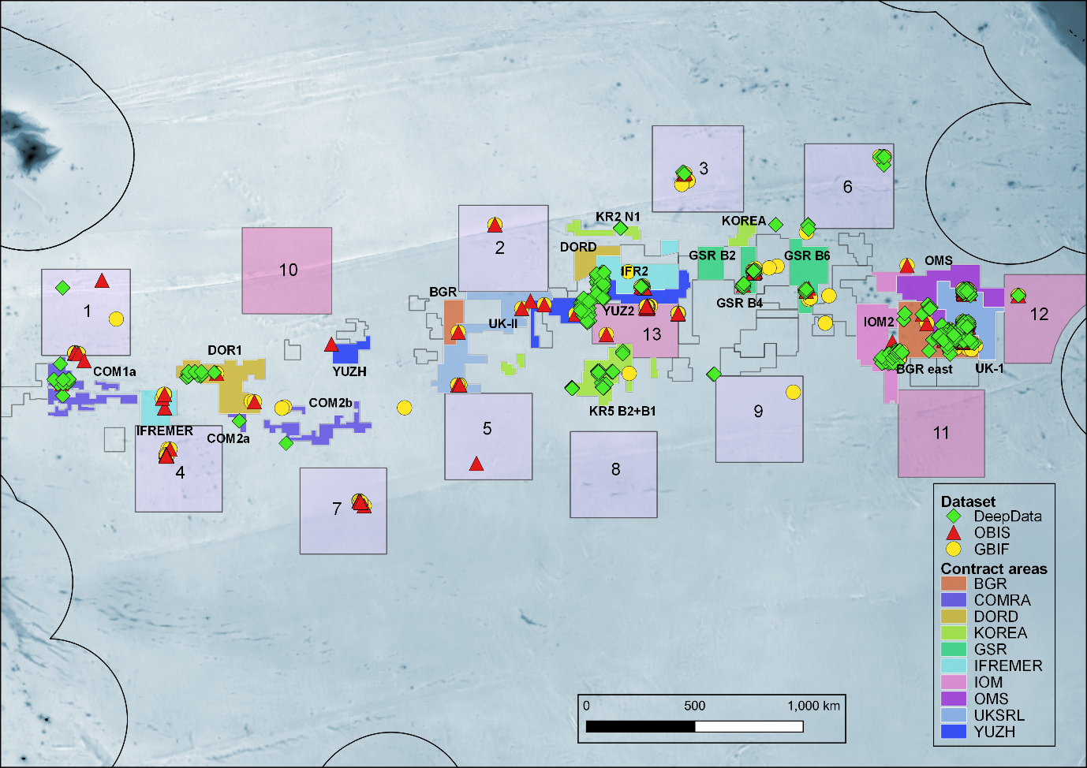S Fig 1: names of contract sub-areas in the Clarion Clipperton Zone

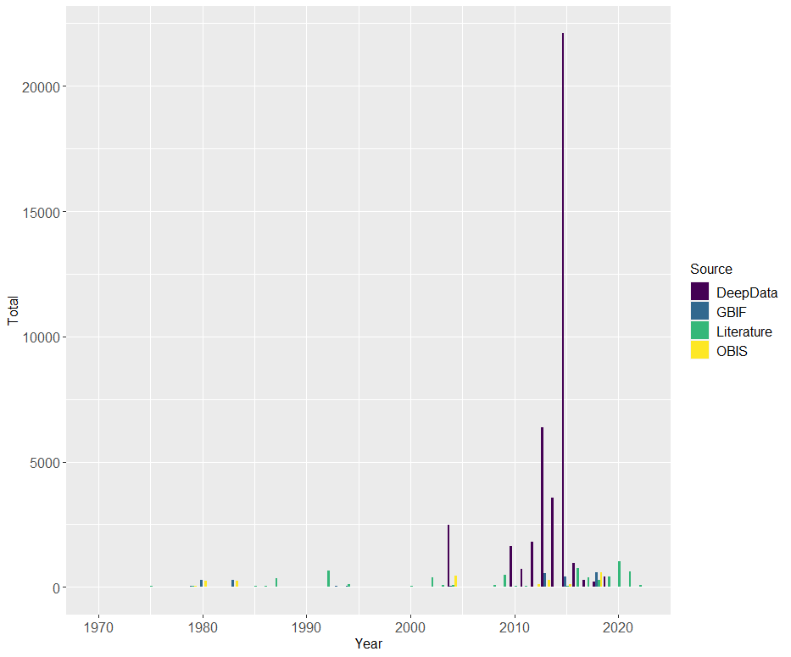

S Fig 2: Temporal coverage of sampling in the Clarion-Clipperton Zone. Record by year of sampling for all data sources from 1970 to the present (earlier records not shown to optimise display).

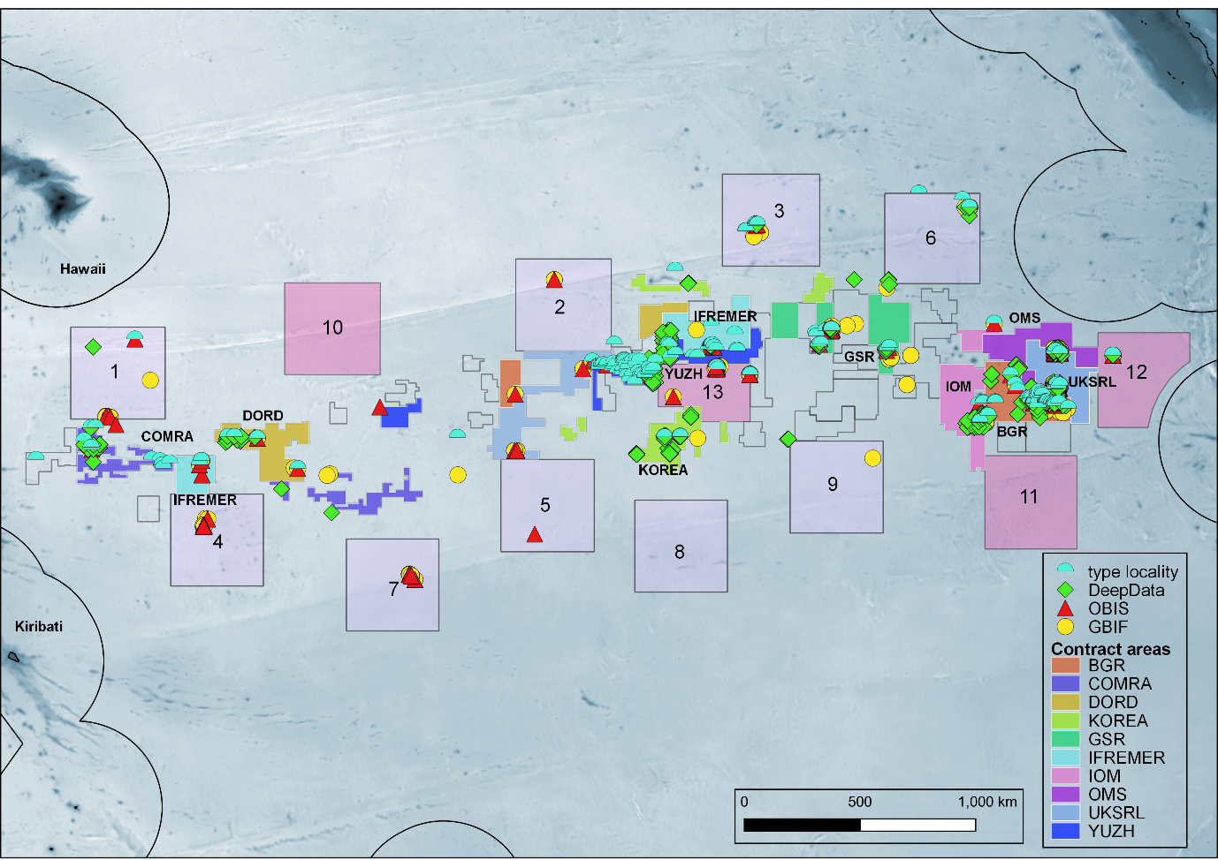

S Fig 3: type localities of species described from the CCZ

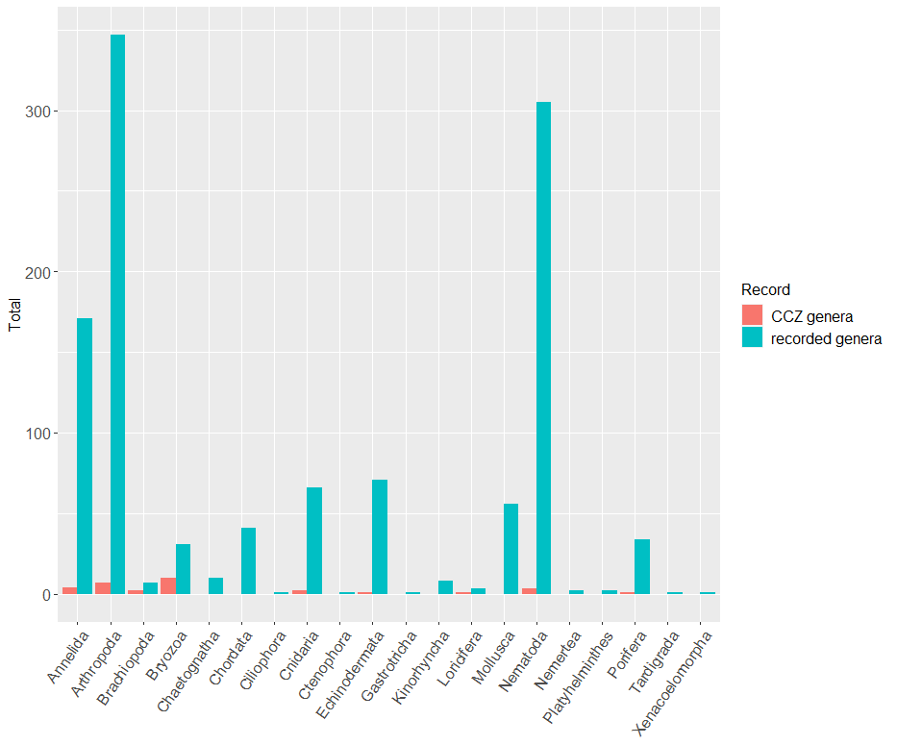

S Fig 4: Assessment of taxonomic effort in the Clarion-Clipperton Zone. Comparison of numbers of (A) CCZ genera (red bars) with numbers of genus names in the CCZ Checklist, i.e. all genera recorded from the CCZ region.

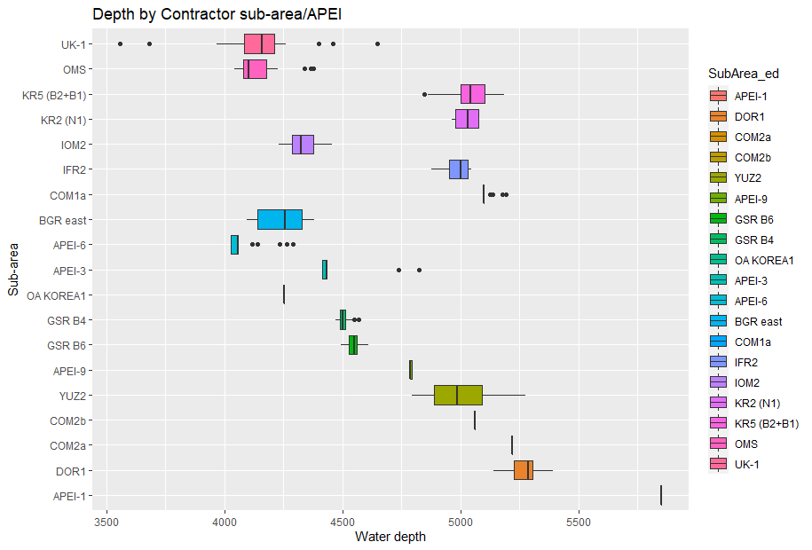

S Fig 5: contract sub-area/APEI by depth

## Supplementary Data Files

Metadata files are provided for all datasets, with the same filename with the suffix ‘_meta’, e.g. “SDF1A_DD_PUBLISHED_main_file_2021-07-12_v10_meta.csv” as shown in the first file, 7.3.1

Note all database downloads from the 12th of July, DeepData (points and lines), OBIS, and GBIF are archived in a separate folder within the Supplementary Data File folder “RAW_DATA_DOWNLOADS_12TH_JULY_ARCHIVE”.

All supplementary data is available for download in the link here: ADD .

### Supplementary Data File 1: DeepData

All biological data records published on DeepData on 12th of July, 2021

File SDF 1A, processed download “SDF1A_DD_PUBLISHED_main_file_2021-07-12_v10.csv”, metadata file “SDF1A_DD_PUBLISHED_main_file_2021-07-12_v10_meta”

File SDF 1B, final for analysis “SDF1B_DD_PUBLISHED_4analysis_ed_2022-05-24.csv”, metadata file “SDF1B_DD_PUBLISHED_4analysis_ed_2022-05-24_meta.csv”

### Supplementary Data File 2: OBIS

Biological records from the CCZ region within ISA jurisdiction- contract areas, reserved areas or APEIs (see Fig 1) published on OBIS, 12th of July, 2021, in Darwin Core format.

File SDF 2A, processed download from all depths from all depths frm the ‘CCZ polygon as specified in methods “SDF2A_OBIS_CCZ_all_depths_2021-07-12_v12 .csv”; metadata file: “SDF2A_OBIS_CCZ_all_depths_2021-07-12_v12_meta.csv”;

File SDF 2B, final dataset for analysis (filtered by depth, DeepData records removed) “SDF2B_OBIS_only_4_analysis_2022-04-21.csv”; metadata file: “SDF2B_OBIS_only_4_analysis_2022-04-21-meta.csv”. File SDF 2B, OBIS ISA node records separated from main dataset: SDF2C_OBIS_DD_4_analysis_2022-04-20 .csv”; metadata file: “SDF2C_OBIS_DD_4_analysis_2022-04-20_meta.csv”. For data collection, selection and processing see methods 2.1.2 & 2.2.2

### Supplementary Data File 3: GBIF

Biological records from the CCZ region within ISA jurisdiction- contract areas, reserved areas or APEIs (see Fig 1) published on GBIF, 12th of July, 2021, in Darwin Core format.

File SDF 3A, processed download from all depths frm the ‘CCZ polygon as specified in methods “SDF3A_GBIF_CCZ_all_depths_2021-07-12_v10.csv”; metadata file: “SDF3A_GBIF_CCZ_all_depths_2021-07-12_v10_meta.csv”;

File SDF 3B, final dataset for analysis

“SDF3B_GBIF_CCZ_4analysis_2022-04-21.csv”; metadata file “SDF3B_GBIF_CCZ_4analysis_2022-04-21_meta.csv”. For data collection, selection and processing see methods 2.1.2 & 2.2.2

### Supplementary Data File 4: INSDC

INSDC records- GenBank and Barcode of Life (BOLD) sequence accessions for the CCZ and related data. (File SDF4 “SDF4_CCZ_GENBANK_2022-06-24.csv”); metadata file: “SDF4_CCZ_GENBANK_2022-06-24_meta.csv”.

### Supplementary Data File 5: Literature

Taxonomic information from the published literature (all collected records of metazoans from the CCZ). (File SDF 5A, table of records (both new species and distributional records) “SDF5A_CCZ_LITERATURE_RECORDS_2022-06-23.csv”; metadata file: “SDF5A_CCZ_LITERATURE_RECORDS_2022-06-23_meta.csv”.

File SDF 5B, table of publications, “SDF5B_CCZ_LITERATURE_PAPERS_2022-06-24.csv”; metadata file: “SDF5B_CCZ_LITERATURE_PAPERS_2022-06-24_meta.csv”

### Supplementary Data File 6: The CCZ Checklist

Checklist of all accepted scientific names recorded from the CCZ, compiled from DeepData, OBIS, GBIF and the published literature. File SDF 6A named species (and records at higher taxonomic level), “SDF6A_CCZ_CHECKLIST_ 2022-06-12.csv”; metadata file: “SDF6A_CCZ_CHECKLIST_2022-06-12_meta.csv”. File SDF 6B morphospecies, “SDF6B_CCZ_MSPP_CHECKLIST_2022-04-24.csv”.

### Supplementary Data File 7: subset of unprocessed Contractor environmental data

Subset of unprocessed annual Contractor environmental data submissions, also referred to as ‘raw files’,

File SDF 7 “SDF7_DD_Contractor_data_raw_files_2021-04-02.csv”

File SDF7_” SDF7_DD_Contractor_data_raw_files_2021-04-02_meta.csv”

### Supplementary Data File 8: Species matrix tables

Species matrix tables: for named species and all (named and morphospecies), by contract area, sub-area and site, provided as excel with tables separated by tab.

File SDF 8 “SDF8_CCZ_SPP_MATRIX_TABLES_2022-04-241.xlsx”.

### Supplementary File 1: ISA Enivronmental Data Reporting Template

ISA environmental data reporting template- version 9th of June, 2021.

File SF 1 “SF1_Env_Template_20181005.xlsx”.

### Supplementary File 2: R script

R script for data collections, processing and analysis; File SF 2A, “CCZ_DD_ANALYSIS_SHORT_2022-04-20.R”

# REFERENCES

## Main report references

Baker, E. and Beaudoin, Y., 2013. Deep Sea Minerals: Manganese Nodules, a physical, biological, environmental, and technical review. *Secretariat of the Pacific Community*, *36*.

Barbosa, A.M. 2015. fuzzySim: applying fuzzy logic to binary similarity indices in ecology. Methods in Ecology and Evolution, 6(7), 853-858. doi:10.1111/2041-210X.12372

Baselga, A., 2010. Partitioning the turnover and nestedness components of beta diversity. Global ecology and biogeography, 19(1), pp.134-143.

Baselga, A. and Orme, C. D. L.: betapart: an R package for the study of beta diversity, Methods in Ecology and Evolution., 3, 808–812, doi:10.1111/j.2041-210X.2012.00224.x, 2012.

Bickford, D., Lohman, D.J., Sodhi, N.S., Ng, P.K., Meier, R., Winker, K., Ingram, K.K. and Das, I., 2007. Cryptic species as a window on diversity and conservation. Trends in ecology & evolution, 22(3), pp.148-155. doi:10.1016/j.tree.2006.11.004

Bingham, H., Doudin, M., Weatherdon, L., Despot-Belmonte, K., Wetzel, F., Groom, Q., et al. 2017. The biodiversity informatics landscape: elements, connections and opportunities. Res. Ideas Outcomes 3:e14059. doi:10.3897/rio.3.e14059

Brandt, A., Gooday, A.J., Brandao, S.N., Brix, S., Brökeland, W., Cedhagen, T., Choudhury, M., Cornelius, N., Danis, B., De Mesel, I. and Diaz, R.J., 2007. First insights into the biodiversity and biogeography of the Southern Ocean deep sea. nature, 447(7142), pp.307-311.

Brix, S., Held, C., Kaiser, S., Jennings, R.M., Driskell, A. and Brandt, A., 2021. Evolution and phylogeny of the deep-sea isopod families Desmosomatidae Sars, 1897 and Nannoniscidae Hansen, 1916 (Isopoda: Asellota). Organisms Diversity & Evolution, 21(4), pp.691-717.

Chao, A., Gotelli, N. J., Hsieh, T., Sander, E. L., Ma, K., Colwell, R. K., et al. (2014). Rarefaction and extrapolation with Hill numbers: a framework for sampling and estimation in species diversity studies. Ecol. Monogr. 84, 45–67. doi: 10.1890/13-0133.1

Chao, A. 1987. “Estimating the Population Size for Capture-Recapture Data with Unequal Catchability.” Biometrics, 783–91

Choi, J.W., Kim, D.S., Hyun, J.H. and Lee, C.H., 2004. Macrozoobenthic communities of the deep sea sediments in the Northeastern Pacific Ocean. Ocean and Polar Research, 26(2), pp.367-376.

Collins, J.E., Rabone, M., Vanagt, T., Amon, D.J., Gobin, J. and Huys, I., 2021. Strengthening the global network for sharing of marine biological collections: recommendations for a new agreement for biodiversity beyond national jurisdiction. *ICES Journal of Marine Science*, *78*(1), pp.305-314., doi:10.1093/icesjms/fsaa227

Conway, J. R., Lex, A., and Gehlenborg, N. 2017. UpSetR: an R package for the visualization of intersecting sets and their properties, Bioinformatics, 33, 2938–2940, doi:10.1093/bioinformatics/btx364, 2017

Colwell, R.K. and Coddington, J.A., 1994. Estimating terrestrial biodiversity through extrapolation. Philosophical Transactions of the Royal Society of London. Series B: Biological Sciences, 345(1311), pp.101-118.

Danovaro, R., Company, J.B., Corinaldesi, C., D'Onghia, G., Galil, B., Gambi, C., Gooday, A.J., Lampadariou, N., Luna, G.M., Morigi, C. and Olu, K., 2010. Deep-sea biodiversity in the Mediterranean Sea: the known, the unknown, and the unknowable. PloS one, 5(8), p.e11832.

Droege, G., Barker, K., Seberg, O., Coddington, J.A. et al. (2016) “The Global Genome Biodiversity Network (GGBN) Data Standard Specification. Database 2016:baw125”. doi:10.1093/database/baw125

Flanders Marine Institute Database (2019) Maritime Boundaries Geodatabase: Maritime Boundaries and Exclusive Economic Zones (200NM), version 11. Available online at https://www.marineregions.org/. doi:10.14284/386

Gehlenborg, N. 2019. UpSetR: A More Scalable Alternative to Venn and Euler Diagrams for

Visualizing Intersecting Sets. R package version 1.4.0.

https://CRAN.R-project.org/package=UpSetR

Glover, A.G.; Higgs, N.; Horton, T. World Register of Deep-Sea Species; Available online:http://www.marinespecies.org/deepsea (accessed Frebuary to October 2021).

Glover, A.G., Wiklund, H., Chen, C. and Dahlgren, T.G., 2018. Point of view: managing a sustainable deep-sea ‘blue economy’requires knowledge of what actually lives there. Elife, 7, p.e41319. doi:10.7554/eLife.41319

Glover, A.G., Smith, C.R., Paterson, G.L.J., Wilson, G.D.F., Hawkins, L. and Sheader, M., 2002. Polychaete species diversity in the central Pacific abyss: local and regional patterns, and relationships with productivity. Marine Ecology Progress Series, 240, pp.157-170.

Gollner, S., Kaiser, S., Menzel, L., Jones, D.O., Brown, A., Mestre, N.C., Van Oevelen, D., Menot, L., Colaço, A., Canals, M. and Cuvelier, D., 2017. Resilience of benthic deep-sea fauna to mining activities. Marine Environmental Research, 129, pp.76-101.

Gooday, A. J., Goineau, A., & Voltski, I. (2015). Abyssal foraminifera attached to polymetallic nodules from the eastern Clarion Clipperton Fracture Zone: a preliminary description and comparison with North Atlantic dropstone assemblages. Marine Biodiversity, 45(3), 391–412. doi:10.1007/s12526-014-0301-9

Gooday AJ, Holzmann M, Caulle C, Goineau A, Kamenskaya O, Weber AA-T, Pawlowski J (2017) Giant protists (xenophyophores, Foraminifera) are exceptionally diverse in parts of the abyssal eastern Pacific licensed for polymetallic nodule exploration. Biological Conservation 207: 106–116. https://doi.org/10.1016/j.biocon.2017.01.006

Gooday AJ, Holzmann M, Caulle C, Goineau A, Jones DOB, Kamenskaya O, Simon-Lledó E, Weber AA-T, Pawlowski J (2018d) New species of the xenophyophore genus Aschemonella (Rhizaria: Foraminifera) from areas of the abyssal eastern Pacific licensed for polymetallic nodule exploration. Zoological Journal of the Linnean Society 182: 479–499. https://doi.org/10.1093/zoolinnean/zlx052

Gooday AJ, Holzmann M, Goineau A, Pearce RB, Voltski I, Weber AA-T, Pawlowski J (2018b) Five new species and two new genera of xenophyophores (Foraminifera: Rhizaria) from part of the abyssal equatorial Pacific licensed for polymetallic nodule exploration. Zoological Journal of the Linnean Society 183: 723–748. doi:10.1093/zoolinnean/zlx093

Gooday AJ, Holzmann M, Goineau A, Kamenskaya O, Melnik VF, Pearce RB, Weber AA-T, Pawlowski J (2018c) Xenophyophores (Rhizaria, Foraminifera) from the Eastern Clarion-Clipperton Zone (equatorial Pacific): the Genus Psammina. Protist 169: 926–957. https://doi.org/10.1016/j.protis.2018.09.003

Gooday AJ, Durden JM, Holzmann M, Pawlowski J, Smith CR (2020b) Xenophyophores (Rhizaria, Foraminifera), including four new species and two new genera, from the western Clarion-Clipperton Zone (abyssal equatorial Pacific). European Journal of Protistology 75: 125715. https://doi.org/10.1016/j.ejop.2020.125715

Guralnick, R.P., Cellinese, N., Deck, J., Pyle, R.L. et al. (2015) “Community Next Steps for Making Globally Unique Identifiers Work for Biocollections Data”. ZooKeys 494: 133–154. doi:10.3897/zookeys.494.9352

Guralnick, R., Conlin, T., Deck, J., Stucky, B.J. and Cellinese, N. (2014) “The Trouble with Triplets in Biodiversity Informatics: A Data-Driven Case against Current Identifier Practices”. PLoS ONE 9(12): e114069. doi:10.1371/journal.pone.0114069

Hall, C.E. and Gurnis, M., 2005. Strength of fracture zones from their bathymetric and gravitational evolution. Journal of Geophysical Research: Solid Earth, 110(B1).

Herrington, R., 2021. Mining our green future. Nature Reviews Materials, 6(6), pp.456-458.

Hessler, R.R. and Jumars, P.A., 1974, March. Abyssal community analysis from replicate cores in the central North Pacific. Deep Sea Research and Oceanographic Abstracts 21: 185–209. doi:10.1016/0011-7471(74)90058-8

Higgs, N.D. and Attrill, M., 2015. Biases in biodiversity: wide-ranging species are discovered first in the deep sea. Frontiers in Marine Science, 2, p.61.

Hill, Mark O. 1973. “Diversity and Evenness: A Unifying Notation and Its Consequences.” Ecology 54 (2): 427–32.

Horton, T., Marsh, L., Bett, B.J., Gates, A.R., Jones, D.O., Benoist, N., Pfeifer, S., Simon-Lledó, E., Durden, J.M., Vandepitte, L. and Appeltans, W., 2021. Recommendations for the standardisation of open taxonomic nomenclature for image-based identifications. Frontiers in Marine Science, 8, p.62. doi:10.3389/fmars.2021.620702

Horton, T., Gofas, S., Kroh, A., Poore, G.C., Read, G., Rosenberg, G., Stöhr, S., Bailly, N., Boury-Esnault, N., Brandão, S.N. and Costello, M.J., 2017. Improving nomenclatural consistency: a decade of experience in the World Register of Marine Species. European Journal of Taxonomy, (389). doi:10.5852/ejt.2017.389

Hsieh, T. C., Ma, K. H., and Chao, A., 2020. iNEXT: iNterpolation and

EXTrapolation for Species Diversity. R Package Version 2.0.20. Available online

at: http://chao.stat.nthu.edu.tw/wordpress/software-download/ (Online)

(accessed January 28, 2020).

Humphries, F., Rabone, M. and Jaspars, M., 2021. Traceability Approaches for marine genetic resources under the proposed Ocean (BBNJ) Treaty. Frontiers in Marine Science, 8, 661313; doi:10.3389/fmars.2021.661313

Jaspars, M., Rabone, M., Humphries, F., 2021. Tracing Options for Marine Genetic Resources from within National Jurisdictions; Report prepared for Commonwealth Secretariat.

Jażdżewska, A.M., Horton, T., Hendrycks, E., Mamos, T., Driskell, A.C., Brix, S. and Arbizu, P.M., 2021. Pandora’s Box in the Deep Sea–Intraspecific Diversity Patterns and Distribution of Two Congeneric Scavenging Amphipods. Frontiers in Marine Science. doi:10.3389/fmars.2021.750180

Jones, D.O., Simon-Lledó, E., Amon, D.J., Bett, B.J., Caulle, C., Clément, L., Connelly, D.P., Dahlgren, T.G., Durden, J.M., Drazen, J.C. and Felden, J., 2021. Environment, ecology, and potential effectiveness of an area protected from deep-sea mining (Clarion Clipperton Zone, abyssal Pacific). *Progress in Oceanography*, *197*, p.102653.

Jones, D.O., Kaiser, S., Sweetman, A.K., Smith, C.R., Menot, L., Vink, A., Trueblood, D., Greinert, J., Billett, D.S., Arbizu, P.M. and Radziejewska, T., 2017. Biological responses to disturbance from simulated deep-sea polymetallic nodule mining. PLoS One, 12(2), p.e0171750.

Jost, L., 2006. Entropy and diversity. Oikos 113, 363–375.

Kaiser, S., Smith, C. and Martinez Arbizu, P., 2017. Editorial: Biodiversity of the Clarion Clipperton Fracture Zone, Marine Biodivers., 47, 259–264.

Kamenskaya O, Gooday AJ, Radziejewska T, Wawrzyniak-Wydrowska B (2012) Large, enigmatic foraminiferan-like protists in the eastern part of the Clarion-Clipperton Fracture Zone (abyssal north-eastern subequatorial Pacific): biodiversity and vertical distribution in the sediment. Marine Biodiversity 42: 311–327. https://doi.org/10.1007/s12526-012-0114-7

Kamenskaya O, Melnik VF, Gooday AJ (2013) Giant protists (xenophyophores and komokiaceans) from the Clarion-Clipperton ferromanganese nodule field (eastern Pacific). Biology Bulletin Reviews 3: 388–398. https://doi.org/10.1134/S2079086413050046

Kamenskaya, O. E., Gooday, A. J., Tendal, O. S.,&Melnik, V. F. (2015). Xenophyophores (Protista, Foraminifera) from the Clarion-Clipperton Fracture Zone with description of three new species. Marine Biodiversity, 45(3), 581–593. doi:10.1007/s12526-015-0330-z

Kamenskaya O, Gooday AJ, Tendal OS, Melnik VF (2017) Xenophyophores (Rhizaria, Foraminifera) from the Russian license area of the Clarion-Clipperton Zone (eastern equatorial Pacific), with the description of three new species. Marine Biodiversity 47: 299–306. https://doi.org/10.1007/s12526-016-0595-x

Kembel S, Cowan P, Helmus M, Cornwell W, Morlon H, Ackerly D, Blomberg S, Webb C (2010). “Picante: R tools for integrating phylogenies and ecology.” Bioinformatics, 26, 1463–1464.

Kim, D.S., Hyun, J.H., Choi, J.W., Lee, K.Y. 2000. Meiobenthic Faunal Communities of the Deep-sea Sediments in the Northeastern Pacific along a Latitudinal Transect. The Sea: Journal of the Korean Society of Oceanography, 5(3), pp.245-254.

Klein, E., Appeltans, W., Provoost, P., Saeedi, H., Benson, A., Bajona, L., Peralta, A.C. and Bristol, R., 2019. OBIS infrastructure, lessons learned, and vision for the future. Frontiers in Marine Science, 6, p.588.

Koleff, Patricia, Kevin J Gaston, and Jack J Lennon. 2003. “Measuring Beta Diversity for Presence–Absence Data.” Journal of Animal Ecology 72 (3): 367–82.

Langenkämper, D., M. Zurowietz, T. Schoening, and T. W. Nattkemper. 2017. BIIGLE 2.0 - Browsing and Annotating Large Marine Image Collections. Frontiers in Marine Science 4:10.

Le, J.T., Levin, L.A., Lejzerowicz, F., Cordier, T., Gooday, A.J. and Pawlowski, J., 2022. Scientific and budgetary trade‐offs between morphological and molecular methods for deep‐sea biodiversity assessment. Integrated Environmental Assessment and Management, 18(3), pp.655-663.

Levin, L.A., Bett, B.J., Gates, A.R., Heimbach, P., Howe, B.M., Janssen, F., McCurdy, A., Ruhl, H.A., Snelgrove, P., Stocks, K.I. and Bailey, D., 2019. Global observing needs in the deep ocean. Frontiers in Marine Science, 6, p.241. doi: 10.3389/fmars.2019.00241

Lins, L., Zeppilli, D., Menot, L., Michel, L.N., Bonifácio, P., Brandt, M., Pape, E., Rossel, S., Uhlenkott, K., Macheriotou, L. and Bezerra, T.N., 2021. Toward a reliable assessment of potential ecological impacts of deep‐sea polymetallic nodule mining on abyssal infauna. Limnology and Oceanography: Methods, 19(9), pp.626-650.

Mayer, L., Jakobsson, M., Allen, G., Dorschel, B., Falconer, R., Ferrini, V., Lamarche, G., Snaith, H. and Weatherall, P., 2018. The Nippon Foundation—GEBCO seabed 2030 project: The quest to see the world’s oceans completely mapped by 2030. Geosciences, 8(2), p.63.

Mincks, S. and Smith, C., 2006. Critical Review of Benthic Biological Data from the Clarion-Clipperton Zone (CCZ) and Adjoining Areas Project: Development of Benthic Biological Parameters for Input into the Geological Model (GEOLOGICAL MODEL PHASE 2).

Moher D, Liberati A, Tetzlaff J, Altman DG. Preferred Reporting Items for Systematic Reviews and Meta-Analyses: The PRISMA Statement. PLoS Medicine. 2009; 6(7):e1000097. https://doi.org/10.1371/journal.pmed.1000097

Moraga, P., Cano, J., Baggaley, R.F., Gyapong, J.O., Njenga, S.M., Nikolay, B., Davies, E., Rebollo, M.P., Pullan, R.L., Bockarie, M.J. and Hollingsworth, T.D., 2015. Modelling the distribution and transmission intensity of lymphatic filariasis in sub-Saharan Africa prior to scaling up interventions: integrated use of geostatistical and mathematical modelling. Parasites & vectors, 8(1), pp.1-16.

McQuaid, K.A., Attrill, M.J., Clark, M.R., Cobley, A., Glover, A.G., Smith, C.R. and Howell, K.L., 2020. Using habitat classification to assess representativity of a protected area network in a large, data-poor area targeted for deep-sea mining. Frontiers in Marine Science, 7, p.1066.

Mullineaux, L.S., 1987. Organisms living on manganese nodules and crusts: distribution and abundance at three North Pacific sites. Deep Sea Research Part A. Oceanographic Research Papers, 34(2), pp.165-184.

Neal, L., Wiklund, H., Gunton, L. M., Rabone, M., Bribiesca-Contreras, G., Dahlgren, T. G., Glover, A. G. G. 2022. Abyssal fauna of polymetallic nodule exploration areas, eastern Clarion-Clipperton Zone, central Pacific Ocean: Annelida: Amphinomidae and Euphrosinidae. Zookeys, *In review*

Neal, L., Wiklund, H., Rabone, M., Dahlgren, T. G., Glover, A. G. G. 2022. Abyssal fauna of polymetallic nodule exploration areas, eastern Clarion-Clipperton Zone, central Pacific Ocean: Annelida: Spionidae and Poecilochaetidae. Marine Biodiversity, *in press*

OBIS (2021) Ocean Biodiversity Information System. Intergovernmental Oceanographic Commission of UNESCO. www.obis.org.

Oksanen, J., Blanchet, G., Friendly, M., Kindt, R., Legendre, P., Mcglinn, D., et al., 2018. vegan: Community Ecology Package. R package Version 2.4-6. Available online at: http://CRAN.Rproject.org/package=vegan.

(accessed Sept 27, 2021).

Poore, G.C., Avery, L., Błażewicz-Paszkowycz, M., Browne, J., Bruce, N.L., Gerken, S., Glasby, C., Greaves, E., McCallum, A.W., Staples, D. and Syme, A., 2015. Invertebrate diversity of the unexplored marine western margin of Australia: taxonomy and implications for global biodiversity. Marine Biodiversity, 45(2), pp.271-286.

Provoost P and Bosch S (2017). “robis: R Client to access data from the OBIS API.” Ocean Biogeographic Information System. Intergovernmental Oceanographic Commission of UNESCO. R package version 1.0.0, <https://cran.r-project.org/package=robis>.

Rabone, M., Harden-Davies, H., Collins, J.E., Zajderman, S., Appeltans, W., Droege, G., Brandt, A., Pardo-Lopez, L., Dahlgren, T.G., Glover, A.G. and Horton, T., 2019. Access to Marine Genetic Resources (MGR): raising awareness of best-practice through a new agreement for Biodiversity Beyond National Jurisdiction (BBNJ). Frontiers in Marine Science, 6, p.520. doi:10.3389/fmars.2019.00520

The Royal Society (2017) Future Ocean Resources: Metal-Rich Minerals and Genetics – Evidence Pack. London: The Royal Society.

Rue, H., Martino, S. and Chopin, N., 2009. Approximate Bayesian inference for latent Gaussian models by using integrated nested Laplace approximations. Journal of the royal statistical society: Series b (statistical methodology), 71(2), pp.319-392.

Sigovini, M., Keppel, E. and Tagliapietra, D., 2016. Open Nomenclature in the biodiversity era. Methods in Ecology and Evolution, 7(10), pp.1217-1225.

Simon-Lledó, E., Thompson, S., Yool, A., Flynn, A., Pomee, C., Parianos, J. and Jones, D.O., 2019. Preliminary observations of the abyssal megafauna of Kiribati. Frontiers in Marine Science, p.605.

Simon-Lledó, E., Bett, B.J., Huvenne, V.A., Köser, K., Schoening, T., Greinert, J. and Jones, D.O., 2019. Biological effects 26 years after simulated deep-sea mining. Scientific reports, 9(1), pp.1-13.

Sinniger, F., Pawlowski, J., Harii, S., Gooday, A.J., Yamamoto, H., Chevaldonné, P., Cedhagen, T., Carvalho, G. and Creer, S., 2016. Worldwide analysis of sedimentary DNA reveals major gaps in taxonomic knowledge of deep-sea benthos. Frontiers in Marine Science, 3, p.92.

Smith, C. R., Washburn, T., Menot, L., Bonifacio, P., Pape, E., Ju, S. J., et al.

(2019). “Deep-sea biodiversity synthesis workshop - Macrofaunal report,” in

Proceedings of the Deep CCZ Biodiversity Synthesis Workshop (Friday Harbor,

WA: University of Hawaii at Manoa & International Seabed Authority

Smith CR, Clark MR, Goetze E, Glover AG and Howell KL (2021) Editorial: Biodiversity, Connectivity and Ecosystem Function Across the Clarion-Clipperton Zone: A Regional Synthesis for an Area Targeted for Nodule Mining. Front. Mar. Sci. 8:797516. doi: 10.3389/fmars.2021.797516

Sorensen, T.A., 1948. A method of establishing groups of equal amplitude in plant sociology based on similarity of species content and its application to analyses of the vegetation on Danish commons. *Biol. Skar.*, *5*, pp.1-34.

Stephenson, F., Rowden, A.A., Anderson, O.F., Pitcher, C.R., Pinkerton, M.H., Petersen, G. and Bowden, D.A., 2021. Presence-only habitat suitability models for vulnerable marine ecosystem indicator taxa in the South Pacific have reached their predictive limit. ICES Journal of Marine Science.

Stratmann, T., Soetaert, K., Kersken, D. and van Oevelen, D., 2021. Polymetallic nodules are essential for food-web integrity of a prospective deep-seabed mining area in Pacific abyssal plains. Scientific reports, 11(1), pp.1-11.

Uhlenkott, K., Vink, A., Kuhn, T., Gillard, B. and Martínez Arbizu, P., 2021. Meiofauna in a Potential Deep-Sea Mining Area—Influence of Temporal and Spatial Variability on Small-Scale Abundance Models. Diversity, 13(1), p.3.

Vandepitte, L., Vanhoorne, B., Decock, W., Vranken, S., Lanssens, T., Dekeyzer, S., et al. (2018) A decade of the World Register of Marine Species - General insights and experiences from the Data Management Team: Where are we, what have we learned and how can we continue? PLoS ONE 13 (4): e0194599. doi:10.1371/journal.pone.0194599

Veillette, J., Sarrazin, J., Gooday, A.J., Galéron, J., Caprais, J.C., Vangriesheim, A., Étoubleau, J., Christian, J.R. and Juniper, S.K., 2007. Ferromanganese nodule fauna in the Tropical North Pacific Ocean: Species richness, faunal cover and spatial distribution. Deep Sea Research Part I: Oceanographic Research Papers, 54(11), pp.1912-1935.

Washburn, T.W., Jones, D.O., Wei, C.L. and Smith, C.R., 2021. Environmental heterogeneity throughout the clarion-clipperton zone and the potential representativity of the APEI network. Frontiers in Marine Science, 8, p.319.

Whittaker, Robert H. 1972. “Evolution and Measurement of Species Diversity.” Taxon 21 (2-3): 213–51.

Wickham et al., (2019). Welcome to the tidyverse. Journal of Open Source Software, 4(43), 1686, doi:10.21105/joss.01686

Wickham, H. and Grolemund, G., 2016. R for data science: import, tidy, transform, visualize, and model data. O'Reilly Media, Inc. Sebastopol, California

Wilkinson, M., Dumontier, M., Aalbersberg, I. et al. “The FAIR Guiding Principles for Scientific Data Management and Stewardship”. Sci Data 3: 160018 (2016). doi:10.1038/sdata.2016.18

WoRMS Editorial Board (2021). World Register of Marine Species. Available from https://www.marinespecies.org at VLIZ. Accessed 2021-11-04. doi:10.14284/170

Zhao, M., Liu, Q., Zhang, D., Liu, Z., Wang, C. and Liu, X., 2020. Deep-sea meiofauna assemblages with special reference to marine nematodes in the Caiwei Guyot and a Polymetallic Nodule Field in the Pacific Ocean. Marine Pollution Bulletin, 160, p.111564

## References for taxonomic literature review

Amon, D.J., Ziegler, A.F., Drazen, J.C., Grischenko, A.V., Leitner, A.B., Lindsay, D.J., Voight, J.R., Wicksten, M.K., Young, C.M. and Smith, C.R., 2017. Megafauna of the UKSRL exploration contract area and eastern Clarion-Clipperton Zone in the Pacific Ocean: Annelida, Arthropoda, Bryozoa, Chordata, Ctenophora, Mollusca. Biodiversity Data Journal, (5).: e14598. doi:10.3897/BDJ.5.e14598

Amon, D.J., Ziegler, A.F., Kremenetskaia, A., Mah, C.L., Mooi, R., O'Hara, T., Pawson, D.L., Roux, M. and Smith, C.R., 2017. Megafauna of the UKSRL exploration contract area and eastern Clarion-Clipperton Zone in the Pacific Ocean: Echinodermata. Biodiversity Data Journal, (5).: e11794. doi:10.3897/BDJ.5.e11794

Amon, D.J., Hilario, A., Arbizu, P.M. and Smith, C.R., 2017. Observations of organic falls from the abyssal Clarion-Clipperton Zone in the tropical eastern Pacific Ocean. Marine Biodiversity, 47(2), pp.311-321. doi:10.1007/s12526-016-0572-4

Amon, D.J., Ziegler, A.F., Dahlgren, T.G., Glover, A.G., Goineau, A., Gooday, A.J., Wiklund, H. and Smith, C.R., 2016. Insights into the abundance and diversity of abyssal megafauna in a polymetallic-nodule region in the eastern Clarion-Clipperton Zone. Scientific Reports, 6(1), pp.1-12.doi:10.1038/srep30492

Amos AF, Daubin SC, Garside CF, Malone TC, Paul AZ, Rice GE, Roels OA. 1975. Report on a Cruise to Study Environmental Base Line Conditions In a Manganese Nodule Province. In Offshore Technology Conference, Dallas, Texas. pp 341-356. OTC-2162, doi:10.4043/2162-MS

Amos, A.F., Roels, O.A. and Paul, A.Z., 1976. Environmental baseline conditions in a manganese-nodule province in April-May 1975. In Offshore Technology Conference, Dallas, Texas, OTC 2456. doi:10.4043/2456-MS

Araujo-Silva, C.L., Froufe, E. and Larsen, K., 2015. Two new species of family Neotanaidae (Peracarida: Tanaidacea) from the Antarctic and Mid-Pacific Oceans. Zootaxa, 4018(4), pp.535-552.

Bai, L., Wang, X., Zhou, Y., Lin, S., Meng, F. and Fontoura, P., 2020. Moebjergarctus clarionclippertonensis, a new abyssal tardigrade (Arthrotardigrada, Halechiniscidae, Euclavarctinae) from the Clarion-Clipperton Fracture Zone, North-East Pacific. Zootaxa, 4755(3), pp.zootaxa-4755.

Bezerra, T.N., Pape, E., Hauquier, F. and Vanreusel, A., 2021. Description and distribution of *Erebussau* nom. nov. pro *Erebus* Bussau, 1993 nec *Erebus* Latreille, 1810 with description of a new species, and of *Odetenema gesarae* gen. nov., sp. nov.(Nematoda: Desmoscolecida) from nodule-bearing abyssal sediments in the Pacific. Zootaxa, 4903(4), pg 542, Zootaxa, 4948(4), pp.600-600.

Bitner, M.A., Melnik, V.P. and Zezina, O.N., 2013. New paedomorphic brachiopods from the abyssal zone of the North-eastern Pacific Ocean. Zootaxa, 3613(3), pp.281-288. doi:10.11646/zootaxa.3613.3.6

Blake, J.A., 2020. New species and records of deep-water Orbiniidae (Annelida, Polychaeta) from the Eastern Pacific continental slope, abyssal Pacific Ocean, and the South China Sea. Zootaxa, 4730(1), pp.1-61. doi:10.11646/zootaxa.4730.1.1

Blake, J.A., 2019. New species of Cirratulidae (Annelida, Polychaeta) from abyssal depths of the Clarion-Clipperton Fracture Zone, North Equatorial Pacific Ocean. Zootaxa, 4629(2), pp.151-187.

Blake, J.A., 2017. Polychaeta Orbiniidae from Antarctica, the Southern Ocean, the Abyssal Pacific Ocean, and off South America. Zootaxa, 4218(1), pp.1-145.

Blake, J.A., 2016. Kirkegaardia (Polychaeta, Cirratulidae), new name for *Monticellina* Laubier, preoccupied in the Rhabdocoela, together with new records and descriptions of eight previously known and sixteen new species from the Atlantic, Pacific, and Southern Oceans. Zootaxa, 4166(1), pp.1-93.

Błażewicz, M., Jóźwiak, P., Jennings, R.M., Studzian, M. and Frutos, I., 2019a. Integrative systematics and ecology of a new deep-sea family of tanaidacean crustaceans. Scientific reports, 9(1), pp.1-70. doi:10.1038/s41598-019-53446-1

Błażewicz, M., Jóźwiak, P., Menot, L. and Pabis, K., 2019b. High species richness and unique composition of the tanaidacean communities associated with five areas in the Pacific polymetallic nodule fields. Progress in Oceanography, 176, p.102141. doi:10.1016/j.pocean.2019.102141

Bluhm, H., 1994. Monitoring megabenthic communities in abyssal manganese nodule sites of the East Pacific Ocean in association with commercial deep‐sea mining. Aquatic Conservation: Marine and Freshwater Ecosystems, 4(3), pp.187-201.

Bonifacio, P. and Menot, L., 2019. New genera and species from the Equatorial Pacific provide phylogenetic insights into deep-sea Polynoidae (Annelida). Zoological Journal of the Linnean Society, 185(3), pp.555-635.https://doi.org/10.1093/zoolinnean/zly063

Bonifácio, P., Martínez Arbizu, P. and Menot, L., 2020. Alpha and beta diversity patterns of polychaete assemblages across the nodule province of the eastern Clarion-Clipperton Fracture Zone (equatorial Pacific). Biogeosciences, 17(4), pp.865-886. doi:10.5194/bg-17-865-2020

Bonifácio, P., Neal, L. and Menot, L., 2021. Diversity of deep-sea scale-worms (Polynoidae) in the Clarion-Clipperton Fracture Zone. Frontiers in Marine Science, 8:656899. doi:10.3389/fmars.2021.656899

Bribiesca-Contreras, G., Dahlgren, T. G., Amon, D. J., Cairns, S., Drennan, R., Durden, J. M, Eléaume, M. P., Hosie, A., Kremenetskaia, A., McQuaid, K., O’Hara, T. D., Rabone, M., Simon-Lledó, E., Smith, C. R., Watling, L., Wiklund, H., Glover, A.G., 2022. Benthic megafauna of the western Clarion-Clipperton Zone, Pacific Ocean. ZooKeys, 1113, pp.1-110.

Bribiesca-Contreras, G., Dahlgren, T.G., Drazen, J.C., Drennan, R., Horton, T., Jones, D.O., Leitner, A.B., McQuaid, K., Smith, C.R., Taboada, S. and Wiklund, H., 2021. Biogeography and connectivity across habitat types and geographical scales in Pacific abyssal scavenging amphipods. Frontiers in Marine Science, 8, p.1028.

Brix, S., Held, C., Kaiser, S., Jennings, R.M., Driskell, A. and Brandt, A., 2021. Evolution and phylogeny of the deep-sea isopod families Desmosomatidae Sars, 1897 and Nannoniscidae Hansen, 1916 (Isopoda: Asellota). Organisms Diversity & Evolution, 21(4), pp.691-717.

Brix, S., Osborn, K.J., Kaiser, S., Truskey, S.B., Schnurr, S.M., Brenke, N., Malyutina, M. and Martinez Arbizu, P., 2020. Adult life strategy affects distribution patterns in abyssal isopods–implications for conservation in Pacific nodule areas. Biogeosciences, 17(23), pp.6163-6184.

Cairns, S.D., 2016. New abyssal Primnoidae (Anthozoa: Octocorallia) from the Clarion-Clipperton Fracture Zone, equatorial northeastern Pacific. Marine Biodiversity, 46(1), pp.141-150.

Chim, C.K. and Tong, S.J., 2020. Two new species of paratanaoid tanaidaceans of the family incertae sedis (Crustacea: Peracarida) from polymetallic nodule fields in the eastern Clarion-Clipperton Fracture Zone. Zootaxa, 4758(3), pp.461-485.

Cho, D.H., Wi, J.H. and Suh, H.L., 2016. Two new species of the deep-sea genus Parameiropsis (Copepoda: Harpacticoida) from the eastern central Pacific. Zootaxa, 4132(4), pp.521-539.

Choi, J.W., Kim, D.S., Hyun, J.H. and Lee, C.H., 2004. Macrozoobenthic communities of the deep-sea sediments in the Northeastern Pacific Ocean. Ocean and Polar Research, 26(2), pp.367-376.

Christodoulou, M., O’Hara, T.D., Hugall, A.F. and Arbizu, P.M., 2019. Dark ophiuroid biodiversity in a prospective abyssal mine field. Current Biology, 29(22), pp.3909-3912.

Christodoulou, M., O'Hara, T., Hugall, A.F., Khodami, S., Rodrigues, C.F., Hilario, A., Vink, A. and Martinez Arbizu, P., 2020. Unexpected high abyssal ophiuroid diversity in polymetallic nodule fields of the northeast Pacific Ocean and implications for conservation. Biogeosciences, 17(7), pp.1845-1876.

Chuar, C.H., Tong, S.J.W., Chim, C.K., San Wong, H.P. and Tan, K.S., 2020. Abyssal macrofaunal community structure in the polymetallic nodule exploration area at the easternmost region of the Clarion-Clipperton Fracture Zone, Pacific Ocean. Deep Sea Research Part I: Oceanographic Research Papers, 161, p.103284.

Cuvelier, D., Ribeiro, P.A., Ramalho, S.P., Kersken, D., Martinez Arbizu, P. and Colaço, A., 2020. Are seamounts refuge areas for fauna from polymetallic nodule fields?. Biogeosciences, 17(9), pp.2657-2680.

Dahlgren, T.G., Wiklund, H., Rabone, M., Amon, D.J., Ikebe, C., Watling, L., Smith, C.R. and Glover, A.G., 2016. Abyssal fauna of the UK-1 polymetallic nodule exploration area, Clarion-Clipperton Zone, central Pacific Ocean: Cnidaria. Biodiversity data journal, (4): e9277. doi:10.3897/BDJ.4.e9277

Decraemer, W. and Gourbault, N., 1997. Deep‐sea nematodes (Nemata, Prochaetosomatinae): new taxa from hydrothermal vents and a polymetallic nodule formation of the Pacific (East Rise; North Fiji and Lau Basins; Clarion‐Clipperton fracture zone). Zoologica scripta, 26(1), pp.1-12.

De Smet, B., Simon-Lledó, E., Mevenkamp, L., Pape, E., Pasotti, F., Jones, D. O., & Vanreusel, A. (2021). The megafauna community from an abyssal area of interest for mining of polymetallic nodules. Deep Sea Research Part I: Oceanographic Research Papers, 172, 103530.

De Smet, B., Pape, E., Riehl, T., Bonifácio, P., Colson, L. and Vanreusel, A., 2017. The community structure of deep-sea macrofauna associated with polymetallic nodules in the eastern part of the Clarion-Clipperton Fracture Zone. *Frontiers in Marine Science*, *4*, p.103.

Drazen, J.C., Leitner, A.B., Jones, D.O. and Simon-Lledó, E., 2021. Regional variation in communities of demersal fishes and scavengers across the Clarion Clipperton Zone and Pacific ocean. Frontiers in Marine Science, p.1110.

Drennan, R., Wiklund, H., Rabone, M., Georgieva, M. N., Dahlgren, T. G., & Glover, A. G. (2021). Neanthes goodayi sp. nov. (Annelida, Nereididae), a remarkable new annelid species living inside deep-sea polymetallic nodules. European Journal of Taxonomy, 760(1), 160-185. doi:10.5852/ejt.2021.760.1447

Durden, J.M., Putts, M., Bingo, S.R.D., Leitner, A.B., Drazen, J.C., Gooday, A.J., Jones, D.O., Sweetman, A.K., Washburn, T.W. and Smith, C.R., 2021. Megafaunal ecology of the western Clarion Clipperton Zone. Frontiers in Marine Science, 8, p.722.

Foell, E.J. and Pawson, D.L., 1986. Photographs of invertebrate megafauna from abyssal depths of the north-eastern equatorial Pacific Ocean.86:61–68.

Fujimoto, S. and Murakami, C., 2020. A new genus and species of Nanaloricidae (Loricifera: Nanaloricida) from the Clarion-Clipperton Fracture Zone. Zoologischer Anzeiger, 289, pp.177-188.

Fukushima, T., Imajima, M., 1997. A study of a macrobenthos community in a deep sea resedimentation area. Proceedings of International Symposium on Environmental Studies for Deep-Sea Mining, Tokyo, Japan, November 20-21, 1997, pp. 331-335.

Gebruk, A.V., Kremenetskaia, A. and Rouse, G.W., 2020. A group of species “Psychropotes longicauda”(Psychropotidae, Elasipodida, Holothuroidea) from the Kuril-Kamchatka Trench area (North-West Pacific). Progress in Oceanography, 180, p.102222.

Gheerardyn, H. and George, K.H., 2019. Description of a new species of *Neoargestes* Drzycimski, 1967 (Copepoda, Harpacticoida, Argestidae) from the Clarion Clipperton Fracture Zone (Pacific Ocean), with remarks on the systematics of the genus. Marine Biodiversity, 49(4), pp.1891-1912.

Glover, A.G., Wiklund, H., Rabone, M., Amon, D.J., Smith, C.R., O'Hara, T., Mah, C.L. and Dahlgren, T.G., 2016. Abyssal fauna of the UK-1 polymetallic nodule exploration claim, Clarion-Clipperton Zone, central Pacific Ocean: Echinodermata. Biodiversity data journal, (4).

Glover, A.G., Smith, C.R., Paterson, G.L.J., Wilson, G.D.F., Hawkins, L. and Sheader, M., 2002. Polychaete species diversity in the central Pacific abyss: local and regional patterns, and relationships with productivity. Marine Ecology Progress Series, 240, pp.157-170.

Grischenko, A.V., Gordon, D.P. and Melnik, V.P., 2018. Bryozoa (Cyclostomata and Ctenostomata) from polymetallic nodules in the Russian exploration area, Clarion-Clipperton Fracture Zone, eastern Pacific Ocean-taxon novelty and implications of mining. Zootaxa, 4484(1), pp.1-91.

Grischenko, A.V., Gordon, D.P. and Melnik, V.P., 2021. *Vasopora ceramica* n. gen., n. sp.—a new abyssal cyclostome bryozoan from polymetallic nodules in the Russian exploration area, Clarion–Clipperton Fracture Zone, eastern Pacific Ocean. Zootaxa, 5047(4), pp.444-452.

Guggolz, T., Meißner, K., Schwentner, M., Dahlgren, T.G., Wiklund, H., Bonifácio, P. and Brandt, A., 2020. High diversity and pan-oceanic distribution of deep-sea polychaetes: Prionospio and Aurospio (Annelida: Spionidae) in the Atlantic and Pacific Ocean. Organisms Diversity & Evolution, pp.1-17.

Harbour, R.P., Leitner, A.B., Ruehlemann, C., Vink, A. and Sweetman, A.K., 2020. Benthic and Demersal Scavenger Biodiversity in the Eastern End of the Clarion-Clipperton Zone–An Area Marked for Polymetallic Nodule Mining. Frontiers in Marine Science, 7, p.458.

Hauquier, F., Macheriotou, L., Bezerra, T.N., Egho, G., Martínez Arbizu, P. and Vanreusel, A., 2019. Distribution of free-living marine nematodes in the Clarion–Clipperton Zone: implications for future deep-sea mining scenarios. Biogeosciences, 16(18), pp.3475-3489.

Hecker, B, Paul, AZ (1979) Abyssal community structure of the benthic infauna of the eastern equatorial Pacific: DOMES sites A, B, and C. In: Bischoff, JL and Piper, DZ (eds) Marine Geology and Oceanography of the Pacific Manganese Nodule Province, Plenum Press, New York, NY, pp. 287-308.

Herzog, S., Amon, D.J., Smith, C.R. and Janussen, D., 2018. Two new species of *Sympagella* (Porifera: Hexactinellida: Rossellidae) collected from the Clarion-Clipperton Zone, East Pacific. Zootaxa, 4466(1), pp.152-163. doi:10.11646/zootaxa.4466.1.12

Jakiel, A., Palero, F. and Błażewicz, M., 2019. Deep ocean seascape and pseudotanaidae (crustacea: tanaidacea) diversity at the Clarion-Clipperton Fracture Zone. Scientific reports, 9(1), pp.1-49. doi:10.1038/s41598-019-51434-z

Janssen, A., Stuckas, H., Vink, A. and Arbizu, P.M., 2019. Biogeography and population structure of predominant macrofaunal taxa (Annelida and Isopoda) in abyssal polymetallic nodule fields: implications for conservation and management. Marine Biodiversity, 49(6), pp.2641-2658.

Janssen, A., Kaiser, S., Meissner, K., Brenke, N., Menot, L. and Martínez Arbizu, P., 2015. A Reverse Taxonomic Approach to Assess Macrofaunal Distribution Patterns in Abyssal Pacific Polymetallic Nodule Fields. PLoS ONE 10(2): e0117790.

doi:10.1371/journal.pone.0117790

Jażdżewska, A.M., Brandt, A., Martínez Arbizu, P. and Vink, A., 2021a. Exploring the diversity of the deep sea—four new species of the amphipod genus *Oedicerina* described using morphological and molecular methods. Zoological Journal of the Linnean Society. 1-45. doi:10.1093/zoolinnean/zlab032

Jażdżewska, A. M., Horton, T., Hendrycks, E., Mamos, T., Driskell, A. C., Brix, S. and Martínez Arbizu P (2021) Pandora’s Box in the Deep Sea –Intraspecific Diversity Patterns and Distribution of Two Congeneric Scavenging Amphipods. Front. Mar. Sci. 8:750180. doi: 10.3389/fmars.2021.750180

Jones, D.O., Simon-Lledó, E., Amon, D.J., Bett, B.J., Caulle, C., Clément, L., Connelly, D.P., Dahlgren, T.G., Durden, J.M., Drazen, J.C. and Felden, J., 2021. Environment, ecology, and potential effectiveness of an area protected from deep-sea mining (Clarion Clipperton Zone, abyssal Pacific). Progress in Oceanography, 197, p.102653.

Kaiser, S., Kihara, T.C., Brix, S., Mohrbeck, I., Janssen, A. and Jennings, R.M., 2021. Species boundaries and phylogeographic patterns in new species of *Nannoniscus* (Janiroidea: Nannoniscidae) from the equatorial Pacific nodule province inferred from mtDNA and morphology. Zoological Journal of the Linnean Society. zlaa174. doi:10.1093/zoolinnean/zlaa174

Kaiser, S., Brix, S., Kihara, T.C., Janssen, A. and Jennings, R.M., 2018. Integrative species delimitation in the deep-sea genus Thaumastosoma Hessler, 1970 (Isopoda, Asellota, Nannoniscidae) reveals a new genus and species from the Atlantic and central Pacific abyss. Deep Sea Research Part II: Topical Studies in Oceanography, 148, pp.151-179. doi:10.1016/j.dsr2.2017.05.006

Kaiser, S., 2014. New species of *Hebefustis* Siebenaller & Hessler 1977 (Isopoda, Asellota, Nannoniscidae) from the Clarion Clipperton Fracture Zone (equatorial NE Pacific). Zootaxa, 3784(2), pp.101-119.

Kersken, D., Janussen, D. and Arbizu, P.M., 2019. Deep-sea glass sponges (Hexactinellida) from polymetallic nodule fields in the Clarion-Clipperton Fracture Zone (CCFZ), northeastern Pacific: Part II—Hexasterophora. Marine Biodiversity, 49(2), pp.947-987. doi:10.1007/s12526-018-0880-y

Kersken, D., Janussen, D. and Arbizu, P.M., 2018a. Deep-sea glass sponges (Hexactinellida) from polymetallic nodule fields in the Clarion-Clipperton Fracture Zone (CCFZ), northeastern Pacific: Part I–Amphidiscophora. Marine Biodiversity, 48(1), pp.545-573.

Kersken, D., Kocot, K., Janussen, D., Schell, T., Pfenninger, M. and Arbizu, P.M., 2018b. First insights into the phylogeny of deep-sea glass sponges (Hexactinellida) from polymetallic nodule fields in the Clarion-Clipperton Fracture Zone (CCFZ), northeastern Pacific. Hydrobiologia, 811(1), pp.283-293. doi:10.1007/s10750-017-3498-3

Kersten, O., Vetter, E.W., Jungbluth, M.J., Smith, C.R. and Goetze, E., 2019. Larval assemblages over the abyssal plain in the Pacific are highly diverse and spatially patchy. PeerJ, 7, p.e7691.

Kersten, O., Smith, C.R. and Vetter, E.W., 2017. Abyssal near-bottom dispersal stages of benthic invertebrates in the Clarion-Clipperton polymetallic nodule province. Deep Sea Research Part I: Oceanographic Research Papers, 127, pp.31-40.

Khodami, S., Mercado-Salas, N.F. and Martìnez Arbizu, P., 2020. Genus level molecular phylogeny of Aegisthidae Gisbrecht, 1893 (Copepoda: Harpacticoida) reveals morphological adaptations to deep-sea and plagic habitats. BMC evolutionary biology, 20(1), pp.1-17.

Kim, D.S., Hyun, J.H., Choi, J.W., Lee, K.Y. 2000. Meiobenthic Faunal Communities of the Deep-sea Sediments in the Northeastern Pacific along a Latitudinal Transect. The Sea: Journal of the Korean Society of Oceanography, 5(3), pp.245-254.

Kristensen, R.M., Gooday, A.J. and Goineau, A., 2019. Loricifera inhabiting spherical agglutinated structures in the abyssal eastern equatorial Pacific nodule fields. Marine Biodiversity, 49(5), pp.2455-2466.

Kupriyanova, E.K., Bailey-Brock, J. and Nishi, E., 2011. New records of Serpulidae (Annelida, Polychaeta) collected by R/V “Vityaz” from bathyal and abyssal depths of the Pacific Ocean. Zootaxa, 2871(1), pp.43-60.

Laakmann, S., Markhaseva, E.L. and Renz, J., 2019. Do molecular phylogenies unravel the relationships among the evolutionary young “Brafordian” families (Copepoda; Calanoida)? Molecular Phylogenetics and Evolution, 130, pp.330-345.

Laming, S.R., Christodoulou, M., Arbizu, P.M. and Hilário, A., 2021. Comparative reproductive biology of deep-sea ophiuroids inhabiting polymetallic-nodule fields in the Clarion-Clipperton Fracture Zone. Frontiers in Marine Science. 8:663798. doi: 10.3389/fmars.2021.663798

Laroche, O., Kersten, O., Smith, C.R. and Goetze, E., 2020. From sea surface to seafloor: a benthic allochthonous eDNA survey for the abyssal ocean. Frontiers in Marine Science, 7, p.682. doi:10.3389/fmars.2020.00682

Larsen, K. and Araujo-Silva, C., 2014. A new genus of Colletteidae (Crustacea: Peracarida: Tanaidacea) from the Pacific with comments on dimorphic males with species specific characters. Journal of the Marine Biological Association of the United Kingdom, 94(5), pp.969-974.

Larsen, K., 2011a. Tanaidaceans (Crustacea) from the Central Pacific Manganese Nodule Province. I. The genera *Collettea, Robustochelia* and *Tumidochelia*. ZooKeys, (87), p.19.

Larsen, K., 2011b. The tanaidacean assemblage from the Central Pacific Manganese Nodule Province. II. The genera *Stenotanais* and *Typhlotanais* (Crustacea). Zootaxa, 3088(1), pp.39-53.

Larsen, K., 1999. Pacific Tanaidacea (Crustacea): Revision of the genus *Agathotanais* with description of three new species. RECORDS-AUSTRALIAN MUSEUM, 51, pp.99-112.

Leitner, A.B., Drazen, J.C. and Smith, C.R., 2021. Testing the Seamount Refuge Hypothesis for Predators and Scavengers in the Western Clarion-Clipperton Zone. Frontiers in Marine Science, p.1146.

Leitner, A.B., Neuheimer, A.B., Donlon, E., Smith, C.R. and Drazen, J.C., 2017. Environmental and bathymetric influences on abyssal bait-attending communities of the Clarion Clipperton Zone. Deep Sea Research Part I: Oceanographic Research Papers, 125, pp.65-80.

Lejzerowicz, F., Gooday, A.J., Barrenechea Angeles, I., Cordier, T., Morard, R., Apothéloz-Perret-Gentil, L., Lins, L., Menot, L., Brandt, A., Levin, L.A. and Martinez Arbizu, P., 2021. Eukaryotic biodiversity and spatial patterns in the Clarion-Clipperton zone and other abyssal regions: insights from sediment DNA and RNA metabarcoding. Frontiers in Marine Science, 8, p.536.

Lim, S.C., Wiklund, H., Glover, A.G., Dahlgren, T.G. and Tan, K.S., 2017. A new genus and species of abyssal sponge commonly encrusting polymetallic nodules in the Clarion-Clipperton Zone, East Pacific Ocean. Systematics and biodiversity, 15(6), pp.507-519. doi:10.1080/14772000.2017.1358218

Lörz, A.N. and Horton, T., 2021. Investigation of the Amathillopsidae (Amphipoda, Crustacea), including the description of a new species, reveals a clinging lifestyle in the deep sea worldwide. ZooKeys, 1031, p.19.

Macheriotou, L., Rigaux, A., Derycke, S. and Vanreusel, A., 2020. Phylogenetic clustering and rarity imply risk of local species extinction in prospective deep-sea mining areas of the Clarion–Clipperton Fracture Zone. Proceedings of the Royal Society B, 287(1924), p.201

Maciolek, N.J., 2020. Anguillosyllis (Annelida: Syllidae) from multiple deep-water locations in the northern and southern hemispheres. Zootaxa, 4793(1), pp.1-73.92666.

Mahatma, R., 2009. Meiofauna communities of the Pacific Nodule Province: abundance, diversity and community structure (Doctoral dissertation, Universität Oldenburg).

Mahatma, R., Arbizu, P.M. and Ivanenko, V.N., 2008. A new genus and species of Brychiopontiidae Humes, 1974 (Crustacea: Copepoda: Siphonostomatoida) associated with an abyssal holothurian in the Northeast Pacific nodule province. Zootaxa, 1866(1), pp.290-302.

Malyutina, M.V., Kihara, T.C. and Brix, S., 2020. A new genus of Munnopsidae Lilljeborg, 1864 (Crustacea, Isopoda), with descriptions of two abyssal new species from the Clarion Clipperton Fracture Zone, north-eastern tropical Pacific. Marine Biodiversity, 50, pp.1-31. doi:10.1007/s12526-020-01061-z

Malyutina, M.V., 2011. Description of two new species of munnopsid isopods (Crustacea: Isopoda: Asellota) from manganese nodules area of the Clarion-Clipperton Fracture Zone, Pacific Ocean. Zootaxa, 2783(1), pp.1-20.

Markhaseva, E.L., Mohrbeck, I. and Renz, J., 2017. Description of *Pseudeuchaeta vulgaris* n. sp. (Copepoda: Calanoida), a new aetideid species from the deep Pacific Ocean with notes on the biogeography of benthopelagic aetideid calanoids. Marine Biodiversity, 47(2), pp.289-297. doi:10.1007/s12526-016-0527-9

Matsuyama, K., Janssen, A., Arbizu, P.M., Martha, S.O. and Freiwald, A., 2014. Bryozoans from RV Sonne deep-sea cruises SO 167 ‘Louisville’and SO 205 ‘Mangan’. Zootaxa, 3856(1), pp.100-116.

Menzel, L., 2011. First descriptions of copepodid stages, sexual dimorphism and intraspecific variability of Mesocletodes Sars, 1909 (Copepoda, Harpacticoida, Argestidae), including the description of a new species with broad abyssal distribution. ZooKeys, (96), p.39.

Mercado-Salas, N.F., Khodami, S. and Martínez Arbizu, P., 2019. Convergent evolution of mouthparts morphology between Siphonostomatoida and a new genus of deep-sea Aegisthidae Giesbrecht, 1893 (Copepoda: Harpacticoida). Marine Biodiversity, 49(4), pp.1635-1655. doi:10.1007/s12526-018-0932-3

Miljutin, D.M. and Miljutina, M.A., 2016. Intraspecific variability of morphological characters in the species-rich deep-sea genus Acantholaimus Allgén, 1933 (Nematoda: Chromadoridae). Nematology, 18(4), pp.455-473.

Miljutin, D., Miljutina, M. and Messié, M., 2015. Changes in abundance and community structure of nematodes from the abyssal polymetallic nodule field, Tropical Northeast Pacific. Deep Sea Research Part I: Oceanographic Research Papers, 106, pp.126-135.

Miljutin, D.M., Miljutina, M.A., Arbizu, P.M. and Galéron, J., 2011. Deep-sea nematode assemblage has not recovered 26 years after experimental mining of polymetallic nodules (Clarion-Clipperton Fracture Zone, Tropical Eastern Pacific). Deep Sea Research Part I: Oceanographic Research Papers, 58(8), pp.885-897.

Miljutina, M.A. and Miljutin, D.M., 2012. Seven new and four known species of the genus *Acantholaimus* (Nematoda: Chromadoridae) from the abyssal manganese nodule field (Clarion-Clipperton Fracture Zone, North-Eastern Tropical Pacific). Helgoland Marine Research, 66(3), pp.413-462.

Miljutina, M.A., Miljutin, D.M., Mahatma, R. and Galéron, J., 2010. Deep-sea nematode assemblages of the Clarion-Clipperton Nodule Province (tropical north-eastern Pacific). Marine Biodiversity, 40(1), pp.1-15. doi:10.1007/s12526-009-0029-0

Min, W.G., Kim, D., Rho, H.S., Chi, S.B. and Son, S.K., 2018. Distribution and variability of the meiobenthic assemblages near the Korean polymetallic nodule claim area of the Clarion-Clipperton Fracture zone (subequatorial NE Pacific). Ocean Science Journal, 53(2), pp.315-336.

Mohrbeck, I., Horton, T., Jażdżewska, A.M. and Arbizu, P.M., 2021. DNA barcoding and cryptic diversity of deep-sea scavenging amphipods in the Clarion-Clipperton Zone (Eastern Equatorial Pacific). Marine Biodiversity, 51(2), pp.1-15.

Molodtsova, T.N. and Opresko, D.M., 2017. Black corals (Anthozoa: Antipatharia) of the clarion-clipperton fracture zone. Marine Biodiversity, 47(2), pp.349-365. doi:10.1007/s12526-017-0659-6

Morgan, C. L., Nichols, J. A., Selk, B. W., Toth, J. R. and Wallin, C. 1993. ‘Preliminary analysis of exploration data from Pacific deposits of manganese nodules’, Marine Georesources and Geotechnology, 11, 1-25.

Mullineaux, L.S., 1987. Organisms living on manganese nodules and crusts: distribution and abundance at three North Pacific sites. Deep Sea Research Part A. Oceanographic Research Papers, 34(2), pp.165-184.

Neal, L., Wiklund, H., Gunton, L. M., Rabone, M., Bribiesca-Contreras, G., Dahlgren, T. G., Glover, A. G. G. 2022. Abyssal fauna of polymetallic nodule exploration areas, eastern Clarion-Clipperton Zone, central Pacific Ocean: Annelida: Amphinomidae and Euphrosinidae. *In preparation*

Neal, L., Wiklund, H., Rabone, M., Dahlgren, T. G., Glover, A. G. G. 2022. Abyssal fauna of polymetallic nodule exploration areas, eastern Clarion-Clipperton Zone, central Pacific Ocean: Annelida: Spionidae and Poecilochaetidae. Marine Biodiversity, *in press*

O’Loughlin, P. M. and Ahearn, C., 2005. A review of pygal-furrowed Synallactidae (Echinodermata: Holothuroidea), with new species from the Antarctic, Atlantic and Pacific oceans. Memoirs of Museum Victoria, 62(2), pp.147-179.

Pape, E., Bezerra, T.N., Gheerardyn, H., Buydens, M., Kieswetter, A. and Vanreusel, A., 2021. Potential impacts of polymetallic nodule removal on deep-sea meiofauna. Scientific reports, 11(1), pp.1-15.

Pape, E., Bezerra, T.N., Hauquier, F. and Vanreusel, A., 2017. Limited spatial and temporal variability in meiofauna and nematode communities at distant but environmentally similar sites in an area of interest for deep-sea mining. Frontiers in Marine Science, 4, p.205.

Park, H.S., Chi, S.B., Paik, S.K. and Kim, W.S., 2004. Responses of benthic animals in spatial distribution to the sedimentary environments on the deep-sea floor, the Clarion-Clipperton fracture zone, Northeastern Pacific Ocean. Ocean and Polar Research, 26(2), pp.311-321.

Pasotti; Francesca, P., Mevenkamp, L., Pape, E., Błażewicz, M., Bonifácio, P., Riehl, T., De Smet, B., Lefaible, N., Lins, L. and Vanreusel, A., 2021. A local scale analysis of manganese nodules influence on the Clarion-Clipperton Fracture Zone macrobenthos. Deep Sea Research Part I: Oceanographic Research Papers, 168, p.103449.

Patel, T., Robert, H., D'Udekem D'Acoz, C., Martens, K., Mesel, I.D., Degraer, S. and Schön, I., 2020. Biogeography and community structure of abyssal scavenging Amphipoda (Crustacea) in the Pacific Ocean. Biogeosciences, 17(10), pp.2731-2744.

Paterson, G.L., Neal, L., Altamira, I., Soto, E.H., Smith, C.R., Menot, L., Billett, D.S., Cunha, M.R., Marchais-Laguionie, C. and Glover, A.G., 2016. New *Prionospio* and *Aurospio* species from the deep sea (Annelida: Polychaeta). Zootaxa, 4092(1), pp.1-32.

Pawson, D.L. and Foell, E.J., 1985. An annotated atlas of abyssal echinoderms from the Clipperton-Clarion Fracture Zone, equatorial eastern north Pacific. In Echinodermata (pp. 168-168). CRC Press.

Pawson, D.L., 1983. *Psychronaetes hanseni*, a new genus and species of elasipodan sea cucumber from the eastern central Pacific (Echinodermata: Holothuroidea). Proceedings of the Biological Society of Washington; ISSN 0006-324X; USA; DA. 1983; Vol. 96; No 1; pp. 154-159

Pawson, D. L., 1988. Abyssal plain megafauna in the Clarion Clipperton Fracture Zone, Eastern Central Pacific Ocean: Photographic survey of a manganese nodule field. NOAA report. pp 1-80

Pawson D, Foell E (1986) *Peniagone leander* new species, an abyssal benthopelagic sea cucumber (Echinodermata: Holothuroidea) from the eastern central Pacific Ocean. Bulletin of Marine Science 38: 293–299.

Petrov, N.B., Vladychenskaya, I.P., Dil’man, A.B. and Mironov, A.N., 2016. Taxonomic position of the family Porcellanasteridae within the class Asteroidea. Biology Bulletin, 43(6), pp.483-490.

Poltarukha, O.P. and Melnik, V.F., 2012. New records of deep-sea barnacles (Cirripedia: Thoracica: Scalpelliformes) from the Clarion-Clipperton region, Pacific Ocean. Zootaxa, 3297(1), pp.34-40.

Quintanilla Alcaide, E., Rodrigues, C.F., Henriques, I. and Hilário, A., Microbial associations of abyssal gorgonians and anemones (> 4000 meters depth) at the Clarion-Clipperton Fracture Zone. Frontiers in Microbiology, p.743.

Radziejewska, T., Drzycimski, I., Galtsova, V.V., Kulangieva, L.V. and Stoyanova, V., 2001. Changes in Genus-level Diversity of Meiobenthic Free-living Nematodes (Nematoda) and Harpacticoids (Copepoda Harpacticoida) at an Abyssal Site following Experimental Sediment Disturbance. In Proceedings of the ISOPE Ocean Mining Symposium (pp. 38-43).

Radziejewska,T. Stoyanova, S. 2000. Abyssal epibenthic megafauna of the Clarion-Clipperton area (NE Pacific): changes in time and space versus anthropogenic environmental disturbance. Oceanological Studies, 29(2), p.83.

Renaud-Mornant, J. and Gourbault, N., 1990. Evaluation of abyssal meiobenthos in the eastern central Pacific (Clarion-Clipperton Fracture Zone). Progress in Oceanography, 24(1-4), pp.317-329.

Ridley, S.O.; Dendy, A. (1887). Report on the Monaxonida collected by H.M.S. 'Challenger' during the years 1873-76. Report on the Scientific Results of the Voyage of H.M.S. Challenger during the years 1873–76. Zoology. 20 (part 59): i-lxviii, 1-275, pl. 1-51

Riehl, T. and De Smet, B., 2020. *Macrostylis metallicola* spec. nov.— an isopod with geographically clustered genetic variability from a polymetallic-nodule area in the Clarion-Clipperton Fracture Zone. PeerJ, 8, p.e8621. doi:10.7717/peerj.8621

Riehl, T., Wilson, G.D. and Malyutina, M.V., 2014. Urstylidae—a new family of abyssal isopods (Crustacea: Asellota) and its phylogenetic implications. Zoological Journal of the Linnean Society, 170(2), pp.245-296.

Roux, M. and Pawson, D.L., 1999. Two new Pacific Ocean species of hyocrinid crinoids (Echinodermata), with comments on presumed giant-dwarf gradients related to seamounts and abyssal plains. Pacific Science 53, pp. 289-298

Sánchez, N., Pardos, F. and Arbizu, P.M., 2019. Deep-sea Kinorhyncha diversity of the polymetallic nodule fields at the Clarion-Clipperton Fracture Zone (CCZ). Zoologischer Anzeiger, 282, pp.88-105. doi:10.1016/j.jcz.2019.05.007

Shimada D, Takeda N, Tsune A, Murakami C. (2021). Two new species of Trophomera Rubtzov & Platonova, 1974 (Nematoda: Plectida: Benthimermithidae) from the Clarion-Clipperton Fracture Zone, North Pacific. Cahiers de Biologie Marine. 62: 157-167

Shimada, D., Takeda, N., Tsune, A. and Murakami, C., 2020. Three new species of free-living marine nematodes (Nematoda: Enoplida) from the Clarion-Clipperton Fracture Zone (CCFZ), North Pacific. Zootaxa, 4859(4), pp.zootaxa-4859.

Shirayama Y, Fukushima T (1997). Responses of meiobenthos community to the rapid re-sedimentation. In: Proceedings of the international symposium on environmental impact of deep sea mining, MMAJ, Tokyo, Japan, pp 187–196

Simon-Lledó, E., Pomee, C., Ahokava, A., Drazen, J.C., Leitner, A.B., Flynn, A., Parianos, J. and Jones, D.O., 2020. Multi-scale variations in invertebrate and fish megafauna in the mid-eastern Clarion Clipperton Zone. Progress in Oceanography, 187, p.102405. doi:10.1016/j.pocean.2020.102405

Simon‐Lledó, E., Bett, B.J., Huvenne, V.A., Schoening, T., Benoist, N.M. and Jones, D.O., 2019A. Ecology of a polymetallic nodule occurrence gradient: Implications for deep‐sea mining. Limnology and Oceanography, 64(5), pp.1883-1894. doi:10.1002/lno.11157

Simon-Lledó, E., Bett, B.J., Huvenne, V.A., Schoening, T., Benoist, N.M., Jeffreys, R.M., Durden, J.M. and Jones, D.O., 2019B. Megafaunal variation in the abyssal landscape of the Clarion Clipperton Zone. Progress in oceanography, 170, pp.119-133. doi:10.1016/j.pocean.2018.11.003

Singh, R., Miljutin, D.M., Vanreusel, A., Radziejewska, T., Miljutina, M.M., Tchesunov, A., Bussau, C., Galtsova, V. and Martinez Arbizu, P., 2016. Nematode communities inhabiting the soft deep-sea sediment in polymetallic nodule fields: do they differ from those in the nodule-free abyssal areas?. Marine Biology Research, 12(4), pp.345-359.

Smith, C.R., Paterson, G., Lambshead, J., Glover, A., Rogers, A., Gooday, A., Kitazato, H., Sibuet, M., Galeron, J. and Menot, L., 2008. Biodiversity, species ranges, and gene flow in the abyssal Pacific nodule province: predicting and managing the impacts of deep seabed mining. ISA report

Stepien A, Józwiak P, Jakiel A, Pełczynska A and Błazewicz M. 2022. Diversity of Pacific Agathotanais (Peracarida: Tanaidacea). Frontiers of Marine Science 8:741536. doi:10.3389/fmars.2021.741536

Taboada, S., Riesgo, A., Wiklund, H., Paterson, G.L., Koutsouveli, V., Santodomingo, N., Dale, A.C., Smith, C.R., Jones, D.O., Dahlgren, T.G. and Glover, A.G., 2018a. Implications of population connectivity studies for the design of marine protected areas in the deep sea: An example of a demosponge from the Clarion‐Clipperton Zone. Molecular ecology, 27(23), pp.4657-4679.

Taboada, S., Kenny, N.J., Riesgo, A., Wiklund, H., Paterson, G.L., Dahlgren, T.G. and Glover, A.G., 2018b. Mitochondrial genome and polymorphic microsatellite markers from the abyssal sponge *Plenaster craigi* Lim & Wiklund, 2017: tools for understanding the impact of deep-sea mining. Marine Biodiversity, 48(1), pp.621-630.

Tilot, V., Ormond, R., Moreno Navas, J. and Catalá, T.S., 2018. The benthic megafaunal assemblages of the CCZ (Eastern Pacific) and an approach to their management in the face of threatened anthropogenic impacts. Frontiers in Marine Science, 5, p.7.

Tilot. V. 1992. La structure des assemblages mégabenthiques d’une province à nodules polymétalliques de l’océan Pacifique tropical est. PhD-Thesis. Université de Bretagne Occidentale.

Trueblood, D.D. and Ozturgut, E., 1997, May. The benthic impact experiment: A study of the ecological impacts of deep seabed mining on abyssal benthic communities. In *International Offshore and Polar Engineering Conference. Proceedings* (pp. 481-487).

Uhlenkott, K., Simon-Lledó, E., Vink, A. and Martínez Arbizu, P., 2022. Investigating the benthic megafauna in the eastern Clarion Clipperton Fracture Zone (north-east Pacific) based on distribution models predicted with random forest. Scientific reports, 12(1), pp.1-11.

Uhlenkott, K., Vink, A., Kuhn, T., Gillard, B. and Martínez Arbizu, P., 2020. Meiofauna in a Potential Deep-Sea Mining Area—Influence of Temporal and Spatial Variability on Small-Scale Abundance Models. Diversity, 13(1), p.3.

Vanreusel, A., Hilario, A., Ribeiro, P.A., Menot, L. and Arbizu, P.M., 2016. Threatened by mining, polymetallic nodules are required to preserve abyssal epifauna. Scientific reports, 6(1), pp.1-6.

Vecchione, M., 2017. Notes on cephalopods photographed near the bottom in the Clipperton-Clarion Fracture Zone. Marine Biodiversity, 47(2), pp.307-310.

Veillette, J., Sarrazin, J., Gooday, A.J., Galéron, J., Caprais, J.C., Vangriesheim, A., Étoubleau, J., Christian, J.R. and Juniper, S.K., 2007. Ferromanganese nodule fauna in the Tropical North Pacific Ocean: Species richness, faunal cover and spatial distribution. Deep Sea Research Part I: Oceanographic Research Papers, 54(11), pp.1912-1935.

Wang, C., Zhang, Y., Lu, B. and Wang, D., 2018. New Hexactinellid Sponge Chaunoplectella megapora sp. nov.(Lyssacinosida: Leucopsacidae) from Clarion-Clipperton Fracture Zone, Eastern Pacific Ocean. Zootaxa, 4375(1), pp.136-142.

Wang, X.G., Zhou, Y.D., Zhang, D.S., Hong, L.S. and Wang, C.S., 2013. A study of meiofauna in the COMRA’s contracted area during the summer of 2005. Acta Ecol. Sin, 33, pp.492-500.

Washburn, T.W., Menot, L., Bonifácio, P., Pape, E., Błażewicz, M., Bribiesca-Contreras, G., Dahlgren, T.G., Fukushima, T., Glover, A.G., Ju, S.J. and Kaiser, S., 2021. Patterns of macrofaunal biodiversity across the Clarion-Clipperton Zone: an area targeted for seabed mining. Frontiers in Marine Science, 8, p.250.

Weston, J.N. and Jamieson, A.J., 2022. The Multi-Ocean Distribution of the Hadal Amphipod, Hirondellea dubia (Crustacea, Amphipoda). Frontiers in Marine Science, 9, p.824640.

Wi, J.H., Suh, H.L. and Kim, D., 2015. Three New Species of the Deep-Sea Genus Collettea (Tanaidacea; Colletteidae) in the Eastern Central Pacific. Journal of Crustacean Biology, 35(5), pp.714-727.

Wi, J.H., Suh, H.L. and Yu, O.H., 2015. Description of two new species of Neotanais Beddard, 1886 (Crustacea, Tanaidacea) from KODOS area. Zootaxa, 3926(2), pp.244-256.

Wi, J.H., Suh, H.L. and Yu, O.H., 2014. Two new species of the deep-sea genus Neotanais Beddard, 1886 (Tanaidacea: Neotanaididae) from the Eastern Central Pacific. Journal of Crustacean Biology, pp.875-885.

Wiklund, H., Neal, L., Glover, A.G., Drennan, R., Rabone, M. and Dahlgren, T.G., 2019. Abyssal fauna of polymetallic nodule exploration areas, eastern Clarion-Clipperton Zone, central Pacific Ocean: Annelida: Capitellidae, Opheliidae, Scalibregmatidae, and Travisiidae. ZooKeys, 883, p 1–82. doi:10.3897/zookeys.883.36193

Wiklund, H., Taylor, J.D., Dahlgren, T.G., Todt, C., Ikebe, C., Rabone, M. and Glover, A.G., 2017. Abyssal fauna of the UK-1 polymetallic nodule exploration area, Clarion-Clipperton Zone, central Pacific Ocean: Mollusca. ZooKeys, (707), p.1-46. doi:10.3897/zookeys.707.13042

Wilson, G.D., 2017. Macrofauna abundance, species diversity and turnover at three sites in the Clipperton-Clarion Fracture Zone. Marine Biodiversity, 47(2), pp.323-347.

Yu, O.H., Lee, H.G., Kim, D., Wi, J.H., Kim, K.H. and Yoo, C.M., 2018. Characterization of deep-sea macrofauna in the Korean exploration claim area in the Clarion-Clipperton Fracture Zone, northeastern Pacific Ocean. Ocean Science Journal, 53(2), pp.301-314.

1. In addition to the DeepData records, we analysed 48,554 additional OBIS records derived from DeepData (records harvested from DeepData by OBIS and published on the OBIS ISA node in June)
2. This total includes three species from a description currently in press (Neal et al., in press). One species description published in 1997 is not included in the total as not recognised because of issues with the type (*Eudraconema dracocephalum*)
3. The distributions of these species cannot be assessed as the temporary names are generally in usage with contract area only
4. Chao1 estimator is a widely used species richness estimate base on abundances, for providing an estimate for species accumulated over sampling effort.
5. The current Regional Environmental Management plan was adopted by the ISA in 2012, and reviewed in 2021
6. YUZH contract area for YUZ JSC Yuzhmorgeologiya (Russian Federation)
7. Calculated as total unique morphospecies names recorded from the CCZ = 4436 (total of named and morphospecies = 5089)
8. LTC report for the 26th Council Session of the ISA (ISBA/26/C/58)
9. Meiofauna are generally defined as animals being retained on a 63µm sieve, macrofauna, on a 250-300µm sieve, and megafauna, as 2cm and larger. Reporting is also required for microfauna, i.e. microbial communities- bacteria [ISBA/25/LTC/6](https://www.isa.org.jm/node/19270)
10. ISBA/8/C/6; [ISBA/5/C/6](https://www.isa.org.jm/document/isba5c6); [ISBA/21/C/16](https://www.isa.org.jm/document/isba21c16); [ISBA/22/LTC/15](https://www.isa.org.jm/document/isba22ltc15)
11. https://www.isa.org.jm/deepdata
12. Geochemical samples may also be collected from multiple corers for example. Biological sampling from box corers, multiple corers and epibenthic sledges generally of sediment and or nodule, for benthic trawls, primarily water, although water sampling may be done from box corers and multiple corers
13. For further discussion of data standards and the wider biodiversity data landscape, see Jaspars et al. (2021) Rabone et al. (2019) and Bingham et al. (2017).
14. Via usage of the Darwin Core term ‘extendedMeasurementOrFact’
15. A checklist is an inventory of species names, often grouped by taxon or region
16. Administered by the Research Organization of Information and System National Institute of Genetics(NIG) with endorsement of the Japanese Ministry of Education, Culture, Sports, Science and Technology
17. administered by the European Molecular Biology Laboratory and the The European Bioinformatics Institute (EMBL-EBI)
18. administered by the National Center for Biotechnology Information (NCBI)
19. In some cases sequences are published on INSDC or similar ‘standalone’ without an associated publication, but this is not regarded as ‘best practice’ (see Rabone et al., 2019).
20. Here Contractors are listed by mineral type (CRFC, PMN, PMS), with separate entries for the same Contractor holding contracts in different mineral types (<https://data.isa.org.jm/isa/map/>)
21. Locations listed: Central Indian Ocean; Central Indian Ridge and Southeast Indian Ridge; Clarion-Clipperton Fracture Zone; Indian Ocean; Indian Ocean Ridge; Mid-Atlantic Ridge; Rio Grande Rise, South Atlantic Ocean; Southwest Indian Ridge; Variable - PMN Reserved Areas; Western Pacific Ocean
22. <https://www.isa.org.jm/minerals/maps>
23. JSON polgygon search string as follows: (POLYGON(-164.01462 15.70629,-155.04998 -5.51238, -101.9181 6.05623,-117.66088 23.72549,-164.01462 15.70629); GBIF dataset doi:10.15468/dl.u93gxs
24. DOIs not yet available from the robis package
25. Observations were spread over rows and columns, analogous to a ‘wide format’ and long format table combined into one. See section 3.10.1 for explanation and diagram.
26. Species name here being the genus and the species epithet combined, e.g. “*Sicyonis tuberculata*”
27. Museum records from Challenger and Agassiz expeditions
28. CCZ shapefile as designated in Section 2.1.2: NW 164.01462, 15.70629; SW -155.04998 -5.51238; SE -101.9181 6.05623; NE -117.66088 23.72549
29. Usage of the qualifier cf. would not invalidate an identification e.g. a species name with cf. would generally still be present as a species record (as in other cases in the database records, this appears to be an algorithim error likely resulting from the qualifier being recorded in the scientific name column (rather than the identification qualifier column ‘identificationQualifier’).
30. The qualifiers cf. = to compare with (confer) e.g. with the type or reference materail, aff. – affinitiy to, incertae sedis – uncertain identification (see Horton et al., 2021).
31. Inaccurate for high taxonomic levels, or example ‘Arthopoda’ however
32. Including two publications in press (Neal et al., in press; Bribiesca-Contreras et al., in press).
33. In one of these papers, interpretation of the genetic data has been revisited, with conclusions that claims on para-poly or monophyly of particular taxa in phylogenetic analyses being unsubstantiated (Dohrman et al., 2019 analysis of Kersten et al., 2019b). Another paper which undertook genetic analysis and stated that sequences were accessioned in GenBank but these were not present in the database (Jakiel et al., 2019) was not included in the total including new genetic data.
34. Added to WoRMS in May 2022 after checking with editor
35. This species was described solely from imagery given the lack of available specimens at the time and the likelihood given sampling challenges of no specimens becoming available for some time, and that it so common and abundantly clear it was a new species (Pawson & Foell, 1986; Dave Pawson, pers. comm.).
36. The calanoid copepods are mainly pelagic but this description is of a benthopelagic species, collected at depths 4054-4076m (Markhaseva et al., 2017).
37. The total number is to be confirmed
38. (<https://isa.org.jm/exploration-contracts/polymetallic-nodules>)
39. For the literature, records are not shown in the map as site data including type localities are currently being compiled.
40. NOAA Deep Sea Corals Research and Technology Program dataset
41. In the case of overlapping records, there is the possibility they may be assessed as separate records for example if identifications are different/different versions. To accurately resolve records, common unique identifiers are needed
42. Assessing all records in aggregate not the total number of individual taxa recorded
43. A third category, “voucher” was also recorded in identification method for >1000 records, potentially here the specimen is a morphological or molecular voucher, but it is not clear exactly what this refers to
44. The records tagged humanObservation tend to be a mix of specimen records and observations
45. recorded in ‘putative species name or number’ field in the database. In OBIS and GBIF, morphospecies names would be recorded in taxonConceptID
46. Same datasets and therefore accessions in Amon et al. (2017a) as Dahlgren et al. (2016) and Glover et al. (2016).
47. These records being those published on the OBIS ISA node (see section 3.6.7). In OBIS the sequence was mapped to the associatedSequences Darwin Core field
48. If no genus name was included in the morphospecies name, here we include it in brackets so it is clear what the morphospecies refers to
49. It is therefore not included in the Checklist
50. A term in data science for a standard list of terms, for example in thie context, phylum names, where the list would be accepted names only (with correct spelling)
51. 2 other BGR datasets were published on OBIS via ISA in June (BGRPMN12017 Env Template MANGAN2016 and BGRPMN12017 Env Template FLUM), but these housed 10 and 18 records respectively
52. See <https://github.com/iobis/notebook-deepdata>
53. See list of datasets published on DeepData at <https://github.com/iobis/notebook-deepdata>
54. ISA node of OBIS at (https://obis.org/node/9d2d95be-32eb-4d81-8911-32cb8bc641c8)
55. <https://isa.org.jm/files/files/documents/Deep%20CCZ%20Biodiversity%20Synthesis%20Workshop%20Report%20-%20Final-for%20posting-clean-1.pdf>
56. Including a few publications utilizing existing genetic data, i.e. not publishing new genetic data